Tool G: Cause and effect (fishbone) diagram

What it is
A cause and effect diagram helps to identify the main causes of a problem, including possible root causes.

When to use it
To collect and organise the current understanding of potential causes, issues or problems.
To aid understanding that there are many causes contributing to an effect.
To graphically display the relationship of the causes to the effect and to each other.
- To help identify potential changes to test for the quality improvement work.

How to use it
Identify the key problem (usually a negative statement).
Work out major contributing factors to the problem – these are usually grouped into major categories. In health care, categories could include staff, patients, equipment, environment, measurements and processes.
Brainstorm possible causes of the problem in these categories.
TOOL H
page 37
Use observations to add to the diagram.
It should show all possible causes relating to the problem.
- Analyse the diagram – you can use tools such as a Pareto chart (see Tool H) to discover areas on which to focus improvement efforts or use the 5 Whys (see Tool J) to check for root causes and inter-relationships.
TOOL J
page 42
The figure below is an example of a cause and effect diagram analysing all of the factors that contributed to a fall.
You can use the 5 Whys to drill down further into the identified causes on the branches of the diagram. For example, the walker was not in the room – why? The walker was not delivered – why? Only therapy can provide walkers – why didn’t therapy provide the walker? This would be a good point to ensure you have a therapy team member on your improvement team.

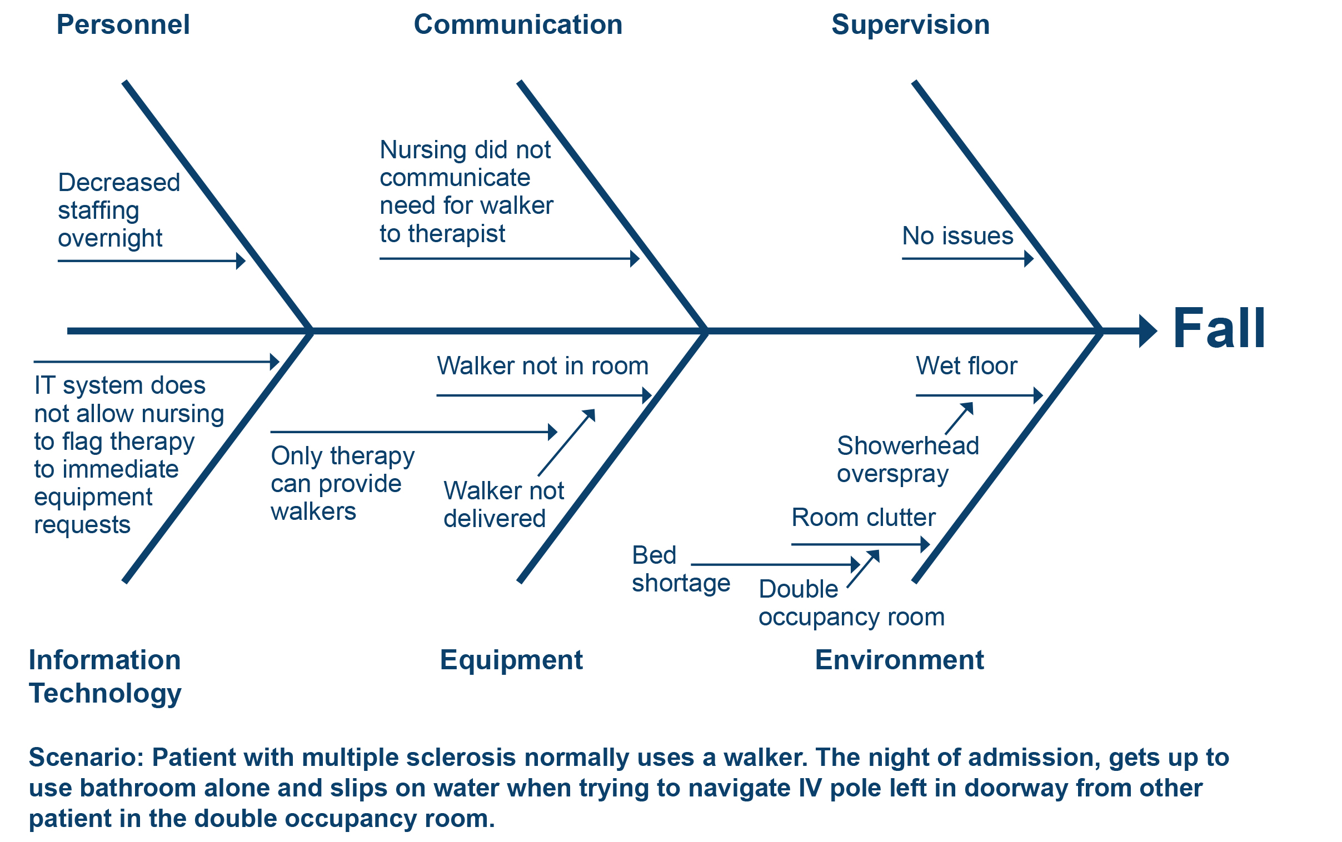

Cumbler EU, Simpson JR, Rosenthal LD, et al. 2013. Inpatient Falls: Defining the Problem and Identifying Possible Solutions. Part II: Application of Quality Improvement Principles to Hospital Falls. The Neurohospitalist 3(4): 203–8. http://doi.org/10.1177/1941874412470666.

