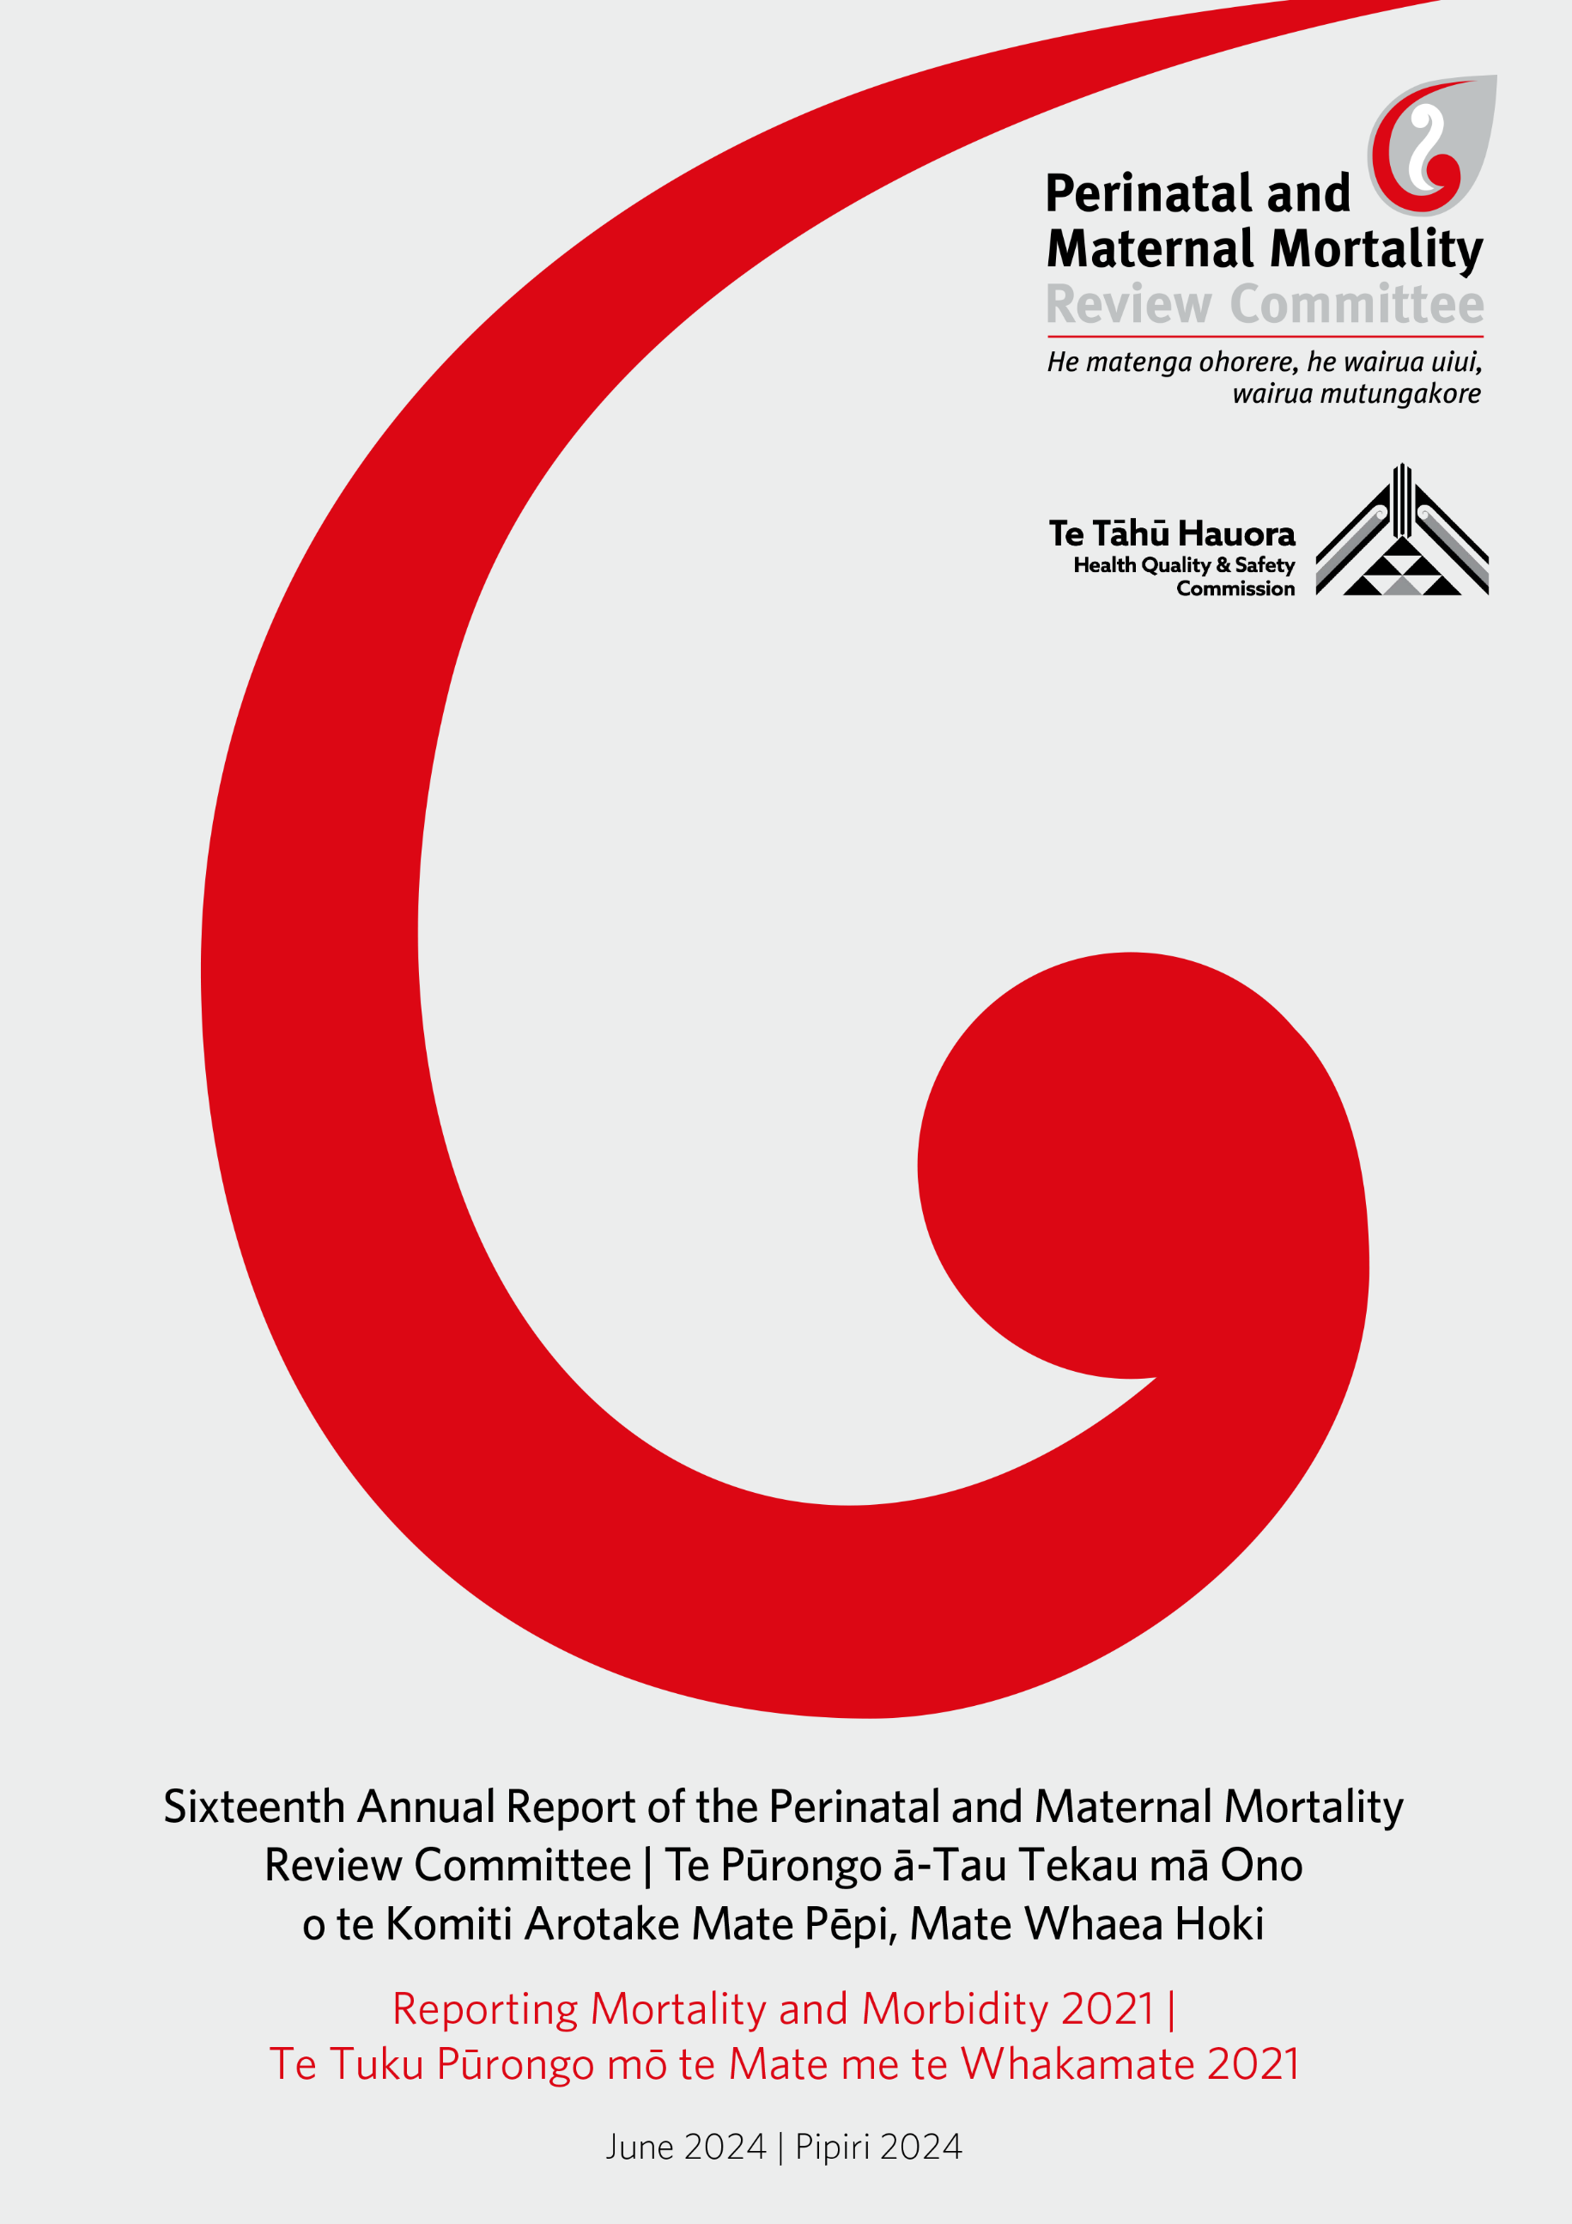

Perinatal and Maternal Mortality Review Committee. 2024. Sixteenth Annual Report of the Perinatal and Maternal Mortality Review Committee | Te Pūrongo ā-Tau Tekau mā Ono o te Komiti Arotake Mate Pēpi, Mate Whaea Hoki: Reporting Mortality and Morbidity 2021 | Te Tuku Pūrongo mō te Mate me te Whakamate 2021. Wellington: Te Tāhū Hauora Health Quality & Safety Commission.
Published in June 2024 by the Perinatal and Maternal Mortality Review Committee, PO Box 25496, Wellington 6146, New Zealand
ISBN 978-1-991122-20-9 (online)
The document is available online at: www.hqsc.govt.nz/our-work/national-review-of-avoidable-deaths/mortality-review-workstreams

He mihi | Acknowledgements
In 2023, all mortality review committees (including the Perinatal and Maternal Mortality Review Committee [PMMRC]) were disestablished and a national mortality review committee (NMRC) implemented. The former PMMRC members have become subject matter experts (SMEs) in the perinatal and maternal area.
The NMRC is now the primary advisor on mortality review to the board of Te Tāhū Hauora Health Quality & Safety Commission (Te Tāhū Hauora). Some of the NMRC’s advisory responsibilities include:
- strategic oversight of mortality review and system-level impact
- compliance with Te Tiriti o Waitangi across all aspects of mortality review
- identification of areas for potential in-depth reviews, analysis or surveillance
- provision of recommendations that are clear, coordinated and impactful.
The perinatal and maternal mortality review SMEs are grateful to the following groups and individuals for their assistance in the production of this report over the 2021–2024 period:
- The lead maternity carers, Health New Zealand – Te Whatu Ora clinicians throughout Aotearoa and local coordinators within each district who assisted with the collection of data within this report.
- The University of Otago New Zealand Mortality Review Data Group (NZMRDG): The epidemiology team of Dr Pauline Dawson, Dr Wendy Burgess (Ngāti Kahungunu, Ngāti Hāwea) and Dr Owen Sinclair (Te Rarawa), who designed the analysis and prepared this report, and Joseph Hii, Craig Rayner, Kirstin Charters and Jakub Zavacky, led by Kasia Szymanska, who established and maintain the perinatal and maternal mortality and morbidity websites, collated the data and produced the tables and figures in this report, all led by NZMRDG operations director and research fellow, Dr Rachael Lawrence-Lodge. The NZMRDG thanks David Hood (University of Otago) for his input on COVID-19 analysis and also Professor Robin Turner, director of the Biostatistics Centre, University of Otago.
- The PMMR secretariat of Te Tāhū Hauora, which includes Debbie Davies and Jo Sorasio, who contributed to many aspects of data collection, processing and report production.
- Pania Mitchell (Ngāruahinerangi ki Taranaki, Ngāti Rakaipaaka ki Nūhaka, Te Aitanga o Hauiti ki Tologa Bay), youth social worker, celebrant, māmā and volunteer for Sands New Zealand, an organisation that supports families after the death of a baby or infant, who has provided narrative and guidance through the report development.
- Members of the previous maternal mortality review working group and expert advisors, who reviewed the maternal deaths and provided guidance on classifications included within the maternal mortality chapter.
- Members of the previous neonatal encephalopathy working group, who provided guidance on neonatal encephalopathy classification and preliminary review of analysis for the neonatal encephalopathy chapter.
- Dame Teuila Percival (ofu, Papua), Ms Nicole Pihema (Ngāpuhi, Te Rarawa) and Professor John Thompson, who peer reviewed an earlier version of the report (note: this final report does not necessarily reflect their views).
- The staff at Data & Digital | National Collections & Reporting, Health New Zealand – Te Whatu Ora, who provided the denominator data.

Perinatal and maternal mortality review subject matter experts
- Mr John Tait ONZM (chair), president of Asia & Oceania Federation of Obstetrics and Gynaecology, ex officio member of the National Maternity Monitoring Group
- Dr Liza Edmonds (Ngāpuhi, Ngāti Whātua), National Mortality Review Committee chair, Ngā Pou Arawhenua member, neonatal paediatrician, Health New Zealand – Te Whatu Ora associate professor (research) National Centre for Women’s Health Research Aotearoa—Te Tātai Hauora o Hine, Victoria University
- Dr Rose Elder (deputy chair), obstetrician and gynaecologist, Health New Zealand – Te Whatu Ora Capital, Coast and Hutt Valley
- Dr Robin Cronin, research midwife specialist, Health New Zealand – Te Whatu Ora Counties Manukau
- Claire MacDonald, midwifery advisor and midwife, New Zealand College of Midwives | Te Kāreti o ngā Kaiwhakawhānau ki Aotearoa
- Dr Kasey Tawhara (Ngāti Raukawa ki te Tonga, Ngāti Porou, Taranaki, Te Arawa), Ngā Pou Arawhenua member, obstetrician and gynaecologist, Health New Zealand – Te Whatu Ora Lakes; chair of Te Ohu Rata o Aotearoa – Māori Medical Practitioners Association.
A special thanks also to PMMRC Pou Tikanga Mr Denis Grennell (Ngāti Maniapoto), Ngā Pou Arawhenuakaumatua, cultural facilitation, development, coaching and training consultant.

Experts contributing to the review of maternal deaths from 2021
- Dr Rose Elder (chair, Maternal Mortality Review Working Group), obstetrician and gynaecologist, Health New Zealand – Te Whatu Ora Capital, Coast and Hutt Valley
- Mr John Tait ONZM (chair, PMMR SMEs), president of Asia & Oceania Federation of Obstetrics and Gynaecology, ex officio member of the National Maternity Monitoring Group
- Jo McMullan, midwife manager – birthing suite, Health New Zealand – Te Whatu Ora Capital, Coast and Hutt Valley
- Dr Amy Spark, forensic pathologist, Health New Zealand – Te Whatu Ora Te Pae Hauora o Ruahine o Tararua MidCentral
- Dr Sue Tutty, general practitioner and GP liaison women’s health, Health New Zealand – Te Whatu Ora Counties Manukau
- Dr Lindsay Twiss, perinatal psychiatrist, Health New Zealand – Te Whatu Ora Te Toka Tumai Auckland
- Ms Karen Whiterod, specialty clinical nurse, Perinatal Mental Health, Te Uru Pā Harakeke | Healthy Women, Children and Youth, Health New Zealand – Te Whatu Ora Te Pae Hauora o Ruahine o Tararua MidCentral
- Brigid Beehan, midwifery advisor, New Zealand College of Midwives | Te Kāreti o ngā Kaiwhakawhānau ki Aotearoa
- Dr Philip Suisted (nō te tauihu o te waka a Māui), obstetrician and gynaecologist, Health New Zealand – Te Whatu Ora Te Pae Hauora o Ruahine o Tararua MidCentral, member of He Hono Wāhine (Royal Australian and New Zealand College of Obstetricians and Gynaecologists Māori Committee), member of the National Maternity Monitoring Group
- Dr Sue Belgrave, obstetrician and gynaecologist, Health New Zealand – Te Whatu Ora Te Toka Tumai Auckland
- Dr Eileen Bass, obstetric physician, Health New Zealand – Te Whatu Ora Capital, Coast and Hutt Valley
- Victoria Roper (Ngāti Raukawa ki te Tonga, Ngāti Rarua), midwife, expert advisor
- Ms Annabel Johns (Ngāti Apa, Ngāti Raukawa), lead clinical advisor Maaori Midwifery, Health New Zealand – Te Whatu Ora Counties Manukau

Experts contributing to neonatal encephalopathy review from 2021
- Dr Jutta van den Boom (chair, Neonatal Encephalopathy Working Group), neonatal paediatrician, Health New Zealand – Te Whatu Ora Waikato
- Mr John Tait ONZM (chair, PMMR SMEs), president of Asia & Oceania Federation of Obstetrics and Gynaecology, ex officio member of the National Maternity Monitoring Group
- Dr Malcolm Battin, neonatal paediatrician, Health New Zealand – Te Whatu Ora Te Toka Tumai Auckland
- Dr Kitty Bach, neonatal paediatrician, Health New Zealand – Te Whatu Ora Te Toka Tumai Auckland
- Dr David Bailey, obstetrician and gynaecologist, Health New Zealand – Te Whatu Ora Te Tai Tokerau
- Ms Karen Bennington, neonatal nurse practitioner, Health New Zealand – Te Whatu Ora Capital, Coast and Hutt Valley
- Dr Robin Cronin, research midwife specialist, Health New Zealand – Te Whatu Ora Counties Manukau
- Julie Richards, midwife, lecturer, Ara Institute of Canterbury, Health New Zealand – Te Whatu Ora Nelson Marlborough

Rārangi take | Contents
He mihi | Acknowledgements i
Karakia – Te Kaireka Pūhia 1
Mihi – Haupokia 2
He kupu whakatūpato | Content warning 3
Te kupu whakataki a te manukura | Chair’s introduction – Mr John Tait 4
Te Pou 6
Review 6
Data 6
Reporting 7
1 Whakarāpopototanga matua | Executive summary 8
Key clinical findings 8
Key system findings 8
Call to action 9
Conclusions 9
Ngā tūtohinga | Recommendations 11
2 Te tikanga | Methods 12
Definitions used by the PMMRC 12
Perinatal and infant mortality 13
Ethnic comparisons 13
Inclusive language 13
Babies not born 13
The National Maternity Collection 14
Perinatal Society of Australia and New Zealand death classifications 14
Statistical analysis 14
3 Te mate pēpi | Perinatal mortality 15
Introduction 15
Overview 15
Demographics 26
Who you are 27
Where you live 37
COVID-19 impact on perinatal outcomes 44
4 Te māuiui roro I ngā pēpi whānau hou | Neonatal encephalopathy 65
Introduction 65
International comparisons 66
Findings 66
Neonatal encephalopathy appended tables 82
5 Te Mate o ngā whāea | Maternal mortality 84
Key findings 84
Summary 84
Definitions 85
Findings 85

Ngā tatau | Figures
Figure 3.1: Perinatal related mortality rates (per 1,000 births) 2007–2021 16
Figure 3.2: Perinatal related mortality rates (per 1,000 births, with 95% confidence intervals) by maternal prioritised ethnic group 2012–2021 31
Figure 3.3: Perinatal related mortality rates (per 1,000 births, with 95% confidence intervals) by baby prioritised ethnic group 2012–2021 31
Figure 3.4: Neonatal death risk (per 1,000 ongoing pregnancies) by gestation at birth and maternal ethnicity excluding congenital anomalies 2012–2021 34
Figure 3.5: Perinatal related mortality rates (per 1,000 births, with 95% confidence intervals) by maternal age and maternal prioritised ethnic group 2012–2021 36
Figure 3.6: Perinatal death classification (PSANZ-PDC) specific perinatal related mortality rates (per 1,000 births, with 95% confidence intervals) (excluding congenital anomalies) by NZDep quintile 2012–2021 38
Figure 3.7: Perinatal related mortality rates (per 1,000 births) by urban/rural residence and maternal prioritised ethnic group (with 95% confidence intervals) 2012–2021 39
Figure 3.8: Perinatal related mortality rates (per 1,000 births, with 95% confidence intervals) by DHB of maternal residence compared with Aotearoa perinatal related mortality 2012–2021 41
Figure 3.9: Stillbirth rates (per 1,000 births, with 95% confidence intervals) by DHB of maternal residence compared with average stillbirth rates 2012–2021 42
Figure 3.10: Neonatal mortality rates (per 1,000 live births, with 95% confidence intervals) by DHB of maternal residence compared with Aotearoa neonatal mortality 2012–2021 43
Figure 3.11: Perinatal related mortality rates by month (per 1,000 births) 2017–2021 46
Figure 4.1: Neonatal encephalopathy annual and 3-year rolling rates (per 1,000 term births 2010–2021 and all births ≥35 weeks’ gestation annual rate from 2016) 66
Figure 4.2: Neonatal encephalopathy rates (per 1,000 births at ≥35 weeks’ gestation, with 95% confidence intervals) by maternal prioritised ethnic group 2017–2021 67
Figure 4.3: Neonatal encephalopathy rates (per 1,000 births at ≥35 weeks’ gestation, with 95% confidence intervals) by NZDep quintile 2017–2021 68
Figure 4.4: Neonatal encephalopathy rates (per 1,000 births at ≥35 weeks’ gestation, with 95% confidence intervals) by DHB of maternal residence (compared with all of New Zealand neonatal encephalopathy rate) 2017–2021 69
Figure 4.5: Neonatal encephalopathy rates by gestation (per 1,000 births at ≥35 weeks’ gestation with 95% confidence intervals) 2017–2021 70
Figure 4.6: Neonatal encephalopathy rates (per 1,000 births at ≥35 weeks’ gestation, with 95% confidence intervals) by parity prior to index birth 2017–2021 72
Figure 4.7: NE rates (per 1,000 births at ≥35 weeks’ gestation, with 95% confidence intervals) by parity and gestation 2017–2021 73
Figure 4.8: Neonatal encephalopathy rates (per 1,000 births at ≥35 weeks’ gestation with 95% confidence intervals) by place of birth 2017–2021 77
Figure 5.1: Maternal mortality ratios (per 100,000 maternities) (rolling 1-year and 3-year) 2006–2021 86
Figure 5.2: Maternal 3-year rolling mortality ratios (per 100,000 maternities) by prioritised ethnic group (Māori and New Zealand European) and year 2006–2021 89

Ngā tūtohi | Tables
Table 3.1: Summary of New Zealand perinatal related mortality rates (≥20 weeks or ≥400 g if gestation is unknown) 2007–2021 17
Table 3.2: Perinatal related deaths by perinatal death classification (PSANZ-PDC) 2021 19
Table 3.3: Perinatal death classification (PSANZ-PDC) specific perinatal related mortality rates (per 1,000 births) 2012–2021 21
Table 3.4: Perinatal death classification (PSANZ-PDC) specific stillbirth rates (per 1,000 births) 2012–2021 22
Table 3.5: Intrapartum stillbirth rates (per 1,000 ongoing pregnancies) by gestation, excluding congenital anomalies 2012–2021 23
Table 3.6: Neonatal death classification (PSANZ-NDC) specific neonatal death rates (per 1,000 live births) 2012–2021 24
Table 3.7: Sociodemographic and other characteristics of all births compared with perinatal related deaths 2012–2021 29
Table 3.8: Perinatal death classification (PSANZ-PDC) specific perinatal related mortality rates (excluding congenital anomalies) by maternal prioritised ethnic group 2012–2021 33
Table 3.9: Perinatal related mortality rates (per 1,000 births) by rurality and maternal prioritised ethnic group 2012–2021 40
Table 3.10 Confirmed COVID-19 infection during pregnancy 2020–2021 45
Table 3.11: Proportion of people receiving at least one anatomy ultrasound in pregnancy 2017–2021 47
Table 3.12: Perinatal related death and perinatal death classification (PSANZ-PDC) 2021 48
Table 3.13: Neonatal death and primary neonatal death classification (PSANZ-NDC) 2021 51
Table 3.14: Summary of Aotearoa perinatal related mortality rates (≥20 weeks or ≥400 g if gestation unknown), babies of Māori and New Zealand European women and birthing people, 2007–2021 53
Table 3.15: Perinatal Society of Australia and New Zealand Perinatal & Neonatal Death Classification (PSANZ-PDC/NDC) 56
Table 3.16: New Zealand perinatal related mortality rates (per 1,000 births) using the international definition (≥1,000 g or ≥28 weeks if birthweight unknown) 2007–2021 58
Table 3.17: Perinatal related mortality rates (per 1,000 births) by maternal prioritised ethnic group 2012–2021 60
Table 3.18: Perinatal related mortality rates (per 1,000 births) by baby prioritised ethnic group 2012–2021 60
Table 3.19: Perinatal related mortality rates (per 1,000 births) by maternal prioritised ethnic group and year 2012–2021 61
Table 3.20: Perinatal related mortality rates (per 1,000 births) by maternal age 2012–2021 62
Table 3.21: Perinatal related mortality rates (per 1,000 births) by DHB of maternal residence 2012–2021 63
Table 3.22: Perinatal related mortality rates (per 1,000 births) by gestation and birthweight 2021 64
Table 4.1: Neonatal encephalopathy rates (per 1,000 births at ≥35 weeks’ gestation) by gestation, sex, birthweight and plurality 2017–2021 71
Table 4.2: Neonatal encephalopathy rates (per 1,000 births at ≥35 weeks’ gestation) by maternal age, maternal prioritised ethnic group, NZDep quintile, rurality, smoking at registration, gestation at first antenatal registration and parity 2017–2021 74
Table 4.3: Antenatal complications, obstetric interventions and maternal outcomes among neonatal encephalopathy cases by parity and Sarnat stage 2017–2021 75
Table 4.4: Peripartum complications and mode of birth among neonatal encephalopathy cases 2017–2021 76
Table 4.5: Neonatal encephalopathy rates (per 1,000 births at ≥35 weeks’ gestation) by place of birth 2017–2021 77
Table 4.6: Immediate newborn wellbeing among babies with neonatal encephalopathy 2017–2021 78
Table 4.7: Induced cooling therapy among babies with neonatal encephalopathy 2017–2021 78
Table 4.8: Use of cooling and outcomes by Sarnat stage among babies with neonatal encephalopathy 2017–2021 79
Table 4.9: Neonatal resuscitation and early neonatal management by Sarnat stage among babies with neonatal encephalopathy 2017–2021 80
Table 4.10: Investigations and neonatal outcome by Sarnat stage of neonatal encephalopathy survivors 2017–2021 81
Table 4.11: Immediate newborn wellbeing among babies with neonatal encephalopathy 2010–2021 82
Table 4.12: Neonatal encephalopathy rates (per 1,000 births ≥35 weeks’ gestation) by DHB of maternal residence 2017–2021 83
Table 5.1: Single-year and 3-year rolling maternal mortality ratios (per 100,000 maternities) 2006–2021 87
Table 5.2: Demographic characteristics among maternal deaths compared with all births 2006–2021 88
Table 5.3: Maternal mortality ratio (per 100,000 maternities) and cause of maternal death 2006–2021 90
Table 5.4: Maternal suicide by prioritised ethnic group 2006–2021 91

Karakia – Te Kaireka Pūhia
Tu tohia te ao Tu tohia te ao
Kahu rara tangata a uta
Me turaki atu ki tangata a tai
Kahu rara tangata a uta
Pera hoki ra te korepe nui
Te korepe roa, te wahi awa
Te toitoi awa whakamoea e tama ki te ara
Whakamaua e tama ki te ara
Ko Tu ko Rongo kaua raka ra
E tama e uhia, tuku atu e tama
Ki waho i te tawhangawhanga
He putanga ariki no Rongo
Mai e mai e mai te tipua
Mai e mai e mai te tawhito
I haere mai koe i te whakaoti nuku
I te whakaoti rangi
Ko te manawa ko taku manawa
He tane ka irihia whano whano
Hara mai te toki
Haumi e hui e taiki e

Mihi – Haupokia

E ngā reo, e ngā mana, e ngā karangaranga maha kei waenganui i a tātou huri noa i te motu tēnā koutou, tēnā koutou, tēnā koutou katoa.
Ko te mea tuatahi kia wehi ki te Atua nānā nei ngā mea katoa mai i te rangi ki te whenua. Nānā i homai nānā anō e tango atu. Arā nei ngā mihi ki ngā whaea, ki ngā taonga mai i te Atua kua ngaro nei i te pō, i roto i te whānautanga mai o te pepi. Nā reira ki ngā whānau e noho mokemoke ana nei i te ngarotanga atu, ānei rā te mihi ki a koutou i uru mai ki tēnei pūrongo, ānei ngā mihi ki te katoa huri noa i te motu. Ko te kaupapa o te purongo nei kia kimihia ngā take kua ngaro penei nei a tātou tāngata; whaea, pepi kia whai tikanga kia kore a tātou taonga ka ngaro penei ai i ngā tau e haere mai nei.
Tēnā e inoi atu ki te Atua kia tau tōna manaakitanga ki runga i a mātou i tēnei wā, kia tāhuringia i a mātou ki roto i tō aroha tae noa ki te mutunga o tēnei purongo haere tonu rā ki te ao whānui.
Haumia hui e taiki e.

He kupu whakatūpato | Content warning
The content of this report necessarily presents and discusses data about the death/mortality of babies, women and birthing people. The maternal chapter also discusses suicide. This content may be distressing to some and emotionally and intellectually challenging to engage with. We have endeavoured to engage bravely, empathetically and thoughtfully with this difficult topic throughout the report.

Te kupu whakataki a te manukura | Chair’s introduction – Mr John Tait
On behalf of the perinatal and maternal mortality review subject matter experts, I want to acknowledge the individuals, families and whānau affected by those represented in this report. The report covers 15 years of reporting, which includes nearly 10,000 lives lost, and hundreds of babies diagnosed with moderate or severe neonatal encephalopathy. Our sincere thoughts are with each and every family and whānau grieving the loss of a life or life imagined.
The former Perinatal and Maternal Mortality Review Committee (PMMRC) have contributed over nearly 2 decades to supporting a health system that provides safe care and to the prevention of adverse outcomes that may occur in the perinatal period. There has been some improvement during this time, albeit small. For example, maternal death due to amniotic fluid embolism is now an incredibly rare event and, although not true for all population groups, there has been a decrease in the rate of stillbirth. However, the lack of change for some populations in the rate of stillbirth is evidence of the persistent inequities in perinatal outcomes in Aotearoa New Zealand.
The vision articulated by the PMMRC in 2019 was:
Te mahi tahi puta noa I te pūnaha kia kore rawa ai e mate, e whara ngā māmā me ā rātau pēpi, whānau hoki mai i ngā mate, wharanga rānei ka taea te ārai.
Working together across the system towards zero preventable deaths or harm for all mothers and babies, families and whānau.
This vision provides the motivation for this report and all the work that we do in perinatal and maternal health. Without the dedication and collaboration of all involved, it is impossible to come close to realising this vision.
This report is primarily written for decision- and policy-makers in health, clinicians, researchers or anyone who can make system- or service-level change to reduce mortality and morbidity during the perinatal period. It is the health sector that plays the lead role in enabling improved access to services and culturally safe, clinically competent care for women, birthing people and their babies. There is much that can and should be improved, including but not limited to improved access to services and systems to support such care.
We also want to highlight that this report is important for those in social sectors. We cannot ignore the significant impact that social determinants of health, bias that favours some groups and disadvantages others and other ongoing drivers of inequity in access and care have on outcomes. It is feasible and necessary that decision-makers and experts collaborate across departmental boundaries to keep health on all policy agendas.
If you have read our reports in the past, you will notice that we have approached this one differently, within constrained timeframes, leading to a more focused report. We have endeavoured to capture the context in which these deaths occurred and provide commentary about future prevention. We have centred this approach on whānau and Te Pou, which is described in the report. For members of the public who have an interest in perinatal and maternal mortality, a summary of this report will be provided on the website of Te Tāhū Hauora Health Quality & Safety Commission.
I want to use this opportunity to elevate the Healing, learning and improving from harm policy, released by Te Tāhū Hauora in July 2023. This policy requires us to focus on culturally responsive and restorative practices when harm has occurred. It highlights the importance of involving whānau in the review process. Including and partnering with whānau can deepen our understanding and provide an opportunity for healing.
There is much to be learnt through taking a national view of maternal morbidity. Through learning from near-miss events, we can seek to understand these events, which can guide system learning and change. These findings can inform guidelines, policy and practice to drive change that is relevant and sustainable, thereby improving outcomes. However, it must be noted that guidelines and policies cannot influence outcomes unless there exists:
- appropriate resourcing
- a good implementation plan that includes an audit loop
- buy-in from health organisations, health care workers and whānau.
The lack of action on some prior recommendations remains a frustration for PMMRC members. In 2019, we recommended that a bereavement pathway be developed, but it has taken until 2024 for an agency to be commissioned to start work on a national service.
Volunteer groups such as Sands New Zealand and Baby Loss NZ provide essential support, information and services for bereaved parents, families and whānau. They do an exceptional job with limited support, but the need continues to grow, and these groups need more support.
I want to acknowledge the important role that care providers and local coordination plays in this journey. Our thanks go to you all for providing care and support, often going above and beyond in your roles. In addition to supporting whānau in those immediate moments of grief, your roles often continue into reviewing and learning from these deaths, developing recommendations for future pregnancies and working towards wider change to prevent deaths from occurring for others.
I also acknowledge the significant amount of work that has been undertaken by the former Neonatal Encephalopathy Working Group and the Maternal Mortality Review Working Group. These two working groups of the PMMRC came to a close in June 2023. Experts within these groups have provided their time and expertise to this work, and they continue to be strong advocates in their regions and within other professional groups.
This report represents only a part of the work that members of this group and the working groups have done in an effort to reduce perinatal and maternal mortality. Experts within the PMMRC and working groups have strived for timely communication and action for improvement in this space. This was particularly evident during the COVID-19 pandemic.
In my role as chair of the perinatal and maternal subject matter experts group and as former chair of the PMMRC, I call on the health sector and all those who can influence and make improvements to continue to advocate for change, to continue to review previous recommendations of the PMMRC and to make ongoing improvements. More specifically, the sector must continue to collect quality data on perinatal and maternal mortality and neonatal encephalopathy and to prioritise equity and must address the overrepresentation of some population groups that is visible year after year.
The work we have undertaken for the past 18 years – the reviews of deaths that have been embedded in the hearts of PMMRC members, local and national coordinators and working groups over time – must form a platform upon which the health system can make positive changes for all of Aotearoa New Zealand.
Ngā mihi nui ki a koutou katoa.

Te Pou
Te Pou, the Māori responsive rubric and guidelines, were developed in response to the disproportionate and inequitable burden of mortality on Māori whānau, hapū, iwi and communities in Aotearoa. Ngā Pou Arawhenua, through the production of the guidelines, aims to assist the Te Tāhū Hauora Health Quality & Safety Commission (Te Tāhū Hauora) mortality review committees to advance Māori health, achieve equity and increase and improve the application of te ao Māori in mortality review.
In the last few years, the broader Perinatal Mortality and Maternity Review group subject matter experts (SMEs), Te Tāhū Hauora secretariat and the New Zealand Mortality Review Data Group (NZMRDG) have all worked to embrace the good practice expectations of Te Pou.
We are committed to this work, and we acknowledge that this is a journey that all people involved in perinatal and maternal mortality review are on and that processes will continue to be addressed and refined.
The four Pou are:
- Tika: Getting the story and the interpretation right.
- Manaakitanga: Being culturally and socially responsible.
- Mana: Advancing equity, self-determination and social justice
- Mahi tahi: Establishing relationships for positive change.
The work being done in regard to Te Pou in perinatal and maternal mortality review and reporting is significant and woven throughout our work in different ways. We offer just a few examples of how the pou are guiding us and being implemented throughout review, analysis and reporting.

Review
The perinatal and maternal mortality review processes begin in the former district health boards (DHBs; now Health New Zealand – Te Whatu Ora health districts), where local coordinators work with families, enter data and arrange local case review. It is early days, and how this works differs in each location. For example, some regions have begun to engage more with whānau after the death of a baby and use aspects of Te Pou to guide the way in which they interact. The hope is that this change will help build relationships and enable ongoing engagement and sharing of information.

Data
Most data is entered directly via the perinatal and maternity mortality review online portal. All of this data is stored in Aotearoa within secure NZMRDG systems. Data is treated as a taonga and cared for accordingly. The NZMRDG data team are guided by the principles of the Te Kāhui Raraunga Māori data governance model. One example is the group working with Births, Deaths and Marriages to ensure that macrons and other language-specific symbols are added to data extracts received weekly from their database to ensure we correctly capture and honour the names and their ancestry/whakapapa.

Reporting
Analysis and draft reporting is completed by the NZMDRG and finalised in association with the former Perinatal and Maternal Mortality Review Committee (PMMRC; now subject matter experts). This group consists of respected clinical leaders in the sector, Māori representatives and consumer input. Each brings varying skillsets and viewpoints to this work, but all are united in an aim to reduce perinatal and maternal mortality and reduce inequity in the interpretation of data.
The NZMRDG epidemiology team is made up of Dr Wendy Burgess, obstetrician (Ngāti Kahungunu, Ngāti Hāwea); Dr Owen Sinclair, paediatrician (Te Rarawa); and Dr Pauline Dawson, midwife/data scientist. All are respected leaders in perinatal and maternal health and active clinicians and academics. This combination of disciplines and strong Māori participation has been brought together with the aim to honour the data and lives contained therein by employing an equity-driven lens for our work. Together, we consider the influences of colonisation, intergenerational trauma, inequity and social determinants of health in Aotearoa society on the mortality outcomes and trends we identify.
For this report, we also sought guidance from Pania Mitchell, a consumer representative who generously lent her voice to guide the report writing.

Whakarāpopototanga matua | Executive summary
This 16th report is a product of the final work programme of the former PMMRC; due to timeframes and data provision delays and limitations, it is a more focused report than its predecessors. However, it retains essential elements to describe and give context to the nature of perinatal and maternal mortalities experienced in Aotearoa for the 2006–2021 monitoring period.

Key clinical findings
- The overall perinatal related mortality rate (which includes deaths both during pregnancy and in the first 28 days after birth) has not significantly decreased in the period 2007–2021.
- There continues to be a small significant decrease in the rate of stillbirths.
- The report identifies that certain groups continue to have much worse clinical outcomes than others. These clinical disparities exist in all findings and have existed for the 15 years in which this report has been being produced. The report recognises that the following groups have worse clinical outcomes than groups with the best clinical outcomes:
    - Māori
    - Pacific peoples
    - Indian populations
    - those aged under 20 years
    - those living in areas of high deprivation.
- The report identifies a significant amount of preventable mortality, and this is especially true in the groups who were most disadvantaged.
- Rates of neonatal encephalopathy show a small, statistically significant trend upwards. Although it is recommended that all babies with moderate neonatal encephalopathy receive magnetic resonance imaging (MRI), this is still not being achieved.
- Wāhine Māori, Pacific women and birthing people and those living in higher deprivation areas carry a disproportionate burden of maternal mortality.
- Those of New Zealand European ethnicity were 67% less likely than wāhine Māori to die by suicide – a direct contributor to maternal mortality in the 2006–2021 period.

Key system findings
This report records significant inequities; these are differences between population groups that are avoidable and unjust and include a level of preventable mortality. Although some change has been seen over the 15-year period of reporting, these changes are small and unequally distributed. A maternal death due to amniotic fluid embolism is now an incredibly rare event and, although not true for all ethnic groups, there has been a decrease in the rate of stillbirth. The lack of change for priority populations in the rate of stillbirth and other causes of mortality is concerning. A full understanding of the reasons for the lack of change for priority populations is beyond the scope of this report and requires further investigation and remedial action by the responsible authorities.
Certain groups are shown to have different clinical outcomes. Most disturbingly, people of some ethnic groups and those living in areas of deprivation have significantly worse outcomes than Europeans and those living in the wealthiest areas. This disparity and inequity has persisted unchanged over the 15 years of reporting. We have documented that the people with a combination of certain clinical conditions (some of which are preventable) and non-clinical factors, such as ethnicity and poverty, had much higher rates of mortality over the reporting period.
Significant inequitable ethnic disparities are reported herein. The health system will always have preventable deaths, but inequity produces more avoidable deaths among some groups, and we need a more robust way to describe deaths that are preventable.
Although all inequities are unjust and unfair, in this context they represent a systemic failure of the maternal and health system, and society more widely, to provide adequate care to those in the most at-risk groups. The inability of the system to recognise all risks associated with poor outcomes and then adjust models of care to need must be viewed as a missed opportunity to significantly reduce poor outcomes in Aotearoa. Different approaches and intensities of care are required for different population groups. The concept of standardisation of care is a barrier to this multifaceted approach. This is especially true for groups in Aotearoa who already carry disproportionate burdens of poor health and poverty.

Call to action
Why we have not made progress and why certain groups have worse outcomes are appropriate questions to ask after reading this report. Although these are uncomfortable questions, if this report leads to the acknowledgement of the issues, a search for solutions and system changes, it can be considered successful.

Conclusions
Over the past 15 years, the former PMMRC has consistently delivered globally recognised, high-quality reports. This series of reports has produced a vast volume of data that has revealed significant inequities in perinatal clinical outcomes relating to demographic and socioeconomic factors, including ethnicity and poverty. The reporting of these disparities over a long period of time has not resulted in any meaningful action to address them, and the PMMRC reports have served to document that systemic indifference and persistent inequity.
This 16th report builds upon this legacy by providing not only comprehensive information but also incorporating contextual and practical commentary. Emphasising that health care is just one facet of an individual’s or family’s broader health and wellbeing, this report underscores the disparities in perinatal outcomes evident in both current and preceding reports, particularly among populations in high-deprivation areas and specific ethnic groups.
This report asks for change but must concede that how data is presented must also change. The data must be placed in context, recognising pregnancy and childbirth as significant life events occurring within the fabric of communities, beyond clinical settings. This acknowledges that any mortality arising from these events has enduring and far-reaching consequences.
This report also acknowledges that the context for Māori is rooted in a history of colonisation and oppression that saw land confiscation; suppression of Māori beliefs, values and traditional practices; and the loss of te reo Māori, to name a few. This history had profound effects on wāhine, hapū and whānau hauora In addition, this history saw the birthing of babies move away from whanau and communities. This report highlights the devastating effect of colonisation on generations of Māori and the need for the health system response to actively address the negative impacts of this history.
Although this document is not written for whānau specifically, they want to be seen and heard within the data and for their voice to be part of what clinicians and policy makers hear and consider when they read it. This report also highlights that other communities, such as Pacific and Indian peoples, also carry an inequitable burden in perinatal outcomes.
Our approach adheres to the Te Tāhū Hauora Health Quality & Safety Commission’s Te Pou framework and aligns with the four pou principles: getting the story right; social and cultural responsibility; advancing equity, self-determination and social justice; and the establishing of relationships to foster social change.
If change does not occur, the outcomes will stay the same.
Each data point in this report represents the death of a whānau member, and we acknowledge ‘the sorrow and distress represented in those data.’
Nā koutou i tangi, nā tatau katoa
When you cry, your tears are shed by us all

Ngā tūtohinga | Recommendations
The findings in this report replicate many of those from previous reports. These findings form the following recommendations, which echo key areas previously identified as needing improvement. The challenge is to move from the learnings and recommendations to central and collaborative action to improve care and outcomes. This requires system-level change and recognition of each individual’s role in the system. It is only through collaboration that these recommendations can be realised.
- Preterm birth: Central government to provide adequate funding to support and strengthen current transdisciplinary work being undertaken in preterm birth. This should be with a view to implementing national targeted initiatives to reduce preterm birth rates and improve care and outcomes for babies born preterm, including reducing mortality. Focus should be on those most affected, including Indian, Pacific and Māori communities and those living in areas of high deprivation.
- National guidelines: Health New Zealand to resource national guidelines and ensure that these become embedded into policies, protocols and practices in all regions. Guidelines and policies cannot influence outcomes unless:
- they have appropriate resourcing for both roll-out and operationalising
- they include a good implementation plan that includes an audit loop to identify enablers of and barriers to engagement and to determine whether the guideline has led to desired outcomes
- buy-in is obtained from Health New Zealand, health professionals and whānau to ensure guidelines are accessible and acceptable to all communities.
- Cultural safety: Health care regulatory authorities are responsible for setting standards for clinical and cultural competence and ethical conduct in line with the Health Practitioners Competence Assurance Act 2003, section 118(1)(i). To increase progress towards making the provision of care culturally safe, everyone involved must increase their commitment and collaboration. This includes the setting of standards, regulation, service provision arrangements and personal responsibility. The principle of mahi tahi must guide collective responsibility and commitment to ensure ongoing education is provided and audit of safe, equitable care is in place, regardless of the setting in which care is provided. Further work is required by the agencies involved to reflect their shared responsibilities in achieving the outcome of culturally safe care.
- Missing data – As a matter of urgency, Health New Zealand should prioritise the collection of complete and robust maternity and neonatal data to allow monitoring of equitable outcomes and allow the audit of quality and safety initiatives used to improve maternity and neonatal care. Data collection processes must recognise that Māori data is a taonga; maintaining data sovereignty will ensure Māori are partners in the collection, ownership and application of their data, as outlined under Te Tiriti o Waitangi.

Te tikanga | Methods
For full description of the methods, see the associated Methods and Definitions for Perinatal and Maternal Mortality Review Committee Reporting document at www.hqsc.govt.nz/resources/resource-library/sixteenth-annual-report-of-the-perinatal-and-maternal-mortality-review-committee-te-purongo-a-tau-tekau-ma-ono-o-te-komiti-arotake-mate-pepi-mate-whaea-hoki.

Definitions used by the PMMRC
Fetal death is the death of a fetus at 20 weeks’ gestation or beyond (≥20 weeks) or weighing at least 400 g if gestation is unknown. Fetal death includes stillbirth and termination of pregnancy.
Termination of pregnancy is the interruption of an ongoing pregnancy (whether the baby was stillborn or live born). This report only includes termination of pregnancy from 20 weeks’ gestation.
Neonatal death is the death of any baby showing signs of life at 20 weeks’ gestation or beyond or weighing at least 400 g if gestation is unknown that occurs up until midnight of the 2^{7t}h day of life. Early neonatal death is a death that occurs up until midnight on the sixth day of life. Late neonatal death is a death that occurs between the seventh day and midnight of the 2^{7t}h day of life.
Perinatal mortality is fetal and early neonatal death from 20 weeks’ gestation (or weighing at least 400 g if gestation is unknown) until midnight of the sixth day of life.
Perinatal related mortality is fetal deaths (including terminations of pregnancy and stillbirths) and neonatal deaths (up to midnight of the 2^{7t}h day of life) per 1,000 total babies born at 20 weeks’ gestation or beyond and weighing at least 400 g if gestation was unknown.
A maternal death is the death of a person while pregnant or within 42 days of the end of pregnancy (miscarriage, termination or birth), irrespective of the duration and site of the pregnancy, from any cause related to or aggravated by the pregnancy or its management. It does not include accidental or incidental causes of death of a pregnant person.
Maternities are all live births and all fetal deaths at 20 weeks’ gestation or beyond or weighing at least 400 g if gestation is unknown. The maternal mortality ratio is calculated per 100,000 maternities.
Neonatal encephalopathy (NE) is a clinically defined syndrome of disturbed neurological function within the first week of life, manifested by difficulty initiating and maintaining respiration, depression of tone and reflexes, subnormal level of consciousness and often seizures.

Perinatal and infant mortality
Gestation Birth 7 days 28 days 1 year
20 weeks or more
or
≥400 grams birthweight
0–<7 days
7–27 days
28 days–<1 year
Late neonatal deaths
Early
neonatal deaths
Post-neonatal deaths
Fetal deaths
Perinatal deaths
Perinatal related deaths
Neonatal deaths
Infant deaths
(Adapted from New Zealand Health Information Service and Ministry of Health.)

Ethnic comparisons
Throughout the report, comparisons are made between prioritised ethnic groups. At times, outcomes for babies of Māori women and birthing people are compared with outcomes for babies of New Zealand European women and birthing people. Te Tiriti o Waitangi underlies both the health sector’s obligations to Māori and Māori rights to monitor the Crown to ensure that these responsibilities are met and that there are equitable outcomes for Māori in the health sector. Treaty-based Māori rights are augmented by the broader rights of women and children to equitable outcomes regardless of their ethnicity. The presentation of comparisons between different ethnic groups is not to provide commentary on the deficits of any particular ethnic group but rather to highlight the deficits of a society that creates, maintains and tolerates these differences.

Inclusive language
As previously signalled, we have endeavoured to use gender inclusive language in this report. The exception to this is when we are using technical and legal definitions such as maternal death and lead maternity carer (LMC). We consulted with the PMMR subject matter expert group and the Te Tāhū Hauora Rainbow Connection group, and we also considered the principles of Te Pou in this decision. The language and terminology in this area is constantly evolving and the approach and language used here will likely need updating in future. We acknowledge that this report encompasses all those who are birthing, including women and transgender, non-binary, intersex and gender-diverse people.

Babies not born
The perinatal mortality data set used for this report contains 24 babies who were not born. Under law in Aotearoa, only babies who were issued from their mother/parent are counted as stillbirths. This means that, if a woman/birthing person dies with a baby in utero and the baby is not birthed, the baby has no legal status/is not considered a legal entity and is therefore not recorded by Births, Deaths and Marriages and has no national health index (NHI) number or official birth or death date. The PMMR SMEs have decided to include these babies in this report to acknowledge these losses and the impact on their whānau and communities. Although this report only considers losses after 20 weeks, as defined above, we also acknowledge the many pregnancy losses that occur before that time.

The National Maternity Collection
The National Maternity Collection (MAT) is based on several sources:
- primary maternity services provided under the Primary Maternity Services Notice Pursuant to Section 88 of The New Zealand Public Health And Disability Act 2000 (now section 94 of the Pae Ora (Healthy Futures) Act 2022 [Pae Ora Act]), which is sourced from LMC claims for payment
- the National Minimum Dataset, which contains information on inpatient and day patient health event data during pregnancy, birth and the postnatal period for the woman/birthing person and baby
- data supplied to Health New Zealand – Te Whatu Ora by the DHBs providing primary maternity services.
Although MAT should have a record of most births that occur in Aotearoa, either through the National Minimum Dataset for those who give birth in hospital or through LMC claims, antenatal data is not always reliably uploaded for women and birthing people who are receiving care from providers other than LMC midwives, general practitioners or obstetricians. In particular, women and birthing people whose antenatal care is provided through their DHB may not have complete, or indeed any, antenatal data entered into MAT. Many DHBs, such as Counties Manukau, routinely provide primary antenatal care, and LMC workforce issues mean this is becoming more common nationally. Technical issues mean that complete data from DHBs is not always uploaded into MAT, even when they are provided. The 14th report of the PMMRC presented an approximation of the effect of this with regard to smoking status and showed the substantial differences between those whose antenatal records are in MAT and those whose records are not.

Perinatal Society of Australia and New Zealand death classifications
All perinatal deaths are classified according to the 2017 revision of the Perinatal Society of Australia and New Zealand (PSANZ) Perinatal Death Classification (PDC) or the PSANZ Neonatal Death Classification (NDC) (Table 3.15 – appended).

Statistical analysis
Data is largely presented descriptively as counts, proportions and rates.
We have used simple linear regression analysis to investigate linear change across time and investigated autocorrelation and normality of the residuals for all models. From each model, the change across time is estimated, along with the 95% confidence interval (CI). A positive slope indicates an increase in rate during that time period, whereas a negative slope indicates a decrease over time.

Te mate pēpi | Perinatal mortality

Introduction

Key findings
- There has been no statistical change in perinatal mortality rates in Aotearoa over the 15 years from 2007 to 2021.
- Significant inequities, related to a number of factors, including ethnicity, have always occurred in perinatal mortality. These inequities remain unchanged for Māori, Pacific and Indian populations.
- Some combinations of ethnicity and other factors, for example, deprivation, have more than twice the risk of disease compared with the population with the lowest risk.
- Inequities are caused by structural issues and a failure of the health system to adjust to the different needs of the most at-risk groups. A multiagency approach, including health, housing, social service and income support providers, is needed to provide effective services that support hapū (pregnant) whānau and those with young pēpi to be and remain well.

Summary
This section on perinatal mortality documents rates and inequities that have remained unchanged over 15 years. This report, based on statistical information, was unable to determine the cause of this status quo. Unfortunately, that status quo has some populations suffering more than others over a long period of time.
However, several possibilities could explain this lack of progress:
- any interventions enacted may have been ineffective
- no attempt has been made to address perinatal mortality and its inequities at the time of this reporting period.
Further initiatives have been implemented since 2021 (the end date of this report), and these and prior programmes may not yet be embedded into clinical practice and accessible to all.
Given the high-quality reporting of perinatal mortality over 15 years, these possibilities should make everyone in the health system and the wider social policy area uncomfortable. If that discomfort makes people understand the problem, consider what might be done and implement interventions, then this report could be considered a success.
Policies and procedures aimed at reducing inequalities in the perinatal health system have the greatest potential to significantly reduce perinatal mortality in Aotearoa. The issues revealed in this report should be viewed as opportunities – such changes to system policies and procedures will aid not just those most in need but all.

Overview

The last 15 years
Over the 15 years that the PMMRC has collected data, perinatal mortality rates have not changed substantially (Figure 3.1). The rate of stillbirths has decreased overall, with a notable decrease from 2007 to 2012, but little has changed in the last 10 years. This is matched by an increase in the rate of terminations of pregnancy. This has resulted in a slight decrease in the fetal death rate but not in overall perinatal related mortality. Overall rates of neonatal death have not significantly changed over this period (Figure 3.1, Table 3.1).
Figure 3.1: Perinatal related mortality rates (per 1,000 births) 2007–2021
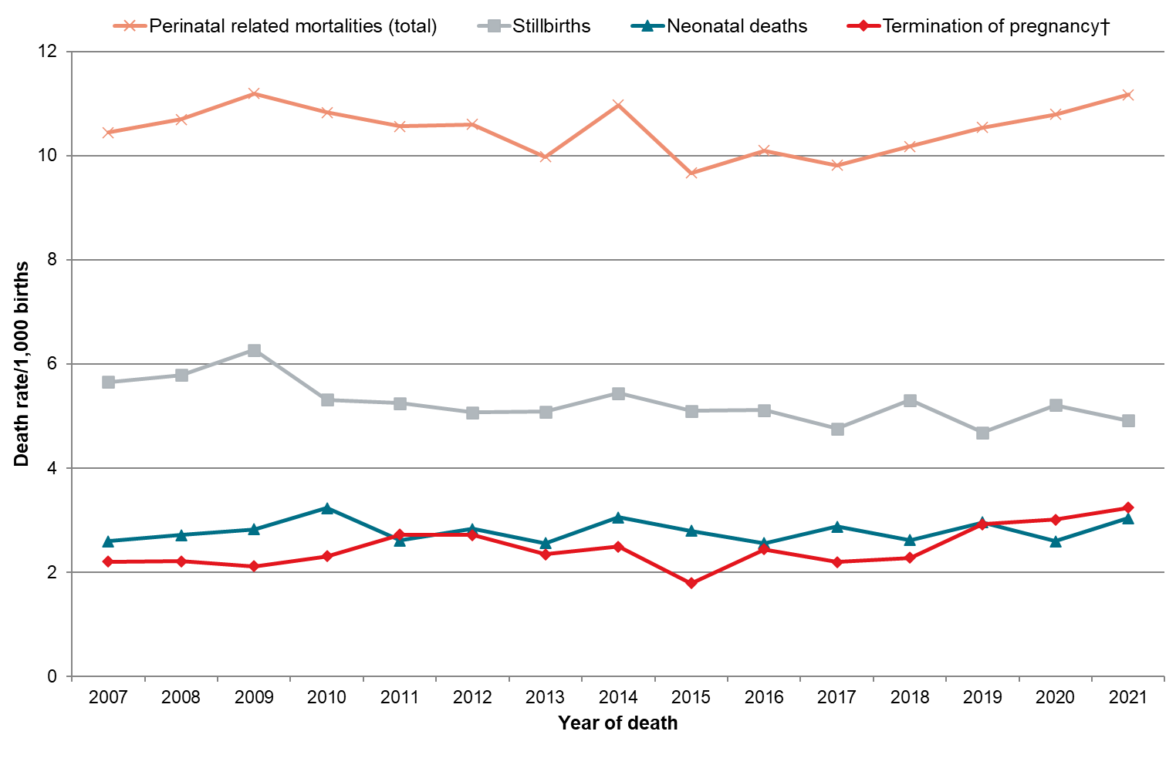
† In this report, ‘Termination of pregnancy’ refers to the interruption of an ongoing pregnancy from 20 weeks’ gestation onwards.
Sources: Numerator: PMMRC perinatal data extract 2007–2021; Denominator: MAT births 2007–2021.

Table 3.1: Summary of New Zealand perinatal related mortality rates (≥20 weeks or ≥400 g if gestation is unknown) 2007–2021
 | n
 | 2007 | 2008 | 2009 | 2010 | 2011 | 2012 | 2013 | 2014 | 2015 | 2016 | 2017 | 2018 | 2019 | 2020 | 2021
Total births | 65,214 | 65,634 | 65,205 | 65,459 | 63,252 | 63,294 | 60,147 | 60,084 | 59,798 | 60,628 | 60,502 | 59,325 | 60,610 | 59,477 | 63,296
Fetal deaths (terminations of pregnancy and stillbirths)† | 513 | 525 | 547 | 499 | 504 | 493 | 447 | 477 | 412 | 458 | 421 | 450 | 461 | 489 | 516
Terminations of pregnancy | 144 | 145 | 138 | 151 | 172 | 172 | 141 | 150 | 107 | 148 | 133 | 135 | 177 | 179 | 205
Stillbirths | 369 | 380 | 409 | 348 | 332 | 321 | 306 | 327 | 305 | 310 | 288 | 315 | 284 | 310 | 311
Early neonatal deaths <7 days | 134 | 134 | 137 | 165 | 139 | 142 | 122 | 150 | 131 | 123 | 138 | 116 | 143 | 117 | 146
Late neonatal deaths 7–27 days | 34 | 43 | 46 | 45 | 25 | 36 | 31 | 32 | 35 | 31 | 35 | 38 | 35 | 36 | 45
Neonatal deaths <28 days# | 168 | 177 | 183 | 210 | 164 | 178 | 153 | 182 | 166 | 154 | 173 | 154 | 178 | 153 | 191
Perinatal mortalities+ | 647 | 659 | 684 | 664 | 643 | 635 | 569 | 627 | 543 | 581 | 559 | 566 | 604 | 606 | 662
Perinatal related mortalities^ | 681 | 702 | 730 | 709 | 668 | 671 | 600 | 659 | 578 | 612 | 594 | 604 | 639 | 642 | 707
Perinatal mortalities excluding lethal and terminated fetal anomalies• | 463 | 482 | 513 | 464 | 444 | 441 | 414 | 447 | 397 | 413 | 405 | 414 | 430 | 449 | 473
Perinatal related mortalities excluding lethal and terminated fetal anomalies• | 483 | 510 | 544 | 495 | 460 | 463 | 432 | 466 | 415 | 434 | 430 | 440 | 453 | 474 | 506
 | Rate |  |  |  |  |  |  |  |  |  |  |  |  |  |  | 2007–2020  Regression  for trend  (95% CI)
 | 2007 | 2008 | 2009 | 2010 | 2011 | 2012 | 2013 | 2014 | 2015 | 2016 | 2017 | 2018 | 2019 | 2020 | 2021
Total births
Fetal deaths (terminations of pregnancy and stillbirths)† | 7.87 | 8.00 | 8.39 | 7.62 | 7.97 | 7.79 | 7.43 | 7.94 | 6.89 | 7.55 | 6.96 | 7.59 | 7.61 | 8.22 | 8.15 | −0.017  (−0.073–0.039)
Terminations of pregnancy | 2.21 | 2.21 | 2.12 | 2.31 | 2.72 | 2.72 | 2.34 | 2.50 | 1.79 | 2.44 | 2.20 | 2.28 | 2.92 | 3.01 | 3.24 | 0.047 *  (0.004–0.091)
Stillbirths | 5.66 | 5.79 | 6.27 | 5.32 | 5.25 | 5.07 | 5.09 | 5.44 | 5.10 | 5.11 | 4.76 | 5.31 | 4.69 | 5.21 | 4.91 | −0.064 **  (−0.103 to −0.026)
Early neonatal deaths <7 days
Late neonatal deaths 7–27 days
Neonatal deaths <28 days# | 2.60 | 2.72 | 2.83 | 3.23 | 2.61 | 2.83 | 2.56 | 3.05 | 2.80 | 2.56 | 2.88 | 2.62 | 2.96 | 2.59 | 3.04 | 0.004  (−0.024–0.032)
Perinatal mortalities+ | 9.92 | 10.04 | 10.49 | 10.14 | 10.17 | 10.03 | 9.46 | 10.44 | 9.08 | 9.58 | 9.24 | 9.54 | 9.97 | 10.19 | 10.46 | −0.016  (−0.074–0.043)
Perinatal related mortalities^ | 10.44 | 10.70 | 11.20 | 10.83 | 10.56 | 10.60 | 9.98 | 10.97 | 9.67 | 10.09 | 9.82 | 10.18 | 10.54 | 10.79 | 11.17 | −0.013  (−0.076–0.049)
Perinatal mortalities excluding lethal and terminated fetal anomalies• | 7.10 | 7.34 | 7.87 | 7.09 | 7.02 | 6.97 | 6.88 | 7.44 | 6.64 | 6.81 | 6.69 | 6.98 | 7.09 | 7.55 | 7.47 | −0.007  (−0.053–0.039)
Perinatal related mortalities excluding lethal and terminated fetal anomalies• | 7.41 | 7.77 | 8.34 | 7.56 | 7.27 | 7.32 | 7.18 | 7.76 | 6.94 | 7.16 | 7.11 | 7.42 | 7.47 | 7.97 | 7.99 | −0.002  (−0.054–0.050)
* p <0.05.
** p <0.01.
† Fetal death rate per 1,000 babies born (includes terminations and stillbirths).
# Neonatal death rate per 1,000 live born babies.
+ Fetal deaths and early neonatal deaths per 1,000 babies born.
^ Fetal deaths and early and late neonatal deaths per 1,000 babies born.
• Lethal and terminated fetal anomalies are all perinatal related deaths with PSANZ–PDC of congenital anomaly and neonatal deaths with PSANZ-NDC of congenital anomaly.
CI = confidence interval; MAT = National Maternity Collection; NDC = Neonatal Death Classification; PDC = Perinatal Death Classification; PMMRC = Perinatal and Maternal Mortality Review Committee; PSANZ = Perinatal Society of Australia and New Zealand.
Sources: Numerator: PMMRC perinatal data extract 2007–2021; Denominator: MAT births 2007–2021.

In 2021
In 2021, there were 707 perinatal related deaths: 205 terminations, 311 stillbirths and 191 neonatal deaths. The overall leading causes were congenital anomalies, spontaneous preterm labour and rupture of membranes at <37 weeks (Table 3.2).
Of the terminations, 64.9% were due to congenital anomaly, 16.7% due to complications of pregnancy and the remainder due to maternal conditions (Table 3.2 and Table 3.8). The abortion law reform, which moved abortion from the Crimes Act 1961 to a health provision, came into effect in March 2020 to ease, support and enable earlier access. National data collection accuracy also improved at this time. The proportion of terminations at >20 weeks’ gestation in Aotearoa was <1% in 2021, which is lower than the 1–2% reported in other countries where abortion is available as a health care procedure, such as Sweden and the UK.,
Unexplained antepartum fetal death remains the highest cause of stillbirth, meaning no explanation can be given to 28% of families and whānau who have a stillborn baby. The inability to explain these deaths may be due to incomplete investigations or a full investigation that does not find a cause.
The leading cause for neonatal death (34%) was preterm labour and rupture of membranes. Addressing the clinical causes and contextual factors underlying this remains a priority.
Table 3.2: Perinatal related deaths by perinatal death classification (PSANZ-PDC) 2021
Perinatal death classification (PSANZ-PDC) | Fetal deaths |  |  |  | Neonatal deaths |  | Perinatal related deaths (total)
 | Termination of pregnancy |  | Stillbirths
 | n=205 |  | n=311 |  | n=191 |  | n=707
 | n | % | n | % | n | % | n | %
Congenital anomaly | 133 | 64.9 | 23 | 7.4 | 41 | 21.5 | 197 | 27.9
Perinatal infection | 3 | 1.5 | 12 | 3.9 | 6 | 3.1 | 21 | 3.0
Hypertension | 3 | 1.5 | 11 | 3.5 | 8 | 4.2 | 22 | 3.1
Antepartum haemorrhage | 7 | 3.4 | 37 | 11.9 | 32 | 16.8 | 76 | 10.7
Maternal conditions | 37 | 18.0 | 13 | 4.2 | 3 | 1.6 | 53 | 7.5
Complications of multiple pregnancy | <3 | x | 14 | 4.5 | 7 | 3.7 | 23 | 3.3
Specific perinatal conditions | <3 | x | 13 | 4.2 | 3 | 1.6 | 18 | 2.5
Hypoxic peripartum death | - | - | 5 | 1.6 | 11 | 5.8 | 16 | 2.3
Placental dysfunction or causative placental pathology | 3 | 1.5 | 50 | 16.1 | 3 | 1.6 | 56 | 7.9
Spontaneous preterm labour or rupture of membranes (<37 weeks’ gestation) | 14 | 6.8 | 44 | 14.1 | 65 | 34.0 | 123 | 17.4
Unexplained antepartum fetal death | <3 | x | 87 | 28.0 | - | - | 88 | 12.4
Neonatal death without obstetric antecedent | - | - | <3 | x | 11 | 5.8 | 12 | 1.7
Unknown | - | - | <3 | x | <3 | x | <3 | x
‘x’ indicates percentage suppressed due to small numbers.
PDC = Perinatal Death Classification; PMMRC = Perinatal and Maternal Mortality Review Committee; PSANZ = Perinatal Society of Australia and New Zealand
Source: PMMRC perinatal data extract 2021.

The last 10 years
There has been no changing trend for any cause of perinatal related mortality in the last 10 years; however, the rate of babies lost to preterm labour or early rupture of membranes in 2021 was 1.94 per 1,000 births, which was the highest since 2014 (Table 3.3).
The most frequent cause of death in the period 2012–2021 was congenital anomalies, mostly ending in termination of pregnancy.

Table 3.3: Perinatal death classification (PSANZ-PDC) specific perinatal related mortality rates (per 1,000 births) 2012–2021
Perinatal death classification  (PSANZ-PDC) | 2012 |  | 2013 |  | 2014 |  | 2015 |  | 2016 |  | 2017 |  | 2018 |  | 2019 |  | 2020 |  | 2021 |  | 2012–2021  Regression  for trend  (95% CI)
 | N=63,294 |  | N=60,147 |  | N=60,084 |  | N=59,798 |  | N=60,628 |  | N=60,502 |  | N=59,325 |  | N=60,610 |  | N=59,477 |  | N=63,296
 | n | Rate | n | Rate | n | Rate | n | Rate | n | Rate | n | Rate | n | Rate | n | Rate | n | Rate | n | Rate
Congenital anomaly | 206 | 3.25 | 164 | 2.73 | 191 | 3.18 | 163 | 2.73 | 177 | 2.92 | 163 | 2.69 | 162 | 2.73 | 183 | 3.02 | 165 | 2.77 | 197 | 3.11 | −0.012  (−0.068–0.045)
Perinatal infection | 19 | 0.30 | 20 | 0.33 | 24 | 0.40 | 22 | 0.37 | 26 | 0.43 | 28 | 0.46 | 21 | 0.35 | 17 | 0.28 | 14 | 0.24 | 21 | 0.33 | −0.006  (−0.024–0.012)
Hypertension | 19 | 0.30 | 13 | 0.22 | 13 | 0.22 | 21 | 0.35 | 9 | 0.15 | 13 | 0.21 | 19 | 0.32 | 18 | 0.30 | 26 | 0.44 | 22 | 0.35 | 0.014  (−0.006–0.034)
Antepartum haemorrhage | 60 | 0.95 | 75 | 1.25 | 69 | 1.15 | 79 | 1.32 | 72 | 1.19 | 78 | 1.29 | 59 | 0.99 | 49 | 0.81 | 67 | 1.13 | 76 | 1.20 | −0.007  (−0.050–0.037)
Maternal conditions | 36 | 0.57 | 34 | 0.57 | 39 | 0.65 | 29 | 0.49 | 37 | 0.61 | 29 | 0.48 | 42 | 0.71 | 34 | 0.56 | 57 | 0.96 | 53 | 0.84 | 0.032  (0.000–0.064)
Complications of multiple pregnancy | 25 | 0.40 | 26 | 0.43 | 25 | 0.42 | 10 | 0.17 | 21 | 0.35 | 21 | 0.35 | 31 | 0.52 | 30 | 0.49 | 22 | 0.37 | 23 | 0.36 | 0.004  (−0.021–0.030)
Specific perinatal conditions | 27 | 0.43 | 25 | 0.42 | 27 | 0.45 | 33 | 0.55 | 32 | 0.53 | 31 | 0.51 | 28 | 0.47 | 27 | 0.45 | 33 | 0.55 | 18 | 0.28 | −0.004  (−0.025–0.018)
Hypoxic peripartum death | 21 | 0.33 | 11 | 0.18 | 17 | 0.28 | 17 | 0.28 | 13 | 0.21 | 13 | 0.21 | 6 | 0.10 | 7 | 0.12 | 16 | 0.27 | 16 | 0.25 | −0.009  (−0.028–0.010)
Placental dysfunction or causative placental pathology | 57 | 0.90 | 57 | 0.95 | 45 | 0.75 | 43 | 0.72 | 53 | 0.87 | 54 | 0.89 | 56 | 0.94 | 50 | 0.82 | 34 | 0.57 | 56 | 0.88 | −0.010  (−0.041–0.020)
Spontaneous preterm labour or rupture of membranes (<37 weeks’ gestation) | 115 | 1.82 | 88 | 1.46 | 122 | 2.03 | 77 | 1.29 | 87 | 1.44 | 85 | 1.40 | 101 | 1.70 | 107 | 1.77 | 95 | 1.60 | 123 | 1.94 | 0.012  (−0.054–0.078)
Unexplained antepartum fetal death | 77 | 1.22 | 81 | 1.35 | 80 | 1.33 | 77 | 1.29 | 79 | 1.30 | 71 | 1.17 | 77 | 1.30 | 100 | 1.65 | 104 | 1.75 | 88 | 1.39 | 0.036  (−0.004–0.076)
Neonatal death without obstetric antecedent | 9 | 0.14 | 6 | 0.10 | 7 | 0.12 | 7 | 0.12 | 6 | 0.10 | 8 | 0.13 | <3 | s | 17 | 0.28 | 9 | 0.15 | 12 | 0.19 | 0.008  (−0.008–0.024)
Other | - | - | - | - | - | - | - | - | - | - | - | - | - | - | - | - | - | - | <3 | s | 0.002  (−0.001–0.004)
‘s’ indicates rate suppressed due to small numbers.
* p <0.05.
** p <0.01.
MAT = National Maternity Collection; PDC = Perinatal Death Classification; PMMRC = Perinatal and Maternal Mortality Review Committee; PSANZ = Perinatal Society of Australia and New Zealand
Sources: Numerator: PMMRC perinatal data extract 2012–2021; Denominator: MAT births 2012–2021.

Stillbirth
There was a small downwards trend for stillbirth due to congenital anomaly (Table 3.4) but not for any other causes.
Table 3.4: Perinatal death classification (PSANZ-PDC) specific stillbirth rates (per 1,000 births) 2012–2021
Perinatal death classification  (PSANZ-PDC) | 2012 |  | 2013 |  | 2014 |  | 2015 |  | 2016 |  | 2017 |  | 2018 |  | 2019 |  | 2020 |  | 2021 |  | 2012–2021  Regression  for trend  (95% CI)
 | N=63,294 |  | N=60,147 |  | N=60,084 |  | N=59,798 |  | N=60,628 |  | N=60,502 |  | N=59,325 |  | N=60,610 |  | N=59,477 |  | N=63,296
 | n | Rate | n | Rate | n | Rate | n | Rate | n | Rate | n | Rate | n | Rate | n | Rate | n | Rate | n | Rate
Congenital anomaly | 38 | 0.60 | 24 | 0.40 | 35 | 0.58 | 30 | 0.50 | 31 | 0.51 | 29 | 0.48 | 34 | 0.57 | 20 | 0.33 | 19 | 0.32 | 23 | 0.36 | −0.023 *  (−0.045 to −0.001)
Perinatal infection | 9 | 0.14 | 10 | 0.17 | 12 | 0.20 | 12 | 0.20 | 10 | 0.16 | 17 | 0.28 | 11 | 0.19 | 12 | 0.20 | 7 | 0.12 | 12 | 0.19 | 0.001  (−0.011–0.013)
Hypertension | 9 | 0.14 | 8 | 0.13 | 9 | 0.15 | 16 | 0.27 | 8 | 0.13 | 10 | 0.17 | 10 | 0.17 | 9 | 0.15 | 20 | 0.34 | 11 | 0.17 | 0.009  (−0.008–0.025)
Antepartum haemorrhage | 31 | 0.49 | 44 | 0.73 | 33 | 0.55 | 46 | 0.77 | 38 | 0.63 | 37 | 0.61 | 29 | 0.49 | 21 | 0.35 | 37 | 0.62 | 37 | 0.58 | −0.011  (−0.043–0.021)
Maternal conditions | 19 | 0.30 | 22 | 0.37 | 21 | 0.35 | 22 | 0.37 | 17 | 0.28 | 12 | 0.20 | 23 | 0.39 | 10 | 0.16 | 13 | 0.22 | 13 | 0.21 | −0.017  (−0.034–0.000)
Complications of multiple pregnancy | 15 | 0.24 | 21 | 0.35 | 12 | 0.20 | 7 | 0.12 | 18 | 0.30 | 16 | 0.26 | 23 | 0.39 | 11 | 0.18 | 11 | 0.18 | 14 | 0.22 | −0.004  (−0.026–0.018)
Specific perinatal conditions | 21 | 0.33 | 12 | 0.20 | 23 | 0.38 | 25 | 0.42 | 29 | 0.48 | 25 | 0.41 | 18 | 0.30 | 19 | 0.31 | 26 | 0.44 | 13 | 0.21 | −0.001  (−0.027–0.024)
Hypoxic peripartum death | 11 | 0.17 | 3 | 0.05 | 7 | 0.12 | 9 | 0.15 | 4 | 0.07 | 4 | 0.07 | <3 | s | <3 | s | 11 | 0.18 | 5 | 0.08 | −0.004  (−0.020–0.011)
Placental dysfunction or causative placental pathology | 54 | 0.85 | 53 | 0.88 | 44 | 0.73 | 39 | 0.65 | 47 | 0.78 | 48 | 0.79 | 49 | 0.83 | 44 | 0.73 | 31 | 0.52 | 50 | 0.79 | −0.016  (−0.041–0.010)
Spontaneous preterm labour or rupture of membranes (<37 weeks’ gestation) | 40 | 0.63 | 28 | 0.47 | 52 | 0.87 | 24 | 0.40 | 31 | 0.51 | 21 | 0.35 | 40 | 0.67 | 39 | 0.64 | 31 | 0.52 | 44 | 0.70 | 0.003  (−0.039–0.045)
Unexplained antepartum fetal death | 74 | 1.17 | 81 | 1.35 | 79 | 1.31 | 75 | 1.25 | 77 | 1.27 | 69 | 1.14 | 77 | 1.30 | 97 | 1.60 | 104 | 1.75 | 87 | 1.37 | 0.037  (−0.004–0.078)
Neonatal death without obstetric antecedent | - | - | - | - | - | - | - | - | - | - | - | - | - | - | - | - | - | - | <3 | s | 0.001  (0.000–0.002)
‘s’ indicates rate suppressed due to small numbers
p <0.05.
MAT = National Maternity Collection; PDC = Perinatal Death Classification; PMMRC = Perinatal and Maternal Mortality Review Committee; PSANZ = Perinatal Society of Australia and New Zealand
Sources: Numerator: PMMRC perinatal data extract, stillbirths only, 2012–2021; Denominator: MAT births 2012–2021.

Intrapartum stillbirth
Losing a baby during labour and birth is uncommon but occurs for an average of 20 families each year. These are more common in extreme prematurity and babies at term but not common between 28 and 36 weeks. There have been very small reductions in intrapartum stillbirth rates at premature gestations, but 14 babies were lost at term in 2021 (Table 3.5). Both the New Zealand College of Midwives and the Royal Australian and New Zealand College of Obstetricians and Gynaecologists have produced fetal monitoring guidance documents, aimed at improving these outcomes.
Table 3.5: Intrapartum stillbirth rates (per 1,000 ongoing pregnancies) by gestation, excluding congenital anomalies 2012–2021
Gestation at birth (weeks) | 2012 |  | 2013 |  | 2014 |  | 2015 |  | 2016 |  | 2017 |  | 2018 |  | 2019 |  | 2020 |  | 2021
 | n | N | n | N | n | N | n | N | n | N | n | N | n | N | n | N | n | N | n | N
23–27 | 10 | 337 | 10 | 315 | 8 | 324 | 8 | 323 | 6 | 315 | 4 | 323 | 8 | 310 | 6 | 362 | 3 | 396 | 4 | 389
28–36 | 3 | 4,450 | <3 | 4,193 | 3 | 4,190 | <3 | 4,115 | <3 | 4,312 | 3 | 4,254 | <3 | 4,184 | <3 | 4,358 | <3 | 4,331 | - | 4,605
≥37 | 12 | 57,430 | 3 | 55,100 | 10 | 54,954 | 17 | 54,842 | 12 | 55,432 | 10 | 55,368 | 8 | 54,267 | 11 | 55,335 | 17 | 54,120 | 14 | 57,546
Gestation at birth (weeks) | 2012 |  | 2013 |  | 2014 |  | 2015 |  | 2016 |  | 2017 |  | 2018 |  | 2019 |  | 2020 |  | 2021 |  | 2012–2021  Regression  for trend  (95%CI)
 | Risk |  | Risk |  | Risk |  | Risk |  | Risk |  | Risk |  | Risk |  | Risk |  | Risk |  | Risk
23–27 |  | 0.16 |  | 0.17 |  | 0.13 |  | 0.13 |  | 0.10 |  | 0.07 |  | 0.14 |  | 0.10 |  | 0.05 |  | 0.06 | −0.011 **  (−0.018 to −0.005)
28–36 |  | 0.05 |  | s |  | 0.05 |  | s |  | s |  | 0.05 |  | s |  | s |  | s |  | 0.00 | −0.004 **  (−0.007 to −0.002)
≥37 |  | 0.21 |  | 0.05 |  | 0.18 |  | 0.31 |  | 0.22 |  | 0.18 |  | 0.15 |  | 0.20 |  | 0.31 |  | 0.24 | 0.010  (−0.008–0.029)
‘s’ indicates rate suppressed due to small numbers.
* p <0.05.
** p <0.01.
CI = confidence interval; MAT = National Maternity Collection; N = number of ongoing pregnancies at each gestational age; PMMRC = Perinatal and Maternal Mortality Review Committee
Sources: Numerator: PMMRC perinatal data extract, stillbirths only (excluding congenital anomalies) 2012–2021; Denominator: MAT births 2012–2021.

Neonatal death
Neonatal death causes for 2012–2021 are split into above or below 28-week gestations (extreme prematurity) in Table 3.6. Prematurity remains the leading cause of death, although there has been a small trend downwards in the <28 week cohort. This may be indicative of improved care and technology for very early babies during this period and may be positively influenced by the implementation of new guidance regarding periviability in 2019. This guideline also includes an associated ‘care bundle’ that emphasises good communication and shared decision-making between clinicians and patients and their families and whānau. Much work remains to be done in this area, and it is a focus of current research within Aotearoa.
Table 3.6: Neonatal death classification (PSANZ-NDC) specific neonatal death rates (per 1,000 live births) 2012–2021
Neonatal death classification  (PSANZ-NDC) | 2012 |  | 2013 |  | 2014 |  | 2015 |  |  | 2016 |  | 2017 |  | 2018 |  | 2019 |  | 2020 |  | 2021 |  | 2012–2021  Regression  for trend  (95% CI)
 | n | Rate | n | Rate | n | Rate |  | n | Rate | n | Rate | n | Rate | n | Rate | n | Rate | n | Rate | n | Rate
Gestation  <28 weeks | N=251 |  | N=254 |  | N=272 |  | N=254 |  |  | N=251 |  | N=282 |  | N=259 |  | N=279 |  | N=303 |  | N=313
Congenital anomaly | <3 | s | <3 | s | <3 | s |  | 3 | 11.81 | <3 | s | 4 | 14.18 | <3 | s | <3 | s | 3 | 9.90 | 3 | 9.58 | 0.302  (−0.623–1.227)
Extreme prematurity | 67 | 266.93 | 63 | 248.03 | 69 | 253.68 |  | 51 | 200.79 | 55 | 219.12 | 70 | 248.23 | 63 | 243.24 | 68 | 243.73 | 43 | 141.91 | 59 | 188.50 | −8.133*  (−16.026 to −0.241)
Cardio-respiratory disorders | 10 | 39.84 | 5 | 19.69 | 12 | 44.12 |  | 10 | 39.37 | 6 | 23.90 | 9 | 31.91 | 10 | 38.61 | 13 | 46.59 | 12 | 39.60 | 18 | 57.51 | 1.919  (−0.568–4.405)
Infection | 10 | 39.84 | 5 | 19.69 | 7 | 25.74 |  | <3 | s | 4 | 15.94 | 8 | 28.37 | 7 | 27.03 | 8 | 28.67 | 11 | 36.30 | 13 | 41.53 | 1.310  (−1.336–3.956)
Neurological | 6 | 23.90 | 8 | 31.50 | 12 | 44.12 |  | 11 | 43.31 | 8 | 31.87 | 9 | 31.91 | 3 | 11.58 | 8 | 28.67 | 15 | 49.50 | 6 | 19.17 | −0.539  (−3.666–2.588)
Gastrointestinal | <3 | s | <3 | s | <3 | s |  | <3 | s | 3 | 11.95 | 4 | 14.18 | 6 | 23.17 | 3 | 10.75 | <3 | s | 6 | 19.17 | 1.190  (−0.231–2.611)
Other | <3 | s | <3 | s | <3 | s |  | 4 | 15.75 | <3 | s | <3 | s | - | - | 3 | 10.75 | - | - | <3 | s | −0.246  (−1.530–1.039)
Gestation  ≥28 weeks | N=61,701 |  | N=59,119 |  | N=58,962 |  | N=58,782 |  |  | N=59,556 |  | N=59,452 |  | N=58,282 |  | N=59,535 |  | N=58,282 |  | N=61,967
Congenital anomaly | 36 | 0.58 | 31 | 0.52 | 43 | 0.73 |  | 42 | 0.71 | 33 | 0.55 | 28 | 0.47 | 34 | 0.58 | 33 | 0.55 | 33 | 0.57 | 37 | 0.60 | −0.006  (−0.027–0.015)
Extreme prematurity | - | - | - | - | - | - |  | - | - | - | - | - | - | - | - | <3 | s | - | - | - | - | 0.001  (−0.001–0.002)
Cardio-respiratory disorders | 4 | 0.06 | <3 | s | 4 | 0.07 |  | 6 | 0.10 | 5 | 0.08 | 7 | 0.12 | 4 | 0.07 | 4 | 0.07 | 3 | 0.05 | 4 | 0.06 | 0.001  (−0.006–0.008)
Infection | 7 | 0.11 | 7 | 0.12 | 8 | 0.14 |  | 5 | 0.09 | 10 | 0.17 | 7 | 0.12 | 5 | 0.09 | <3 | s | 4 | 0.07 | 5 | 0.08 | −0.007  (−0.016–0.001)
Neurological | 19 | 0.31 | 17 | 0.29 | 12 | 0.20 |  | 20 | 0.34 | 16 | 0.27 | 14 | 0.24 | 13 | 0.22 | 15 | 0.25 | 17 | 0.29 | 22 | 0.36 | 0.002  (−0.011–0.015)
Gastrointestinal | <3 | s | - | - | <3 | s |  | <3 | s | <3 | s | - | - | 3 | 0.05 | <3 | s | - | - | - | - | 0.000  (−0.005–0.004)
Other | 13 | 0.21 | 13 | 0.22 | 9 | 0.15 |  | 10 | 0.17 | 8 | 0.13 | 12 | 0.20 | 4 | 0.07 | 18 | 0.30 | 10 | 0.17 | 13 | 0.21 | 0.001  (−0.016–0.018)
‘s’ indicates rate suppressed due to small numbers.
* p <0.05.
CI = confidence interval; MAT = National Maternity Collection; NDC = Neonatal Death Classification; PMMRC = Perinatal and Maternal Mortality Review Committee; PSANZ = Perinatal Society of Australia and New Zealand.
Source: Numerator: PMMRC perinatal data extract neonatal deaths only 2012–2021; Denominator: MAT births excluding fetal deaths 2012–2021.

Demographics
Over the years of perinatal mortality surveillance and reporting, many clinical guidelines, improvements and initiatives have been developed, but outcomes are yet to improve (Figure 3.1). Although consistent national guidance is of value, it has not always been followed up with clear implementation plans or resourcing to ensure everyone receiving maternity care has access to what is recommended. As mentioned, although continuing improvements in clinical care and interventions are vital, this report focuses further on observed mortality outcomes with consideration of their social determinants. By doing so, we intend to highlight areas of intervention and support that could contribute to improvement in perinatal care and outcomes in addition to clinical efforts.
Some national initiatives that potentially impact perinatal outcomes:
- Small for Gestational Age and Fetal Growth Restriction in Aotearoa New Zealand – Clinical Practice Guideline (update; 2023) and national roll-out of GROW 2.0 tool (2023)
- Guidelines for Consultation with Obstetric and Related Medical Services (Referral Guidelines) (updated in 2023)
- Mandatory fortification of flour with folic acid (2023)
- Revised smoking cessation guidelines (2014 and 2021)
- Immediate postnatal observation guidance (2012)
- Hypertension in pregnancy guidelines and update (2018 and 2022)
- Neonatal encephalopathy consensus statement (2019)
- New Zealand consensus statement on the care of mother and baby(ies) at periviable gestations (2019)
- Gestational diabetes guideline (2014 – being updated)
- New Zealand College of Midwives (2022) Intermittent Auscultation and Royal Australian and New Zealand College of Obstetricians and Gynaecologists (2019) fetal surveillance guidance
- National Perinatal Pathology Service panui (2020) findings inform risk management for future pregnancies.
Some of the programmes listed above have been implemented since the end date of this report (2021). These and historic initiatives are yet to show efficacy in the recorded perinatal mortality outcome data. Other programmes, such as the Carosika Collaborative, a multidisciplinary working group including people with lived experience, are ongoing and working towards improving perinatal outcomes.
The affordability, accessibility and acceptability of health care services has a significant effect on perinatal health and, as this report indicates, the health sector must address the inequities arising from service provision. In addition, we need to consider the influence of socioeconomic, political and cultural environments, including education, food, housing and employment, along with factors such as ethnicity, gender and societal exclusion. Health is also influenced by the distribution of power, money and commercial interests. More in-depth work is required for each contributing factor and their interactions.
Historically, structural elements of the health care systems have not catered for individual needs in an increasingly diverse population. Systems entrenched in western, colonial paradigms do not serve the needs of all. Sir Mason Durie wrote that ‘Māori health development can only occur when Māori can define their own priorities for health’ and that an integrated approach to managing and delivering their own services and work in partnership with the State is required. This applies to all those who have been shown to continually experience significant perinatal inequities in these 16 perinatal mortality reports.
In this report, we identify Māori as the reference group (1.00) in relative risk calculations. This is to frame Māori as the normative or baseline group and illustrate how some other groups suffer lower numbers of deaths of babies in pregnancy or soon after.
In relation to perinatal and maternal wellbeing, services need to be easily accessed and culturally appropriate. Early support should not be difficult to navigate, and families and whānau must be treated with manaaki and aroha, particularly when perinatal or maternal loss or severe morbidity occurs. A poor experience of health systems may cause distrust, delay access to care in later interactions and result in ongoing trauma. Families want to be heard, acknowledged, understood and able to establish a respectful relationship with carers. This enables and supports tino rangatiratanga regarding whānau health.
The data collected by Health New Zealand – Te Whatu Ora and in the PMMR process does not necessarily include other social demographic factors that could be explored in relation to understanding perinatal mortality outcomes.
Examples of these factors include the rainbow community, refugee populations and those living with disability who also often express challenges engaging with perinatal care systems. Qualitative research has demonstrated some access issues relating to cultural safety for gender diverse people, and there is a case for good data collection.
In an equitable world, who you are and where you live should not impact your health outcomes, but local and international literature consistently demonstrates that health does differ by demographic groups. This is also the case in the context of perinatal outcomes in Aotearoa.

Who you are
Table 3.7 shows the composition of the perinatal mortality population compared with the general birthing population. Statistical testing shows that the distribution in both populations is significantly different in each category. However, the relative risks indicate that some groups are substantially more affected by perinatal loss than others (younger and older women and birthing people, those living in deprivation quintile 5 and Indian, Pacific and Māori populations).
This table should be treated with some caution as large amounts of data are missing from the denominator (MAT) set, highlighted by the numbers in the unknown categories for each characteristic. In past reports, this has been tempered by restriction of some analysis to only those who have registered with an LMC as their primary carer; however, that restriction was removed for this report. This was to reflect that, within Aotearoa, prevailing LMC workforce pressures are reducing the availability of/access to midwives, and Health New Zealand – Te Whatu Ora is providing more primary maternity care. Unfortunately, as outlined in the Methods and Definitions for Perinatal and Maternal Mortality Review Committee Reporting document, the extent of the detail provided in DHB data can vary compared with that sourced from LMC claims. However, there is some evidence that people receiving primary care from DHBs may be those already experiencing poor access to services, and it is important not to exclude these people from analysis.
Note: This report does not contain multivariate analysis. The last time this was done was in the 12th PMMRC report and was limited to those aged <20 years. This 16th report includes demographic tables in each chapter so that, in future, adjusted odds ratios for perinatal related mortality rates can be calculated to allow for demographic variance.

Table 3.7: Sociodemographic and other characteristics of all births compared with perinatal related deaths 2012–2021
 | Total births |  | Perinatal related  deaths (total) |  | Rate  (per 1,000 births) |  |  |  | Chi-squared  test  (p)
 | N=607,161 |  | n=6,306 |  | /1,000 | 95% CI | RR | 95% CI
 | N | % | n | %
Maternal age (years)
<20 | 26,154 | 4.3 | 435 | 6.9 | 16.63 | 15.07–18.20 | 1.80 | 1.62–2.00 | <0.001
20–24 | 96,902 | 16.0 | 1,130 | 17.9 | 11.66 | 10.98–12.34 | 1.26 | 1.17–1.36
25–29 | 163,942 | 27.0 | 1,513 | 24.0 | 9.23 | 8.76–9.69 | 1.00 | -
30–34 | 190,438 | 31.4 | 1,769 | 28.1 | 9.29 | 8.86–9.72 | 1.01 | 0.94–1.08
35–39 | 104,253 | 17.2 | 1,089 | 17.3 | 10.45 | 9.83–11.07 | 1.13 | 1.05–1.22
≥40 | 25,313 | 4.2 | 366 | 5.8 | 14.46 | 12.98–15.94 | 1.57 | 1.40–1.75
Unknown | 159 | 0.0 | 4 | 0.1 | - | - | - | -
Maternal prioritised ethnic group
Māori | 155,359 | 25.6 | 1,661 | 26.3 | 10.69 | 10.18–11.21 | 1.00 | - | <0.001
Pacific peoples | 62,861 | 10.4 | 790 | 12.5 | 12.57 | 11.69–13.44 | 1.18 | 1.08–1.28
Asian | 102,613 | 16.9 | 1,097 | 17.4 | 10.69 | 10.06–11.32 | 1.00 | 0.93–1.08
Indian | 37,125 | 6.1 | 535 | 8.5 | 14.41 | 13.19–15.63 | 1.35 | 1.22–1.48
Other Asian | 65,488 | 10.8 | 562 | 8.9 | 8.58 | 7.87–9.29 | 0.80 | 0.73–0.88
MELAA | 14,260 | 2.3 | 141 | 2.2 | 9.89 | 8.26–11.52 | 0.92 | 0.78–1.10
European | 271,701 | 44.7 | 2,612 | 41.4 | 9.61 | 9.24–9.98 | 0.90 | 0.85–0.96
NZ European | 212,729 | 35.0 | 2,248 | 35.6 | 10.57 | 10.13–11.00 | 0.99 | 0.93–1.05
Other European | 58,972 | 9.7 | 364 | 5.8 | 6.17 | 5.54–6.81 | 0.58 | 0.52–0.65
Unknown | 367 | 0.1 | 5 | 0.1 | - | - | - | -
Deprivation quintile
1 (least deprived) | 88,182 | 14.5 | 780 | 12.4 | 8.85 | 8.22–9.47 | 1.00 | - | <0.001
2 | 98,794 | 16.3 | 889 | 14.1 | 9.00 | 8.41–9.59 | 1.02 | 0.92–1.12
3 | 109,613 | 18.1 | 1,077 | 17.1 | 9.83 | 9.24–10.41 | 1.11 | 1.01–1.22
4 | 138,085 | 22.7 | 1,375 | 21.8 | 9.96 | 9.43–10.48 | 1.13 | 1.03–1.23
5 (most deprived) | 167,139 | 27.5 | 2,153 | 34.1 | 12.88 | 12.34–13.43 | 1.46 | 1.34–1.58
Missing | 5,348 | 0.9 | 32 | 0.5 | - | - | - | -
Rurality†
Urban | 499,730 | 82.3 | 5,108 | 81.0 | 10.22 | 9.94–10.50 | 1.00 | - | <0.001
Rural | 102,093 | 16.8 | 1,166 | 18.5 | 11.42 | 10.77–12.08 | 1.12 | 1.05–1.19
Unknown | 5,338 | 0.9 | 32 | 0.5 | - | - | - | -
Smoking at registration with LMC
Yes | 77,010 | 12.7 | 598 | 9.5 | 7.77 | 7.14–8.39 | 1.85 | 1.69–2.03 | <0.001
No | 506,638 | 83.4 | 2,121 | 33.6 | 4.19 | 4.01–4.36 | 1.00 | -
Missing | 23,513 | 3.9 | 3,587 | 56.9 | - | - | - | -
First registration with LMC
First | 402,098 | 66.2 | 4,303 | 68.2 | 10.70 | 10.38–11.02 | 1.00 | - | <0.001
Second | 147,240 | 24.3 | 835 | 13.2 | 5.67 | 5.29–6.06 | 0.53 | 0.49–0.57
Third | 28,004 | 4.6 | 459 | 7.3 | 16.39 | 14.89–17.89 | 1.53 | 1.39–1.69
Postpartum | 5,898 | 1.0 | - | - | - | - | - | -
Missing | 23,921 | 3.9 | 709 | 11.2 | - | - | - | -
Parity
0 | 233,830 | 38.5 | 2,720 | 43.1 | 11.63 | 11.20–12.07 | 1.30 | 1.23–1.38 | <0.001
1 | 194,920 | 32.1 | 1,743 | 27.6 | 8.94 | 8.52–9.36 | 1.00 | -
2 | 86,026 | 14.2 | 923 | 14.6 | 10.73 | 10.04–11.42 | 1.20 | 1.11–1.30
3 | 34,709 | 5.7 | 424 | 6.7 | 12.22 | 11.05–13.38 | 1.37 | 1.23–1.52
≥4 | 29,125 | 4.8 | 441 | 7.0 | 15.14 | 13.73–16.55 | 1.69 | 1.53–1.88
Unknown | 28,551 | 4.7 | 55 | 0.9 | - | - | - | -
† Urban and rural categories as defined by the Aotearoa Geographic Classification for Health (see the Methods and Definitions for Perinatal and Maternal Mortality Review Committee Reporting document).
CI = confidence interval; LMC = lead maternity carer; MAT = National Maternity Collection; MELAA = Middle Eastern, Latin American or African; PMMRC = Perinatal and Maternal Mortality Review Committee; RR = relative rate.
Sources: Numerator: PMMRC perinatal data extract 2012–2021; Denominator: MAT births 2012–2021.

Perinatal related mortality by prioritised ethnic group
During 2012–2021, inequities across ethnic groups continue in perinatal related mortality outcomes (Figure 3.2). Women and birthing people of Indian ethnicity continue to have the highest rate, with 14.41 mortalities per 1,000 births. Some of the published research from Aotearoa has suggested that these adverse pregnancy outcomes may be related to metabolic-related factors that were more common in the Indian (South Asian) ethnic group. High-quality funded studies are needed to elucidate the risks and mitigating factors in Indian women and birthing people who, despite access to and engagement with antenatal care, continue to experience disproportionate rates of perinatal loss. Pacific families are also unequally affected by perinatal related mortality, at a rate of 12.57 deaths per 1,000 births, which is the second highest rate. Clinical and access challenges may also impact on perinatal wellbeing specific to this community, as identified in Ola Manuia: Interim Pacific Health Plan as a Pacific Health priority area (Figure 3.2, Figure 3.3 and Table 3.19 (appended)).
If the mortality rates for Māori were the same as those for the composite European ethnic group, 47 more babies of māmā Māori would have survived in 2021. The 2021 rate for Māori was 12.6 perinatal mortalities per 1,000 births, and this was the worst in the 10-year period being reported (Table 3.19 appended). This difference was driven by a very low perinatal mortality rate in the ‘other’ European group.
Calls to address these inequities for tangata whenua are being actioned, and multi-agency programmes that focus on the first 1,000 days (including pregnancy) are being implemented, and need to be supported and strengthened to achieve equitable outcomes.
Although overall perinatal related mortality rates vary by ethnicity, more is revealed when considering the causes, outcomes at different gestations and age of the woman/birthing person in the following tables and figures.
Figures 3.2 and 3.3 illustrate ethnicity data drawn from registrations/bookings with carers and from Births, Deaths and Marriages birth/stillbirth/death registrations as described in the Methods and Definitions for Perinatal and Maternal Mortality Review Committee Reporting document.
Figure 3.2: Perinatal related mortality rates (per 1,000 births, with 95% confidence intervals) by maternal prioritised ethnic group 2012–2021
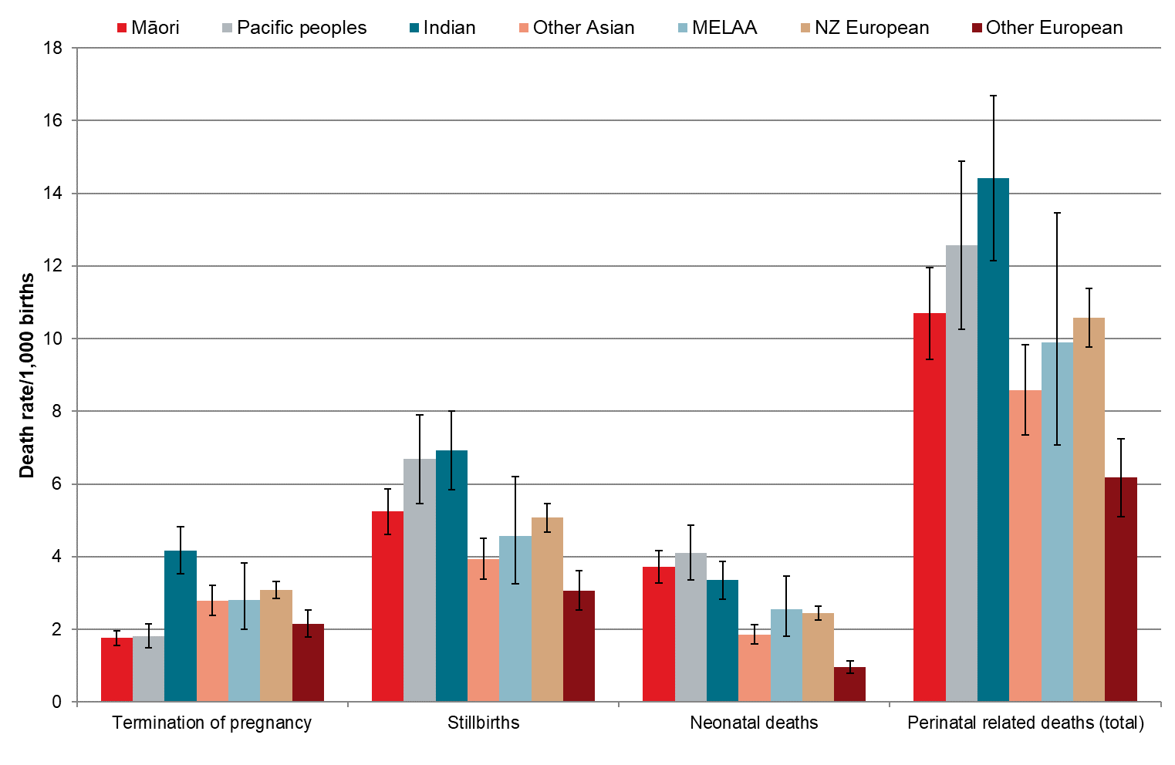
MAT = National Maternity Collection; MELAA = Middle Eastern, Latin American or African; PMMRC = Perinatal and Maternal Mortality Review Committee.
Sources: Numerator: PMMRC perinatal data extract 2012–2021; Denominator: MAT births 2012–2021.
Figure 3.3: Perinatal related mortality rates (per 1,000 births, with 95% confidence intervals) by baby prioritised ethnic group 2012–2021
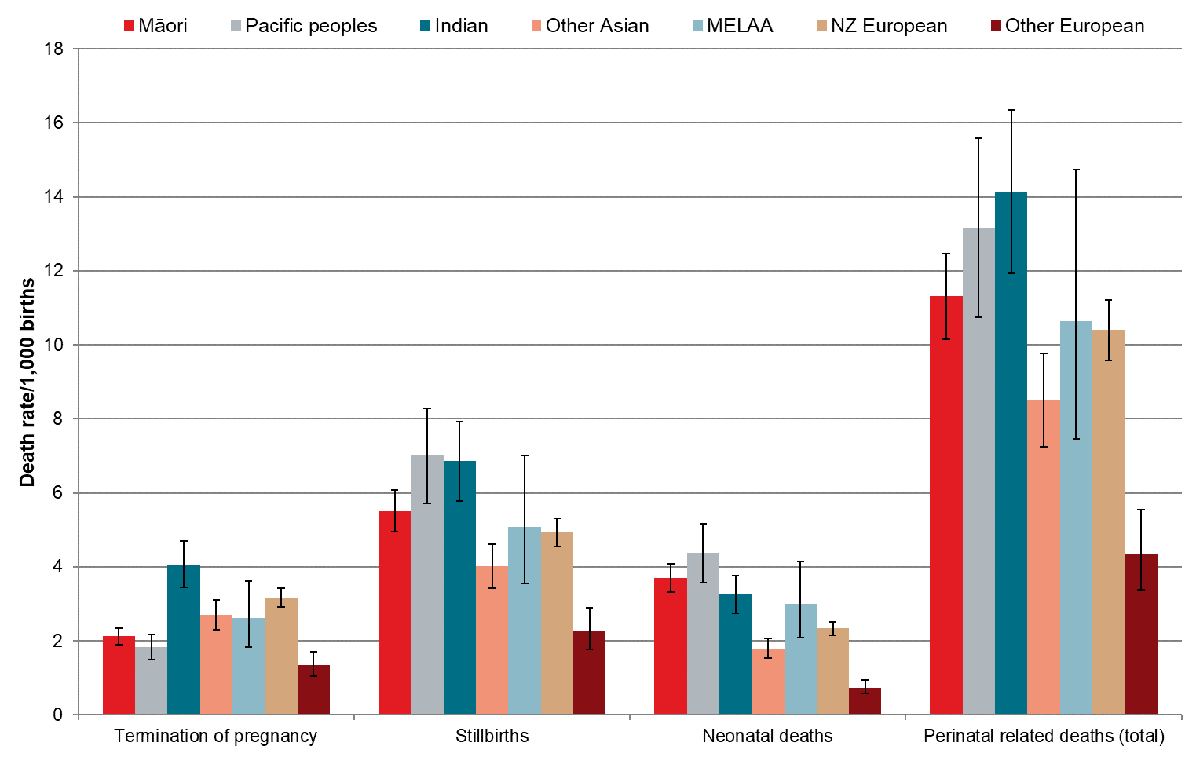
MAT = National Maternity Collection; MELAA = Middle Eastern, Latin American, or African; PMMRC = Perinatal and Maternal Mortality Review Committee.
Sources: Numerator: PMMRC perinatal data extract 2012–2021; Denominator: MAT births 2012–2021.
Perinatal related mortality rates by perinatal death classification and maternal prioritised ethnic group are presented in Table 3.8. Over the 2012–2021 period (when congenital anomalies were excluded), the leading explained classification of death for all ethnicities was spontaneous preterm labour or rupture of membranes, and rates were higher for those of Māori, Pacific or Indian ethnicity. Across all ethnic groups, the cause of many perinatal related mortalities remained unexplained (12.4%).
Table 3.8 shows significant inequitable ethnic disparities. These inequities demonstrate unjust and avoidable deaths. The health system will always have preventable deaths, but inequity produces more deaths that are unjust and avoidable among some groups, and we currently do not have a robust metric against which to judge preventability.
If the rates of perinatal infection, hypertension, antepartum haemorrhage and maternal conditions were the same for all ethnic groups, there would be a large reduction in mortality. Equalisation of rates with the European group would result in a 28% (n = 127) reduction of Māori mortality for this group of conditions, a reduction of 46% (n = 110) for Pacific peoples and a reduction of 41% (n = 53) for Indian populations. This would mean a total reduction in mortality of 290 pēpi and the elimination of a much larger amount of whānau and family grief.
The identification that perinatal infection, hypertension, antepartum haemorrhage and maternal conditions are conditions associated with a greater chance of adverse perinatal outcomes in Māori, Pacific and Indian populations is a key finding of this report.
The health system in Aotearoa must ask itself why, compared with the European population, Māori have a 43% higher chance of perinatal related mortality from infection, Pacific peoples have double the mortality from hypertension and Indian populations have an 84% higher chance of mortality from antepartum haemorrhage. This discussion should be uncomfortable but will result in opportunities to save lives.
A health service that identifies the risks and develops systems to address those risks will improve outcomes. The data in this report should not just be recorded, it should result in the development of policies and practices that include specific, targeted treatment plans that recognise the increased risk for women and birthing people in the presence of clinical conditions combined with the disproportionate exposure to social determinants of health/ill health experienced by some ethnic groups. Impacted communities must be fundamentally involved in the development of these interventions and solutions to ensure they are appropriate and acceptable.

Table 3.8: Perinatal death classification (PSANZ-PDC) specific perinatal related mortality rates (excluding congenital anomalies) by maternal prioritised ethnic group† 2012–2021
Perinatal death classification  (PSANZ-PDC) | Māori |  |  | Pacific peoples |  |  | Asian |  |  |  |  |  |  |  |  | MELAA |  |  | European
 |  |  |  |  |  |  | Indian |  |  | Other Asian |  |  | Total Asian |  |  |  |  |  | NZ European |  |  | Other European |  |  | Total European
 | N=155,359 |  |  | N=62,861 |  |  | N=37,125 |  |  | N=65,488 |  |  | N=102,613 |  |  | N=14,260 |  |  | N=212,729 |  |  | N=58,972 |  |  | N=271,701
 | n | % | Rate | n | % | Rate | n | % | Rate | n | % | Rate | n | % | Rate | n | % | Rate | n | % | Rate | n | % | Rate | n | % | Rate
Perinatal infection | 69 | 5.3 | 0.44 | 33 | 5.2 | 0.52 | 13 | 3.4 | 0.35 | 17 | 4.8 | 0.26 | 30 | 4.1 | 0.29 | 3 | 3.4 | 0.21 | 66 | 4.3 | 0.31 | 11 | 5.1 | 0.19 | 77 | 4.4 | 0.28
Hypertension | 59 | 4.5 | 0.38 | 31 | 4.9 | 0.49 | 12 | 3.1 | 0.32 | 13 | 3.7 | 0.20 | 25 | 3.4 | 0.24 | <3 | x | s | 51 | 3.3 | 0.24 | 5 | 2.3 | 0.08 | 56 | 3.2 | 0.21
Antepartum haemorrhage | 209 | 15.9 | 1.35 | 97 | 15.3 | 1.54 | 69 | 18.0 | 1.86 | 57 | 16.2 | 0.87 | 126 | 17.1 | 1.23 | 12 | 13.6 | 0.84 | 215 | 14.1 | 1.01 | 24 | 11.2 | 0.41 | 239 | 13.7 | 0.88
Maternal conditions | 108 | 8.2 | 0.70 | 78 | 12.3 | 1.24 | 35 | 9.1 | 0.94 | 23 | 6.5 | 0.35 | 58 | 7.9 | 0.57 | 10 | 11.4 | 0.70 | 105 | 6.9 | 0.49 | 15 | 7.0 | 0.25 | 120 | 6.9 | 0.44
Complications of multiple pregnancy | 46 | 3.5 | 0.30 | 32 | 5.1 | 0.51 | 21 | 5.5 | 0.57 | 15 | 4.3 | 0.23 | 36 | 4.9 | 0.35 | <3 | x | s | 106 | 6.9 | 0.50 | 13 | 6.1 | 0.22 | 119 | 6.8 | 0.44
Specific perinatal conditions | 39 | 3.0 | 0.25 | 37 | 5.9 | 0.59 | 27 | 7.0 | 0.73 | 24 | 6.8 | 0.37 | 51 | 6.9 | 0.50 | 13 | 14.8 | 0.91 | 116 | 7.6 | 0.55 | 25 | 11.7 | 0.42 | 141 | 8.1 | 0.52
Hypoxic peripartum death | 45 | 3.4 | 0.29 | 9 | 1.4 | 0.14 | 5 | 1.3 | 0.13 | 6 | 1.7 | 0.09 | 11 | 1.5 | 0.11 | 4 | 4.5 | 0.28 | 63 | 4.1 | 0.30 | 5 | 2.3 | 0.08 | 68 | 3.9 | 0.25
Placental dysfunction or causative placental pathology | 107 | 8.1 | 0.69 | 63 | 10.0 | 1.00 | 56 | 14.6 | 1.51 | 45 | 12.8 | 0.69 | 101 | 13.7 | 0.98 | 8 | 9.1 | 0.56 | 196 | 12.8 | 0.92 | 30 | 14.0 | 0.51 | 226 | 13.0 | 0.83
Spontaneous preterm labour or rupture of membranes (<37 weeks gestation) | 363 | 27.6 | 2.34 | 141 | 22.3 | 2.24 | 85 | 22.1 | 2.29 | 68 | 19.3 | 1.04 | 153 | 20.8 | 1.49 | 16 | 18.2 | 1.12 | 284 | 18.6 | 1.34 | 38 | 17.8 | 0.64 | 322 | 18.5 | 1.19
Unexplained antepartum fetal death | 228 | 17.4 | 1.47 | 99 | 15.7 | 1.57 | 58 | 15.1 | 1.56 | 78 | 22.2 | 1.19 | 136 | 18.5 | 1.33 | 19 | 21.6 | 1.33 | 303 | 19.9 | 1.42 | 47 | 22.0 | 0.80 | 350 | 20.1 | 1.29
Neonatal death without obstetric antecedent | 40 | 3.0 | 0.26 | 12 | 1.9 | 0.19 | 3 | 0.8 | 0.08 | 6 | 1.7 | 0.09 | 9 | 1.2 | 0.09 | - | - | - | 21 | 1.4 | 0.10 | <3 | x | s | 22 | 1.3 | 0.08
‘x’ indicates percentage suppressed due to small numbers.
‘s’ indicates rate suppressed due to small numbers.
† Excludes 367 unknown maternal ethnicity among total births and five unknown maternal ethnicity perinatal related deaths (total).
MAT = National Maternity Collection; MELAA = Middle Eastern, Latin American or African; PDC = Perinatal Death Classification; PSANZ = Perinatal Society of Australia and New Zealand.
Sources: Numerator: PMMRCs perinatal data extract (excluding congenital anomaly) 2012–2021; Denominator: MAT births 2012–2021.

The prevalence of neonatal death is higher among Indian, Pacific and Māori whānau and families (Figure 3.4), and prematurity is a prevalent contributing factor (Table 3.8)
Even though Māori, Pacific and Indian ethnic groups experience the highest rate of mortality from premature birth, there are no national recommendations for culturally appropriate care or national targeted programmes that have been shown to work for other indigenous peoples. Research is ongoing about the lived experiences of indigenous peoples experiencing these very early births. Inequities in the prevalence of premature births are the focus of other mahi, for example, the Carosika Collaborative.
It could be expected that neonatal death rates would decrease at each gestation given the maturity of the baby and ability to adapt to life after being born. However, we see higher rates for babies ≥35 weeks for many ethnic groups, especially for Māori. This is unexplained and warrants urgent attention (Figure 3.4).
Figure 3.4: Neonatal death risk (per 1,000 ongoing pregnancies) by gestation at birth and maternal ethnicity excluding congenital anomalies 2012–2021
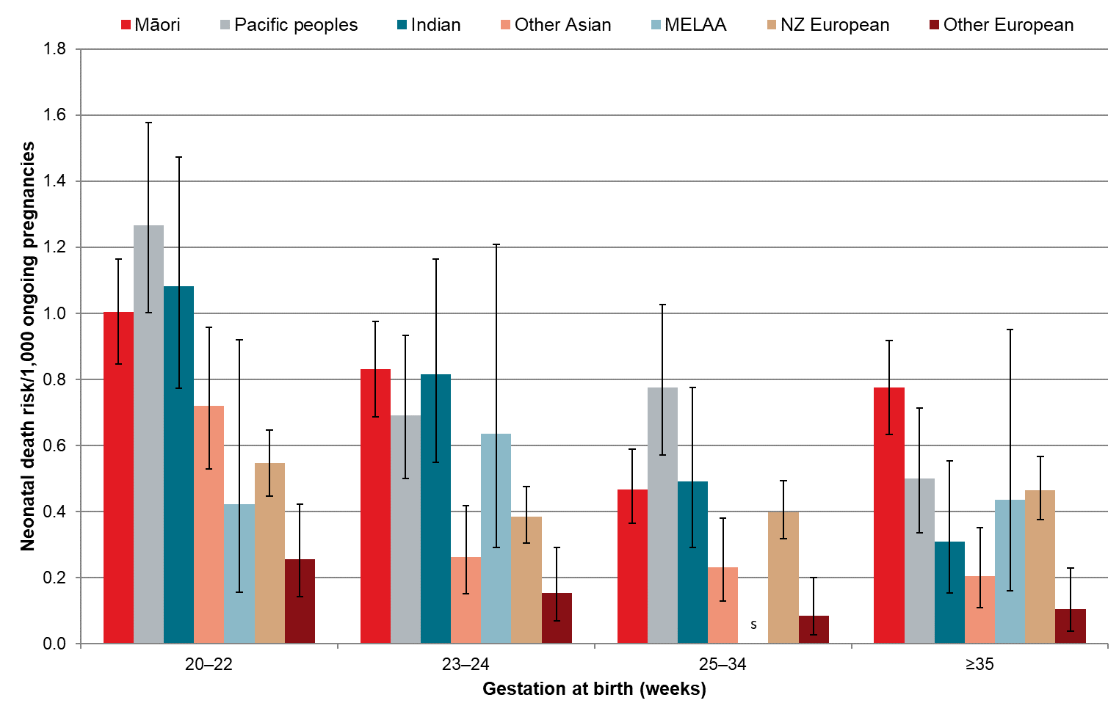
‘s’ indicates rate suppressed due to small numbers.
Note: Unknown/other ethnicity not included
MAT = National Maternity Collection; MELAA = Middle Eastern, Latin American or African; PMMRC = Perinatal and Maternal Mortality Review Committee; .
Sources: Numerator: PMMRC perinatal data extract excluding congenital anomaly 2012–2021; Denominator: MAT births 2012–2021.

Women and birthing people aged <20 years are most impacted by perinatal mortality, with a rate of 16.63 deaths per 1,000 births overall, and this increases again to 14.46 deaths per 1,000 births for those aged ≥40 years (Table 3.20 appended). However, the age distribution changes between ethnic groups (Figure 3.5). As identified in previous reports, although the overall teen pregnancy rates are declining, young parents face many challenges. Regardless of reduced pregnancy rates, this group continue to experience significant poor outcomes, and urgent focus on systems to provide support to this group is needed.
‘Other European’ populations do not have worse outcomes for those aged <20 years, although numbers are small and CIs wide. As identified in previous reports, although overall pregnancy rates among people aged <20 years are declining, young women and birthing people face unique challenges. It is important to note that pregnancy may not be negative in of itself for young people but that this group encounters access barriers and stigmatisation when interacting with health systems. These issues need to be addressed to ensure adequate and appropriate support within communities and systems to attain better perinatal outcomes for young people and their pēpi. Appropriate services for young people are needed to support informed decision-making about their sexuality and reproductive options.
Age disparity occurs in all prioritised ethnic groups, but patterns differ. There may be an intercorrelation between poorer outcome in older ages and parity, but fertility patterns vary substantially between groups with differing ages at first child and family sizes., This requires further investigation and analysis.
Figure 3.5: Perinatal related mortality rates (per 1,000 births, with 95% confidence intervals) by maternal age and maternal prioritised ethnic group 2012–2021
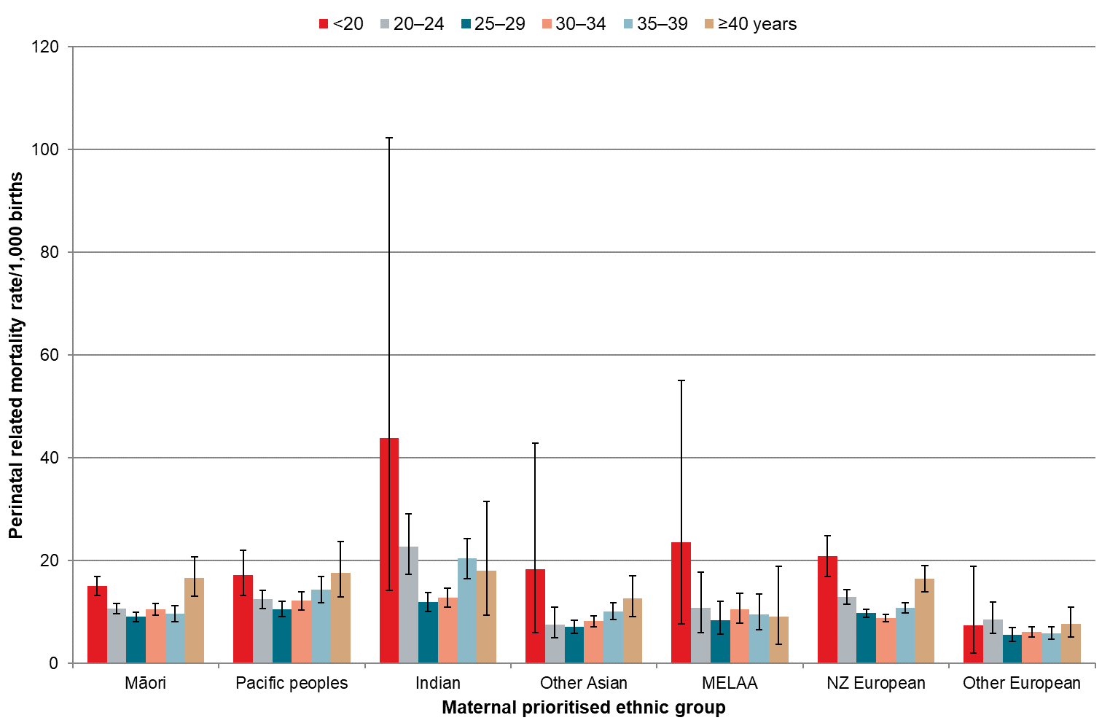
MAT = National Maternity Collection; MELAA = Middle Eastern, Latin American or African; PMMRC = Perinatal and Maternal Mortality Review Committee.
Sources: Numerator: PMMRC perinatal data extract 2012–2021; Denominator: MAT births 2012–2021.

Where you live
One of the main aims of the reorganisation of the health system in Aotearoa in 2022 (after the data reported herein) was to eliminate or at least mediate inequitable access and outcomes. Impacts of the reform may possibly be seen in future surveillance of perinatal outcomes.

Deprivation
Deprivation, indicated in this report by the New Zealand Index of Deprivation (NZDep; where quintile 1 represents the least deprived zones in Aotearoa and quintile 5 the most deprived; see the Methods and Definitions for Perinatal and Maternal Mortality Review Committee Reporting document) has been shown across many years of local and international research to influence health outcomes. It is of note that in Aotearoa in this period, 50.2% of all births and 55.9% of perinatal related mortalities were in those living in NZDep quintiles 4 or 5.
As can be seen in Figure 3.6, causes of perinatal mortality vary by deprivation quintile. Of particular note is the higher rate of perinatal mortality caused by spontaneous preterm labour/preterm rupture of membranes in the most deprived quintile (0.99 per 1,000 births in quintile 1 compared with 2.48 in quintile 5). The available data in this report cannot readily explain this relationship. However, these results are consistent with research indicating a very complex web of needs in highly deprived areas that correlate to poor perinatal outcomes. These multiple interactions between deprivation, ethnicity, smoking and other factors warrant further exploration. There are also other probable influences that the PMMRC does not gather data for or report on that are also not included within the framework of the NZDep, such as food security and health system engagement.
It is likely that people in highly deprived areas have more difficulty accessing health care and may be treated inequitably within the health system because of discrimination and stigmatisation. Established factors mediating this include continuity of care, culturally safe clinical relationships, a diverse and representative workforce with an understanding of the complexity of people’s lives and the flexibility of carers to meet needs in a system that may not function well for all.
Deprivation is a demographic influence on perinatal related mortality, with a relative risk 1.46 times greater for those in living in deprivation quintile 5 geographic areas than for those in quintile 1 (Table 3.7).
Figure 3.6: Perinatal death classification (PSANZ-PDC) specific perinatal related mortality rates (per 1,000 births, with 95% confidence intervals) (excluding congenital anomalies) by NZDep quintile† 2012–2021
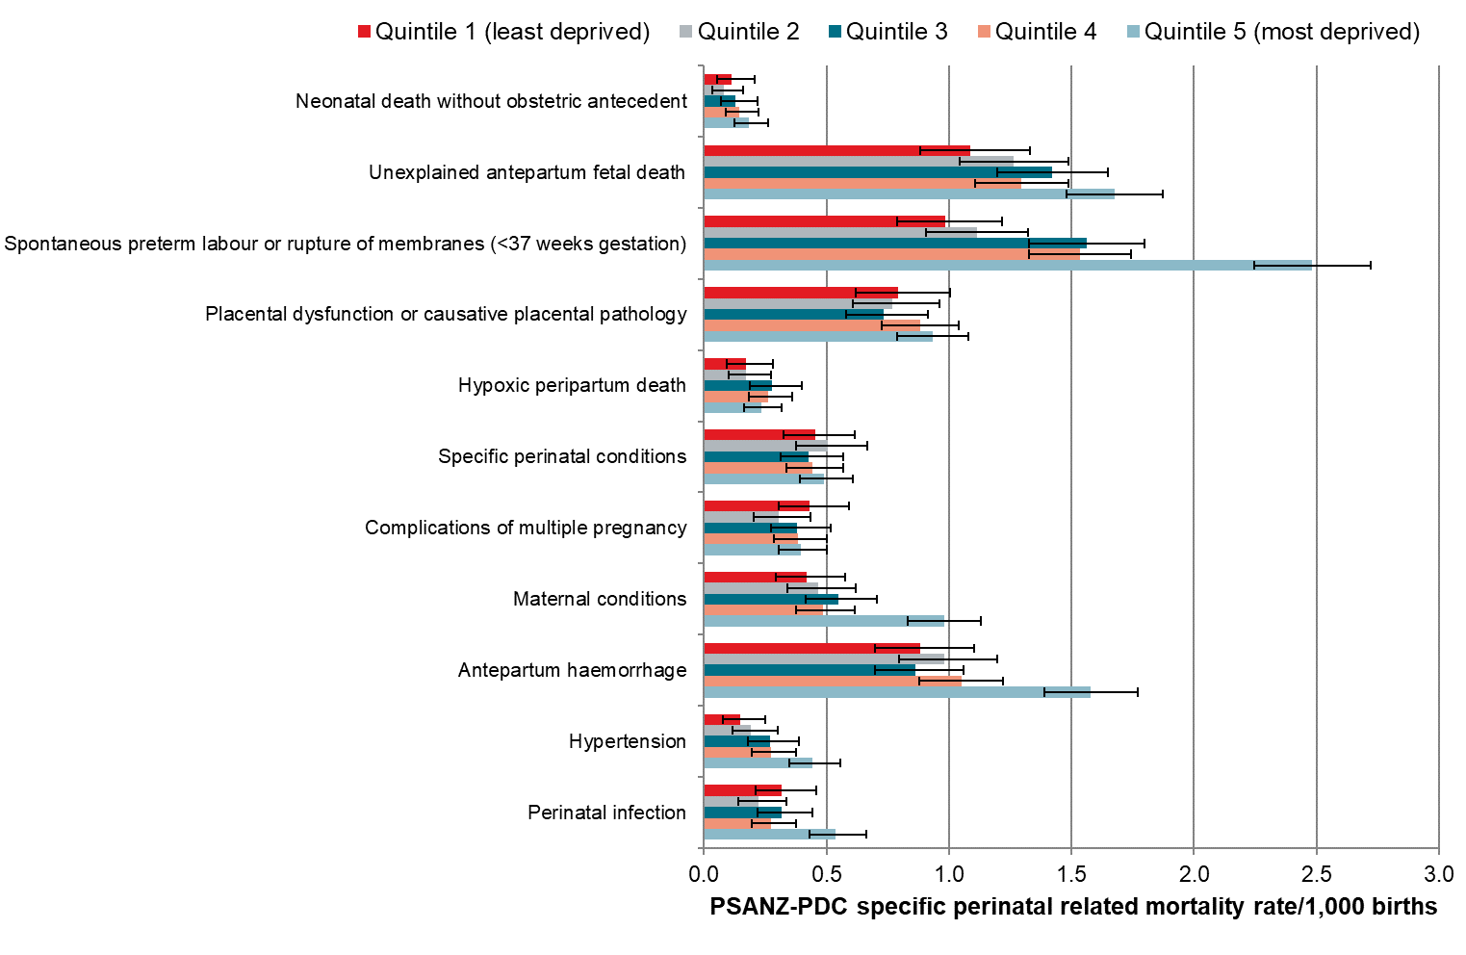
† Excludes 23 with unknown deprivation quintiles.
MAT = National Maternity Collection; PDC = Perinatal Death Classification; PMMRC = Perinatal and Maternal Mortality Review Committee; PSANZ = Perinatal Society of Australia and New Zealand.
Sources: Numerator: PMMRC perinatal data extract (excluding congenital anomalies) 2012–2021; Denominator: MAT births 2012–2021.

Rurality
A demographic factor being examined for the first time in this report is rural/urban residential locality of women and birthing people. Using the Geographic Classification for Health (GCH) categories developed by Whitehead et al. (see the Methods and Definitions for Perinatal and Maternal Mortality Review Committee Reporting document) residential area was determined to be rural or urban based on residential address at registration.
The incidence of mortality is worse for rural people in Aotearoa across the lifespan. There is a small higher relative risk of 1.12 for rural families experiencing a perinatal loss than for those living in urban areas (Table 3.7).
As rural Māori have been shown to be further disadvantaged in other areas of mortality in Aotearoa, we examined outcome by rural/urban location and ethnic group in Figure 3.7 and Table 3.9. This showed unexpected variation between groups and locations; for example, some have reduced rates in rural areas, whereas Māori and Indian populations had higher rates, although there are very small numbers for some groups and large CIs. However, when broken down by prioritised ethnic group, there were no significant differences between individual groups when comparing rural and urban residence.
Figure 3.7: Perinatal related mortality rates (per 1,000 births) by urban/rural residence and maternal prioritised ethnic group (with 95% confidence intervals) 2012–2021
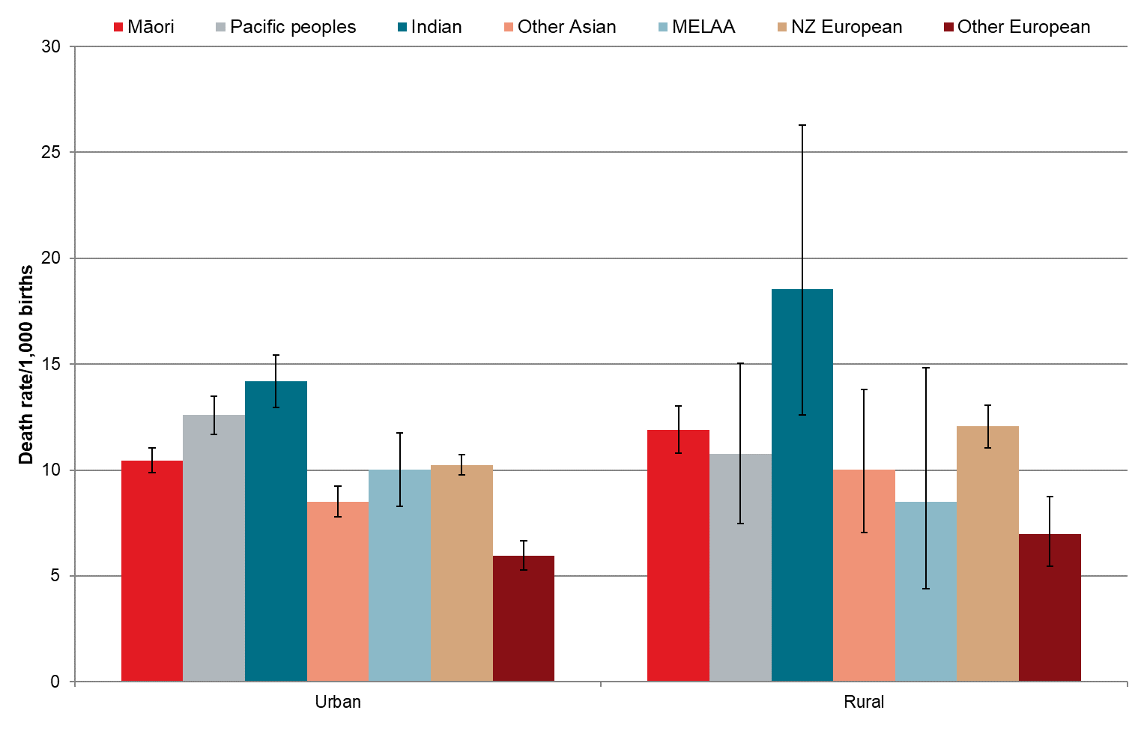
MAT = National Maternity Collection; MELAA = Middle Eastern, Latin American or African; PMMRC = Perinatal and Maternal Mortality Review Committee.
Sources: Numerator: PMMRC perinatal data extract 2012–2021; Denominator: MAT births 2012–2021.

Table 3.9: Perinatal related mortality rates (per 1,000 births) by rurality and maternal prioritised ethnic group 2012–2021
Prioritised ethnic group  (maternal) | Total births |  | Urban |  |  |  |  | Rural |  |  |  |  | Unknown |  |  |  | Perinatal related deaths (total)
 | N=607,161 |  | N=499,730 |  | n=5,108* |  |  | N=102,093 |  | n=1,166 |  |  | N=5,338 |  | n=32 |  | n=6,306
 | N | % | N | % | n | % | Rate | N | % | n | % | Rate | N | % | n | % | n | % | Rate
Māori | 155,359 | 25.6 | 116,986 | 23.4 | 1,222 | 23.9 | 10.45 | 36,538 | 35.8 | 435 | 37.3 | 11.91 | 1,835 | 34.4 | 4 | 12.5 | 1,661 | 26.3 | 10.69
Pacific peoples | 62,861 | 10.4 | 59,086 | 11.8 | 744 | 14.6 | 12.59 | 3,158 | 3.1 | 34 | 2.9 | 10.77 | 617 | 11.6 | 12 | 37.5 | 790 | 12.5 | 12.57
Asian | 102,613 | 16.9 | 96,724 | 19.4 | 1,024 | 20.0 | 10.59 | 5,365 | 5.3 | 68 | 5.8 | 12.67 | 524 | 9.8 | 5 | 15.6 | 1,097 | 17.4 | 10.69
Indian | 37,125 | 6.1 | 35,290 | 7.1 | 501 | 9.8 | 14.20 | 1,673 | 1.6 | 31 | 2.7 | 18.53 | 162 | 3.0 | 3 | 9.4 | 535 | 8.5 | 14.41
Other Asian | 65,488 | 10.8 | 61,434 | 12.3 | 523 | 10.2 | 8.51 | 3,692 | 3.6 | 37 | 3.2 | 10.02 | 362 | 6.8 | <3 | x | 562 | 8.9 | 8.58
MELAA | 14,260 | 2.3 | 12,770 | 2.6 | 128 | 2.5 | 10.02 | 1,414 | 1.4 | 12 | 1.0 | 8.49 | 76 | 1.4 | <3 | x | 141 | 2.2 | 9.89
European | 271,701 | 44.7 | 214,131 | 42.8 | 1,988 | 38.9 | 9.28 | 55,615 | 54.5 | 617 | 52.9 | 11.09 | 1,955 | 36.6 | 7 | 21.9 | 2,612 | 41.4 | 9.61
NZ European | 212,729 | 35.0 | 166,132 | 33.2 | 1,702 | 33.3 | 10.24 | 45,133 | 44.2 | 544 | 46.7 | 12.05 | 1,464 | 27.4 | <3 | x | 2,248 | 35.6 | 10.57
Other European | 58,972 | 9.7 | 47,999 | 9.6 | 286 | 5.6 | 5.96 | 10,482 | 10.3 | 73 | 6.3 | 6.96 | 491 | 9.2 | 5 | 15.6 | 364 | 5.8 | 6.17
‘x’ indicates percentage suppressed due to small numbers.
Note: Denominators include 367 with unknown maternal ethnicity among total births and five with unknown maternal ethnicity among perinatal related deaths (total).
MAT = National Maternity Collection; MELAA = Middle Eastern, Latin American or African; PMMRC = Perinatal and Maternal Mortality Review Committee.
Sources: Numerator: PMMRC perinatal data extract 2012–2021; Denominator: MAT births 2012–2021

DHB of maternal residence
In line with the rural/urban findings outlined above, it follows that some DHBs (as they were configured in 2021 and prior) may have variable perinatal related mortality rates influenced by the proportion of people living in rural areas. This regional variation is shown in Figure 3.8 (and Table 3.21 appended). Northland and Counties Manukau have higher perinatal mortality rates that are significantly higher than the national average. Northland has a large rural population with approximately 60% living in small towns and rural areas, and the population of Counties Manukau is mostly urban. Therefore, DHB-level disparities cannot be exclusively attributed to rural/urban disparities.
It might also be expected that some regional variation would be related to the demographic makeup of these areas and the interaction with these factors and the geographic ones as shown in Figure 3.7. However, assumptions in this regard should be treated with caution. For example, Hauora Tairāwhiti has remote rural areas, with 45% Māori and 65% of the population living in highly deprived areas (deciles 8–10), yet its perinatal related mortality rate (10.26) is below the national rate.
Further investigation into these regional variations and relationships to perinatal outcomes is needed to better understand potential opportunities for focused support and resources.

Figure 3.8: Perinatal related mortality rates (per 1,000 births, with 95% confidence intervals) by DHB of maternal residence compared with Aotearoa perinatal related mortality 2012–2021
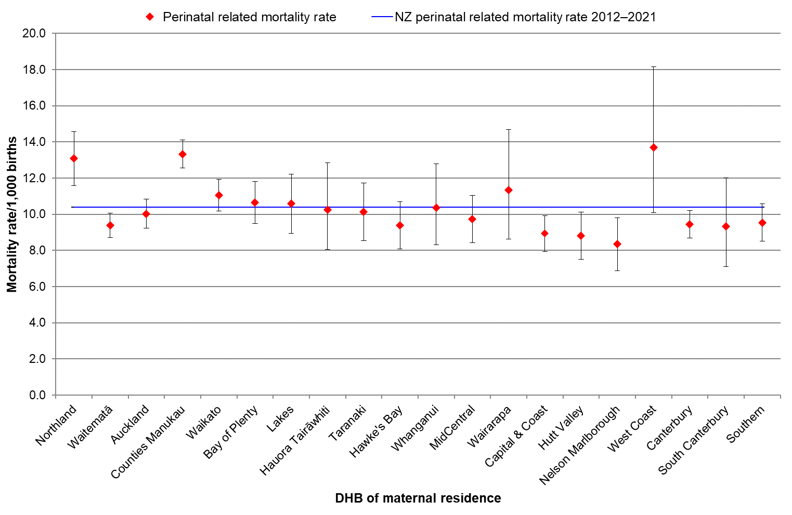
DHB = district health board; MAT = National Maternity Collection; PMMRC = Perinatal and Maternal Mortality Review Committee.
Sources: Numerator: PMMRCs perinatal data extract 2012–2021; Denominator: MAT births 2012–2021.

Figure 3.8 also shows that several DHBs, including Waitematā, Capital & Coast, Hutt Valley, Nelson Marlborough and Canterbury, all had perinatal related mortality rates significantly lower than the
national rate.

Looking more closely at the types of perinatal death in Figure 3.9, stillbirth rates also varied by region: Northland and Counties Manukau rates were significantly above the national rate. In addition, higher rates of stillbirth are present in the Wairarapa and West Coast districts, with their large proportion of rural residents; however, the CIs are very wide because of the smaller overall population base in those regions. Waitematā, Auckland, MidCentral and Nelson Marlborough all had rates significantly lower than the national rate.
Figure 3.9: Stillbirth rates (per 1,000 births, with 95% confidence intervals) by DHB of maternal residence compared with average stillbirth rates 2012–2021
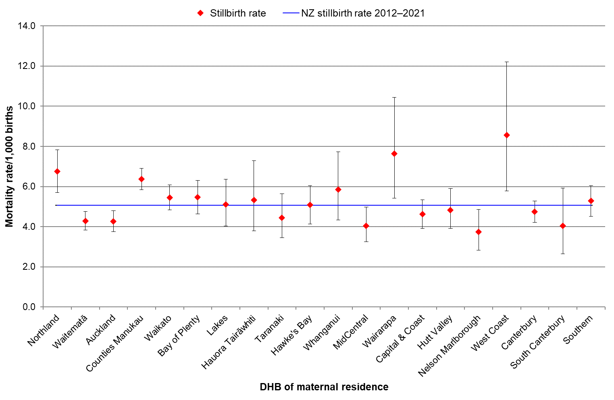
DHB = district health board; MAT = National Maternity Collection; PMMRC = Perinatal and Maternal Mortality Review Committee.
Sources: Numerator: PMMRC perinatal data extract stillbirths only, 2012–2021; Denominator: MAT births 2012–2021.

There was more variation in neonatal death rates compared with the national rate, as shown in Figure 3.10: rates in Counties Manukau and Taranaki were significantly higher than the national rate, and rates in Waitematā, Canterbury and Southern were all significantly lower.
Figure 3.10: Neonatal mortality rates (per 1,000 live births, with 95% confidence intervals) by DHB of maternal residence compared with Aotearoa neonatal mortality 2012–2021
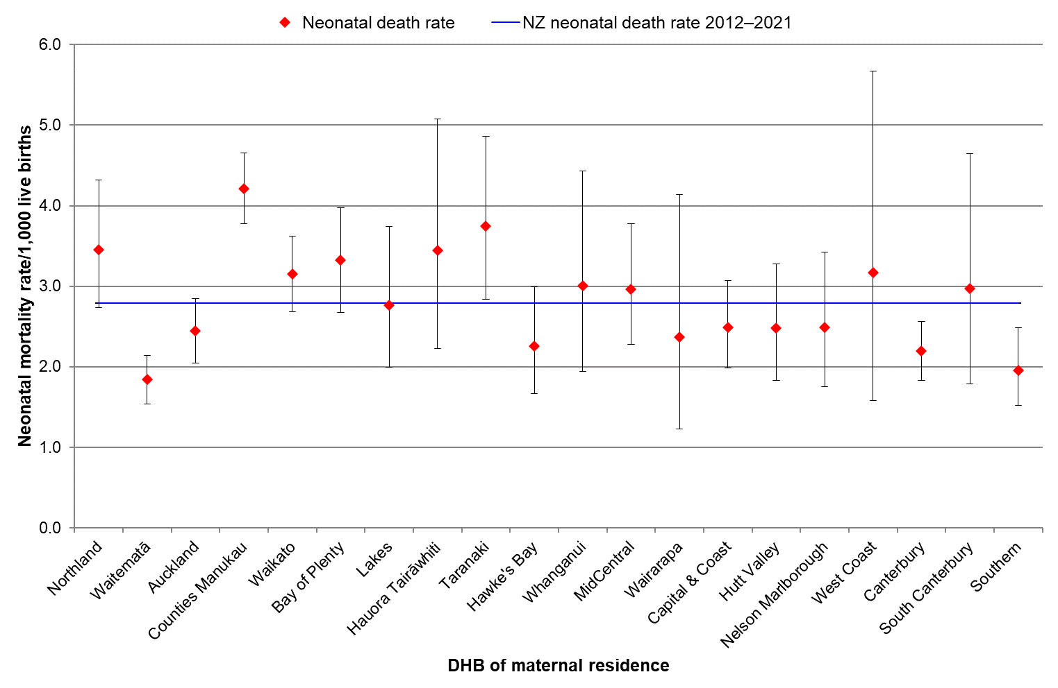
DHB = district health board; MAT = National Maternity Collection; PMMRC = Perinatal and Maternal Mortality Review Committee.
Sources: Numerator: PMMRC perinatal data extract, neonatal deaths only, 2012–2021; Denominator: MAT births excluding fetal deaths 2012–2021.

Work is underway to address regional service variation and access through the health system restructuring that began in 2022. Continuing to monitor regional variation in perinatal mortality outcomes for improvement across the country will be an important indicator of success.

COVID-19 impact on perinatal outcomes

Definitions
- COVID-19 Infection during pregnancy: A confirmed positive COVID-19 rapid antigen test (RAT)/polymerase chain reaction (PCR) test recorded during pregnancy.
- During pregnancy includes the pregnancy start date and the delivery date. Pregnancy start was calculated using the delivery date minus the gestation weeks.
- Birthing population: all births over 20 weeks’ gestation, including live and stillbirths.
- Data source: COVID-19 case data was sourced from Health New Zealand – Te Whatu Ora and matched to the MAT (also from Health New Zealand) and the perinatal set by encrypted NHI number.
- Ultrasound data: This data is from pregnancy ultrasound maternity claims and may exclude anatomy scans done in publicly funded outpatient services.

Background
The 15th PMMRC report noted that the outbreak of severe acute respiratory syndrome coronavirus-2 (SARS-CoV-2; coronavirus disease 2019 [COVID-19]) affected maternity care in several ways after the World Health Organization (WHO) declared a pandemic on 30 January 2020. The health-based response in Aotearoa is estimated to have saved thousands of people’s lives by minimising COVID-19 infection rates, including the possibility of fewer adverse pregnancy outcomes. However, the pandemic response also had an impact on service delivery. Pregnancy outcomes could have been affected not only by the potential adverse effects of COVID-19 infection on pregnancies but also by reduced access to services across the health and disability sector during lockdowns and by social impacts due to many factors, including border restrictions, isolation periods and limited access to family support in maternity facilities.
The context in Aotearoa changed in 2021, with both widespread community infection and transmission, the arrival of the delta variant and the availability of vaccines but with continued lockdowns, some of which were location specific.
Although no significant differences in perinatal and maternal mortality outcomes were detected in 2020, we continued to monitor in 2021 for potential differences that may be related to COVID-19. For this report, we were able to source infection data from national data repositories and match it to all births, including mortalities, and we examined service provision data from the limited data available within the national maternity and PMMRC data collections.
The following findings raise several important areas of concern that could be further explored but were beyond the scope of this report.

Findings: infections
In 2021, the rate of confirmed infection was 285 per 100,000 for all women in the population aged 20–49 years but approximately 87 per 100,000 births in the population that gave birth after 20 weeks’ gestation. Some of this difference may in part relate to COVID-19-avoidant behaviour.
Five people experienced a perinatal mortality and had a confirmed COVID-19 infection in their pregnancy (Table 3.10). However, the likelihood of a pregnancy ending in a perinatal death was 7.37 times higher for those with a confirmed COVID-19 infection during pregnancy than for those without any confirmed COVID-19 infection. The 95% CI was broad (2.96–18.36) but significant (p <0.01).
Table 3.10 Confirmed COVID-19 infection during pregnancy 2020–2021
COVID infection  during pregnancy | Perinatal related deaths |  | OR | 95% CI
 | N=121,860
 | Yes | No
Yes | 5 | 63 | 7.37 | 2.96–18.36
No | 1,297 | 120,495 | 1.00 | -
CI = confidence interval; MAT = National Maternity Collection; OR = odds ratio; PMMRC = Perinatal and Maternal Mortality Review Committee.
Sources: Numerator: PMMRCs perinatal data extract, where matched to MAT data 2017–2021; Denominator: MAT births 2017–2021. Matched to COVID-19 infection data by Health New Zealand.

Note, this does not cover those who may have become infected in the 28 days following birth, which potentially could have an interaction with neonatal mortalities.
Small numbers meant it was not possible to robustly analyse possible demographic differences. However, in the national context of the general population, disparities in regard to COVID-19 infection were noted, with adverse impacts falling more heavily on Māori, Pacific peoples, those with pre-existing health conditions, disabled people and those with lower incomes.
Detailed analysis of the 2021 year on a month-by-month basis showed fluctuation in overall perinatal death rates. Figure 3.11 shows the variability of these rates over the last 5 years. In the fourth quarter of 2021, local coordinators reported concerns about a sudden increase in perinatal deaths, and there is some evidence of this in the data from that period. This peak in August to October correlates with the delta variant outbreak in Aotearoa, first detected on 17 August 2021. International data has shown that the delta variant is associated with poorer perinatal outcomes, such as preterm birth, low birthweight and unusual placental histology (SARS-CoV-2 placentitis). The delta variant has not been detected in Aotearoa since March 2022.
Figure 3.11: Perinatal related mortality rates by month (per 1,000 births) 2017–2021
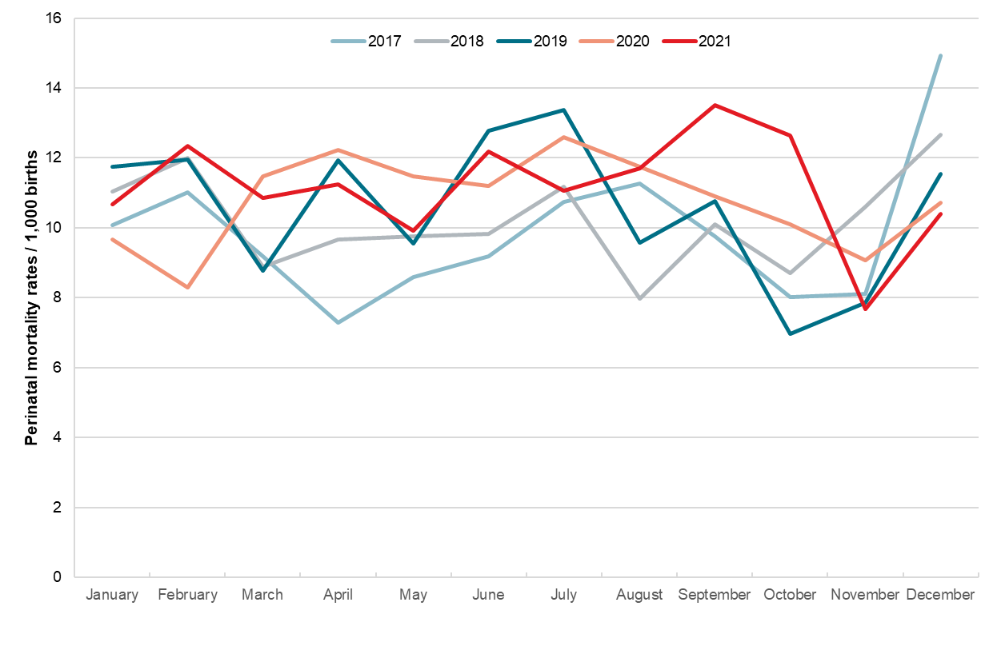
MAT = National Maternity Collection; PMMRC = Perinatal and Maternal Mortality Review Committee.
Sources: Numerator: PMMRC perinatal data extract, where matched to MAT data 2017–2021; Denominator: MAT births 2017–2021.

It is important to note that influenza infection in pregnancy also has serious impact on outcomes, and there is some early evidence that infection with the COVID omicron variant during pregnancy has an impact similar to that of influenza. This highlights the critical importance of improving maternal vaccination coverage in general.

Findings: services
Selected possible indictors that could have been affected during the restrictions and changes in service during 2020 and 2021 included trimester of first registration, small for gestational age (SGA) babies, smoking cessation and anatomy ultrasound. Historically, these indicators continue to correlate with perinatal mortality, some of which are shown in Table 3.7.
Investigation of these factors did not show significant changes in patterns during the initial years of the COVID-19 pandemic. A small decrease in SGA babies in the COVID-19 years 2020 and 2021 was noted in both the mortality and the whole birth population, and this is congruent with international findings.,
During routine pregnancy care, an anatomy ultrasound scan is offered to all pregnant people at 18–20 weeks. Although the scan itself does not necessarily impact outcomes, results may influence recommendations for pregnancy care and decision-making as it may be the first indication of factors that could influence fetal growth or wellbeing, including fetal anomalies. This scan is also a proxy for access to services, with the concern being that access may have been further reduced during the COVID-19 pandemic. In the last maternity consumer satisfaction survey, 17% of respondents stated that they had issues accessing ultrasound services, and reporting of this barrier was higher among Māori, Pacific peoples, young and disabled people. Survey respondents indicated that availability of services and cost were the two main barriers to accessing ultrasound.
Table 3.11 shows that, in 2017 to 2021, fewer of those who later experienced a perinatal mortality received a routine anatomy scan than the general birthing population. Some of this difference may be attributed to the possibility that those experiencing a pregnancy loss close to 20 weeks’ gestation may not yet have had a scan. The topic of ultrasound inequity in Aotearoa warrants further investigation.
Table 3.11: Proportion of people receiving at least one anatomy ultrasound in pregnancy 2017–2021
 | Total births |  |  | Perinatal related deaths
 | N | Anatomy scan |  | N | Anatomy scan
 |  | n | % |  | n | %
2017 | 60,502 | 52,917 | 87.46 | 577 | 418 | 72.44
2018 | 59,325 | 52,143 | 87.89 | 586 | 408 | 69.62
2019 | 60,610 | 53,121 | 87.64 | 611 | 435 | 71.19
2020 | 59,477 | 52,436 | 88.16 | 627 | 449 | 71.61
2021 | 63,296 | 56,036 | 88.53 | 680 | 466 | 68.53
MAT = National Maternity Collection; PMMRC = Perinatal and Maternal Mortality Review Committee.
Sources: Numerator: PMMRCs perinatal data extract, where matched to MAT data 2020–2021; Denominator: MAT births 2020–2021

The lowest proportion of anatomy scans among those who experienced perinatal related mortality in the 5-year period was in 2021. It is not possible to tell from this data why this occurred, and there is no clear evidence from these data that the COVID-19 restrictions affected access to ultrasound scans.

Findings: other
These data do not include or report whānau experiences of pregnancy during the pandemic years of 2020–2021. Qualitative research indicates both positive and negative psycho-social impacts on whānau,, experiencing birth and early parenting during the pandemic response; however, the lack of whānau support and access to funerals/tangihanga during lockdown periods is likely to have been particularly difficult for those affected by perinatal loss. The current PMMR reporting forms do not include any specific questions to capture COVID-19-related factors or impact.

Perinatal mortality appended tables
Table 3.12: Perinatal related death and perinatal death classification (PSANZ-PDC) 2021
Perinatal death classification (PSANZ-PDC) |  | 2021
 |  | n=707
 |  | n | Rate
1 | Congenital anomaly
1.1 | Structural anomaly | - | -
1.11 | Nervous system | 28 | 0.44
1.12 | Cardiovascular system | 33 | 0.52
1.13 | Genitourinary system | 12 | 0.19
1.14 | Gastrointestinal system | 3 | 0.05
1.15 | Musculoskeletal | 7 | 0.11
1.151 | Congenital diaphragmatic Hernia | 3 | 0.05
1.152 | Gastroschisis/omphalocele | <3 | s
1.16 | Respiratory system (include congenital pulmonary airway malformation (CPAM)) | <3 | s
1.17 | Haematological | - | -
1.18 | Multiple Congenital anomaly (no chromosomal/genetic cause or not tested) | 23 | 0.36
1.19 | Other congenital anomaly | - | -
1.192 | Idiopathic hydrops fetalis | 8 | 0.13
1.193 | Fetal tumour (include sacro-coccygeal teratoma) | 3 | 0.05
1.198 | Other specified | <3 | s
1.199 | Congenital anomaly, unspecified | - | -
1.2 | Chromosomal anomaly | - | -
1.21 | Trisomy 21 (Down syndrome) | 15 | 0.24
1.22 | Trisomy 18 (Edward syndrome) and Trisomy 13 (Patau syndrome) | 15 | 0.24
1.23 | Other trisomies and partial trisomies of the autosomes, not elsewhere classified (includes pathogenic duplications, unbalanced translocations and insertions) | 5 | 0.08
1.24 | Monosomies and deletions from the autosomes, not elsewhere classified (includes pathogenic deletions e.g. 22q11.2 deletion syndrome (iGeorge syndrome), Wolff-Hirschorn syndrome, Cri-du-chat syndrome | 10 | 0.16
1.25 | Turner syndrome (monosomy X) | 3 | 0.05
1.26 | Other sex chromosome abnormalities (e.g. Klinefelter syndrome) | - | -
1.28 | Other chromosomal abnormalities, not elsewhere specified (includes triploidy) | 7 | 0.11
1.29 | Unspecified | - | -
1.3 | Genetic condition | <3 | s
1.31 | Genetic condition, specified(includes inborn errors of metabolism (e.g. Tay-Sachs disease, Fragile X syndrome, imprinting syndromes) and other syndromes with demonstrated genetic mutations (e.g. Kabuki syndrome, Fraser syndrome) | 6 | 0.09
1.32 | Syndrome/association with demonstrated chromosomal/gene anomaly | 6 | 0.09
1.39 | Genetic condition, unspecified | 5 | 0.08
2 | Perinatal infection
2.1 | Bacterial | - | -
2.11 | Group B Streptococcus | 5 | 0.08
2.12 | E coli | <3 | s
2.13 | Listeria monocytogenes | <3 | s
2.14 | Spirochaetal e.g. Syphilis | <3 | s
2.18 | Other bacterial | <3 | s
2.19 | Unspecified bacterial | - | -
2.2 | Viral | - | -
2.21 | Cytomegalovirus | 3 | 0.05
2.22 | Parvovirus | - | -
2.23 | Herpes simplex virus | <3 | s
2.24 | Rubella virus | - | -
2.25 | Zika virus | - | -
2.28 | Other viral | - | -
2.29 | Unspecified viral | - | -
2.3 | Protozoal e.g. Toxoplasma | <3 | s
2.5 | Fungal | - | -
2.8 | Other specified organism | <3 | s
2.9 | Other unspecified organism or no organism identified | 3 | 0.05
3 | Hypertension
3.1 | Chronic hypertension: essential | - | -
3.2 | Chronic hypertension: secondary, e.g. renal disease | <3 | s
3.3 | Chronic hypertension: unspecified | - | -
3.4 | Gestational hypertension | - | -
3.5 | Pre-eclampsia | 12 | 0.19
3.6 | Pre-eclampsia superimposed on chronic hypertension | 8 | 0.13
3.9 | Unspecified hypertension | <3 | s
4 | Antepartum haemorrhage (APH)
4.1 | Placental abruption | 28 | 0.44
4.2 | Placenta praevia | 3 | 0.05
4.3 | Vasa praevia | - | -
4.9 | APH of undetermined origin | 45 | 0.71
5 | Maternal Conditions
5.1 | Termination of pregnancy for maternal psychosocial indications | 37 | 0.58
5.2 | Diabetes | - | -
5.21 | Gestational diabetes | - | -
5.22 | Pre-existing diabetes | 8 | 0.13
5.3 | Maternal injury | - | -
5.31 | Accidental | - | -
5.32 | Non-accidental | - | -
5.4 | Maternal sepsis | 3 | 0.05
5.5 | Antiphospholipid syndrome | - | -
5.6 | Obstetric cholestasis | - | -
5.8 | Other specified maternal conditions | - | -
5.81 | Maternal suicide | - | -
5.88 | Other specified maternal medical or surgical conditions | 5 | 0.08
6 | Complications of multiple pregnancy
6.1 | Monochorionic twins | - | -
6.11 | Twin to twin transfusion syndrome (TTTS) | 9 | 0.14
6.12 | Selective fetal growth restriction (FGR) (i.e affecting only one twin) | - | -
6.13 | Monoamniotic twins (including cord entanglement) | 3 | 0.05
6.18 | Other | <3 | s
6.19 | Unknown or unspecified | 4 | 0.06
6.2 | Dichorionic twins | - | -
6.21 | Early fetal death in a multiple pregnancy (<20 weeks gestation) | <3 | s
6.22 | Selective fetal growth restriction (FGR) | - | -
6.28 | Other | - | -
6.29 | Unknown or unspecified | <3 | s
6.3 | Complications of higher order multiples (3 or more fetuses) | - | -
6.31 | Twin to twin transfusion syndrome (TTTS) | <3 | s
6.32 | Selective fetal growth restriction (FGR) | - | -
6.33 | Monoamniotic multiples (including cord entanglement) | - | -
6.34 | Early fetal death in a multiple pregnancy (<20 weeks gestation) | - | -
6.38 | Other | - | -
6.39 | Unknown or unspecified | - | -
6.4 | Complications where chorionicity is unknown | - | -
6.8 | Other | - | -
6.9 | Unspecified | - | -
7 | Specific perinatal conditions
7.1 | Fetomaternal haemorrhage | 4 | 0.06
7.2 | Antepartum cord or fetal vessel complications (excludes monochorionic twins or higher order multiples) | - | -
7.21 | Cord vessel haemorrhage | <3 | s
7.22 | Cord occlusion (True knot with evidence of occlusion or other) | <3 | s
7.28 | Other cord complications | <3 | s
7.29 | Unspecified cord complications | <3 | s
7.3 | Uterine abnormalities | - | -
7.31 | Developmental anatomical abnormalities (e.g. bicornuate uterus) | - | -
7.38 | Other | - | -
7.39 | Unspecified | - | -
7.4 | Alloimmune disease | <3 | s
7.41 | Rhesus isoimmunisation | - | -
7.42 | Other red cell antibody | - | -
7.43 | Alloimmune thrombocytopenia | - | -
7.48 | Other | - | -
7.49 | Unspecified | - | -
7.5 | Fetal antenatal intracranial injury | - | -
7.51 | Subdural haematoma | - | -
7.52 | Fetal antenatal ischaemic brain injury | <3 | s
7.53 | Fetal antenatal haemorrhagic brain injury | <3 | s
7.6 | Other specific perinatal conditions | - | -
7.61 | Complications of antenatal, diagnostic or therapeutic procedures: | - | -
7.611 | Complications of prenatal diagnostic procedures (e.g. amniocentesis, chorionic villus sampling,) (e.g. rupture of membranes after amniocentesis) | <3 | s
7.612 | Complications of fetal ultrasound guided needle interventions (e.g. FBS/fetal transfusion, thoracocentesis, vesicocentesis, fetal cardiac valvoplasty, division of amniotic bands, fetal skin biopsy, unipolar/bipolar diathermy, RFA procedures) | - | -
7.613 | Complications of fetal shunt interventions (e.g. pleuroamniotic shunt, vesicoamniotic shunt) | - | -
7.614 | Complications of minimally invasive fetoscopic interventions (e.g. fetoscopic laser surgery for TTTS, FETO for CDH, laser ablation of posterior urethral valves) | - | -
7.615 | Complications of open maternal fetal surgery (e.g. open maternal fetal surgery for spina bifida) | - | -
7.618 | Other | - | -
7.62 | Termination of pregnancy for suspected but unconfirmed congenital anomaly | - | -
7.63 | Amniotic band | 3 | 0.05
7.68 | Other | <3 | s
7.8 | Other specified | <3 | s
7.9 | Unspecified | - | -
8 | Hypoxic peripartum death
8.1 | With intrapartum complications (sentinel events) | - | -
8.11 | Uterine rupture | 3 | 0.05
8.12 | Cord prolapse | <3 | s
8.13 | Shoulder dystocia | <3 | s
8.14 | Complications of breech presentation | - | -
8.15 | Birth trauma | - | -
8.16 | Intrapartum haemorrhage | <3 | s
8.18 | Other | - | -
8.2 | Evidence of significant fetal compromise (excluding other complications) | 4 | 0.06
8.3 | No intrapartum complications and no evidence of significant fetal compromise identified | - | -
8.9 | Unspecified hypoxic peripartum death | 5 | 0.08
9 | Placental dysfunction or causative placental pathology
9.1 | Maternal vascular malperfusion | 21 | 0.33
9.2 | Fetal vascular malperfusion | 9 | 0.14
9.3 | High grade villitis of unknown etiology (VUE) | 9 | 0.14
9.4 | Massive perivillous fibrin deposition/maternal floor infarction | 4 | 0.06
9.5 | Severe chronic intervillositis (Histiocytic intervillositis) | 4 | 0.06
9.6 | Placental hypoplasia (small-for gestation placenta) | 3 | 0.05
9.7 | No causal placental pathology demonstrated, with antenatal evidence of poor placental function identified (such as abnormal fetal umbilical artery Doppler) | - | -
9.8 | Placental pathological examination was not performed, with antenatal evidence of poor placental function was identified (such as abnormal fetal umbilical artery Doppler) | <3 | s
9.9 | Other placental pathology (e.g. Multiple pathologies with evidence of loss of placental function leading to death) | 4 | 0.06
10 | Spontaneous preterm labour or rupture of membranes (<37 weeks gestation)
10.1 | Spontaneous preterm | 3 | 0.05
10.11 | With histological chorioamnionitis | 58 | 0.92
10.12 | Without histological chorioamnionitis | 12 | 0.19
10.13 | With clinical evidence of chorioamnionitis, no examination of placenta | 10 | 0.16
10.17 | No clinical signs of chorioamnionitis, no examination of placenta | 16 | 0.25
10.19 | Unspecified or not known whether placenta examined | - | -
10.2 | Spontaneous preterm preceded by premature cervical shortening | 24 | 0.38
11 | Unexplained antepartum fetal death
11.1 | Unexplained antepartum fetal death despite full investigation | 34 | 0.54
11.2 | Unclassifiable antepartum fetal death with incomplete investigation | 52 | 0.82
11.3 | Unclassifiable antepartum fetal death due to unknown level of investigation | <3 | s
12 | Neonatal death without obstetric antecedent
12.1 | Neonatal death with no obstetric antecedent factors despite full investigation | 7 | 0.11
12.2 | Neonatal death unclassifiable as to obstetric antecedent with incomplete investigation | 4 | 0.06
12.3 | Neonatal death unclassifiable as to obstetric antecedent due to unknown level of investigation | <3 | s
. | Not stated | <3 | s
s = percentage suppressed due to small numbers.
PDC = Perinatal Death Classification; PSANZ = Perinatal Society of Australia and New Zealand.
Categories where no deaths occurred have been removed from the table (refer to Table 3.15 for the full code list).
Sources: Numerator: PMMRC perinatal data extract, 2021; Denominator: MAT births excluding fetal deaths 2021.

Table 3.13: Neonatal death and primary neonatal death classification (PSANZ-NDC) 2021
 | Neonatal death classification (PSANZ-NDC) | 2021
 |  | n=191
 |  | n | Rate
1 | Congenital anomaly
1.1 | Structural anomaly | - | -
1.11 | Nervous system | <3 | s
1.12 | Cardiovascular system | 9 | 0.14
1.13 | Genitourinary system | 3 | 0.05
1.14 | Gastrointestinal system | <3 | s
1.15 | Musculoskeletal | <3 | s
1.151 | Congenital diaphragmatic Hernia | <3 | s
1.152 | Gastroschisis/omphalocele | - | -
1.16 | Respiratory system (include congenital pulmonary airway malformation (CPAM)) | <3 | s
1.17 | Haematological | - | -
1.18 | Multiple Congenital anomaly (no chromosomal/genetic cause or not tested) | 4 | 0.06
1.19 | Other congenital anomaly | - | -
1.192 | Idiopathic hydrops fetalis | <3 | s
1.193 | Fetal tumour (include sacro-coccygeal teratoma) | <3 | s
1.198 | Other specified | - | -
1.199 | Congenital anomaly, unspecified | - | -
1.2 | Chromosomal anomaly | - | -
1.21 | Trisomy 21 (Down syndrome) | - | -
1.22 | Trisomy 18 (Edward syndrome) and Trisomy 13 (Patau syndrome) | 5 | 0.08
1.23 | Other trisomies and partial trisomies of the autosomes, not elsewhere classified (includes pathogenic duplications, unbalanced translocations and insertions) | - | -
1.24 | Monosomies and deletions from the autosomes, not elsewhere classified (includes pathogenic deletions e.g. 22q11.2 deletion syndrome (iGeorge syndrome), Wolff-Hirschorn syndrome, Cri-du-chat syndrome | - | -
1.25 | Turner syndrome (monosomy X) | - | -
1.26 | Other sex chromosome abnormalities (e.g. Klinefelter syndrome) | - | -
1.28 | Other chromosomal abnormalities, not elsewhere specified (includes triploidy) | <3 | s
1.29 | Unspecified | - | -
1.3 | Genetic condition | <3 | s
1.31 | Genetic condition, specified(includes inborn errors of metabolism (e.g. Tay-Sachs disease, Fragile X syndrome, imprinting syndromes) and other syndromes with demonstrated genetic mutations (e.g. Kabuki syndrome, Fraser syndrome) | 3 | 0.05
1.32 | Syndrome/association with demonstrated chromosomal/gene anomaly | 4 | 0.06
1.39 | Genetic condition, unspecified | - | -
2 | Periviable infants (typically <24 weeks)
2.1 | Not resuscitated (including infants where there is an antenatal plan for no resuscitation at birth) | 55 | 0.88
2.2 | Unsuccessful resuscitation | 4 | 0.06
2.9 | Unspecified or not known whether resuscitation attempted | - | -
3 | Cardio-respiratory disorders
3.1 | Hyaline membrane disease / Respiratory distress syndrome (RDS) | 10 | 0.16
3.2 | Meconium aspiration syndrome | - | -
3.3 | Primary persistent pulmonary hypertension | - | -
3.4 | Pulmonary hypoplasia | 6 | 0.10
3.5 | Pulmonary haemorrhage | 5 | 0.08
3.6 | Air leak syndromes | - | -
3.61 | Pneumothorax | - | -
3.62 | Pulmonary interstitial emphysema | <3 | s
3.68 | Other | - | -
3.7 | Patent ductus arteriosus | - | -
3.8 | Chronic neonatal lung disease (typically, bronchopulmonary dysplasia) | - | -
3.9 | Other | - | -
3.91 | Neonatal anaemia/hypovolaemia | - | -
4 | Neonatal infection
4.1 | Congenital/Perinatal bacterial infection (early onset<48 hrs) | - | -
4.11 | Blood stream infection/septicaemia | - | -
4.111 | Positive culture of a pathogen | 4 | 0.06
4.112 | Clinical signs of sepsis + ancillary evidence but culture negative | <3 | s
4.12 | Bacterial meningitis | - | -
4.13 | Bacterial pneumonia | <3 | s
4.15 | Multiple site bacterial infection | - | -
4.18 | Other congenital bacterial infection e.g. gastroenteritis, osteomyelitis, cerebral abscess | - | -
4.19 | Unspecified congenital infection | <3 | s
4.2 | Congenital/Perinatal viral infection | <3 | s
4.3 | Congenital fungal, protozoan, parasitic infection | - | -
4.4 | Acquired bacterial infection [late onset>48hrs]. | - | -
4.41 | Blood stream infection/septicaemia | - | -
4.411 | Positive culture of a pathogen | 5 | 0.08
4.412 | Clinical signs of sepsis + ancillary evidence but culture negative | 3 | 0.05
4.42 | Bacterial meningitis | - | -
4.43 | Bacterial pneumonia | - | -
4.48 | Other acquired bacterial infection e.g. gastroenteritis, osteomyelitis | - | -
4.49 | Unspecified acquired infection | - | -
4.5 | Acquired viral infection | - | -
4.6 | Acquired fungal, protozoan, parasitic infection | - | -
5 | Neurological
5.1 | Hypoxic ischaemic encephalopathy / Perinatal asphyxia | 22 | 0.35
5.2 | Cranial haemorrhage | <3 | s
5.21 | Intraventricular Haemorrhage | <3 | s
5.22 | Subgaleal Haemorrhage | - | -
5.23 | Subarachnoid Haemorrhage | - | -
5.24 | Subdural Haemorrhage | - | -
5.28 | Other Intracranial Haemorrhage | <3 | s
5.3 | Post haemorrhagic hydrocephalus | - | -
5.4 | Periventricular leukomalacia | - | -
5.8 | Other | <3 | s
6 | Gastrointestinal
6.1 | Necrotising enterocolitis (NEC) | 5 | 0.08
6.2 | Short gut syndrome | - | -
6.3 | Gastric or intestinal perforation (excluding NEC) | <3 | s
6.4 | Gastrointestinal haemorrhage | - | -
6.8 | Other | - | -
7 | Other
7.1 | Sudden unexpected death in infancy (SUDI) | - | -
7.11 | Sudden Infant Death Syndrome (SIDS) | - | -
7.112 | SIDS Category IA: Classic features of SIDS present and completely documented. | - | -
7.113 | SIDS Category IB: Classic features of SIDS present but incompletely documented. | - | -
7.114 | SIDS Category II: Infant deaths that meet category I except for one or more features. | - | -
7.12 | Unclassified Sudden Infant Death in the neonatal period | - | -
7.121 | Bed sharing/unsafe sleep | 8 | 0.13
7.122 | Not bed sharing | - | -
7.13 | Unclassified Sudden Infant Death in the neonatal period | - | -
7.131 | Bed sharing/unsafe sleep | - | -
7.132 | Not bed sharing | - | -
7.19 | Unknown/Undetermined | <3 | s
7.2 | Multisystem failure | - | -
7.21 | Secondary to intrauterine growth restriction | <3 | s
7.28 | Other specified | <3 | s
7.29 | Unspecified/undetermined primary cause or trigger event | <3 | s
7.3 | Trauma | - | -
7.31 | Accidental | - | -
7.32 | Non accidental | - | -
7.39 | Unspecified | - | -
7.4 | Treatment complications | - | -
7.41 | Surgical | - | -
7.42 | Medical | - | -
7.5 | Unsuccessful resuscitation in infants of 28 weeks gestation or more without an obvious sentinel event | <3 | s
7.8 | Other specified | <3 | s
. | Not stated | <3 | s
s = rate suppressed due to small numbers.
MAT = National Maternity Collection; NDC = Neonatal Death Classification; PMMRC = Perinatal and Maternal Mortality Review Committee; PSANZ = Perinatal Society of Australia and New Zealand;
Categories where no deaths occurred have been removed from the table (refer to Table 3.15 for the full code list)
Sources: Numerator: PMMRC perinatal data extract, neonatal deaths only, 2021; Denominator: MAT births excluding fetal deaths 2021.

Table 3.14: Summary of Aotearoa perinatal related mortality rates (≥20 weeks or ≥400 g if gestation unknown), babies of Māori and New Zealand European women and birthing people, 2007–2021
Māori
Maternal prioritised ethnic group: Māori | n
 | 2007 | 2008 | 2009 | 2010 | 2011 | 2012 | 2013 | 2014 | 2015 | 2016 | 2017 | 2018 | 2019 | 2020 | 2021
Total births | 17,358 | 17,571 | 17,394 | 17,295 | 16,696 | 16,538 | 15,391 | 14,966 | 15,208 | 15,471 | 15,374 | 15,036 | 15,319 | 15,548 | 16,508
Fetal deaths (terminations of pregnancy and stillbirths) † | 126 | 111 | 140 | 123 | 126 | 111 | 106 | 108 | 91 | 120 | 94 | 119 | 97 | 105 | 136
Terminations of pregnancy | 20 | 11 | 29 | 19 | 31 | 34 | 24 | 20 | 20 | 35 | 21 | 21 | 28 | 30 | 40
Stillbirths | 106 | 100 | 111 | 104 | 95 | 77 | 82 | 88 | 71 | 85 | 73 | 98 | 69 | 75 | 96
Early neonatal deaths <7 days | 42 | 45 | 49 | 53 | 39 | 43 | 44 | 47 | 38 | 48 | 49 | 34 | 47 | 46 | 49
Late neonatal deaths 7–27 days | 11 | 14 | 20 | 16 | 11 | 9 | 6 | 11 | 14 | 14 | 11 | 13 | 13 | 15 | 23
Neonatal deaths <28 days# | 53 | 59 | 69 | 69 | 50 | 52 | 50 | 58 | 52 | 62 | 60 | 47 | 60 | 61 | 72
Perinatal mortalities+ | 168 | 156 | 189 | 176 | 165 | 154 | 150 | 155 | 129 | 168 | 143 | 153 | 144 | 151 | 185
Perinatal related mortalities^ | 179 | 170 | 209 | 192 | 176 | 163 | 156 | 166 | 143 | 182 | 154 | 166 | 157 | 166 | 208
Perinatal mortalities excluding lethal and terminated fetal abnormalities• | 137 | 131 | 155 | 146 | 119 | 112 | 111 | 127 | 101 | 124 | 116 | 132 | 119 | 119 | 150
Perinatal related mortalities excluding lethal and terminated fetal abnormalities• | 145 | 144 | 168 | 158 | 127 | 120 | 116 | 135 | 110 | 136 | 126 | 143 | 127 | 132 | 168
Maternal prioritised ethnic group: Māori | Rate |  |  |  |  |  |  |  |  |  |  |  |  |  |  | 2007–2021  Regression  for trend  (95%CI)
 | 2007 | 2008 | 2009 | 2010 | 2011 | 2012 | 2013 | 2014 | 2015 | 2016 | 2017 | 2018 | 2019 | 2020 | 2021
Total births
Fetal deaths (terminations of pregnancy and stillbirths) † | 7.26 | 6.32 | 8.05 | 7.11 | 7.55 | 6.71 | 6.89 | 7.22 | 5.98 | 7.76 | 6.11 | 7.91 | 6.33 | 6.75 | 8.24 | 0.004  (−0.093–0.100)
Terminations of pregnancy | 1.15 | 0.63 | 1.67 | 1.10 | 1.86 | 2.06 | 1.56 | 1.34 | 1.32 | 2.26 | 1.37 | 1.40 | 1.83 | 1.93 | 2.42 | 0.062 *  (0.010–0.114)
Stillbirths | 6.11 | 5.69 | 6.38 | 6.01 | 5.69 | 4.66 | 5.33 | 5.88 | 4.67 | 5.49 | 4.75 | 6.52 | 4.50 | 4.82 | 5.82 | −0.059  (−0.141–0.023)
Early neonatal deaths <7 days
Late neonatal deaths 7–27 days
Neonatal deaths <28 days# | 3.08 | 3.38 | 4.00 | 4.02 | 3.02 | 3.17 | 3.27 | 3.90 | 3.44 | 4.04 | 3.93 | 3.15 | 3.94 | 3.95 | 4.40 | 0.048  (−0.003–0.100)
Perinatal mortalities+ | 9.68 | 8.88 | 10.87 | 10.18 | 9.88 | 9.31 | 9.75 | 10.36 | 8.48 | 10.86 | 9.30 | 10.18 | 9.40 | 9.71 | 11.21 | 0.030  (−0.070–0.130)
Perinatal related mortalities^ | 10.31 | 9.68 | 12.02 | 11.10 | 10.54 | 9.86 | 10.14 | 11.09 | 9.40 | 11.76 | 10.02 | 11.04 | 10.25 | 10.68 | 12.60 | 0.052  (−0.066–0.169)
Perinatal mortalities excluding lethal and terminated fetal abnormalities• | 7.89 | 7.46 | 8.91 | 8.44 | 7.13 | 6.77 | 7.21 | 8.49 | 6.64 | 8.01 | 7.55 | 8.78 | 7.77 | 7.65 | 9.09 | 0.030  (−0.071–0.130)
Perinatal related mortalities excluding lethal and terminated fetal abnormalities• | 8.35 | 8.20 | 9.66 | 9.14 | 7.61 | 7.26 | 7.54 | 9.02 | 7.23 | 8.79 | 8.20 | 9.51 | 8.29 | 8.49 | 10.18 | 0.049  (−0.066–0.164)
Perinatal related mortalities^ | 8.73 | 9.28 | 9.35 | 10.90 | 10.00 | 9.98 | 7.95 | 7.58 | 8.54 | 7.53 | 9.20 | 7.53 | 8.89 | 10.81 | 7.82 | −0.070  (−0.217–0.076)
Perinatal mortalities excluding lethal and terminated fetal abnormalities• | 3.64 | 6.66 | 5.12 | 5.65 | 5.69 | 4.99 | 3.63 | 3.79 | 6.12 | 3.77 | 5.84 | 4.31 | 6.31 | 7.96 | 5.52 | 0.079  (−0.085–0.242)
Perinatal related mortalities excluding lethal and terminated fetal abnormalities• | 3.64 | 7.14 | 5.12 | 6.26 | 5.88 | 4.99 | 3.63 | 4.24 | 6.44 | 3.77 | 5.84 | 4.46 | 6.46 | 8.26 | 5.52 | 0.070  (−0.107–0.247)
NZ European
Maternal prioritised ethnic group: NZ European | n
 | 2007 | 2008 | 2009 | 2010 | 2011 | 2012 | 2013 | 2014 | 2015 | 2016 | 2017 | 2018 | 2019 | 2020 | 2021
Total births | 26,794 | 26,695 | 26,367 | 25,914 | 24,650 | 23,887 | 22,738 | 22,212 | 21,799 | 21,267 | 20,794 | 20,076 | 20,045 | 19,140 | 20,771
Fetal deaths (terminations of pregnancy and stillbirths)† | 235 | 237 | 234 | 202 | 205 | 189 | 179 | 203 | 172 | 169 | 137 | 158 | 169 | 183 | 174
Terminations of pregnancy | 78 | 87 | 69 | 74 | 77 | 66 | 59 | 70 | 58 | 57 | 51 | 54 | 82 | 78 | 80
Stillbirths | 157 | 150 | 165 | 128 | 128 | 123 | 120 | 133 | 114 | 112 | 86 | 104 | 87 | 105 | 94
Early neonatal deaths <7 days | 54 | 59 | 43 | 55 | 51 | 47 | 35 | 53 | 41 | 34 | 31 | 47 | 47 | 27 | 42
Late neonatal deaths 7–27 days | 11 | 16 | 15 | 15 | 7 | 14 | 16 | 6 | 11 | 5 | 15 | 12 | 8 | 12 | 12
Neonatal deaths <28 days# | 65 | 75 | 58 | 70 | 58 | 61 | 51 | 59 | 52 | 39 | 46 | 59 | 55 | 39 | 54
Perinatal mortalities+ | 289 | 296 | 277 | 257 | 256 | 236 | 214 | 256 | 213 | 203 | 168 | 205 | 216 | 210 | 216
Perinatal related mortalities^ | 300 | 312 | 292 | 272 | 263 | 250 | 230 | 262 | 224 | 208 | 183 | 217 | 224 | 222 | 228
Perinatal mortalities excluding lethal and terminated fetal anomalies• | 200 | 195 | 191 | 166 | 171 | 166 | 153 | 172 | 146 | 140 | 113 | 138 | 135 | 150 | 144
Perinatal related mortalities excluding lethal and terminated fetal abnormalities• | 205 | 203 | 202 | 176 | 175 | 173 | 164 | 176 | 150 | 144 | 124 | 146 | 140 | 157 | 152
Maternal prioritised ethnic group: NZ European | Rate |  |  |  |  |  |  |  |  |  |  |  |  |  |  | 2007–2021  Regression  for trend  (95% CI)
 | 2007 | 2008 | 2009 | 2010 | 2011 | 2012 | 2013 | 2014 | 2015 | 2016 | 2017 | 2018 | 2019 | 2020 | 2021
Total births
Fetal deaths (terminations of pregnancy and stillbirths) † | 8.77 | 8.88 | 8.87 | 7.80 | 8.32 | 7.91 | 7.87 | 9.14 | 7.89 | 7.95 | 6.59 | 7.87 | 8.43 | 9.56 | 8.38 | −0.020  (−0.116–0.075)
Terminations of pregnancy | 2.91 | 3.26 | 2.62 | 2.86 | 3.12 | 2.76 | 2.59 | 3.15 | 2.66 | 2.68 | 2.45 | 2.69 | 4.09 | 4.08 | 3.85 | 0.057  (−0.007–0.122)
Stillbirths | 5.86 | 5.62 | 6.26 | 4.94 | 5.19 | 5.15 | 5.28 | 5.99 | 5.23 | 5.27 | 4.14 | 5.18 | 4.34 | 5.49 | 4.53 | −0.078 *  (−0.141 to −0.014)
Early neonatal deaths <7 days
Late neonatal deaths 7–27 days
Neonatal deaths <28 days# | 2.45 | 2.83 | 2.22 | 2.72 | 2.37 | 2.57 | 2.26 | 2.68 | 2.40 | 1.85 | 2.23 | 2.96 | 2.77 | 2.06 | 2.62 | −0.005  (−0.047–0.036)
Perinatal mortalities+ | 10.79 | 11.09 | 10.51 | 9.92 | 10.39 | 9.88 | 9.41 | 11.53 | 9.77 | 9.55 | 8.08 | 10.21 | 10.78 | 10.97 | 10.40 | −0.029  (−0.140–0.082)
Perinatal related mortalities^ | 11.20 | 11.69 | 11.07 | 10.50 | 10.67 | 10.47 | 10.12 | 11.80 | 10.28 | 9.78 | 8.80 | 10.81 | 11.17 | 11.60 | 10.98 | −0.025  (−0.130–0.079)
Perinatal mortalities excluding lethal and terminated fetal abnormalities• | 7.46 | 7.30 | 7.24 | 6.41 | 6.94 | 6.95 | 6.73 | 7.74 | 6.70 | 6.58 | 5.43 | 6.87 | 6.73 | 7.84 | 6.93 | −0.023  (−0.100–0.054)
Perinatal related mortalities excluding lethal and terminated fetal abnormalities• | 7.65 | 7.60 | 7.66 | 6.79 | 7.10 | 7.24 | 7.21 | 7.92 | 6.88 | 6.77 | 5.96 | 7.27 | 6.98 | 8.20 | 7.32 | −0.017  (−0.090–0.055)
* p <0.05.
† Fetal death rate per 1,000 babies born (includes terminations and stillbirths).
# Neonatal death rate per 1,000 live born babies.
+ Fetal deaths and early neonatal deaths per 1,000 babies born.
^ Fetal deaths and early and late neonatal deaths per 1,000 babies born.
• Lethal and terminated fetal abnormalities are all perinatal related deaths with Perinatal Society of Australia and New Zealand Perinatal Death Classification (PSANZ-PDC) of congenital anomaly, and neonatal deaths with PSANZ Neonatal Death Classification (PSANZ-NDC) of congenital anomaly.
‘s’ indicates rate suppressed due to small numbers.
Sources: Numerator: PMMRC perinatal data extract 2007–2021; Denominator: MAT births 2007–2021.
CI = confidence interval; MAT = National Maternity Collection; NDC = Neonatal Death Classification; PDC = Perinatal Death Classification; PMMRC = Perinatal and Maternal Mortality Review Committee; PSANZ = Perinatal Society of Australia and New Zealand.

Table 3.15: Perinatal Society of Australia and New Zealand Perinatal & Neonatal Death Classification (PSANZ-PDC/NDC)
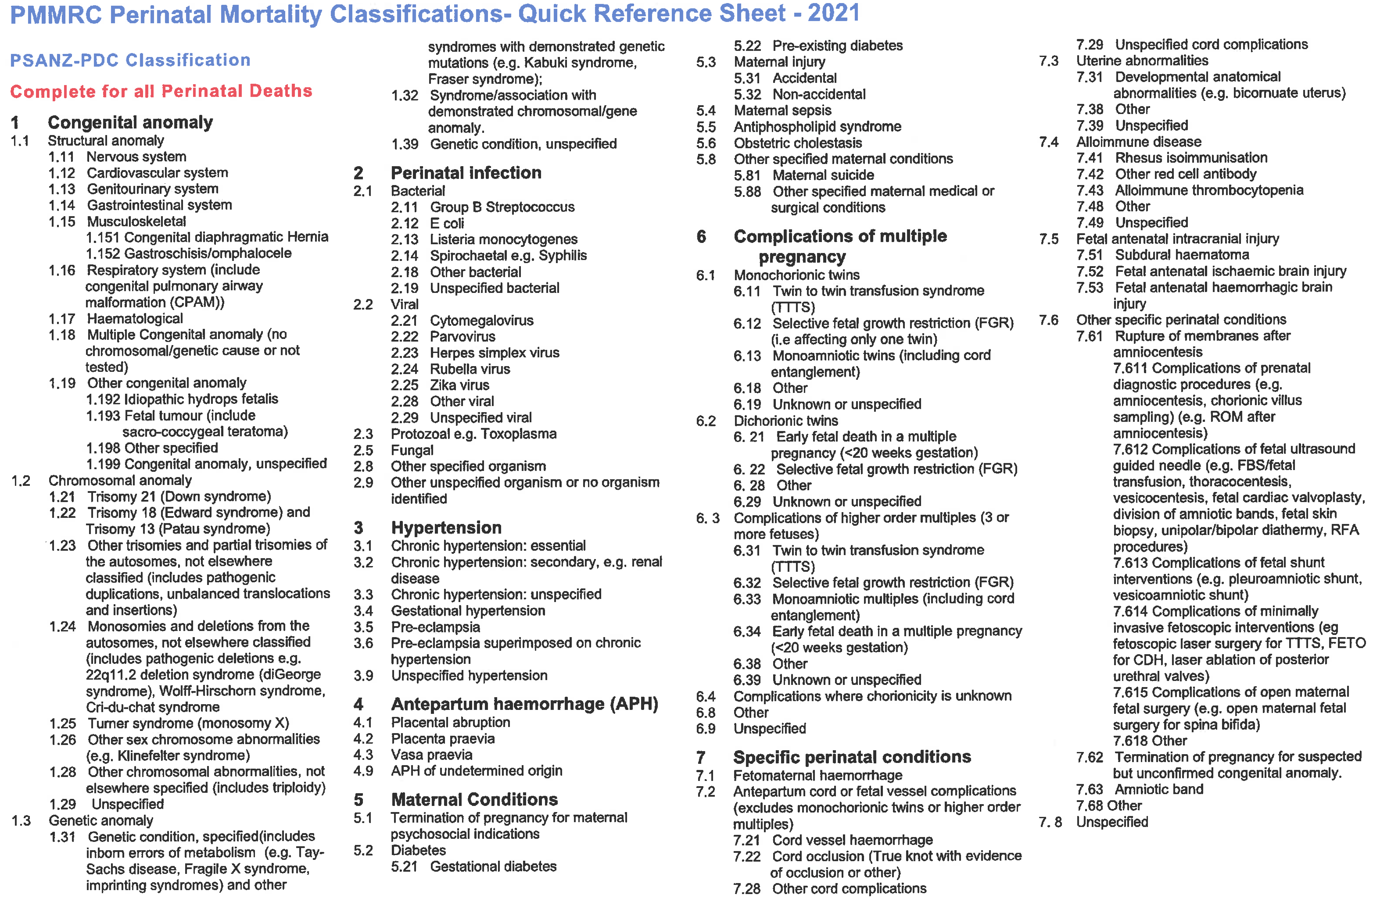
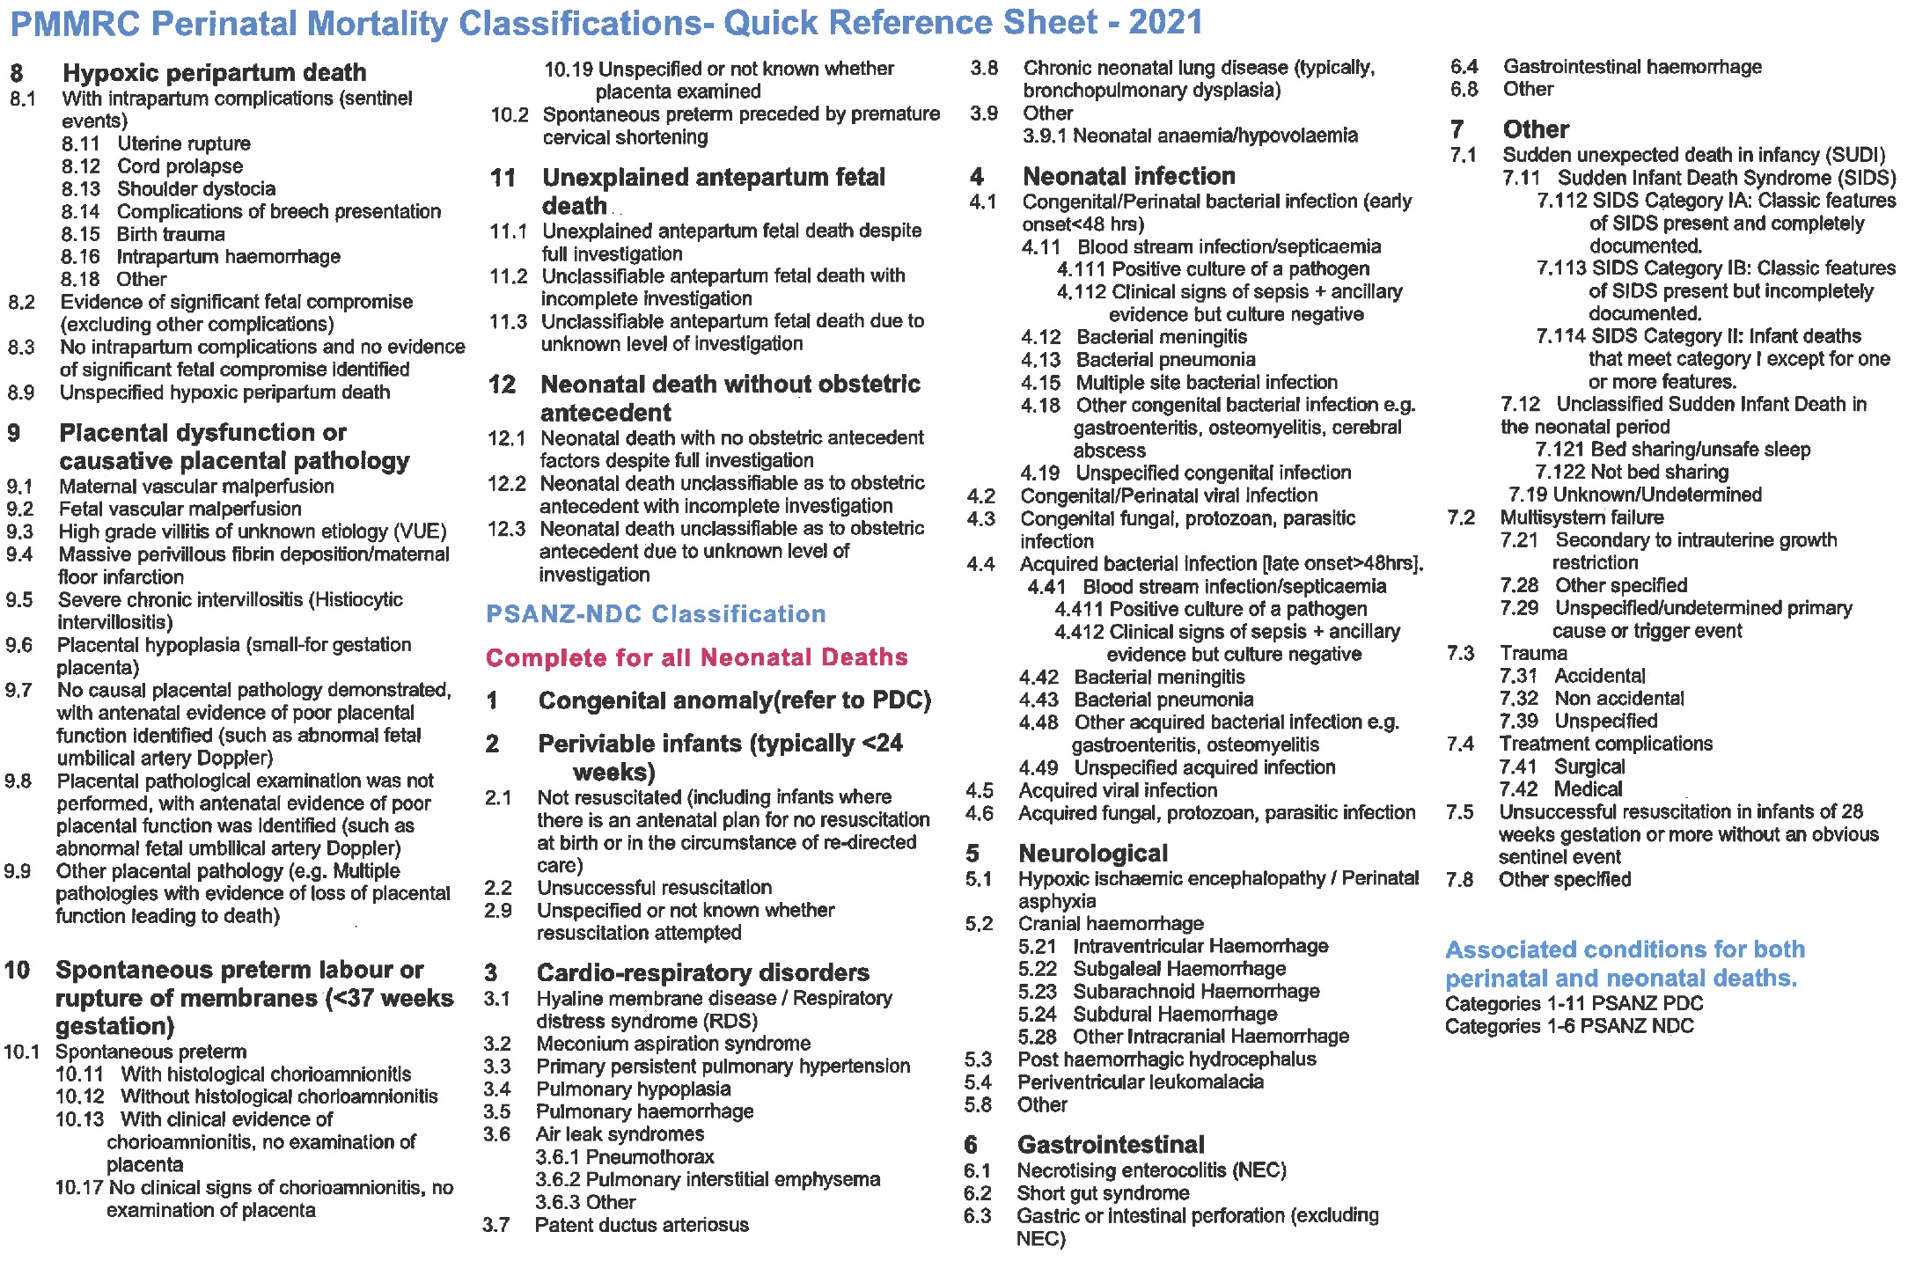

Table 3.16: New Zealand perinatal related mortality rates (per 1,000 births) using the international definition (≥1,000 g or ≥28 weeks if birthweight unknown) 2007–2021
 | n
 | 2007 | 2008 | 2009 | 2010 | 2011 | 2012 | 2013 | 2014 | 2015 | 2016 | 2017 | 2018 | 2019 | 2020 | 2021
Total births | 64,667 | 65,091 | 64,638 | 64,902 | 62,708 | 62,735 | 59,617 | 59,520 | 59,338 | 60,116 | 59,974 | 58,771 | 60,055 | 58,881 | 62,665
Fetal deaths (terminations of pregnancy and stillbirths)† | 211 | 207 | 231 | 199 | 191 | 166 | 155 | 162 | 164 | 171 | 158 | 151 | 155 | 161 | 176
Terminations of pregnancy | 6 | 14 | 9 | 17 | 24 | 13 | 12 | 13 | 7 | 15 | 16 | 7 | 19 | 22 | 30
Stillbirths | 205 | 193 | 222 | 182 | 167 | 153 | 143 | 149 | 157 | 156 | 142 | 144 | 136 | 139 | 146
Early neonatal deaths <7 days | 58 | 67 | 59 | 68 | 65 | 54 | 45 | 59 | 57 | 53 | 46 | 40 | 54 | 49 | 59
Late neonatal deaths 7–27 days | 28 | 35 | 30 | 31 | 18 | 24 | 24 | 23 | 28 | 23 | 22 | 20 | 23 | 20 | 24
Neonatal deaths <28 days# | 86 | 102 | 89 | 99 | 83 | 78 | 69 | 82 | 85 | 76 | 68 | 60 | 77 | 69 | 83
Perinatal mortalities+ | 269 | 274 | 290 | 267 | 256 | 220 | 200 | 221 | 221 | 224 | 204 | 191 | 209 | 210 | 235
Perinatal related mortalities^ | 297 | 309 | 320 | 298 | 274 | 244 | 224 | 244 | 249 | 247 | 226 | 211 | 232 | 230 | 259
Perinatal mortalities excluding lethal and terminated fetal anomalies• | 224 | 215 | 237 | 202 | 179 | 166 | 156 | 167 | 174 | 167 | 156 | 149 | 152 | 166 | 169
Perinatal related mortalities excluding lethal and terminated fetal anomalies• | 238 | 235 | 253 | 219 | 188 | 176 | 167 | 177 | 185 | 180 | 169 | 157 | 164 | 176 | 182
 | Rate |  |  |  |  |  |  |  |  |  |  |  |  |  |  | 2007–2021  Regression  for trend  (95%CI)
 | 2007 | 2008 | 2009 | 2010 | 2011 | 2012 | 2013 | 2014 | 2015 | 2016 | 2017 | 2018 | 2019 | 2020 | 2021
Total births
Fetal deaths (terminations of pregnancy and stillbirths)† | 3.26 | 3.18 | 3.57 | 3.07 | 3.05 | 2.65 | 2.60 | 2.72 | 2.76 | 2.84 | 2.63 | 2.57 | 2.58 | 2.73 | 2.81 | −0.048 **  (−0.075 to −0.021)
Terminations of pregnancy | 0.09 | 0.22 | 0.14 | 0.26 | 0.38 | 0.21 | 0.20 | 0.22 | 0.12 | 0.25 | 0.27 | 0.12 | 0.32 | 0.37 | 0.48 | 0.013 *  (0.001–0.025)
Stillbirths | 3.17 | 2.97 | 3.43 | 2.80 | 2.66 | 2.44 | 2.40 | 2.50 | 2.65 | 2.59 | 2.37 | 2.45 | 2.26 | 2.36 | 2.33 | −0.061 **  (−0.087 to −0.035)
Early neonatal deaths <7 days
Late neonatal deaths 7–27 days
Neonatal deaths <28 days# | 1.33 | 1.57 | 1.38 | 1.53 | 1.33 | 1.25 | 1.16 | 1.38 | 1.44 | 1.27 | 1.14 | 1.02 | 1.29 | 1.18 | 1.33 | −0.019 *  (−0.035 to −0.002)
Perinatal mortalities+ | 4.16 | 4.21 | 4.49 | 4.11 | 4.08 | 3.51 | 3.35 | 3.71 | 3.72 | 3.73 | 3.40 | 3.25 | 3.48 | 3.57 | 3.75 | −0.059 **  (−0.093 to −0.025)
Perinatal related mortalities^ | 4.59 | 4.75 | 4.95 | 4.59 | 4.37 | 3.89 | 3.76 | 4.10 | 4.20 | 4.11 | 3.77 | 3.59 | 3.86 | 3.91 | 4.13 | −0.067 **  (−0.103 to −0.030)
Perinatal mortalities excluding lethal and terminated fetal anomalies• | 3.46 | 3.30 | 3.67 | 3.11 | 2.85 | 2.65 | 2.62 | 2.81 | 2.93 | 2.78 | 2.60 | 2.54 | 2.53 | 2.82 | 2.70 | −0.059 **  (−0.089 to −0.028)
Perinatal related mortalities excluding lethal and terminated fetal anomalies• | 3.68 | 3.61 | 3.91 | 3.37 | 3.00 | 2.81 | 2.80 | 2.97 | 3.12 | 2.99 | 2.82 | 2.67 | 2.73 | 2.99 | 2.90 | −0.063 **  (−0.097 to −0.030)
* p <0.05.
** p <0.01.
† Fetal death rate per 1,000 babies born (includes terminations and stillbirths).
# Neonatal death rate per 1,000 live born babies.
+ Fetal deaths and early neonatal deaths per 1,000 babies born.
^ Fetal deaths and early and late neonatal deaths per 1,000 babies born.
• Lethal and terminated fetal anomalies are all perinatal related deaths with PSANZ-PDC of congenital anomaly, and neonatal deaths with PSANZ-NDC of congenital anomaly.
MAT = National Maternity Collection; NDC = Neonatal Death Classification; PDC = Perinatal Death Classification; PMMRC = Perinatal and Maternal Mortality Review Committee; PSANZ = Perinatal Society of Australia and New Zealand
Sources: Numerator: PMMRC perinatal data extract using the international definition (≥1,000 g or ≥28 weeks if birthweight unknown) 2007–2021; Denominator: MAT births using the international definition (≥1,000 g or ≥28 weeks if birthweight unknown) 2007–2021.

Table 3.17: Perinatal related mortality rates (per 1,000 births) by maternal prioritised ethnic group 2012–2021
Prioritised ethnic group  (maternal) | Total births |  | Fetal deaths |  |  |  |  |  | Neonatal deaths |  |  | Perinatal related deaths (total)
 |  |  | Termination of pregnancy |  |  | Stillbirths
 | N=607,161† |  | n=1,547 |  |  | n=3,077† |  |  | n=1,682 |  |  | n=6,306†
 | N | % | n | % | Rate | n | % | Rate | n | % | Rate | n | % | Rate
Māori | 155,359 | 25.6 | 273 | 17.6 | 1.76 | 814 | 26.5 | 5.24 | 574 | 34.1 | 3.72 | 1,661 | 26.3 | 10.69
Pacific peoples | 62,861 | 10.4 | 114 | 7.4 | 1.81 | 420 | 13.6 | 6.68 | 256 | 15.2 | 4.11 | 790 | 12.5 | 12.57
Asian | 102,613 | 16.9 | 338 | 21.8 | 3.29 | 515 | 16.7 | 5.02 | 244 | 14.5 | 2.40 | 1,097 | 17.4 | 10.69
Indian | 37,125 | 6.1 | 155 | 10.0 | 4.18 | 257 | 8.4 | 6.92 | 123 | 7.3 | 3.35 | 535 | 8.5 | 14.41
Other Asian | 65,488 | 10.8 | 183 | 11.8 | 2.79 | 258 | 8.4 | 3.94 | 121 | 7.2 | 1.86 | 562 | 8.9 | 8.58
MELAA | 14,260 | 2.3 | 40 | 2.6 | 2.81 | 65 | 2.1 | 4.56 | 36 | 2.1 | 2.54 | 141 | 2.2 | 9.89
European | 271,701 | 44.7 | 782 | 50.5 | 2.88 | 1,259 | 40.9 | 4.63 | 571 | 33.9 | 2.12 | 2,612 | 41.4 | 9.61
NZ European | 212,729 | 35.0 | 655 | 42.3 | 3.08 | 1,078 | 35.0 | 5.07 | 515 | 30.6 | 2.44 | 2,248 | 35.6 | 10.57
Other European | 58,972 | 9.7 | 127 | 8.2 | 2.15 | 181 | 5.9 | 3.07 | 56 | 3.3 | 0.95 | 364 | 5.8 | 6.17
† Includes 367 with unknown maternal ethnicity in total births and five with unknown maternal ethnicity in perinatal related deaths (total).
MAT = National Maternity Collection; MELAA = Middle Eastern, Latin American, or African; PMMRC = Perinatal and Maternal Mortality Review Committee.
Sources: Numerator: PMMRC’ perinatal data extract 2012–2021; Denominator: MAT births 2012–2021.
Table 3.18: Perinatal related mortality rates (per 1,000 births) by baby prioritised ethnic group 2012–2021
Prioritised ethnic group  (baby) | Total births |  | Fetal deaths |  |  |  |  |  | Neonatal deaths |  |  | Perinatal related deaths (total)
 |  |  | Termination of pregnancy |  |  | Stillbirths
 | N=607,161† |  | n=1,547† |  |  | n=3,077† |  |  | n=1,682† |  |  | n=6,306†
 | N | % | n | % | Rate | n | % | Rate | n | % | Rate | n | % | Rate
Māori | 172,203 | 28.4 | 365 | 23.6 | 2.12 | 949 | 30.8 | 5.51 | 633 | 37.6 | 3.70 | 1,947 | 30.9 | 11.31
Pacific peoples | 62,148 | 10.2 | 114 | 7.4 | 1.83 | 435 | 14.1 | 7.00 | 269 | 16.0 | 4.37 | 818 | 13.0 | 13.16
Asian | 103,815 | 17.1 | 334 | 21.6 | 3.22 | 528 | 17.2 | 5.09 | 241 | 14.3 | 2.34 | 1,103 | 17.5 | 10.62
Indian | 39,111 | 6.4 | 159 | 10.3 | 4.07 | 268 | 8.7 | 6.85 | 126 | 7.5 | 3.26 | 553 | 8.8 | 14.14
Other Asian | 64,704 | 10.7 | 175 | 11.3 | 2.70 | 260 | 8.4 | 4.02 | 115 | 6.8 | 1.79 | 550 | 8.7 | 8.50
MELAA | 13,814 | 2.3 | 36 | 2.3 | 2.61 | 70 | 2.3 | 5.07 | 41 | 2.4 | 2.99 | 147 | 2.3 | 10.64
European | 248,864 | 41.0 | 696 | 45.0 | 2.80 | 1,092 | 35.5 | 4.39 | 496 | 29.5 | 2.01 | 2,284 | 36.2 | 9.18
NZ European | 198,466 | 32.7 | 628 | 40.6 | 3.16 | 977 | 31.8 | 4.92 | 459 | 27.3 | 2.33 | 2,064 | 32.7 | 10.40
Other European | 50,398 | 8.3 | 68 | 4.4 | 1.35 | 115 | 3.7 | 2.28 | 37 | 2.2 | 0.74 | 220 | 3.5 | 4.37
† Includes 6,317 with unknown baby ethnicity in total births and seven with unknown baby ethnicity in perinatal related deaths (total).
MAT = National Maternity Collection; MELAA = Middle Eastern, Latin American, or African; PMMRC = Perinatal and Maternal Mortality Review Committee.
Sources: Numerator: PMMRC perinatal data extract 2012–2021; Denominator: MAT births 2012–2021.

Table 3.19: Perinatal related mortality rates (per 1,000 births) by maternal prioritised ethnic group† and year 2012–2021
Prioritised  ethnic group  (maternal) | 2012 |  | 2013 |  | 2014 |  | 2015 |  | 2016 |  | 2017 |  | 2018 |  | 2019 |  | 2020 |  | 2021
 | n | N | n | N | n | N | n | N | n | N | n | N | n | N | n | N | n | N | n | N
Māori | 163 | 16,538 | 156 | 15,391 | 166 | 14,966 | 143 | 15,208 | 182 | 15,471 | 154 | 15,374 | 166 | 15,036 | 157 | 15,319 | 166 | 15,548 | 208 | 16,508
Pacific peoples | 94 | 7,084 | 84 | 6,546 | 83 | 6,312 | 71 | 6,196 | 73 | 5,966 | 82 | 6,096 | 72 | 6,100 | 77 | 6,294 | 76 | 6,185 | 78 | 6,082
Asian | 100 | 8,591 | 83 | 8,232 | 95 | 9,364 | 96 | 9,327 | 107 | 10,679 | 121 | 10,712 | 95 | 10,728 | 131 | 11,605 | 134 | 11,523 | 135 | 11,852
Indian | 38 | 2,377 | 37 | 2,444 | 45 | 2,765 | 43 | 3,119 | 53 | 3,508 | 58 | 3,864 | 46 | 4,224 | 69 | 4,634 | 62 | 4,863 | 84 | 5,327
Other Asian | 62 | 6,214 | 46 | 5,788 | 50 | 6,599 | 53 | 6,208 | 54 | 7,171 | 63 | 6,848 | 49 | 6,504 | 62 | 6,971 | 72 | 6,660 | 51 | 6,525
MELAA | 16 | 1,275 | 10 | 1,323 | 15 | 1,307 | 15 | 1,361 | 8 | 1,400 | 17 | 1,566 | 10 | 1,440 | 14 | 1,506 | 16 | 1,408 | 20 | 1,674
European | 296 | 29,760 | 267 | 28,614 | 299 | 28,097 | 253 | 27,668 | 241 | 27,078 | 220 | 26,720 | 261 | 25,980 | 260 | 25,855 | 250 | 24,782 | 265 | 27,147
NZ European | 250 | 23,887 | 230 | 22,738 | 262 | 22,212 | 224 | 21,799 | 208 | 21,267 | 183 | 20,794 | 217 | 20,076 | 224 | 20,045 | 222 | 19,140 | 228 | 20,771
Other European | 46 | 5,873 | 37 | 5,876 | 37 | 5,885 | 29 | 5,869 | 33 | 5,811 | 37 | 5,926 | 44 | 5,904 | 36 | 5,810 | 28 | 5,642 | 37 | 6,376
Prioritised  ethnic group  (maternal) | Rate |  |  |  |  |  |  |  |  |  |  |  |  |  |  |  |  |  |  |  | 2012–2021  Regression  for trend  (95% CI)
 | 2012 |  | 2013 |  | 2014 |  | 2015 |  | 2016 |  | 2017 |  | 2018 |  | 2019 |  | 2020 |  | 2021
Māori | 9.86 |  | 10.14 |  | 11.09 |  | 9.40 |  | 11.76 |  | 10.02 |  | 11.04 |  | 10.25 |  | 10.68 |  | 12.60 |  | 0.166  (−0.056–0.388)
Pacific peoples | 13.27 |  | 12.83 |  | 13.15 |  | 11.46 |  | 12.24 |  | 13.45 |  | 11.80 |  | 12.23 |  | 12.29 |  | 12.82 |  | −0.061  (−0.231–0.108)
Asian | 11.64 |  | 10.08 |  | 10.15 |  | 10.29 |  | 10.02 |  | 11.30 |  | 8.86 |  | 11.29 |  | 11.63 |  | 11.39 |  | 0.068  (−0.173–0.310)
Indian | 15.99 |  | 15.14 |  | 16.27 |  | 13.79 |  | 15.11 |  | 15.01 |  | 10.89 |  | 14.89 |  | 12.75 |  | 15.77 |  | −0.208  (−0.621–0.204)
Other Asian | 9.98 |  | 7.95 |  | 7.58 |  | 8.54 |  | 7.53 |  | 9.20 |  | 7.53 |  | 8.89 |  | 10.81 |  | 7.82 |  | 0.035  (−0.269–0.340)
MELAA | 12.55 |  | 7.56 |  | 11.48 |  | 11.02 |  | 5.71 |  | 10.86 |  | 6.94 |  | 9.30 |  | 11.36 |  | 11.95 |  | 0.020  (−0.616–0.655)
European | 9.95 |  | 9.33 |  | 10.64 |  | 9.14 |  | 8.90 |  | 8.23 |  | 10.05 |  | 10.06 |  | 10.09 |  | 9.76 |  | 0.017  (−0.174–0.207)
NZ European | 10.47 |  | 10.12 |  | 11.80 |  | 10.28 |  | 9.78 |  | 8.80 |  | 10.81 |  | 11.17 |  | 11.60 |  | 10.98 |  | 0.076  (−0.157–0.309)
Other European | 7.83 |  | 6.30 |  | 6.29 |  | 4.94 |  | 5.68 |  | 6.24 |  | 7.45 |  | 6.20 |  | 4.96 |  | 5.80 |  | −0.121  (−0.351–0.109)
† Excludes 367 with unknown maternal ethnicity in total births and five with unknown maternal ethnicity in perinatal related deaths (total).
CI = confidence interval; MAT = National Maternity Collection; MELAA = Middle Eastern, Latin American, or African; PMMRC = Perinatal and Maternal Mortality Review Committee.
Sources: Numerator: PMMRC perinatal data extract 2012–2021; Denominator: MAT births 2012–2021.
Table 3.20: Perinatal related mortality rates (per 1,000 births) by maternal age 2012–2021
Maternal age  (years) | Total births |  | Fetal deaths |  |  |  |  |  | Neonatal deaths |  |  | Perinatal related deaths (total)
 |  |  | Termination of pregnancy |  |  | Stillbirths
 | N=607,161 |  | n=1,547 |  |  | n=3,077 |  |  | n=1,682 |  |  | n=6,306
 | N | % | n | % | Rate | n | % | Rate | n | % | Rate | n | % | Rate
<20 | 26,154 | 4.3 | 84 | 5.4 | 3.21 | 200 | 6.5 | 7.65 | 151 | 9.0 | 5.84 | 435 | 6.9 | 16.63
20–24 | 96,902 | 16.0 | 207 | 13.4 | 2.14 | 560 | 18.2 | 5.78 | 363 | 21.6 | 3.78 | 1,130 | 17.9 | 11.66
25–29 | 163,942 | 27.0 | 360 | 23.3 | 2.20 | 731 | 23.8 | 4.46 | 422 | 25.1 | 2.59 | 1,513 | 24.0 | 9.23
30–34 | 190,438 | 31.4 | 485 | 31.4 | 2.55 | 861 | 28.0 | 4.52 | 423 | 25.1 | 2.24 | 1,769 | 28.1 | 9.29
35–39 | 104,253 | 17.2 | 311 | 20.1 | 2.98 | 531 | 17.3 | 5.09 | 247 | 14.7 | 2.39 | 1,089 | 17.3 | 10.45
≥40 | 25,313 | 4.2 | 100 | 6.5 | 3.95 | 190 | 6.2 | 7.51 | 76 | 4.5 | 3.04 | 366 | 5.8 | 14.46
Unknown | 159 | 0.0 | - | - | - | 4 | 0.1 | - | - | - | - | 4 | 0.1 | -
MAT = National Maternity Collection; PMMRC = Perinatal and Maternal Mortality Review Committee.
Sources: Numerator: PMMRC perinatal data extract 2012–2021; Denominator: MAT births 2012–2021.

Table 3.21: Perinatal related mortality rates (per 1,000 births) by DHB of maternal residence 2012–2021
DHB of maternal residence | Total births |  | Fetal deaths |  |  |  |  |  | Neonatal deaths |  |  | Perinatal related deaths (total)
 |  |  | Termination of pregnancy |  |  | Stillbirths
 | N=607,161 |  | n=1,547 |  |  | n=3,077 |  |  | n=1,682 |  |  | n=6,306
 | N | % | n | % | Rate | n | % | Rate | n | % | Rate | n | % | Rate
Northland | 22,777 | 3.8 | 66 | 4.3 | 2.90 | 154 | 5.0 | 6.76 | 78 | 4.6 | 3.46 | 298 | 4.7 | 13.08
Waitematā | 78,296 | 12.9 | 256 | 16.5 | 3.27 | 336 | 10.9 | 4.29 | 143 | 8.5 | 1.84 | 735 | 11.7 | 9.39
Auckland | 58,996 | 9.7 | 197 | 12.7 | 3.34 | 252 | 8.2 | 4.27 | 143 | 8.5 | 2.44 | 592 | 9.4 | 10.03
Counties Manukau | 84,810 | 14.0 | 237 | 15.3 | 2.79 | 540 | 17.5 | 6.37 | 354 | 21.0 | 4.21 | 1,131 | 17.9 | 13.34
Waikato | 55,009 | 9.1 | 136 | 8.8 | 2.47 | 300 | 9.7 | 5.45 | 172 | 10.2 | 3.15 | 608 | 9.6 | 11.05
Bay of Plenty | 30,328 | 5.0 | 57 | 3.7 | 1.88 | 166 | 5.4 | 5.47 | 100 | 5.9 | 3.32 | 323 | 5.1 | 10.65
Lakes | 15,298 | 2.5 | 42 | 2.7 | 2.75 | 78 | 2.5 | 5.10 | 42 | 2.5 | 2.77 | 162 | 2.6 | 10.59
​Hauora Tairāwhiti | 7,313 | 1.2 | 11 | 0.7 | 1.50 | 39 | 1.3 | 5.33 | 25 | 1.5 | 3.44 | 75 | 1.2 | 10.26
Taranaki | 15,294 | 2.5 | 30 | 1.9 | 1.96 | 68 | 2.2 | 4.45 | 57 | 3.4 | 3.75 | 155 | 2.5 | 10.13
Hawke’s Bay | 21,414 | 3.5 | 44 | 2.8 | 2.05 | 109 | 3.5 | 5.09 | 48 | 2.9 | 2.26 | 201 | 3.2 | 9.39
Whanganui | 8,384 | 1.4 | 13 | 0.8 | 1.55 | 49 | 1.6 | 5.84 | 25 | 1.5 | 3.00 | 87 | 1.4 | 10.38
MidCentral | 21,761 | 3.6 | 60 | 3.9 | 2.76 | 88 | 2.9 | 4.04 | 64 | 3.8 | 2.96 | 212 | 3.4 | 9.74
Wairarapa | 5,110 | 0.8 | 7 | 0.5 | 1.37 | 39 | 1.3 | 7.63 | 12 | 0.7 | 2.37 | 58 | 0.9 | 11.35
Capital & Coast | 34,798 | 5.7 | 64 | 4.1 | 1.84 | 161 | 5.2 | 4.63 | 86 | 5.1 | 2.49 | 311 | 4.9 | 8.94
Hutt Valley | 19,878 | 3.3 | 30 | 1.9 | 1.51 | 96 | 3.1 | 4.83 | 49 | 2.9 | 2.48 | 175 | 2.8 | 8.80
Nelson Marlborough | 14,973 | 2.5 | 32 | 2.1 | 2.14 | 56 | 1.8 | 3.74 | 37 | 2.2 | 2.49 | 125 | 2.0 | 8.35
West Coast | 3,506 | 0.6 | 7 | 0.5 | 2.00 | 30 | 1.0 | 8.56 | 11 | 0.7 | 3.17 | 48 | 0.8 | 13.69
Canterbury | 63,262 | 10.4 | 160 | 10.3 | 2.53 | 300 | 9.7 | 4.74 | 138 | 8.2 | 2.20 | 598 | 9.5 | 9.45
South Canterbury | 6,431 | 1.1 | 15 | 1.0 | 2.33 | 26 | 0.8 | 4.04 | 19 | 1.1 | 2.97 | 60 | 1.0 | 9.33
Southern | 34,466 | 5.7 | 80 | 5.2 | 2.32 | 182 | 5.9 | 5.28 | 67 | 4.0 | 1.96 | 329 | 5.2 | 9.55
Other† | 5,057 | 0.8 | 3 | 0.2 | - | 8 | 0.3 | - | 12 | 0.7 | - | 23 | 0.4 | -
Total | 607,161 | 100.0 | 1,547 | 100.0 | 2.55 | 3,077 | 100.0 | 5.07 | 1,682 | 100.0 | 2.79 | 6,306 | 100.0 | 10.39
† Other includes overseas, unknown and other.
DHB = district health board; MAT = National Maternity Collection; PMMRC = Perinatal and Maternal Mortality Review Committee.
Sources: Numerator: PMMRC perinatal data extract 2012–2021; Denominator: MAT births 2012–2021.

Table 3.22: Perinatal related mortality rates (per 1,000 births) by gestation and birthweight 2021
 | Total births |  | Fetal deaths |  |  |  |  |  | Neonatal deaths |  |  | Perinatal related deaths (total)
 |  |  | Termination of pregnancy |  |  | Stillbirths
 | N=63,296 |  | n=205 |  |  | n=311 |  |  | n=191 |  |  | n=707
 | N | % | n | % | Rate | n | % | Rate | n | % | Rate | n | % | Rate
Gestation at birth (weeks)
20–22 | 252 | 0.4 | 113 | 55.1 | † | 102 | 32.8 | † | 47 | 24.6 | † | 262 | 37.1 | †
23–24 | 135 | 0.2 | 38 | 18.5 | 281.48 | 20 | 6.4 | 148.15 | 39 | 20.4 | 506.49 | 97 | 13.7 | 718.52
25–27 | 254 | 0.4 | 30 | 14.6 | 118.11 | 25 | 8.0 | 98.43 | 21 | 11.0 | 105.53 | 76 | 10.7 | 299.21
28–31 | 531 | 0.8 | 15 | 7.3 | 28.25 | 42 | 13.5 | 79.10 | 11 | 5.8 | 23.21 | 68 | 9.6 | 128.06
32–36 | 4,074 | 6.4 | 8 | 3.9 | 1.96 | 54 | 17.4 | 13.25 | 22 | 11.5 | 5.48 | 84 | 11.9 | 20.62
37–40 | 48,823 | 77.1 | <3 | x | s | 50 | 16.1 | 1.02 | 47 | 24.6 | 0.96 | 98 | 13.9 | 2.01
≥41 | 8,723 | 13.8 | - | - | - | 14 | 4.5 | 1.60 | <3 | x | s | 16 | 2.3 | 1.83
Unknown | 504 | 0.8 | - | - | - | 4 | 1.3 | - | <3 | x | s | 6 | 0.8 | -
Birthweight (g)
<500 | 260 | 0.4 | 108 | 52.7 | † | 109 | 35.0 | † | 50 | 26.2 | † | 267 | 37.8 | †
500–999 | 366 | 0.6 | 67 | 32.7 | 183.06 | 55 | 17.7 | 150.27 | 58 | 30.4 | 237.70 | 180 | 25.5 | 491.80
1,000–1,499 | 377 | 0.6 | 14 | 6.8 | 37.14 | 32 | 10.3 | 84.88 | 8 | 4.2 | 24.17 | 54 | 7.6 | 143.24
1,500–1,999 | 776 | 1.2 | 9 | 4.4 | 11.60 | 15 | 4.8 | 19.33 | 11 | 5.8 | 14.63 | 35 | 5.0 | 45.10
2,000–2,499 | 2,420 | 3.8 | 3 | 1.5 | 1.24 | 19 | 6.1 | 7.85 | 9 | 4.7 | 3.75 | 31 | 4.4 | 12.81
2,500–2,999 | 8,585 | 13.6 | <3 | x | s | 23 | 7.4 | 2.68 | 17 | 8.9 | 1.99 | 41 | 5.8 | 4.78
3,000–3,499 | 19,581 | 30.9 | <3 | x | s | 33 | 10.6 | 1.69 | 22 | 11.5 | 1.13 | 56 | 7.9 | 2.86
3,500–3,999 | 18,452 | 29.2 | <3 | x | s | 15 | 4.8 | 0.81 | 10 | 5.2 | 0.54 | 26 | 3.7 | 1.41
4,000–4,499 | 7,166 | 11.3 | - | - | - | 5 | 1.6 | 0.70 | 5 | 2.6 | 0.70 | 10 | 1.4 | 1.40
≥4,500 | 1,517 | 2.4 | - | - | - | <3 | x | s | <3 | x | s | 3 | 0.4 | 1.98
Unknown | 3,796 | 6.0 | <3 | x | s | 3 | 1.0 | - | - | - | - | 4 | 0.6 | -
x = percentage suppressed due to small numbers.
‘s’ = rate suppressed due to small numbers.
† Denominator data unreliable where present so rates have not been calculated.
MAT = National Maternity Collection; PMMRC = Perinatal and Maternal Mortality Review Committee; Sources: Numerator: PMMRC perinatal data extract 2021; Denominator: MAT births 2021.

Te māuiui roro I ngā pēpi whānau hou | Neonatal encephalopathy

Introduction
Neonatal encephalopathy (NE) is a clinically defined syndrome of disturbed neurological function within the first week after birth in an infant born from 35 weeks’ gestation.
- Clinical features: difficulty initiating and maintaining respiration, depression of tone and reflexes, subnormal level of consciousness and often seizures.
- Severity of the encephalopathy is measured by the Sarnat stages: 1 – mild, 2 – moderate, 3 – severe.

Key findings
- In the 2016–2021 period (with ≥35-week gestations included), there is some evidence of a small increase in the rates of NE in Aotearoa.
- Babies born to those recorded as ‘other European’ continued to have the lowest rates of NE.
- The incidence of NE is greater at earlier gestations, for babies defined as SGA and for babies whose parents lived rurally or were having their first baby.
- Cooling therapy was provided to 78.1% of babies with NE, 76.5% within the optimal 6-hour period.
- Of babies with moderate NE, 14.8% did not receive an MRI over the 2017–2021 period. Māori were the least likely ethnic group to receive an MRI.
A diagnosis of NE and the severe morbidity it entails for their baby can be potentially devastating for a family. Between 2016 and 2021, 375 families received a diagnosis of NE. Although some babies do well, others may experience long-term impacts. There is likely trauma and shock and many ‘unknowns’ – this is not what a family and whānau hoped for or expected. Bonding may be impaired due to initial treatment, management and interventions directly following birth, in the weeks after and possibly long term, on top of fear associated with this outcome. Parents report that clear and consistent communication and opportunities to participate in their child’s clinical care assist with working through the initial acute period. Alongside this, clear planning and support for ongoing care and interactions with health and social services is required. The impact on families cannot be underestimated. Little or no research exists about the cultural context of families experiencing an NE diagnosis in Aotearoa, and this needs to be explored alongside clinical treatments and interventions.
The National Mortality Review Committee collects data on babies who present with moderate or severe NE in the first 7 days after birth. Data have been collected on babies with NE from 37 weeks’ gestation onwards since 2010, following establishment of this monitoring work by the former PMMRC and its NE working group. In 2016, because of a change in the international definition of hypoxic ischaemic encephalopathy, which included 35 and 36 weeks’ gestation, the collection was expanded to include data on babies from 35 weeks’ gestation. Therefore, this report now encompasses babies born at 35 weeks’ gestation onwards. The majority of the following figures and tables report findings from the most recent 5-year period.
Figure 4.1: Neonatal encephalopathy annual and 3-year rolling rates† (per 1,000 term births 2010–2021 and all births ≥35 weeks’ gestation annual rate from 2016)
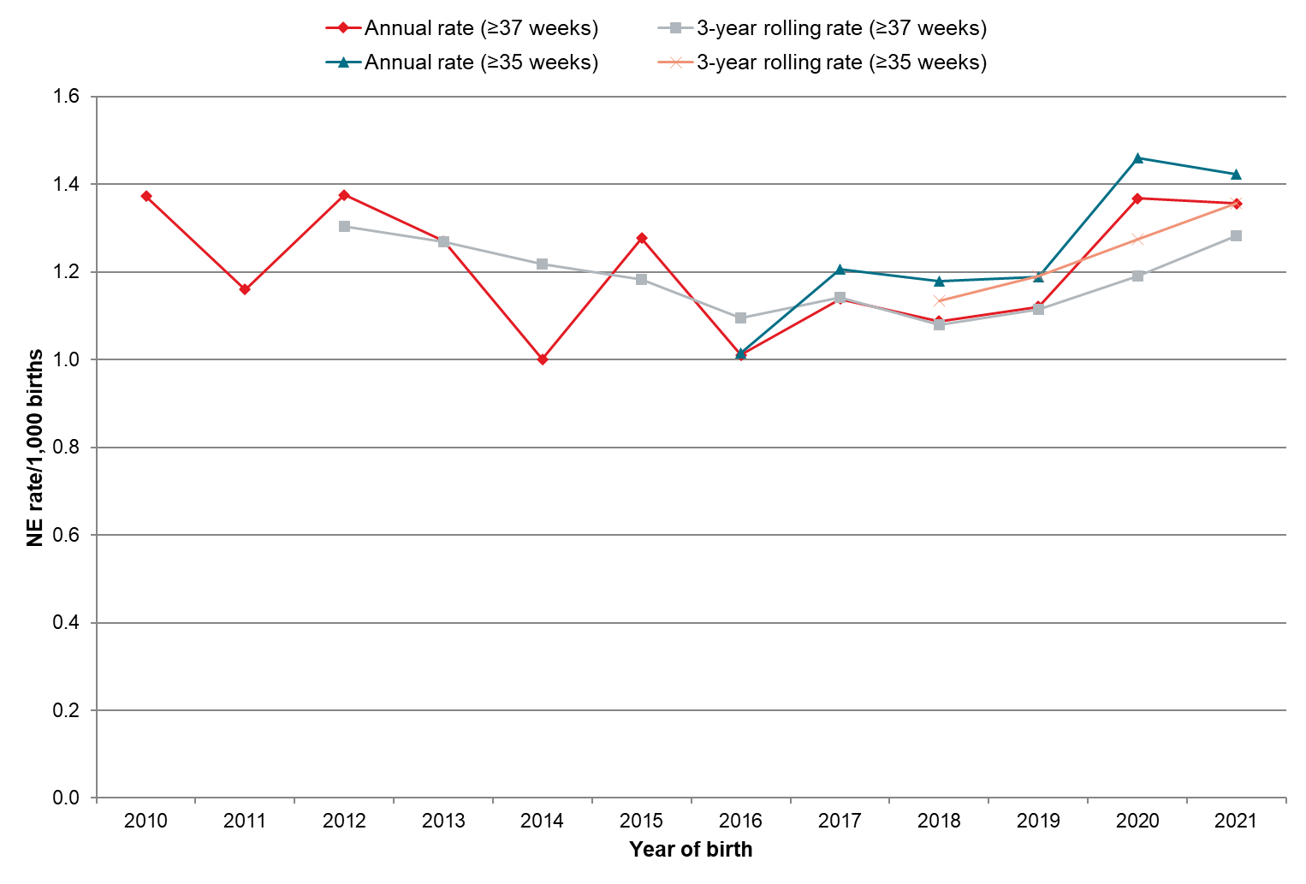
†Rolling 3-year maternal mortality ratio represented at final year of triennium.
MAT = National Maternity Collection; NE = neonatal encephalopathy; PMMRC = Perinatal and Maternal Mortality Review Committee.
Sources: Numerator: PMMRC NE data extract ≥37 weeks 2010–2021 and ≥35 weeks 2016–2021; Denominator: MAT births ≥37 weeks 2010–2021 and ≥35 weeks 2016–2021.

International comparisons
A previous meta-analysis estimated the NE incidence in high-income regions to be 1.6 per 1,000 live births, with some potential variation due to definitions. The Aotearoa rate for babies with NE ≥35 weeks’ gestation of 1.25 per 1,000 live births over the period 2017–2021 is therefore within the range experienced by other high-income regions internationally, from available reporting. Comparison between NE rates in Aotearoa and those of other countries is problematic because of differences in definitions of terms, inclusion and exclusion criteria and data quality issues.

Findings
For the 2016–2021 period (with ≥35-week gestations included), there is some evidence of a small increase in the rates of NE, with a higher rate of 1.46 in 2020 (Figure 4.1). This finding could be explained by improved detection after the implementation of the national NE consensus statement in 2019, but it is impossible to make this attribution without audit or research of the national clinical implementation of this guidance.
Although the incidence of NE did not differ significantly between ethnic groups, babies born to those recorded as ‘other European’ continued to have the lowest rates (Figure 4.2 and Table 4.2), as found in multiple previous PMMRC reports.
Figure 4.2: Neonatal encephalopathy rates (per 1,000 births at ≥35 weeks’ gestation, with 95% confidence intervals) by maternal prioritised ethnic group 2017–2021
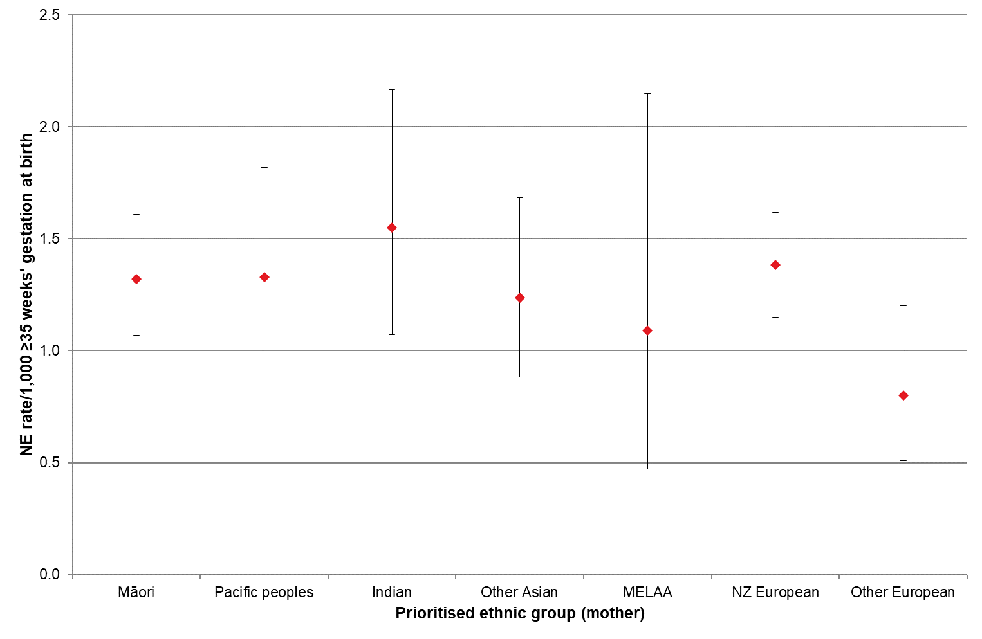
MAT = National Maternity Collection; MELAA = Middle Eastern, Latin American, or African; NE = neonatal encephalopathy; PMMRC = Perinatal and Maternal Mortality Review Committee.
Sources: Numerator: PMMRC NE data extract ≥35 weeks 2017–2021; Denominator: MAT births ≥35 weeks 2017–2021.

Babies born into families living in NZDep quintiles 4 and particularly quintile 5 were more likely to develop NE than those living in quintile 1; however, CIs are broad and overlapping (Figure 4.3 and Table 4.2).
Figure 4.3: Neonatal encephalopathy rates (per 1,000 births at ≥35 weeks’ gestation, with 95% confidence intervals) by NZDep quintile 2017–2021
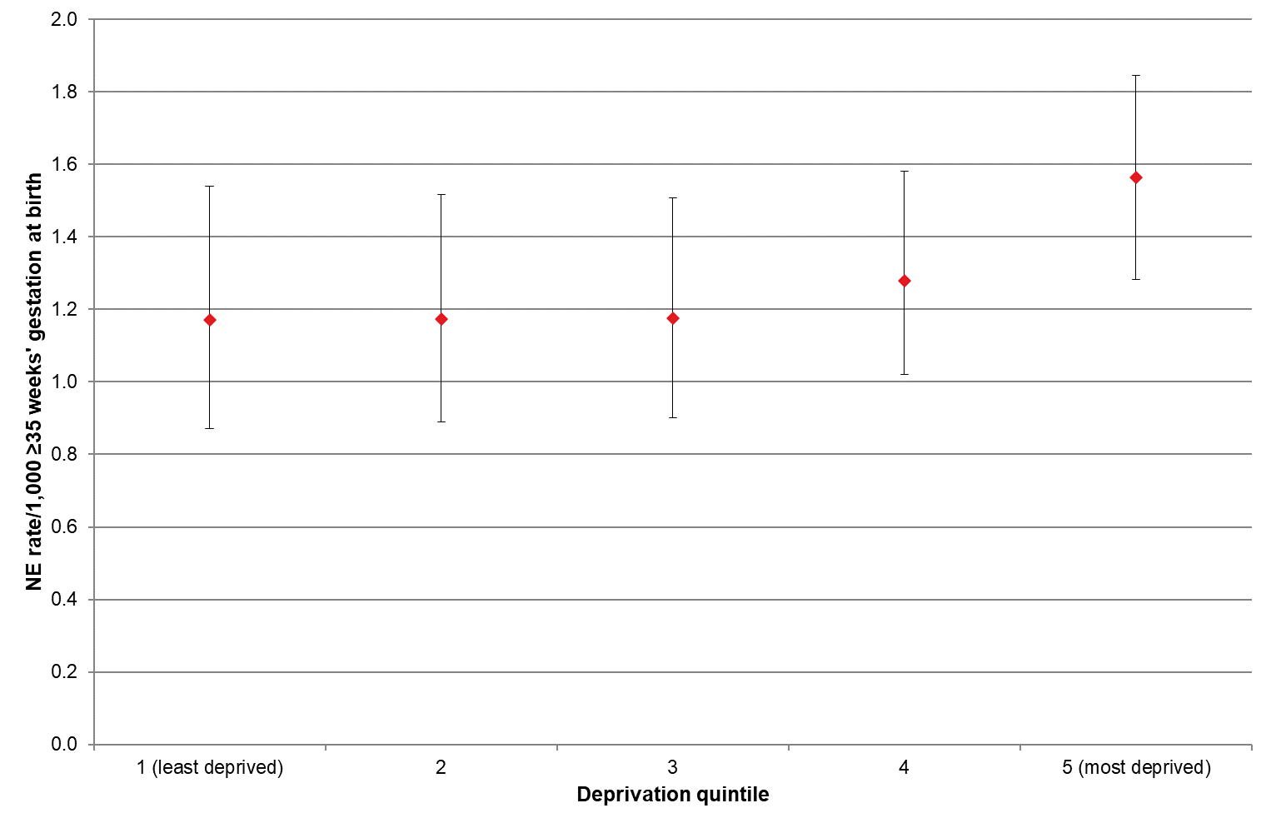
MAT = National Maternity Collection; NE = neonatal encephalopathy; PMMRC = Perinatal and Maternal Mortality Review Committee.
Sources: Numerator: PMMRC NE data extract ≥35 weeks 2017–2021; Denominator: MAT births ≥35 weeks 2017–2021.

NE rates vary by DHB region and, due to broad CIs, most encompass the national rate of 1.29 per 1,000 ≥35 weeks’ gestation births.
Regional variation has been noted in international NE research in relation to use of inconsistent definitions and outcome rankings. National NE guidelines were introduced in 2019; with standardised diagnoses and management, we would expect to see less variation in outcomes.
Only ongoing national audit of how NE diagnosis and treatment are applied regionally would confirm this.
Figure 4.4: Neonatal encephalopathy rates (per 1,000 births at ≥35 weeks’ gestation, with 95% confidence intervals) by DHB of maternal residence (compared with all of New Zealand neonatal encephalopathy rate) 2017–2021
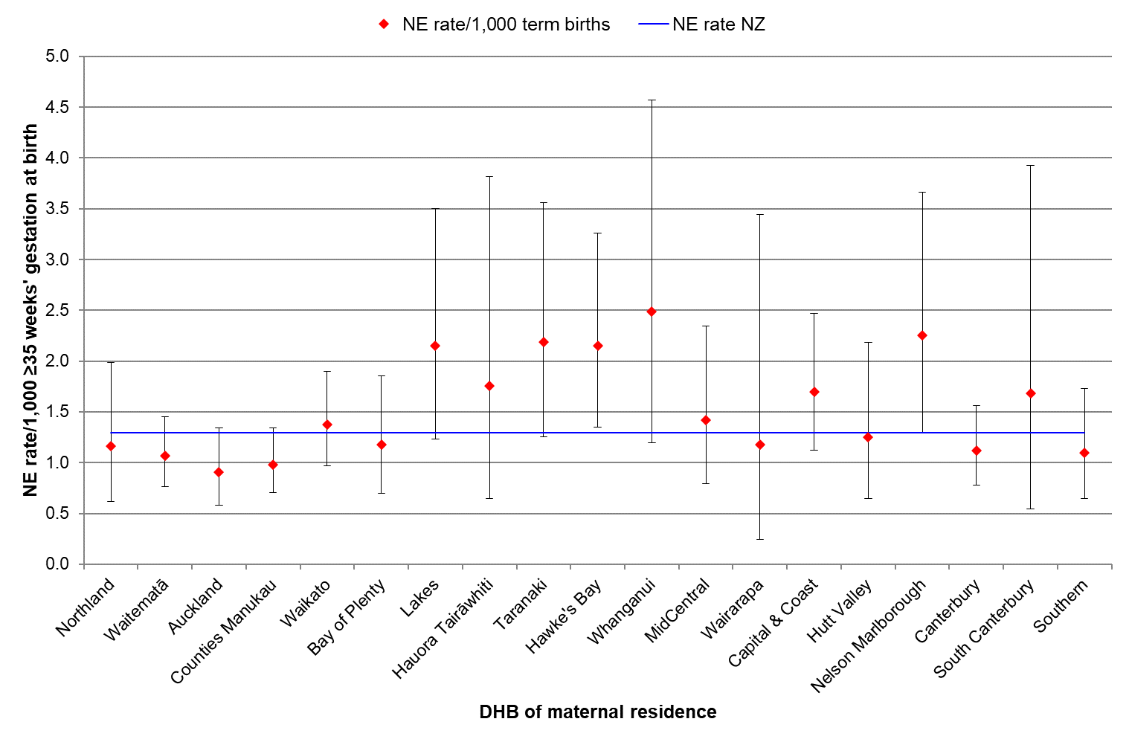
Note: Rates for the West Coast DHB are suppressed because of small numbers.
DHB = district health board; MAT = National Maternity Collection; NE = neonatal encephalopathy; PMMRC = Perinatal and Maternal Mortality Review Committee.
Sources: Numerator: PMMRC NE data extract ≥35 weeks 2017–2021; Denominator: MAT births ≥35 weeks 2017–2021.

As in past reports, the incidence of NE is greater at earlier gestations and rises slightly again at 41 weeks. Numbers of births beyond 41 weeks are much lower, so it is difficult to assess significance at those gestations (Table 4.1 and Figure 4.5). These findings are likely to be compounded by varying complexities and issues that may occur for both babies born preterm (before 37 weeks) and babies born post-term (beyond 42 weeks).
Figure 4.5: Neonatal encephalopathy rates by gestation (per 1,000 births at ≥35 weeks’ gestation with 95% confidence intervals) 2017–2021
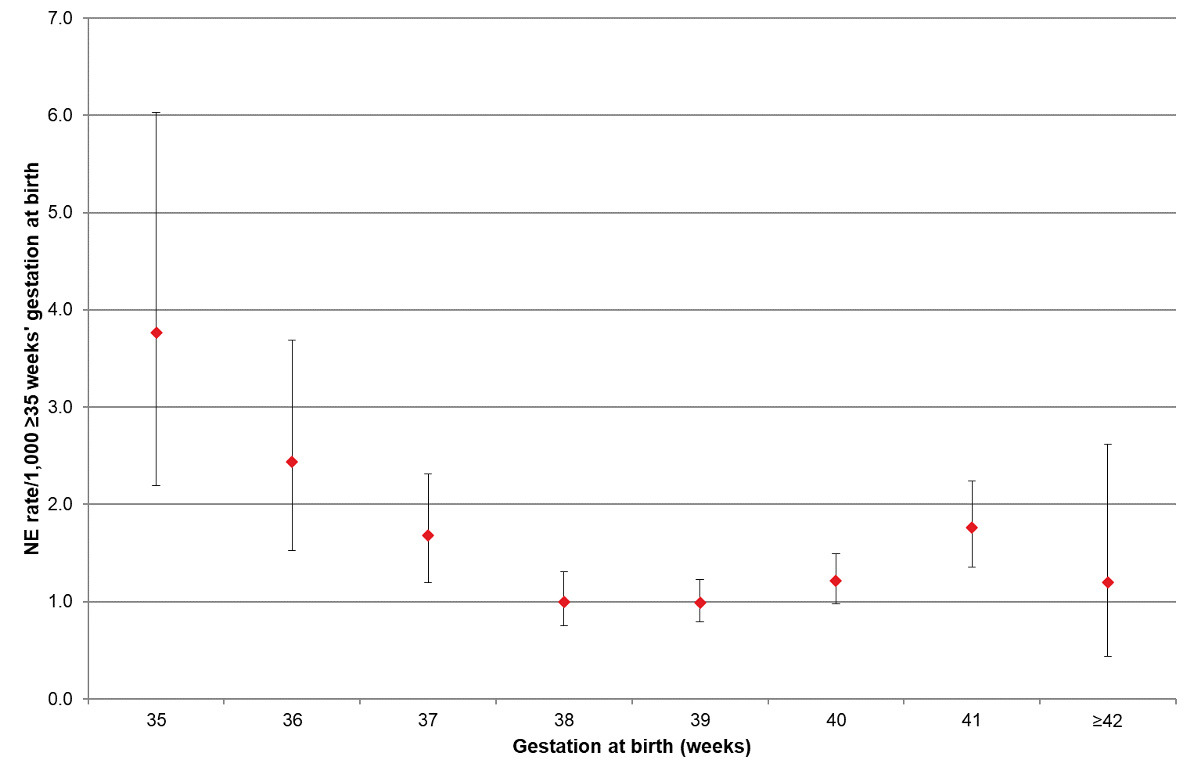
MAT = National Maternity Collection; NE = neonatal encephalopathy; PMMRC = Perinatal and Maternal Mortality Review Committee.
Sources: Numerator: PMMRC NE data extract ≥35 weeks 2017–2021; Denominator: MAT births ≥35 weeks 2017–2021.

Some further characteristics of babies born with NE are shown in Table 4.1. Gestational age and birthweight and the birthweight centiles of babies with NE were significantly different from those in the general birthing population.
Consistent with previous reports, babies with lower or higher birthweight (under 2,500 g and ≥4,500 g) had higher rates of NE. Babies who were multiples had a slightly lower incidence rate than singletons, a change from previous reports. However, numbers were very small, and there was no discernible evidence of difference. Any difference between assigned sex of babies with NE was unremarkable.

Table 4.1: Neonatal encephalopathy rates (per 1,000 births at ≥35 weeks’ gestation) by gestation, sex, birthweight and plurality 2017–2021
 | MAT births  ≥35 weeks |  | NE babies |  | Rate  (per 1,000 births at  ≥35 weeks' gestation) |  | RR | 95% CI | Chi-squared  test  (p)
 | N=290,184 |  | n=375
 | N | % | n | % | /1,000 | 95% CI
Gestation at birth (weeks)
35 | 4,516 | 1.6 | 17 | 4.5 | 3.76 | 2.19–6.03 | 3.80 | 2.26–6.39 | <0.001
36 | 9,032 | 3.1 | 22 | 5.9 | 2.44 | 1.53–3.69 | 2.46 | 1.54–3.93
37 | 22,562 | 7.8 | 38 | 10.1 | 1.68 | 1.19–2.31 | 1.70 | 1.16–2.49
38 | 53,034 | 18.3 | 53 | 14.1 | 1.00 | 0.75–1.31 | 1.01 | 0.72–1.42
39 | 85,775 | 29.6 | 85 | 22.7 | 0.99 | 0.79–1.23 | 1.00 | -
40 | 73,348 | 25.3 | 89 | 23.7 | 1.21 | 0.97–1.49 | 1.22 | 0.91–1.65
41 | 36,926 | 12.7 | 65 | 17.3 | 1.76 | 1.36–2.24 | 1.78 | 1.29–2.45
≥42 | 4,991 | 1.7 | 6 | 1.6 | 1.20 | 0.44–2.62 | 1.21 | 0.53–2.77
Sex
Male | 148,410 | 51.1 | 197 | 52.5 | 1.33 | 1.14–1.51 | 1.06 | 0.86–1.29 | 0.60
Female | 141,671 | 48.8 | 178 | 47.5 | 1.26 | 1.07–1.44 | 1.00 | -
Undetermined/unknown | 103 | 0.0 | - | - | - | - |  | -
Birthweight (g) |  |  |  |  |  |  | 1.00
<2,500 | 10,089 | 3.5 | 29 | 7.7 | 2.87 | 1.93–4.13 | 2.25 | 1.54–3.30 | <0.001
2,500–3,999 | 225,857 | 77.8 | 288 | 76.8 | 1.28 | 1.13–1.42 | 1.00 | -
4,000–4,499 | 33,388 | 11.5 | 39 | 10.4 | 1.17 | 0.83–1.60 | 0.92 | 0.66–1.28
≥4,500 | 6,850 | 2.4 | 19 | 5.1 | 2.77 | 1.67–4.33 | 2.18 | 1.37–3.46
Unknown | 14,000 | 4.8 | - | - | - | - |  | -
Plurality
Singleton | 282,343 | 97.3 | 369 | 98.4 | 1.31 | 1.17–1.44 | 1.00 | - | 0.66
Multiple | 5,504 | 1.9 | 6 | 1.6 | 1.09 | 0.40–2.37 | 0.83 | 0.37–1.87
Unknown | 2,337 | 0.8 | - | - | - | - |  | -
Customised birthweight centiles
Small for gestational age | 25,155 | 8.7 | 87 | 23.2 | 3.46 | 2.77–4.27 | 2.82 | 2.20–3.60 | <0.001
Appropriate for gestational age | 197,837 | 68.2 | 243 | 64.8 | 1.23 | 1.07–1.38 | 1.00 | -
Large for gestational age | 33,817 | 11.7 | 45 | 12.0 | 1.33 | 0.97–1.78 | 1.08 | 0.79–1.49
Unknown | 33,375 | 11.5 | - | - | - | - |  | -
CI = confidence interval; MAT = National Maternity Collection; NE = neonatal encephalopathy; PMMRC = Perinatal and Maternal Mortality Review Committee; RR = relative rate.
Sources: Numerator: PMMRC's NE data extract ≥35 weeks 2017–2021; Denominator: MAT births ≥35 weeks 2017–2021

Between 2017 and 2021, babies of ≥35 weeks’ gestation who were SGA were 2.8 times more likely to have moderate to severe NE than babies who were the appropriate size for their gestational age. SGA is a risk for NE, and this finding supports the national guidance regarding detection and management of SGA babies described below.
The Accident Compensation Corporation (ACC) has funded the implementation of GROW 2.0 in association with national ‘small for gestational age/fetal growth restriction’ guidelines as part of its NE prevention programme; however, full implementation was rolled out in 2023, so these were not in place at the time of data collection for this report. The National Mortality Review Committee neonatal encephalopathy subject matter experts anticipate that ongoing surveillance and evaluation of the effectiveness of this programme will follow once it has been fully embedded throughout Aotearoa.
It should also be noted that SGA as described in this report was diagnosed after the birth, and it is unknown whether or not growth issues were detected antenatally. Therefore, the effectiveness or implementation of tools such as GROW in regard to SGA and NE cannot be assessed within the limits of this report.
Table 4.2 outlines the characteristics of women and birthing people for the whole population and for those whose babies were diagnosed with NE. As discussed in the perinatal chapter and in the Methods and Definitions for Perinatal and Maternal Mortality Review Committee Reporting document, these data are not limited to those who were registered for care with an LMC (a midwife, obstetrician or general practitioner) claiming from the former Section 88 Primary Maternity Services Notice (now section 94 of the Pae Ora Act) as it was in past reports. This is because of the reducing LMC workforce and increasing number of people registering with a DHB as their primary carer. Restricting reporting to LMCs may exclude an important sector of the birthing population. This does mean that there is a greater proportion of data marked ‘unknown’ because of inconsistencies in the way DHBs providing primary maternity care are reporting to Manatū Hauora Ministry of Health (and now Health New Zealand).
The demographic factors of people whose babies experienced NE are compared with those of the general birthing population in Table 4.2, and the relative risk within groups has been calculated. The NE population differed from the whole birthing population only in parity and rurality.
Babies of women and birthing people residing in the highest deprivation areas (quintile 5) or rurally were more affected by NE, as were babies whose parent was giving birth for the first time. The babies of primiparas (those having their first baby after 20 weeks’ gestation, also referred to as ‘parity 0’) had the highest rates of NE. This was significantly higher than babies of multiparas, regardless of parity (Figure 4.6). The relative rate for NE in babies of primiparas compared with multiparas was 2.08 (95% CI 1.69–2.56). Although people having their first baby made up 39.8% of the population birthing at ≥35 weeks, they gave birth to 59.2% of the babies with NE (Table 4.2).
Figure 4.6: Neonatal encephalopathy rates (per 1,000 births at ≥35 weeks’ gestation, with 95% confidence intervals) by parity prior to index birth† 2017–2021
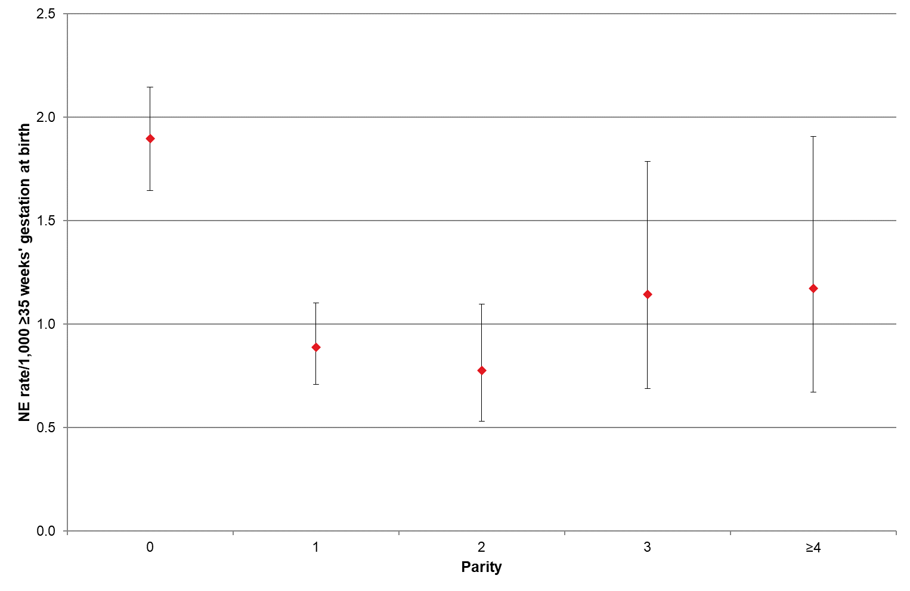
† Parity ‘0’ indicates those having their first baby/babies of ≥20 weeks’ gestation.
MAT = National Maternity Collection; NE = neonatal encephalopathy; PMMRC = Perinatal and Maternal Mortality Review Committee.
Sources: Numerator: PMMRC NE data extract where matched to MAT data, ≥35 weeks 2017–2021; Denominator: MAT births ≥35 weeks 2017–2021
Rates of NE were elevated in those having their first baby, regardless of gestational age, with statistically higher rates at 36 weeks’ gestation and at 41 and 42 weeks (Figure 4.7). There was no observed increase in NE for those who were having a second or subsequent baby.
Figure 4.7: NE rates (per 1,000 births at ≥35 weeks’ gestation, with 95% confidence intervals) by parity and gestation 2017–2021
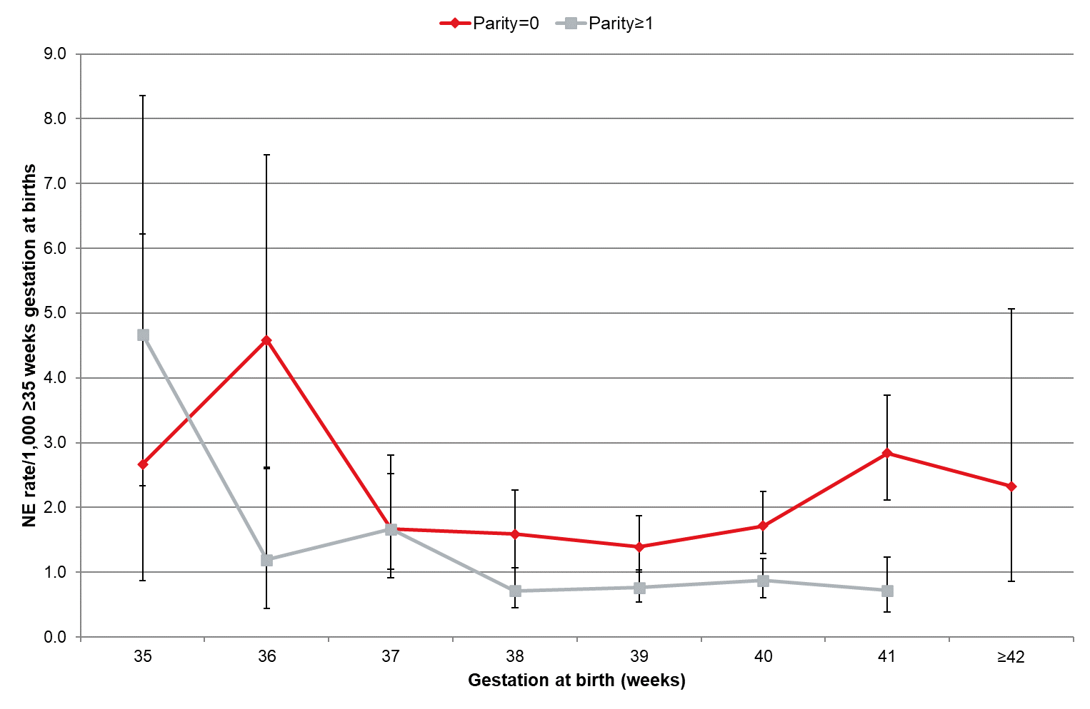
Note: ≥42 weeks for parity ≥1 is supressed due to small numbers.
MAT = National Maternity Collection; NE = neonatal encephalopathy; PMMRC = Perinatal and Maternal Mortality Review Committee.
Sources: Numerator: PMMRC NE data extract where matched to MAT data, ≥35 weeks 2017–2021; Denominator: MAT births ≥35 weeks 2017–2021

In keeping with previous PMMRC reports, NE rates did not differ significantly for babies of women and birthing people who smoked compared with babies of those who did not smoke. However, smoking is a risk factor for preterm birth, late stillbirth and SGA. NE rates also did not vary by gestational age at first antenatal visit. The proportion of those booking in the first trimester has improved over time, with 69.2% of NE cases in the period 2010–2019 booking at ≥14 weeks compared with 70.6% in the general birthing population.
A new demographic factor being examined in this report is rural/urban residential locality of the family/whānau. Using the GCH categories developed by Whitehead et al (see the Methods and Definitions for Perinatal and Maternal Mortality Review Committee Reporting document), residential area was determined to be rural or urban based on statistical meshblock. This showed that those residing in rural areas were 1.34 times more likely to experience an NE outcome than those living in urban areas.
This new finding suggests that research is required to investigate underlying factors, but it does align with research indicating rural Māori are notably affected by poorer outcomes in Aotearoa.
Table 4.2: Neonatal encephalopathy rates (per 1,000 births at ≥35 weeks’ gestation) by maternal age, maternal prioritised ethnic group, NZDep quintile, rurality, smoking at registration, gestation at first antenatal registration and parity 2017–2021
 | MAT births  ≥35 weeks |  | NE cases  (MAT) |  | Rate (per 1,000 births at ≥35 weeks' gestation) |  |  |  | Chi-squared  test  (p)
 | N=290,184† |  | n=370 |  | /1,000 | 95% CI | RR | 95% CI
 | N | % | n | %
Maternal age (years)
<20 | 9,815 | 3.4 | 10 | 2.7 | 1.02 | 0.49–1.87 | 0.76 | 0.41–1.43 | 0.33
20–34 | 218,147 | 75.2 | 291 | 78.6 | 1.33 | 1.18–1.49 | 1.00 | -
35–39 | 50,820 | 17.5 | 53 | 14.3 | 1.04 | 0.78–1.36 | 0.78 | 0.58–1.05
≥40 | 11,394 | 3.9 | 16 | 4.3 | 1.40 | 0.80–2.28 | 1.05 | 0.64–1.74
Unknown | 8 | 0.0 | - | - | - | - | - | -
Prioritised ethnic group (maternal)
Māori | 73,504 | 25.3 | 106 | 28.6 | 1.44 | 1.17–1.72 | 1.00 | - | 0.64
Pacific peoples | 29,330 | 10.1 | 38 | 10.3 | 1.30 | 0.92–1.78 | 0.90 | 0.62–1.30
Asian | 54,303 | 18.7 | 71 | 19.2 | 1.31 | 1.02–1.65 | 0.91 | 0.67–1.22
Indian | 21,948 | 7.6 | 33 | 8.9 | 1.50 | 1.03–2.11 | 1.04 | 0.71–1.54
Other Asian | 32,355 | 11.1 | 38 | 10.3 | 1.17 | 0.83–1.61 | 0.81 | 0.56–1.18
MELAA | 7,340 | 2.5 | 10 | 2.7 | 1.36 | 0.65–2.51 | 0.94 | 0.49–1.81
European | 125,679 | 43.3 | 145 | 39.2 | 1.15 | 0.97–1.34 | 0.80 | 0.62–1.03
NZ European | 96,970 | 33.4 | 111 | 30.0 | 1.14 | 0.93–1.36 | 0.79 | 0.61–1.04
Other European | 28,709 | 9.9 | 34 | 9.2 | 1.18 | 0.82–1.65 | 0.82 | 0.56–1.21
Other | 28 | 0.0 | - | - | - | - | - | -
Deprivation quintile
1 (least deprived) | 43,551 | 15.0 | 47 | 12.7 | 1.08 | 0.79–1.44 | 1.00 | - | 0.14
2 | 49,466 | 17.0 | 53 | 14.3 | 1.07 | 0.80–1.40 | 0.99 | 0.67–1.47
3 | 52,701 | 18.2 | 62 | 16.8 | 1.18 | 0.90–1.51 | 1.09 | 0.75–1.59
4 | 66,525 | 22.9 | 90 | 24.3 | 1.35 | 1.09–1.66 | 1.25 | 0.88–1.78
5 (most deprived) | 76,065 | 26.2 | 115 | 31.1 | 1.51 | 1.24–1.79 | 1.40 | 1.00–1.97
Unknown | 1,876 | 0.6 | 3 | 0.8 | - | - | - | -
Rurality †
Urban | 238,641 | 82.2 | 287 | 77.6 | 1.20 | 1.06–1.34 | 1.00 | - | <0.05
Rural | 49,673 | 17.1 | 80 | 21.6 | 1.61 | 1.28–2.00 | 1.34 | 1.05–1.72
Unknown | 1,870 | 0.6 | 3 | 0.8 | - | - | - | -
Smoking at registration
Yes | 32,620 | 11.2 | 40 | 10.8 | 1.23 | 0.88–1.67 | 0.98 | 0.71–1.36 | 0.91
No | 249,069 | 85.8 | 311 | 84.1 | 1.25 | 1.11–1.39 | 1.00 | -
Unknown | 8,495 | 2.9 | 19 | 5.1 | - | - | - | -
Gestation first antenatal visit (weeks)
≤14 | 204,771 | 70.6 | 256 | 69.2 | 1.25 | 1.10–1.40 | 1.00 | - | 0.77
15–27 | 59,573 | 20.5 | 74 | 20.0 | 1.24 | 0.98–1.56 | 0.99 | 0.77–1.29
≥28 | 13,203 | 4.5 | 18 | 4.9 | 1.36 | 0.81–2.15 | 1.09 | 0.68–1.76
Postnatal registration | 4,212 | 1.5 | 3 | 0.8 | 0.71 | 0.15–2.08 | 0.57 | 0.18–1.78
Unknown | 8,425 | 2.9 | 19 | 5.1 | - | - | - | -
Parity
0 | 115,553 | 39.8 | 219 | 59.2 | 1.90 | 1.64–2.15 | 2.13 | 1.66–2.74 | <0.001
1 | 94,466 | 32.6 | 84 | 22.7 | 0.89 | 0.71–1.10 | 1.00 | -
2 | 41,201 | 14.2 | 32 | 8.6 | 0.78 | 0.53–1.10 | 0.87 | 0.58–1.31
3 | 16,620 | 5.7 | 19 | 5.1 | 1.14 | 0.69–1.79 | 1.29 | 0.78–2.11
≥4 | 13,632 | 4.7 | 16 | 4.3 | 1.17 | 0.67–1.91 | 1.32 | 0.77–2.25
Unknown | 8,712 | 3.0 | - | - | - | - | - | -
Parity
Primiparous | 115,553 | 39.8 | 219 | 59.2 | 1.90 | 1.64–2.15 | 2.08 | 1.69–2.56 | <0.001
Multiparous (≥1) | 165,919 | 57.2 | 151 | 40.8 | 0.91 | 0.76–1.06 | 1.00 | -
Unknown | 8,712 | 3.0 | - | - | - | - | - | -
† Includes all births, including those where demographic characteristic is unknown.
CI = confidence interval; MAT = National Maternity Collection; MELAA = Middle Eastern, Latin American or African; PMMRC = Perinatal and Maternal Mortality Review Committee; RR = relative rate.
† Urban and rural designation as defined by the Aotearoa Geographic Classification for Health (see the Methods and Definitions for Perinatal and Maternal Mortality Review Committee Reporting document).
Sources: Numerator: PMMRC NE data extract where matched to MAT data, ≥35 weeks 2017–2021; Denominator: MAT births ≥35 weeks 2017–2021

Birth, diagnosis and treatment
The following tables, figures and other details indicate the prevalence of distressing events during pregnancy and labour and soon after birth (eg, resuscitation at birth) that occurred with babies diagnosed with NE. Both woman/birthing person and baby may have survived, but these events surrounding the birth may have long-lasting social, emotional and clinical effects.
A number of antenatal complications were recorded in pregnancies where babies developed NE (Table 4.3). These included antepartum haemorrhage and hypertensive disorders (encompassing gestational hypertension and preeclampsia); regardless of parity, these complications were common in pregnancies where babies developed NE. There were also labours induced by a variety of means, and 20% had epidural anaesthesia. We can only make limited comment on whether these factors indicated an increased risk to babies based on data collected. However, annual maternity reports suggest the number of interventions in the NE group are similar to or lower than in the general birthing population. For example, the average percentage of inductions reported in the 2017–2021 period was 27.5% for the whole birthing population and 21.6% for NE babies; 27.6% of the total birthing population and only 20% of the NE group had epidural anaesthesia.
Research has shown an unequal distribution of obstetric interventions in Aotearoa and noted that this is consistent with overuse by some groups and/or with interventions not being delivered when actually needed and appropriate. Based on the proportions shown in Table 4.3, this is a potential area of further investigation in relation to NE.
Although 95.5% of people whose babies developed NE did not experience severe adverse maternal outcomes, 17 either survived with serious morbidity or died (Table 4.3).
Table 4.3: Antenatal complications, obstetric interventions and maternal outcomes among neonatal encephalopathy cases by parity and Sarnat stage 2017–2021
 | NE cases |  | Parity |  |  |  |  | Sarnat stage
 |  |  | Primiparous# |  | Multiparous+ |  | Unknown | Moderate |  | Severe |  | Unknown
 | n=375 |  | n=215 |  | n=156 |  | n=4 | n=258 |  | n=116 |  | n<3
 | n | % | n | % | n | % | n | n | % | n | % | n
Antenatal complications
APH (≥20 weeks vaginal bleeding) | 30 | 8.0 | 19 | 8.8 | 11 | 7.1 | - | 14 | 5.4 | 16 | 13.8 | -
Hypertension | 35 | 9.3 | 22 | 10.2 | 13 | 8.3 | - | 26 | 10.1 | 9 | 7.8 | -
Maternal trauma (antenatal)† | 6 | 1.6 | <3 | x | 4 | 2.6 | - | 4 | 1.6 | <3 | x | -
Induction/augmentation of labour
Induction of labour | 81 | 21.6 | 53 | 24.7 | 27 | 17.3 | 1 | 58 | 22.5 | 23 | 19.8 | -
Induced or augmented labour (any method) | 130 | 34.7 | 86 | 40.0 | 43 | 27.6 | 1 | 97 | 37.6 | 33 | 28.4 | -
Oxytocin for induction or augmentation | 70 | 18.7 | 52 | 24.2 | 17 | 10.9 | 1 | 52 | 20.2 | 18 | 15.5 | -
Epidural anaesthesia | 75 | 20.0 | 56 | 26.0 | 18 | 11.5 | 1 | 61 | 23.6 | 14 | 12.1 | -
Maternal outcome
Deceased or alive with serious morbidity | 17 | 4.5 | 13 | 6.0 | 4 | 2.6 | - | 10 | 3.9 | 7 | 6.0 | -
Alive and well | 358 | 95.5 | 202 | 94.0 | 152 | 97.4 | 4 | 248 | 96.1 | 109 | 94.0 | <3
x = percentage suppressed due to small numbers
† Vehicular, violent personal injury, other.
# Primiparous: parity = 0 defined prior to current birth.
+ Multiparous: parity = ≥1 defined prior to current birth.
APH = antepartum haemorrhage; NE = neonatal encephalopathy; PMMRC = Perinatal and Maternal Mortality Review Committee; .
Source: PMMRC NE data extract ≥35 weeks 2017–2021.

The incidence of antenatal and intrapartum factors that may create risk for NE in babies is reported in Table 4.4. Nearly one-third of babies with NE had an acute peripartum event, including abruption (11.2%) and shoulder dystocia (9.1%).
Table 4.4: Peripartum complications and mode of birth among neonatal encephalopathy cases 2017–2021
 | Total NE cases
 | n=375
 | n | %
Acute peripartum events | 118 | 31.5
Cord prolapse | 16 | 4.3
Abruption | 42 | 11.2
Uterine rupture | 12 | 3.2
Shoulder dystocia | 34 | 9.1
Breech complication | 15 | 4.0
Other complication | 11 | 2.9
Liquor
Blood stained | 35 | 9.3
Thick meconium | 75 | 20.0
Thin meconium | 42 | 11.2
Purulent | <3 | x
Clear | 179 | 47.7
Unknown | 43 | 11.5
Mode of birth
Normal vaginal birth | 140 | 37.3
Operative vaginal birth | 52 | 13.9
Forceps | 24 | 6.4
Ventouse | 26 | 6.9
Both | <3 | x
Unknown | <3 | x
Vaginal breech birth | 11 | 2.9
Caesarean section birth | 172 | 45.9
Elective | 6 | 1.6
Prelabour emergency | 60 | 16.0
Antepartum haemorrhage/Abruption | 9 | 2.4
Suspected fetal distress | 39 | 10.4
Other | 11 | 2.9
Unknown | <3 | x
In labour emergency | 101 | 26.9
Antepartum haemorrhage/Abruption | 8 | 2.1
Suspected fetal distress | 63 | 16.8
Failure to progress/Cephalopelvic disproportion | 6 | 1.6
Other | 23 | 6.1
Unknown | <3 | x
Attempt at operative vaginal birth before caesarean | 7 | 1.9
.‘x’ = percentage suppressed due to small numbers.
Note: Babies can experience more than one of these complications
NE = neonatal encephalopathy; PMMRC = Perinatal and Maternal Mortality Review Committee;
Source: PMMRC NE data extract ≥35 weeks 2017–2021.

Rates of NE continue to vary by the level of facility or place of birth (Table 4.5 and Figure 4.8). Caution should also be exercised when examining the rates of NE by the facility or place of birth, as it is important to also consider contextual information such as where the intended place of birth was and, if transferred, the stage in the pregnancy or birthing process at which the transfer occurred.
Figure 4.8: Neonatal encephalopathy rates (per 1,000 births at ≥35 weeks’ gestation with 95% confidence intervals) by place of birth 2017–2021
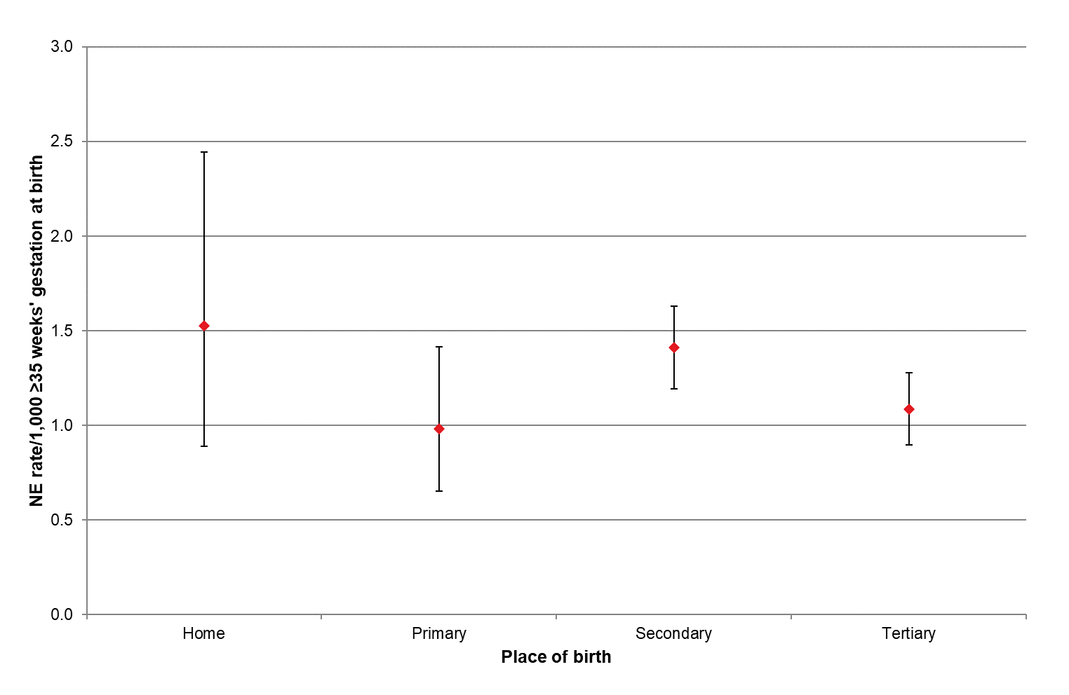
MAT = National Maternity Collection; NE = neonatal encephalopathy; PMMRC = Perinatal and Maternal Mortality Review Committee.
Sources: Numerator: PMMRC NE data extract where matched to MAT data, ≥35 weeks 2017–2021; Denominator: MAT births ≥35 weeks 2017–2021.
Table 4.5: Neonatal encephalopathy rates (per 1,000 births at ≥35 weeks’ gestation) by place of birth 2017–2021
Place of birth | MAT births  ≥35 weeks |  | NE cases |  | Rate (per 1,000 births  at ≥35 weeks' gestation)
 | N=290,184 |  | N=370
 | n | % | n | % | Rate | 95% CI
Home | 11,147 | 3.8 | 17 | 4.6 | 1.53 | 0.89–2.44
Primary | 29,472 | 10.2 | 29 | 7.8 | 0.98 | 0.66–1.41
Secondary | 118,012 | 40.7 | 171 | 46.2 | 1.45 | 1.23–1.67
Tertiary | 129,254 | 44.5 | 146 | 39.5 | 1.13 | 0.95–1.31
Unknown | 2,299 | 0.8 | 7 | 1.9 | 3.04 | -
CI = confidence interval; MAT = National Maternity Collection; NE = neonatal encephalopathy; PMMRC = Perinatal and Maternal Mortality Review Committee.
Sources: Numerator: PMMRC NE data extract where matched to MAT data, ≥35 weeks 2017–2021; Denominator: MAT births ≥35 weeks 2017–2021.

Neonatal wellbeing among babies with neonatal encephalopathy just after birth was consistently poor at 1 minute when measured by Apgar score. In babies with moderate to severe NE during 2017–2021, 77.6% also had an Apgar score <7 at 5 minutes (which is abnormal). The recording of cord blood gases fluctuated from year to year. In the 2017–2021 period, 20% of babies with NE did not have cord blood gases recorded. Of those who did, 63.7% had abnormal results (Table 4.6). These findings may be due to differing local protocols for blood gases, but this is unknown. Immediate wellbeing of all NE babies over the 2010–2021 period is shown in Table 4.11 (appended).

Table 4.6: Immediate newborn wellbeing among babies with neonatal encephalopathy 2017–2021
 | 2017 |  | 2018 |  | 2019 |  | 2020 |  | 2021 |  | Total
 | n=70 |  | n=67 |  | n=69 |  | n=83 |  | n=86 |  | n=375
 | n | % | n | % | n | % | n | % | n | % | n | %
Apgar scores
Apgar score <3 at 1 minute | 42 | 60.0 | 43 | 64.2 | 47 | 68.1 | 56 | 67.5 | 62 | 72.1 | 250 | 66.7
Apgar score <7 at 1 minute | 63 | 90.0 | 62 | 92.5 | 62 | 89.9 | 72 | 86.7 | 80 | 93.0 | 339 | 90.4
Apgar score <7 at 5 minutes | 48 | 68.6 | 50 | 74.6 | 56 | 81.2 | 60 | 72.3 | 77 | 89.5 | 291 | 77.6
Apgar score <7 at 10 minutes | 32 | 45.7 | 37 | 55.2 | 38 | 55.1 | 45 | 54.2 | 51 | 59.3 | 203 | 54.1
Cord blood gases: summary data
Normal (none of pH ≤7, BE ≤−12, lactate ≥6) | 12 | 17.1 | 9 | 13.4 | 14 | 20.3 | 12 | 14.5 | 14 | 16.3 | 61 | 16.3
Abnormal (any of pH ≤7, BE ≤−12, lactate ≥6) | 44 | 62.9 | 50 | 74.6 | 40 | 58.0 | 52 | 62.7 | 53 | 61.6 | 239 | 63.7
No gases reported | 14 | 20.0 | 8 | 11.9 | 15 | 21.7 | 19 | 22.9 | 19 | 22.1 | 75 | 20.0
No gases and Apgar <7 at 1 minute | 3 | 4.3 | <3 | x | 3 | 4.3 | 6 | 7.2 | <3 | x | 14 | 3.7
No gases and Apgar ≥7 at 1 minute | 10 | 14.3 | 7 | 10.4 | 11 | 15.9 | 12 | 14.5 | 16 | 18.6 | 56 | 14.9
No gases and unknown Apgar | <3 | x | - | - | <3 | x | <3 | x | <3 | x | 5 | 1.3
x = percentage suppressed due to small numbers.
BE = base excess; NE = neonatal encephalopathy; PMMRC = Perinatal and Maternal Mortality Review Committee
Source: PMMRC NE data extract ≥35 weeks 2017–2021.

Particulars of induced cooling therapy in babies with NE by year of birth (2017–2021) are shown in Table 4.7. The proportion of babies who were cooled in 2021 dropped slightly after an increase in cooling over the previous 4 previous years. Optimal timing of cooling has also varied across the time period.
Table 4.7: Induced cooling therapy among babies with neonatal encephalopathy 2017–2021
Cooling | 2017 |  | 2018 |  | 2019 |  | 2020 |  | 2021 |  | Total
 | n=70 |  | n=67 |  | n=69 |  | n=83 |  | n=86 |  | n=375
 | n | % | n | % | n | % | n | % | n | % | n | %
Yes | 48 | 68.6 | 52 | 77.6 | 54 | 78.3 | 70 | 84.3 | 69 | 80.2 | 293 | 78.1
No | 22 | 31.4 | 15 | 22.4 | 15 | 21.7 | 13 | 15.7 | 17 | 19.8 | 82 | 21.9
Unknown | - | - | - | - | - | - | - | - | - | - | - | -
Age at cooling | n=48 |  | n=52 |  | n=54 |  | n=70 |  | n=69 |  | n=293
≤6 hours | 40 | 83.3 | 38 | 73.1 | 38 | 70.4 | 58 | 82.9 | 50 | 72.5 | 224 | 76.5
>6 hours | 7 | 14.6 | 10 | 19.2 | 14 | 25.9 | 11 | 15.7 | 17 | 24.6 | 59 | 20.1
Unknown time | <3 | x | 4 | 7.7 | <3 | x | <3 | x | <3 | x | 10 | 3.4
x = percentage suppressed due to small numbers.
NE = neonatal encephalopathy; PMMRC = Perinatal and Maternal Mortality Review Committee.
Source: PMMRC NE data extract ≥35 weeks 2017–2021.
Proportions of induced cooling for babies with moderate and severe Sarnat stages remained lower than perhaps expected for babies surviving with NE (moderate 81.4%, severe 71.6%), with guidelines indicating cooling for most of these babies. There may be a relationship between cooling decisions and cord lactate results that needs further investigation. However, we cannot tell from these data why some babies were not cooled when indicated.
Neonatal intensive care units should have a regular quality process where the systemic reasons why guidelines were not followed and eligible babies were not cooled should be identified, discussed and addressed.
Mortality was much higher in babies with severe NE (57.8%) than in those with moderate NE (3.1%)
(Table 4.8). There was no statistical difference between the rates of cooling or mortality for babies of Māori women and birthing people and those for babies of New Zealand Europeans.
Table 4.8: Use of cooling and outcomes by Sarnat stage among babies with neonatal encephalopathy 2017–2021
 | NE babies |  | Sarnat stage
 |  |  | Moderate |  | Severe |  | Unknown
 | n=375 |  | n=258 |  | n=116 |  | n<3
 | n | % | n | % | n | % | n
Induced cooling
Yes | 293 | 78.1 | 210 | 81.4 | 83 | 71.6 | -
No | 82 | 21.9 | 48 | 18.6 | 33 | 28.4 | <3
Unknown
Deceased
Yes | 76 | 20.3 | 8 | 3.1 | 67 | 57.8 | <3
No | 299 | 79.7 | 250 | 96.9 | 49 | 42.2 | -
Unknown
NE = neonatal encephalopathy; PMMRC = Perinatal and Maternal Mortality Review Committee.
Source: PMMRC NE data extract ≥35 weeks 2017–2021.

Most babies with NE received resuscitation at birth (93.6%) by various methods, ranging from giving oxygen only through to cardiac massage and adrenaline. Anticonvulsants were given to 66.4% of babies. Only 3.7% of babies were noted as having a positive blood culture when tested following birth (Table 4.9).

Table 4.9: Neonatal resuscitation and early neonatal management by Sarnat stage among babies with neonatal encephalopathy 2017–2021
 | NE babies |  | Sarnat stage
 |  |  | Moderate |  | Severe |  | Unknown
 | n=375 |  | n=258 |  | n=116 |  | n<3
 | n | % | n | % | n | % | n
Resuscitation at birth
Yes | 351 | 93.6 | 242 | 93.8 | 108 | 93.1 | <3
No | 23 | 6.1 | 15 | 5.8 | 8 | 6.9 | -
Unknown | <3 | x | <3 | x | - | - | -
Type of resuscitation at birth†
Oxygen only | 5 | 1.3 | 5 | 1.9 | - | - | -
IPPV with mask | 286 | 76.3 | 201 | 77.9 | 84 | 72.4 | <3
IPPV with ETT | 144 | 38.4 | 74 | 28.7 | 70 | 60.3 | -
Cardiac massage | 145 | 38.7 | 80 | 31.0 | 64 | 55.2 | <3
Adrenaline | 58 | 15.5 | 17 | 6.6 | 41 | 35.3 | -
Respiratory and ventilation management†
Mechanical ventilation | 261 | 69.6 | 157 | 60.9 | 103 | 88.8 | <3
Nitric oxide | 84 | 22.4 | 50 | 19.4 | 34 | 29.3 | -
Infection†
Positive blood culture | 14 | 3.7 | 12 | 4.7 | <3 | x | -
Antibiotics | 345 | 92.0 | 246 | 95.3 | 99 | 85.3 | -
Anticonvulsant therapy† | 249 | 66.4 | 162 | 62.8 | 87 | 75.0 | -
Phenobarbitone | 227 | 60.5 | 148 | 57.4 | 79 | 68.1 | -
Phenytoin | 89 | 23.7 | 51 | 19.8 | 38 | 32.8 | -
Benzodiazepines | 81 | 21.6 | 43 | 16.7 | 38 | 32.8 | -
Other | 103 | 27.5 | 61 | 23.6 | 42 | 36.2 | -
‘x’ = percentage suppressed due to small numbers.
† Categories not mutually exclusive.
ETT = endotracheal tube; IPPV = intermittent positive pressure ventilation; NE = neonatal encephalopathy; PMMRC = Perinatal and Maternal Mortality Review Committee; .
Source: PMMRC NE data extract ≥35 weeks 2017–2021.

Of babies diagnosed with NE who survived, 50.8% of those with moderate NE had a normal physical examination on discharge or transfer, compared with 12.2% of those with severe NE. Nearly all babies (98%) with severe NE had an MRI before discharge (Table 4.10). Although the former PMMRC previously recommended that all babies with moderate and severe NE receive an MRI scan, and this is included in national guidelines, 14.8% of babies with moderate NE did not receive an MRI over the 2017–2021 period. Of those babies with moderate NE, Māori were the least likely ethnic group to receive an MRI. Access to neonatal neuroimaging in neonatal intensive care imaging has been identified as a considerable access issue in neonatal care in Aotearoa.

Table 4.10: Investigations and neonatal outcome by Sarnat stage of neonatal encephalopathy survivors 2017–2021
Investigations | Total NE  survivors |  | Sarnat stage
 |  |  | Moderate |  | Severe
 | n=299 |  | n=250 |  | n=49
 | n | % | n | % | n | %
Examination on discharge/transfer
Normal | 133 | 44.5 | 127 | 50.8 | 6 | 12.2
Mild or moderate abnormality | 112 | 37.5 | 89 | 35.6 | 23 | 46.9
Severe abnormality | 35 | 11.7 | 15 | 6.0 | 20 | 40.8
Not examined | 11 | 3.7 | 11 | 4.4 | - | -
Examined but finding unknown | 6 | 2.0 | 6 | 2.4 | - | -
Missing data | <3 | x | <3 | x | - | -
MRI (investigation done) | 261 | 87.3 | 213 | 85.2 | 48 | 98.0
No MRI or Unknown | 38 | 12.7 | 37 | 14.8 | <3 | x
Results of MRI
Moderately/Severely abnormal | 99 | 33.1 | 64 | 25.6 | 35 | 71.4
Normal or only mildly abnormal | 159 | 53.2 | 147 | 58.8 | 12 | 24.5
Unknown result | 41 | 13.7 | 39 | 15.6 | <3 | x
x = percentage suppressed due to small numbers.
MRI = magnetic resonance imaging (of the brain); NE = neonatal encephalopathy; PMMRC = Perinatal and Maternal Mortality Review Committee.
Source: PMMRC’s NE data extract ≥35 weeks 2017–2021.

Neonatal encephalopathy appended tables
Table 4.11: Immediate newborn wellbeing among babies with neonatal encephalopathy 2010–2021
 | ≥37 weeks gestation |  |  |  |  |  |  |  |  |  |  |  |  | ≥35 weeks gestation
 | 2010 |  | 2011 |  | 2012 |  | 2013 |  | 2014 |  | 2015 |  |  | 2016 |  | 2017 |  | 2018 |  | 2019 |  | 2020 |  | 2021 |  | Total
 | n=82 |  | n=67 |  | n=79 |  | n=70 |  | n=55 |  | n=70 |  |  | n=59 |  | n=70 |  | n=67 |  | n=69 |  | n=83 |  | n=86 |  | n=857
 | n | % | n | % | n | % | n | % | n | % | n | % |  | n | % | n | % | n | % | n | % | n | % | n | % | n | %
Apgar scores
Apgar score <3 at 1 minute | 48 | 58.5 | 41 | 61.2 | 47 | 59.5 | 40 | 57.1 | 37 | 67.3 | 39 | 55.7 |  | 40 | 67.8 | 42 | 60.0 | 43 | 64.2 | 47 | 68.1 | 56 | 67.5 | 62 | 72.1 | 542 | 63.2
Apgar score <7 at 1 minute | 73 | 89.0 | 61 | 91.0 | 70 | 88.6 | 65 | 92.9 | 53 | 96.4 | 59 | 84.3 |  | 54 | 91.5 | 63 | 90.0 | 62 | 92.5 | 62 | 89.9 | 72 | 86.7 | 80 | 93.0 | 774 | 90.3
Apgar score <7 at 5 minutes | 61 | 74.4 | 54 | 80.6 | 62 | 78.5 | 57 | 81.4 | 43 | 78.2 | 50 | 71.4 |  | 49 | 83.1 | 48 | 68.6 | 50 | 74.6 | 56 | 81.2 | 60 | 72.3 | 77 | 89.5 | 667 | 77.8
Apgar score <7 at 10 minutes | 39 | 47.6 | 38 | 56.7 | 49 | 62.0 | 32 | 45.7 | 29 | 52.7 | 35 | 50.0 |  | 36 | 61.0 | 32 | 45.7 | 37 | 55.2 | 38 | 55.1 | 45 | 54.2 | 51 | 59.3 | 461 | 53.8
Cord blood gases: summary data
Normal (none of pH ≤7, BE ≤−12, lactate ≥6) | 12 | 14.6 | 14 | 20.9 | 11 | 13.9 | 13 | 18.6 | 7 | 12.7 | 8 | 11.4 |  | 6 | 10.2 | 12 | 17.1 | 9 | 13.4 | 14 | 20.3 | 12 | 14.5 | 14 | 16.3 | 132 | 15.4
Abnormal (any of pH ≤7, BE ≤−12, lactate ≥6) | 47 | 57.3 | 41 | 61.2 | 55 | 69.6 | 48 | 68.6 | 40 | 72.7 | 47 | 67.1 |  | 45 | 76.3 | 44 | 62.9 | 50 | 74.6 | 40 | 58.0 | 52 | 62.7 | 53 | 61.6 | 562 | 65.6
No gases reported | 23 | 28.0 | 12 | 17.9 | 13 | 16.5 | 9 | 12.9 | 8 | 14.5 | 15 | 21.4 |  | 8 | 13.6 | 14 | 20.0 | 8 | 11.9 | 15 | 21.7 | 19 | 22.9 | 19 | 22.1 | 163 | 19.0
No gases and Apgar <7 at 1 minute | 8 | 9.8 | 4 | 6.0 | 5 | 6.3 | 3 | 4.3 | - | - | 9 | 12.9 |  | 2 | 3.4 | 3 | 4.3 | <3 | x | 3 | 4.3 | 6 | 7.2 | <3 | x | 45 | 5.3
No gases and Apgar ≥7 at 1 minute | 14 | 17.1 | 8 | 11.9 | 8 | 10.1 | 6 | 8.6 | 8 | 14.5 | 6 | 8.6 |  | 6 | 10.2 | 10 | 14.3 | 7 | 10.4 | 11 | 15.9 | 12 | 14.5 | 16 | 18.6 | 112 | 13.1
No gases and unknown Apgar | <3 | x | - | - | - | - | - | - | - | - | - | - |  | - | - | <3 | x | - | - | <3 | x | <3 | x | <3 | x | 6 | 0.7
x = percentage suppressed due to small numbers
BE = base excess; NE = neonatal encephalopathy; PMMRC = Perinatal and Maternal Mortality Review Committee.
Source: PMMRC NE data extract ≥37 weeks 2010–2015 and ≥35 weeks 2016–2021.

Table 4.12: Neonatal encephalopathy rates (per 1,000 births ≥35 weeks’ gestation) by DHB of maternal residence 2017–2021
DHB of residence | MAT births ≥35 weeks | Total NE cases | Rate (per 1,000 births at ≥35 weeks' gestation)
 | N=290,184 | n=375
 | n | n | /1,000 | 95% CI
Northland | 11,214 | 13 | 1.16 | 0.62–1.98
Waitematā | 37,426 | 40 | 1.07 | 0.76–1.46
Auckland | 26,575 | 24 | 0.90 | 0.58–1.34
Counties Manukau | 40,690 | 40 | 0.98 | 0.70–1.34
Waikato | 26,870 | 37 | 1.38 | 0.97–1.90
Bay of Plenty | 15,325 | 18 | 1.17 | 0.70–1.86
Lakes | 7,428 | 16 | 2.15 | 1.23–3.50
Hauora Tairāwhiti | 3,420 | 6 | 1.75 | 0.64–3.82
Taranaki | 7,306 | 16 | 2.19 | 1.25–3.56
Hawke's Bay | 10,221 | 22 | 2.15 | 1.35–3.26
Whanganui | 4,023 | 10 | 2.49 | 1.19–4.57
MidCentral | 10,550 | 15 | 1.42 | 0.80–2.35
Wairarapa | 2,548 | 3 | 1.18 | 0.24–3.44
Capital & Coast | 15,903 | 27 | 1.70 | 1.12–2.47
Hutt Valley | 9,594 | 12 | 1.25 | 0.65–2.18
Nelson Marlborough | 7,091 | 16 | 2.26 | 1.29–3.66
West Coast | 1,590 | <3 | x | s
Canterbury | 31,192 | 35 | 1.12 | 0.78–1.56
South Canterbury | 2,974 | 5 | 1.68 | 0.55–3.92
Southern | 16,447 | 18 | 1.09 | 0.65–1.73
Other† | 1,797 | - | - | -
x = percentage suppressed due to small numbers.
s = rate and CI not calculated due to small numbers.
† Other includes overseas, unknown and other.
CI = confidence interval; DHB = district health board; MAT = National Maternity Collection; NE = neonatal encephalopathy; PMMRC = Perinatal and Maternal Mortality Review Committee
Sources: Numerator: PMMRC NE data extract ≥35 weeks 2017–2021; Denominator: MAT births ≥35 weeks 2017–2021.

Te Mate o ngā whāea | Maternal mortality

Key findings
- Maternal mortality is a rare event; this report identified 147 fatal events between 2006 and 2021.
- There has been a small reduction in maternal mortality over the 2006–2021 period.
- There is a significant ethnic difference in maternal mortality in Aotearoa, which has not changed over the 2006–2021 period.
- The European prioritised ethnic group experienced half the rate of maternal mortality of Māori and Pacific ethnic groups. If the Māori and Pacific mortality rates were the same as the European rates, overall maternal mortality in Aotearoa would be 30% lower.
- Socioeconomic deprivation is related to maternal mortality in Aotearoa: the most deprived quintile has 2.38 times the risk of maternal mortality over the least deprived populations.
- Suicide accounts for over 40% of direct maternal mortality events, with Māori having over three times the rate of NZ Europeans.

Summary
Although there has been some reduction in maternal mortality in Aotearoa in the 2006–2021 reporting period, there are significant long-term inequities with respect to these deaths. In Aotearoa, the effects of colonisation, as described earlier, have resulted in substantial increased risks of maternal mortality for wāhine Māori, Pacific peoples and those living in poverty. Although all inequities are unjust and unfair, in this context they represent a systemic failure of the maternal health systems to provide adequate care to the most at-risk groups. The inability of the health system to recognise all risks associated with poor outcomes and then adjust models of care to need must be viewed as a missed opportunity to significantly reduce maternal mortality in Aotearoa. Different approaches to and intensities of care are required for different population groups, and the concept of standardisation of care is a barrier to this multifaceted approach. This is especially true for groups in Aotearoa who already suffer disproportionate burdens of poor health and poverty. Targeted approaches to care have improved outcomes in indigenous communities in Australia.
It is not too late for the health system to change, and with respect to inequity it needs to change with the goal of helping those who need it the most. Directed initiatives, as evidenced in research and local implementation, need to be applied widely, access to acceptable and appropriate services must be improved and programmes such as health navigators must be easily available and accessible.

Definitions
Maternal death is the death of a person while pregnant or within 42 days of the end of pregnancy (miscarriage, termination or birth), irrespective of the duration and site of the pregnancy, from any cause related to or aggravated by the pregnancy or its management, but not from accidental or incidental causes.
The cause of maternal death is sub-classified into the following categories based on The WHO Application of ICD-10 to Deaths during Pregnancy, Childbirth and Puerperium: ICD-MM.
- Direct maternal deaths: those resulting from obstetric complications of the pregnant state (pregnancy, labour or puerperium) from interventions, omissions, incorrect treatment or from a chain of events resulting from the above. In 2018, the former PMMRC adopted the WHO revision to include deaths by suicide with direct maternal deaths. This was then applied retrospectively to data from previous years.
- Indirect maternal deaths: those resulting from previous existing disease or disease that developed during pregnancy and was not due to direct obstetric causes but that was aggravated by the physiologic effects of pregnancy.
- Unknown/undetermined (or unclassifiable) maternal death is a death during pregnancy, childbirth and the puerperium where the underlying cause is unknown or was not determined.
- Coincidental maternal deaths: deaths from unrelated causes that happen to occur in pregnancy or the puerperium.
Although maternal death remains a relatively rare event in Aotearoa, over the 15-year period 2006–2021, information on a total of 147 maternal deaths during pregnancy or within 42 days postpartum was collected, including 30 coincidental deaths. Unless stated otherwise, data relating to coincidental maternal deaths has been excluded.
All death is tragic, but maternal mortality has a magnified impact that affects entire families, whānau and communities. The loss of a woman/birthing person and the loss of a child’s mother/parent is a duality of pain for whānau to cope with. For Māori, these avoidable deaths of wāhine, who hold a vital role in the continuation of whakapapa and each generation within their whānau, is significant.
Birth, parenthood, raising a child and adding to your family are all revered processes in all cultures in Aotearoa. Given this, preventing maternal death should be a high priority for everyone who works in health, social and economic policy and in wider communities.

Findings
The small numbers involved mean that overall maternal mortality ratios have fluctuated over the 2006–2021 period, but there is small reducing trend overall (direct and indirect combined) (Table 5.1, Figure 5.1).
This follows substantial reduction in the maternal mortality ratio in the last 50 years as detailed in previous PMMRC reports. For example, 47 deaths per 100,000 maternities were recorded in 1975 compared with 9.48 per 100,000 in 2021.
Figure 5.1: Maternal mortality ratios (per 100,000 maternities) (rolling 1-year and 3-year)† 2006–2021
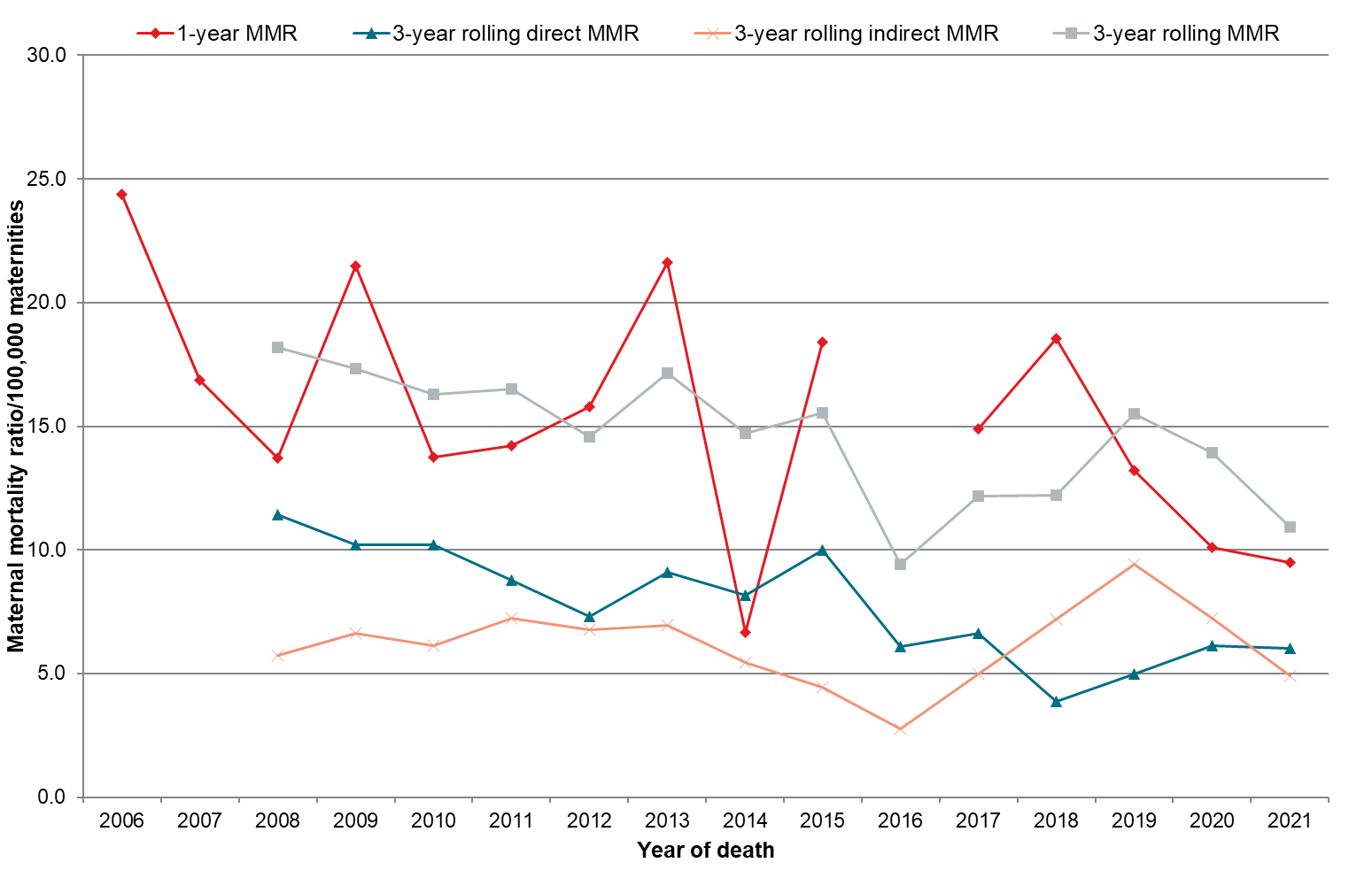
Note: the number of deaths in 2016 was too small to calculate a reliable rate for this year.
† Rolling 3-year maternal mortality rate represented at final year of triennium.
MAT = National Maternity Collection; MMR = maternal mortality ratio; PMMRC = Perinatal and Maternal Mortality Review Committee.
Sources: Numerator: PMMRC maternal mortality data extract 2006–2021; Denominator: MAT data 2006–2021.

Work programmes developed from previous PMMRC recommendations, the National Maternity Monitoring Group and the Maternity Quality & Safety Programme have potentially affected outcomes since 2021. These work programmes included the review and development of Health New Zealand hypertension and preeclampsia guidelines and review of the treatment of postpartum haemorrhage consensus guideline. The work of the Maternal Morbidity Working Group also prompted the national rollout of a Maternal Early Warning System (MEWS). Any impact from these initiatives is yet to be seen in changes in outcomes.

Table 5.1: Single-year and 3-year rolling maternal mortality ratios (per 100,000 maternities) 2006–2021
 | 2006 | 2007 | 2008 | 2009 | 2010 | 2011 | 2012 | 2013 | 2014 | 2015 | 2016 | 2017 | 2018 | 2019 | 2020 | 2021 | 2006–2021 |  |  | 2006–2021  Regression  for trend  (95% CI)
 | n | n | n | n | n | n | n | n | n | n | n | n | n | n | n | n | n | % | Cause-specific  ratio/100,000 maternities
Total maternal deaths | 15 | 11 | 9 | 14 | 9 | 9 | 10 | 13 | 4 | 11 | <3 | 9 | 11 | 8 | 6 | 6 | 147 | 100.0 | 14.80 | −0.585 *  (−1.169 to −0.001)
Single-year MMR | 24.39 | 16.87 | 13.71 | 21.47 | 13.75 | 14.23 | 15.80 | 21.61 | 6.66 | 18.40 | s | 14.88 | 18.54 | 13.20 | 10.09 | 9.48 | - | - | -
Three-year rolling MMR | - | - | 2006–08 | 2007–09 | 2008–10 | 2009–11 | 2010–12 | 2011–13 | 2012–14 | 2013–15 | 2014–16 | 2015–17 | 2016–18 | 2017–19 | 2018–20 | 2019–21 | - | - | -
 |  |  | 18.20 | 17.34 | 16.30 | 16.50 | 14.58 | 17.14 | 14.71 | 15.55 | s | 12.16 | 12.19 | 15.52 | 13.93 | 10.91 | - | - | -
* p <0.05.
s = ratio suppressed due to small numbers
MMR = maternal mortality ratio; PMMRC = Perinatal and Maternal Mortality Review Committee; Sources: Numerator: PMMRC maternal mortality data extract 2006–2021; Denominator: MAT data 2006–2021.

As these rates have shown little change, it is timely to consider that a maternal death can often be termed avoidable as it is the endpoint of a continuum of morbidity events. The 14th report of the PMMRC noted that severe maternal morbidity is where someone ‘would have died had it not been for luck or good care’. Therefore, clinically, there may be more to learn about mortality prevention from ‘near miss’ events than from focusing on review of mortality alone. In the 14th report, the committee stated that they aimed ‘to provide and maintain a sustainable maternal morbidity review function’ and planned to continue to report on morbidity findings in their reports. However, funding has not allowed for this.
Another area to be considered for examination are the socioeconomic, systemic and structural determinants correlated with maternal mortality. Table 5.2 shows that people living in the most deprived areas (quintile 5) are 2.38 times more likely to die than those in the least deprived areas (quintile 1). A complex network of social, cultural and economic contexts of women and birthing people and their whānau in the maternal/perinatal period can substantially impact on outcomes., Multivariate analysis to adjust for demographic factors and testing of variable interactions (eg, ethnicity and deprivation) would be a first step in looking at these causes and identifying need in relation to all perinatal and mortality outcomes. This would be difficult with small numbers and potential changes over time but may provide some insight to allow effective interventions to be developed.
Table 5.2: Demographic characteristics among maternal deaths compared with all births 2006–2021
 | Maternities |  | Maternal mortality  2006–2021 |  |  |  |  |  | Chi-squared  test  (p)
 | N=993,421 |  | n=147 |  | Maternal mortality ratio | 95% CI | RR | 95% CI
 | N | % | n | % | /100,000 maternities
Maternal age (years)
<20 | 54,803 | 5.5 | 6 | 4.1 | 10.95 | 4.02–23.83 | 0.91 | 0.38–2.16 | <0.01
20–24 | 167,212 | 16.8 | 21 | 14.3 | 12.56 | 7.77–19.20 | 1.04 | 0.61–1.79
25–29 | 258,536 | 26.0 | 41 | 27.9 | 15.86 | 11.38–21.51 | 1.32 | 0.84–2.06
30–34 | 299,049 | 30.1 | 36 | 24.5 | 12.04 | 8.43–16.67 | 1.00 | -
35–39 | 172,990 | 17.4 | 28 | 19.0 | 16.19 | 10.76–23.39 | 1.34 | 0.82–2.20
≥40 | 40,510 | 4.1 | 15 | 10.2 | 37.03 | 20.72–61.07 | 3.08 | 1.68–5.62
Unknown | 321 | 0.0 | - | - | - | - | - | -
Maternal prioritised ethnic group
Māori | 258,053 | 26.0 | 59 | 40.1 | 22.86 | 17.40–29.49 | 1.00 | - | <0.001
Pacific peoples | 108,558 | 10.9 | 23 | 15.6 | 21.19 | 13.43–31.79 | 0.93 | 0.57–1.50
Asian | 140,536 | 14.1 | 16 | 10.9 | 11.38 | 6.51–18.49 | 0.50 | 0.29–0.87
Indian | 48,757 | 4.9 | 6 | 4.1 | 12.31 | 4.52–26.78 | 0.54 | 0.23–1.25
Other Asian | 91,779 | 9.2 | 10 | 6.8 | 10.90 | 5.22–20.04 | 0.48 | 0.24–0.93
MELAA | 21,262 | 2.1 | - | - | - | - | - | -
European | 464,284 | 46.7 | 49 | 33.3 | 10.55 | 7.81–13.95 | 0.46 | 0.32–0.67
NZ European | 368,868 | 37.1 | 46 | 31.3 | 12.47 | 9.13–16.63 | 0.55 | 0.37–0.80
Other European | 95,416 | 9.6 | 3 | 2.0 | 3.14 | 0.65–9.19 | 0.14 | 0.04–0.44
Unknown | 728 | 0.1 | - | - | - | - | - | -
Deprivation quintile
1 (least deprived) | 141,774 | 14.3 | 12 | 8.2 | 8.46 | 4.37–14.79 | 1.00 | - | <0.01
2 | 155,886 | 15.7 | 12 | 8.2 | 7.70 | 3.98–13.45 | 0.91 | 0.41–2.02
3 | 179,897 | 18.1 | 24 | 16.3 | 13.34 | 8.55–19.85 | 1.58 | 0.79–3.15
4 | 228,509 | 23.0 | 43 | 29.3 | 18.82 | 13.62–25.35 | 2.22 | 1.17–4.22
5 (most deprived) | 277,932 | 28.0 | 56 | 38.1 | 20.15 | 15.22–26.16 | 2.38 | 1.28–4.44
Unknown | 9,423 | 0.9 | - | - | - | - | - | -
Rurality †
Urban | 809,322 | 81.5 | 136 | 92.5 | 16.80 | 13.98–19.63 | 1.00 | - | <0.01
Rural | 165,400 | 16.6 | 11 | 7.5 | 6.65 | 3.32–11.90 | 0.40 | 0.21–0.73
Unknown | 18,699 | 1.9 | - | - | - | - | - | -
Smoking at booking
Yes | 116,880 | 11.8 | 17 | 11.6 | 14.54 | 8.47–23.29 | 2.42 | 1.38–4.24 | <0.01
No | 714,719 | 71.9 | 43 | 29.3 | 6.02 | 4.35–8.10 | 1.00 | -
Unknown | 161,822 | 16.3 | 87 | 59.2 | - | - | - | -
Parity
0 | 370,054 | 37.3 | 39 | 26.5 | 10.54 | 7.49–14.41 | 0.96 | 0.61–1.52 | <0.001
1 | 309,327 | 31.1 | 34 | 23.1 | 10.99 | 7.61–15.36 | 1.00 | -
2 | 138,698 | 14.0 | 21 | 14.3 | 15.14 | 9.37–23.14 | 1.38 | 0.80–2.37
3 | 56,273 | 5.7 | 20 | 13.6 | 35.54 | 21.71–54.89 | 3.23 | 1.86–5.62
≥4 | 48,642 | 4.9 | 30 | 20.4 | 61.68 | 41.61–88.05 | 5.61 | 3.43–9.17
Unknown | 70,427 | 7.1 | 3 | 2.0 | - | - | - | -
Parity
Primiparous | 370,054 | 37.3 | 39 | 26.5 | 10.54 | 7.49–14.41 | 0.55 | 0.38–0.80 | <0.01
Multiparous (≥1) | 552,940 | 55.7 | 105 | 71.4 | 18.99 | 15.36–22.62 | 1.00 | -
Unknown | 70,427 | 7.1 | 3 | 2.0 | - | - | - | -
CI = confidence interval; MAT = National Maternity Collection; MELAA = Middle Eastern, Latin American, or African; PMMRC = Perinatal and Maternal Mortality Review Committee; RR = relative rate.
† Urban and Rural categories as defined by the Aotearoa Geographic Classification for Health (see the Methods and Definitions for Perinatal and Maternal Mortality Review Committee Reporting document).
Sources: Numerator: PMMRC maternal mortality data extract 2006–2021; Denominator: MAT data 2006–2021.

The demographic characteristics of those who died in 2006–2021 compared with those of all births during that time is shown in Table 5.2. Demographic composition of the maternal mortality population differed from the whole birthing population in all categories. This table also shows the relative risks of those who died within the demographic categories. People of European ethnicity were less than half as likely as wāhine Māori to die during pregnancy, birth and in the following 42 days. Pacific peoples are only slightly less disadvantaged, at 7% less likely to die than Māori.
In line with international reporting and research, the risk of maternal mortality also rises with age. People aged ≥40 years were 3.08 times more likely to die than those aged 30–34 years.
A large amount of data is missing for parity in the ‘all births’ population (33% across the 2006–2021 period), so no comment can be made regarding the impact of demographic factors. A total of 16.3% of data for smoking at booking is also missing in the denominator/all births set.
Figure 5.2: Maternal 3-year rolling mortality ratios (per 100,000 maternities) by prioritised ethnic group (Māori and New Zealand European) and year 2006–2021
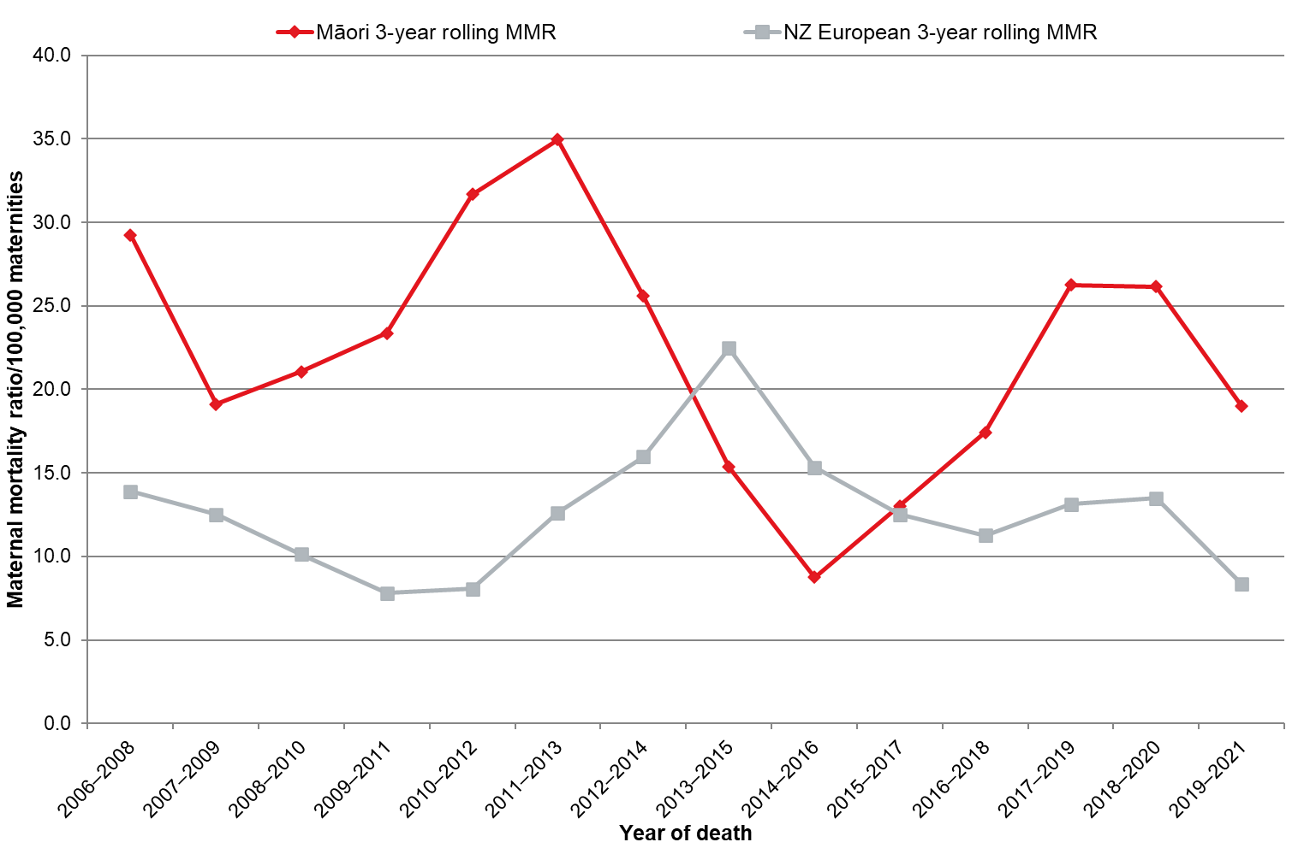
MAT = National Maternity Collection; MMR = maternal mortality ratio; PMMRC = Perinatal and Maternal Mortality Review Committee.
Sources: Numerator: PMMRC maternal mortality data extract 2006–2021; Denominator: MAT data 2006–2021.

It is encouraging that the 3-year rolling maternal mortality ratio for both Māori and New Zealand European populations had a small reduction over the 2006–2011 period, those for Māori remain consistently higher than those for New Zealand Europeans. As discussed in relation to demographic data, more analysis is required to identify the underlying causes of and contributing factors to these disturbing disparities.

Table 5.3: Maternal mortality ratio (per 100,000 maternities) and cause of maternal death† 2006–2021
 | 2006–2021
 | n=147 |  | Cause specific ratio
 | n | % | /100,000 maternities
Maternities | 993,421
Direct maternal death | 80 | 54.8 | 8.05
Suicide | 32 | 21.9 | 3.22
Pregnancies with abortive outcome (ectopic and miscarriage)‡ | 4 | 2.7 | 0.40
Hypertensive disorders | 5 | 3.4 | 0.50
Obstetric haemorrhage | 4 | 2.7 | 0.40
Pregnancy-related infection | 9 | 6.2 | 0.91
Other obstetric complications | 26 | 17.8 | 2.62
Amniotic fluid embolism | 15 | 10.3 | 1.51
Venous thrombo-embolism | 7 | 4.8 | 0.70
Other | 4 | 2.7 | 0.40
Indirect maternal death | 60 | 40.8 | 6.04
Cardiac | 17 | 11.6 | 1.71
Neurological | 15 | 10.3 | 1.51
Infections not a direct result of pregnancy | 10 | 6.8 | 1.01
Other non-obstetric complications | 15 | 10.3 | 1.51
Psychiatric causes - Drugs/alcohol/other | <3 | x | s
Unknown | <3 | x | s
Unknown/undetermined | 7 | 4.8 | -
Note: Excludes 30 coincidental maternal deaths.
x = percentage suppressed due to small numbers.
's' indicates rate suppressed due to small numbers.
† Other causes with small numbers have been suppressed.
‡ This is the World Health Organization category that includes first trimester pregnancy complications such as miscarriages and ectopic pregnancies.
MAT = National Maternity Collection; PMMRC = Perinatal and Maternal Mortality Review Committee;
Sources: Numerator: PMMRC maternal mortality data extract 2006–2021; Denominator: MAT data 2006–2021

Suicide continues to be the major direct cause of maternal mortality, and amniotic fluid embolisms, infection, hypertensive disorders and haemorrhage are also clinically significant. In the past, these latter causes have also been prominent in severe morbidity data. Again, examining data from people who did not die from these causes may allow us to identify key themes that can be supported and improved to reduce terminal events. Quality improvement recommendations in this regard frequently mention identification and awareness of risk factors and early intervention.
Beyond the clinical health care system, addressing the broader needs of women and birthing people and their whānau is indicated, as poor outcomes increase with deprivation (Table 5.2) and there is a demonstratable need for access to increased resources and more engaged, culturally appropriate care in the first 1,000 days.

Maternal suicide
Suicide is a complex issue with many contributing causes. It is devastating for all those personally affected and a tragedy for any community. Maternal suicide continues to be a critical issue in Aotearoa. These deaths need to be considered in the context of suicide within the country as a whole. The total population suicide rates of Aotearoa are in the middle when compared with other Organisation for Economic Co-operation and Development (OECD) countries; for example, they are higher than in the UK but lower than in Australia. However, Aotearoa has one of the highest youth suicide rates, at approximately twice the OECD average. In 2021, suicide in the total population affected males more than females, women of Māori ethnicity (10.9/100,000) were twice as likely to be affected as the non-Māori female population (4.5/100,000).
Table 5.4 shows that, over the 2006–2021 period, New Zealand European women and birthing people were approximately 67% less likely to die by suicide than wāhine Māori. We know from research that māmā Māori are younger than New Zealand European women and birthing people and more likely to live in areas of higher deprivation, which also has a correlation with suicide. During the period of pregnancy and up to 42 days after, people usually have input from health care services. Therefore, this is an opportunity for support and interventions to be offered if risk factors and/or signs of mental health distress present.
Table 5.4: Maternal suicide by prioritised ethnic group† 2006–2021
Maternal prioritised ethnic group | N | n | Rate | RR | 95% CI
Māori | 258,053 | 19 | 7.36 | 1.00 | -
NZ European | 368,868 | 9 | 2.44 | 0.33 | 0.15–0.73

Note: There were no deaths due to suicide in Indian, MELAA, other European or other ethnic groups.
† Excludes four cases that were in Pacific and ‘Other Asian’ ethnic groups.
CI = confidence interval; MAT = National Maternity Collection; PMMRC = Perinatal and Maternal Mortality Review Committee; RR = relative risk.
Sources: Numerator: PMMRC maternal mortality data extract 2006–2021; Denominator: MAT data 2006–2021.

In 1999, the WHO recommended additional routine reporting of late maternal deaths to 42 days–12 months postpartum, including suicide, but this is not a requirement in Aotearoa or for this report. Research is under way to explore the later postnatal period in Aotearoa, as a significant mortality burden has been reported in other countries. For example, in the United Kingdom, ~ 80% of maternal deaths from suicide were after 42 days postpartum.

The international context
Past PMMRC reports have compared the maternal mortality statistics for Aotearoa and the UK data sourced from MBRRACE-UK reports. However, the PMMR SMEs (formerly the PMMRC) concluded that the heterogeneous populations and health systems of these two countries could make such comparisons misleading. The scan of international maternal mortality ratios that follows provides context but also highlights why direct comparisons are difficult.
Overall direct maternal mortality rates in Aotearoa remain slightly higher than in the UK, with notable differences in the area of maternal suicide. Other causes differ, for example Aotearoa records amniotic fluid embolism and sepsis as more common causes but less common than venous thromboembolism and haemorrhage than in the UK.
It is notable that people recorded with an ethnic group of ‘Black’ in the UK and Ireland had a 3.84 risk of death relative to those recorded as ‘white’ in the 2019–2021 period. This ethnic inequity mirrors that of Māori and New Zealand European populations in Aotearoa, as shown in Figure 5.3 and Table 5.4.
Parallels can also be seen in other post-colonial countries with indigenous populations (albeit with substantially different maternity systems). During 2012–2021, the total maternal mortality ratio in Australia (not including late maternal deaths) was 6.3 deaths per 100,000 which is much lower than the 13.04 in Aotearoa for the same period. Suicide accounted for 10% of the deaths in Australia compared with 22% in Aotearoa. Embolism and sepsis were major causes of direct maternal deaths in Australia.
Ethnic differences were also stark. Indigenous Australians had a maternal mortality ratio of 16.8 compared with 5.3 for non-indigenous peoples. It appears that the lower overall ratio in Australia is at the expense of indigenous peoples.
The WHO has observed that, in 2017, the USA was one of only two countries to report a significant increase in its maternal mortality. In 2018, the USA reported a maternal mortality ratio of 17.4 per 100,000 maternities across the country, but some states had much higher rates (eg, Alabama reported an MMR of >30 per 100,000). The causes of maternal mortality were similar, and suicide, hypertensive disorders, embolism and infection were prevalent.
Again, there were parallels with significant ethnic outcome inequities. The maternal death rate for Black women and birthing people (37.1 per 100,000 pregnancies) was 2.5 times that for white women and birthing people (14.7) and three times that for Hispanic women and birthing people (11.8). American Indian/Alaska Native populations had a recorded maternal mortality ratio of 29.7 per 100,000 pregnancies.

Te Tāhū Hauora Health Quality & Safety Commission. 2023. Healing, learning and improving from harm: National adverse events policy 2023 | Te whakaora, te ako me te whakapai ake i te kino: Te kaupapa here ā-motu mō ngā mahi tūkino 2023. Wellington: Te Tāhū Hauora. URL: www.hqsc.govt.nz/resources/resource-library/national-adverse-event-policy-2023.
Wilson D, Crengle S, Cram F. 2020. Improving the quality of mortality review equity reporting: development of an indigenous Māori responsiveness rubric. International Journal for Quality in Health Care 32(8): 517–21. DOI: 10.1093/intqhc/mzaa084.
Health Quality & Safety Commission. 2022. Te Pou – Māori responsive rubric and guidelines. URL: www.hqsc.govt.nz/resources/resource-library/te-pou-maori-responsive-rubric-and-guidelines (accessed January 2024).
Kukutai T, Campbell-Kamariera K, Mead A, et al. 2023. Māori Data Governance Model. Wellington: Te Kāhui Raraunga. URL: www.kahuiraraunga.io/maoridatagovernance (accessed January 2024).
Nolte E, McKee M. 2004. Does health care save lives? Avoidable mortality revisited. Research Report. Nuffield Trust. URL: www.nuffieldtrust.org.uk/research/does-healthcare-save-lives-avoidable-mortality-revisited.
Waitangi Tribunal. 2021. Hauora – the Report on Stage One of the Health Services and Outcomes Kaupapa Inquiry. Wellington: Waitangi Tribunal. URL: www.waitangitribunal.govt.nz/inquiries/kaupapa-inquiries/health-services-and-outcomes-inquiry.
Health Quality & Safety Commission 2022, op. cit.
Cormack D, Paine SJ. 2020. Dear epidemiology: a letter from two Māori researchers. The Pantograph Punch. URL: pantograph-punch.com/posts/dear-epidemiology (accessed December 2023).
New Zealand Health Information Service. 2007. Fetal and Infant Deaths 2003 & 2004. Wellington: Ministry of Health. URL: thehub.swa.govt.nz/resources/fetal-and-infant-deaths-2003-and-2004/ (accessed June 2024)
Ministry of Health. 2010. Fetal and Infant Deaths 2006. Wellington: Ministry of Health. URL: thehub.swa.govt.nz/resources/fetal-and-infant-deaths-2006 accessed June 2024).
Perinatal and Maternal Mortality Review Committee. 2022. Fifteenth Annual Report of the Perinatal and Maternal Mortality Review Committee | Te Pūrongo ā-Tau Tekau mā Whā te Komiti Arotake Mate Pēpi, Mate Whaea Hoki: Reporting mortality and morbidity 2020 | Te tuku pūrongo mō te mate me te whakamate 2020. Wellington: Health Quality & Safety Commission. URL: www.hqsc.govt.nz/resources/resource-library/fifteenth-annual-report-of-the-perinatal-and-maternal-mortality-review-committee-reporting-mortality-and-morbidity-2020 (accessed February 2024).
New Zealand Legislation. Births, Deaths, Marriages, and Relationships Registration Act 1995. www.legislation.govt.nz/act/public/1995/0016/latest/whole.html (accessed February 2024).
Perinatal and Maternal Mortality Review Committee. 2021. Fourteenth Annual Report of the Perinatal and Maternal Mortality Review Committee | Te Pūrongo ā-Tau Tekau mā Whā te Komiti Arotake Mate Pēpi, Mate Whaea Hoki. Reporting mortality and morbidity 2021 | Te tuku pūrongo mō te mate me te whakamate 2018. Wellington: Health Quality & Safety Commission. URL: www.hqsc.govt.nz/resources/resource-library/fourteenth-annual-report-of-the-perinatal-and-maternal-mortality-review-committee-te-purongo-a-tau-tekau-ma-wha-o-te-komiti-arotake-mate-pepi-mate-whaea-hoki (accessed February 2024).
Perinatal Society of Australia and New Zealand. 2018. Appendix U: Changes to PSANZ perinatal death classification and PSANZ neonatal death classification. In: Perinatal Society of Australia and New Zealand Clinical Practice Guideline for Care Around Stillbirth and Neonatal Death (3rd edition). Victoria: PSANZ. URL: https://sanda.psanz.com.au/assets/Uploads/Section-7-PSANZ-Classification-of-perinatal-deaths-V3-23032018.pdf (accessed February 2024)
Regression for trend: −0.064 (95% CI −0.103 to −0.026), p <0.01.
Regression for trend: 0.047 (95% CI 0.004–0.091), p <0.05.
Sum of proportion affected by complications of pregnancy as per PSANZ-PDC classification in Table 3.2.
Manatū Hauora Ministry of Health. 2022. Ratonga Whakatahe i Aotearoa | Abortion Services Aotearoa New Zealand. Pūrongo ā-Tau | Annual Report 2022. Wellington: Manatū Hauora Ministry of Health. URL: www.health.govt.nz/publication/abortion-services-aotearoa-new-zealand-annual-report-2022 (accessed December 2023).
Office for Health Improvement & Disparities. 2024. National statistics. Abortion statistics, England and Wales, 2021. London: OHID. URL: www.gov.uk/government/statistics/abortion-statistics-for-england-and-wales-2021/abortion-statistics-england-and-wales-2021 (accessed December 2023).
Söderlund-Leifler K. 2024. Safe abortion saves women’s lives. Stockholm: Karolinska Institutet. URL: ki.se/en/research/safe-abortion-saves-womens-lives (accessed January 2024).
23–27 weeks: −0.011 (95% CI −0.018 to −0.005) p <0.01; 28–36 weeks: −0.004 (95% CI −0.007 to −0.002) p <0.01.
New Zealand College of Midwives. 2020. Practice guidance document: Intermittent Auscultation for the Assessment of Intrapartum Fetal Wellbeing. Wellington: NZCOM. URL: www.midwife.org.nz/news/intermittent-auscultation-for-the-assessment-of-intrapartum-fetal-wellbeing-explanatory-videos (accessed February 2022).
The Royal Australian and New Zealand College of Obstetricians and Gynaecologists. 2019. Intrapartum Fetal Surveillance. Clinical Guideline. (4th edition). Melbourne: RANZCOG. URL: ranzcog.edu.au/wp-content/uploads/2022/05/Intrapartum-Fetal-Surveillance.pdf (accessed February 2024).
−8.133 (95% CI −16.026 to −0.241) p <0.05.
Newborn Clinical Network. 2019. New Zealand consensus statement on the care of mother and baby(ies) at periviable gestations. URL: starship.org.nz/guidelines/new-zealand-consensus-statement-on-the-care-of-mother-and-baby-ies-at/ (accessed February 2024).
One example is the Carosika Collaborative. URL: www.auckland.ac.nz/en/giving/donate/a-z-list-of-funds/carosika-collaborative.html (accessed February 2024).
Carosika Collaborative, Ibid.
Penchansky R, Thomas JW. 1981. The concept of access: definition and relationship to consumer satisfaction. Medical Care 19(2): 127–40. DOI: 10.1097/00005650-198102000-00001.
Keene L, Dalton S. 2021. Closing the gaps: Health equity by 2040. The New Zealand Medical Journal 134(1543): 12–18.
Ministry of Health. 2018. Achieving Equity in Health Outcomes: Highlights of Important National and International Papers. Wellington: Ministry of Health. URL: www.health.govt.nz/publication/achieving-equity-health-outcomes-highlights-selected-papers (accessed February 2024).
Heys S, Downe S, Thomson G. 2021. ‘I know my place’; a meta-ethnographic synthesis of disadvantaged and vulnerable women's negative experiences of maternity care in high-income countries. Midwifery 103: 103123. DOI: 10.1016/j.midw.2021.103123.
Adcock A, Cram F, Edmonds L, et al. 2023. Culturally safe neonatal care: talking with health practitioners identified as champions by indigenous families. Qualitative Health Research 33(6): 531–42. DOI:10.1177/10497323231164550.
Parker G, Miller S, Baddock S, et al. 2023. Warming the Whare for Trans People and Whānau in Perinatal Care. Dunedin: Otago Polytechnic Press. DOI: 10.34074/rsrp.230727.
Chi-squared goodness-of-fit test. All p-values are <0.001.
Bartholomew K, Morton SMB, Atatoa Carr PE, et al. 2015. Early engagement with a lead maternity carer: results from growing up in New Zealand. Australian & New Zealand Journal of Obstetrics & Gynaecology 55(3): 227–32. DOI: 10.1111/ajo.12291.
See Table 2.4, page 42 in: Health Quality & Safety Commission. 2018. Twelfth Annual Report of the Perinatal and Maternal Mortality Review Committee. Wellington: Health Quality & Safety Commission. URL: www.hqsc.govt.nz/resources/resource-library/twelfth-annual-report-of-the-perinatal-and-maternal-mortality-review-committee (accessed February 2024).
de Graaff E, Sadler L, Lakhdhir H, et al. 2023. An in-depth analysis of perinatal related mortality among women of South Asian ethnicity in Aotearoa New Zealand. BMC Pregnancy and Childbirth 23(1): 535. DOI: 10.1186/s12884-023-05840-x.
Te Whatu Ora – Health New Zealand. 2022. Ola Manuia: Interim Pacific Health Plan July 2022–June 2024. Wellington: Te Whatu Ora. URL: www.tewhatuora.govt.nz/publications/ola-manuia-interim-pacific-health-plan-july-2022-june-2024 (accessed February 2024).
Edmonds LK, Cram F, Bennett M, et al. 2022. Hapū ora (pregnancy wellness): Māori research responses from conception, through pregnancy and ‘the first 1000 days’ – a call to action for us all. Journal of the Royal Society of New Zealand 52(4): 318–34. DOI: 10.1080/03036758.2022.2075401.
Health New Zealand – Te Whatu Ora. (nd). First 1,000 days. URL: www.hpa.org.nz/programme/first-1000-days (accessed January 2024).
Health New Zealand – Te Whatu Ora. 2024. Kahu Taurima | Maternity and Early Years. URL: www.tewhatuora.govt.nz/for-the-health-sector/maternity/kahu-taurima (accessed January 2024).
Terminations over 20 weeks are also required to be registered with Births, Deaths and Marriages in Aotearoa.
Kildea S, Gao Y, Hickey S, et al. 2021. Effect of a birthing on country service redesign on maternal and neonatal health outcomes for First Nations Australians: a prospective, non-randomised, interventional trial. Lancet Global Health 9(5): e651–9. DOI: 10.1016/S2214-109X(21)00061-9.
Adcock A, Cram F, Edmonds L, et al. 2021. He Tamariki Kokoti Tau: Families of Indigenous infants talk about their experiences of preterm birth and neonatal intensive care. International Journal of Environmental Research and Public Health 18(18): 9835. DOI: 10.3390/ijerph18189835.
Carosika Collaborative, Ibid.
Relative rate of 1.80 (95% CI 1.62–2.00) compared with those aged 25–29 years.
Breheny M, Stephens C. 2010. Youth or disadvantage? The construction of teenage mothers in medical journals. Culture, Health & Sexuality 12(3): 307–22. DOI: 10.1080/13691050903513234.
Stevenson K, Filoche S, Cram F, et al. 2016. Lived realities: birthing experiences of Māori women under 20 years of age. AlterNative: An International Journal of Indigenous Peoples 12(2): 124–37. DOI: 10.20507/AlterNative.2016.12.2.2.
RR of 1.80 (95% CI 1.62–2.00) compared with those aged 25–29 years.
Urale PWB, O’Brien MA, Fouché CB. 2019. The relationship between ethnicity and fertility in New Zealand. Kōtuitui: New Zealand Journal of Social Sciences Online 14(1): 80–94. DOI: 10.1080/1177083X.2018.1534746.
Rarere M, Jarallah Y, Kukutai T. 2023. Indigenous fertility in Aotearoa New Zealand: How does ethnic identity affect birth spacing and timing? Journal of Population Research 40: 25. DOI: 10.1007/s12546-023-09321-y.
The largest inequalities were seen in Black and South Asian women in the most socioeconomically deprived quintile.
Crampton P, Bagg W, Bristowe Z, et al. 2023. National cross-sectional study of the sociodemographic characteristics of Aotearoa New Zealand’s regulated health workforce pre-registration students: a mirror on society? BMJ Open 13(3): e065380. DOI: 10.1136/bmjopen-2022-065380.
Griffiths C. 2019. Working Through Complexity: How Women Living in Areas of High Socioeconomic Deprivation in New Zealand Access and Engage With Midwives. Thesis. URL: openrepository.aut.ac.nz/items/e340275d-0d87-4957-ba2d-350921173a46 (accessed February 2024).
Whitehead J, Davie G, de Graaf B, et al. 2022. Defining rural in Aotearoa New Zealand: a novel geographic classification for health purposes. New Zealand Medical Journal 135(1559): 24–40.
Nixon G, Davie G, Whitehead J, et al. 2023. Comparison of urban and rural mortality rates across the lifespan in Aotearoa/New Zealand: a population-level study. Journal of Epidemiology and Community Health 77(9): 571–7. DOI: 10.1136/jech-2023-220337.
RR 1.12 (95% CI 1.05–1.19) p <0.005.
Crengle S, Davie G, Whitehead J, et al. 2022. Mortality outcomes and inequities experienced by rural Māori in Aotearoa New Zealand. Lancet Regional Health – Western Pacific 28: 100570. DOI: 10.1016/j.lanwpc.2022.100570.
Health New Zealand – Te Whatu Ora. 2019. Tairāwhiti – our health profile. URL: www.hauoratairawhiti.org.nz/about-us/who/tairawhiti.
Health New Zealand – Te Whatu Ora. 2024. Changing the system | Te huri i te punaha. URL: www.tewhatuora.govt.nz/whats-happening/changing-the-system (accessed March 2024).
A majority of pregnancy ultrasounds in Aotearoa are completed through this system, but this may exclude some hospital-provided ultrasounds.
Baker MG, Kvalsvig A, Plank MJ, et al. 2023. Continued mitigation needed to minimise the high health burden from COVID-19 in Aotearoa New Zealand. New Zealand Medical Journal 136(1583): 67–91.
Smith ER, Oakley E, Grandner GW, et al. 2023. Adverse maternal, fetal, and newborn outcomes among pregnant women with SARS-CoV-2 infection: an individual participant data meta-analysis. BMJ Global Health 8(1): e009495. DOI: 10.1136/bmjgh-2022-009495.
Calculated from Ministry of Health public case data (numerator) https://github.com/minhealthnz/nz-covid-data/blob/main/cases/covid-case-counts.csv (accessed February 2024) and from StatsNZ InfoShare (denominator) https://infoshare.stats.govt.nz/ (accessed February 2024).
Baker et al 2023, op. cit.
Merriel A, Fitzgerald B, O’Donoghue K. 2024. SARS-CoV-2—Placental effects and association with stillbirth. BJOG: An International Journal of Obstetrics & Gynaecology 131(4): 385–400. DOI: 10.1111/1471-0528.17698.
Manatū Hauora Ministry of Health. 2024. COVID-19: variants 2023. URL: www.health.govt.nz/our-work/diseases-and-conditions/covid-19-novel-coronavirus/covid-19-response-planning/covid-19-variants#delta (accessed February 2024).
Wang R, Yan W, Du M, et al. 2021. The effect of influenza virus infection on pregnancy outcomes: A systematic review and meta-analysis of cohort studies. International Journal of Infectious Diseases 105: 567–78. DOI: 10.1016/j.ijid.2021.02.095.
He J, Wei Z, Leng T, et al. 2023. Vaccination options for pregnant women during the Omicron period. Journal of Reproductive Immunology 156: 103798. DOI: 10.1016/j.jri.2023.103798.
Based on analysis completed from MAT data but not included in this report.
Gurol-Urganci I, Waite L, Webster K, et al. 2022. Obstetric interventions and pregnancy outcomes during the COVID-19 pandemic in England: A nationwide cohort study. PLoS Medicine 19(1): e1003884. DOI: 10.1371/journal.pmed.1003884.
Buchanan S, Kalafatelis E, Magill K, et al. 2023. Whānau and Families’ Experience of New Zealand’s Maternity System (technical report 1). Wellington: Research New Zealand. URL: www.tewhatuora.govt.nz/assets/Uploads/Technical-Report-1_FINAL_20-04-23-qt-1.pdf (accessed February 2024).
Dixon L, Jackson T, Tamati-Elliffe J, et al. 2023. Birth under restrictions: Exploring women’s experiences of maternity care in Aotearoa New Zealand during the COVID-19 lockdown of 2020. New Zealand College of Midwives Journal 59: 5–13. DOI: 10.12784/nzcomjnl59.2023.1.5-13.
Every-Palmer S, Jenkins M, Gendall P, et al. 2020. Psychological distress, anxiety, family violence, suicidality, and wellbeing in New Zealand during the COVID-19 lockdown: A cross-sectional study. PLoS One 15(11): e0241658. DOI: 10.1371/journal.pone.0241658.
Houkamau CA, Dell KM, Newth J, et al. 2021. The wellbeing of Māori pre and post Covid-19 lockdown in Aotearoa / New Zealand. Auckland: University of Auckland, Ngā Pae o te Māramatanga. URL: https://mro-ns.massey.ac.nz/handle/10179/16453.
Nelson KB, Leviton A. 1991. How much of neonatal encephalopathy is due to birth asphyxia? American Journal of Diseases of Children 145(11): 1325–31. DOI: 10.1001/archpedi.1991.02160110117034.
Pilon B, Craig AK, Lemmon ME, et al. 2021. Supporting families in their child's journey with neonatal encephalopathy and therapeutic hypothermia. Seminars in Fetal and Neonatal Medicine 26(5): 101278. DOI: 10.1016/j.siny.2021.101278.
Executive summary: neonatal encephalopathy and neurologic outcome, second edition. Report of the American College of Obstetricians and Gynecologists’ Task Force on Neonatal Encephalopathy. 2014. Obstetrics & Gynecology 123(4): 896–901. DOI: 10.1097/01.AOG.0000445580.65983.d2.
Lee ACC, Kozuki N, Blencowe H, et al. 2013. Intrapartum-related neonatal encephalopathy incidence and impairment at regional and global levels for 2010 with trends from 1990. Pediatric Research 74(Suppl 1): 50–72. DOI: 10.1038/pr.2013.206.
McIntyre S, Nelson KB, Mulkey SB, et al. 2021. Neonatal encephalopathy: focus on epidemiology and underexplored aspects of etiology. Seminars in Fetal and Neonatal Medicine 26(4): 101265. DOI: 10.1016/j.siny.2021.101265.
Regression for trend 2016–2021: 0.080 (95% CI 0.026–0.135) p = 0.01514.
Quirke FA, Ariff S, Battin MR, et al. 2024. COHESION: a core outcome set for the treatment of neonatal encephalopathy. Pediatric Research 95(4): 922–30. DOI: 10.1038/s41390-023-02938-y.
Murzakanova G, Räisänen S, Jacobsen AF, et al. 2020. Adverse perinatal outcomes in 665,244 term and post-term deliveries—a Norwegian population-based study. European Journal of Obstetrics & Gynecology and Reproductive Biology 247: 212–8. DOI: 10.1016/j.ejogrb.2020.02.028.
Chi-squared goodness-of-fit test.
Perinatal Institute for Maternal and Child Health. 2023. URL: www.perinatal.org.uk.
Accident Compensation Corporation, Te Whatu Ora – Health New Zealand. 2023. Small for gestational age / fetal growth restriction guidelines. URL: www.tewhatuora.govt.nz/publications/small-for-gestational-age-fetal-growth-restriction-guidelines/ (accessed January 2024).
Chi-squared goodness-of-fit test.
Whitehead et al 2022, op. cit.
Crengle 2022, op. cit.
Te Whatu Ora – Health New Zealand. 2023. Report on maternity web tool. URL: tewhatuora.shinyapps.io/report-on-maternity-web-tool/ (accessed January 2024).
Harris R, Robson B, Curtis E, et al. 2007. Māori and non-Māori differences in caesarean section rates: a national review. New Zealand Medical Journal 120(1250): U2444.
Starship. 2019. Neonatal Encephalopathy Consensus Statement from the Newborn Clinical Network. URL: starship.org.nz/guidelines/neonatal-encephalopathy-consensus-statement-from-the-newborn-clinical (accessed January 2024).
The rate ratio for cooling of infants of Māori mothers/birthing people compared with New Zealand European mothers/birthing people was 1.02 (95% CI 0.88–1.17).
In the 2016–2020 period, 12.2% of babies with a moderate Sarnat score did not receive an MRI.
Māori 79.7% compared with 85.2% for all ethnicities.
Battin MR, Williams SA, Mackey A, et al. 2022. Neonatal neuroimaging in neonatal intensive care graduates who subsequently develop cerebral palsy. Journal of Clinical Medicine 11(7): 1866. DOI: 10.3390/jcm11071866.
Kildea 2021, op. cit.
World Health Organization. 2023. Data. Maternal mortality. Maternal mortality ratio (per 100 000 live births). Official estimate updated 11 May 2023. URL: data.who.int/indicators/i/AC597B1 (accessed January 2024).
World Health Organization. 2012. The WHO Application of ICD-10 to deaths during pregnancy, childbirth and the puerperium: ICD-MM. Geneva: WHO. URL: apps.who.int/iris/bitstream/handle/10665/70929/9789241548458_eng.pdf (accessed January 2024).
Regression for trend −0.585 (95% CI −1.169 to −0.001) p <0.05.
Te Whatu Ora – Health New Zealand. 2022. Diagnosis and Treatment of Hypertension and Pre-eclampsia in Pregnancy in Aotearoa New Zealand: Te Tautohu, Te Tumahu i te Toto Pōrutu me te Pēhanga Toto Kaha i te Hapūtanga ki Aotearoa: A clinical practice guideline. Wellington: Te Whatu Ora. URL: www.tewhatuora.govt.nz/publications/diagnosis-and-treatment-of-hypertension-and-pre-eclampsia-in-pregnancy-in-aotearoa-new-zealand.
Manatū Hauora Ministry of Health. 2022. National Consensus Guideline for Treatment of Postpartum Haemorrhage | Aratohu Tūtohu ā-Motu mō te Tumahu Ikura Whakawhānau Pēpi. Wellington: Ministry of Health. URL: www.health.govt.nz/publication/national-consensus-guideline-treatment-postpartum-haemorrhage-and-treating-postpartum-haemorrhage
Health Quality & Safety Commission. 2021. Maternity early warning system (MEWS) short-stay maternity vital signs chart (MVSC). Wellington: Health Quality & Safety Commission. URL: www.hqsc.govt.nz/resources/resource-library/maternity-early-warning-system-mews-short-stay-maternity-vital-signs-chart-mvsc (accessed January 2024).
Geller SE, Rosenberg D, Cox SM, et al. 2004. The continuum of maternal morbidity and mortality: Factors associated with severity. American Journal of Obstetrics and Gynecology 191(3): 939–44. DOI: 10.1016/j.ajog.2004.05.099.
Perinatal and Maternal Mortality Review Committee 2021, op. cit.
Geller SE, Koch AR, Garland CE, et al. 2018. A global view of severe maternal morbidity: moving beyond maternal mortality. Reproductive Health 15 (Suppl 1): 98. DOI: 10.1186/s12978-018-0527-2.
Dawson P, Auvray B, Jaye C, et al. 2022. Social determinants and inequitable maternal and perinatal outcomes in Aotearoa New Zealand. Women's Health (Lond) 18: 17455065221075913. DOI: 10.1177/17455065221075913.
Edmonds 2022, op. cit.
Chi-squared goodness-of-fit test; all p-values are <0.01.
Regression for trend −1.006 (95% CI 2.672–0.661).
Regression for trend −0.092 (95% CI −1.031–0.846).
2019–2021 rolling maternity mortality ratio was 19.00 for Māori and 8.34 for New Zealand Europeans.
Perinatal and Maternal Mortality Review Committee 2021, op. cit.
Ahn R, Gonzalez GP, Anderson B, et al. 2020. Initiatives to reduce maternal mortality and severe maternal morbidity in the United States: a narrative review. Annals of Internal Medicine 173(11 Suppl): S3–10. DOI: 10.7326/M19-3258.
Edmonds 2022, op. cit.
Child and Youth Mortality Review Committee, Suicide Mortality Review Committee, Ngā Pou Arawhenua. 2022. Te Mauri The Life Force | Rangatahi Suicide Report | Te Pūrongo mō te mate whakamomori o te rangatahi. Wellington: Health Quality & Safety Commission. URL: www.hqsc.govt.nz/resources/resource-library/te-mauri-the-life-force-i-rangatahi-suicide-report-i-te-purongo-mo-te-mate-whakamomori-o-te-rangatahi (accessed March 2024).
Holden G, Corter AL, Hatters-Friedman S, et al. 2020. Brief report. A qualitative study of maternal mental health services in New Zealand: Perspectives of Māori and Pacific mothers and midwives. Asia-Pacific Psychiatry 12(2): e12369. DOI: 10.1111/appy.12369.
Mental Health Foundation. 2023. Statistics on suicide in New Zealand. URL: mentalhealth.org.nz/suicide-prevention/statistics-on-suicide-in-new-zealand (accessed January 2024).
Coroner’s Court, Te Whatu Ora – Health New Zealand. 2024. Suicide data web tool. URL: tewhatuora.shinyapps.io/suicide-web-tool (accessed January 2024).
McKee 1999, op. cit.
White WR, Coker JL. 2024. The forgotten: Increasing awareness of late maternal deaths. International Journal of Gynecology and Obstetrics 164(3): 1222–3. DOI: 10.1002/ijgo.15245.
Knight M, Bunch K, Felker A, et al. (editors), on behalf of MBRRACE-UK. 2023. Saving Lives Improving Mothers’ Care – Lessons learned to inform maternity care from the UK and Ireland. Confidential Enquiries into Maternal Deaths and Morbidity 2019–21. Oxford: National Perinatal Epidemiology Unit, University of Oxford. URL: https://www.npeu.ox.ac.uk/assets/downloads/mbrrace-uk/reports/maternal-report-2023/MBRRACE-UK_Maternal_Compiled_Report_2023.pdf (accessed Jan 2024).
2010–2021 maternal suicide rate per 100,000: Aotearoa 2.9 and UK 0.58.
Knight et al 2023, op. cit.
‘CANZUS’ settler colonies, as discussed in: Paradies Y, Ben J, Denson N, et al. 2015. Racism as a determinant of health: A systematic review and meta-analysis. PLoS ONE 10(9): e0138511. DOI: 10.1371/journal.pone.0138511.
Australian Institute of Health and Welfare. 2023. Australia's mothers and babies: Maternal Deaths (web report). Canberra: AIHW. URL: www.aihw.gov.au/reports/mothers-babies/maternal-deaths-australia#maternal-deaths.
Ibid.
Declercq E, Zephyrin LC. 2020. Maternal mortality in the United States: a primer. The Commonwealth Fund. DOI: 10.26099/r43h-vh76. URL: https://www.commonwealthfund.org/sites/default/files/2020-12/Declercq_maternal_mortality_primer_db.pdf (accessed January 2024).

