**Minutes of the** **Te Kāhui Mahi Ngātahi | Consumer Advisory Group (CAG)**

**to the Te Tāhū Hauora** **Board**

|  |  |
| --- | --- |
| Co-chairs | Angie Smith & Russ Aiton |
| Members in attendance | Lisa Lawrence, Mary Schnackenberg, Maine Johnson |
| He Hoa Tiaki in attendance | DJ Adams, Dez McCormack (minutes) |
| Apologies | Jodie Bennett, Boyd Broughton, Delphina Soti |

The hui was held in person at Rydges Wellington Airport on 25 July 2024.

The hui began at 1.15pm

### Welcome and karakia.

Russ welcomed everyone to the hui and Angie opened with karakia.

### General business

* 1. The minutes from 31 May 2024 were confirmed as true and correct. Moved by Jodie and seconded by Angie.

2.2 Action items were completed. Nothing ongoing.

2.3 Interests register is up to date. One update from Lisa for next time

### De-brief on board hui 14 June 2024

Russ gave the update.

First hui via zoom with Board. Difficult not being in person. Didn’t feel part of conversations.

For future hui the consumer update will be at the front of agenda. The group unanimously supported co-chairs to making representation to the Board chair (via the CE) to attending board hui in person.

### Member environmental scan

Members reports were taken as read. Following is a brief outline of members comments.

**Mary -** Reiterated the importance of accessibility of information and collaboration. Also recommended CAG note the Whaikaha IDEA Services report. This will be forwarded to CAG. (action item)

**Lisa -** mentioned her point raised in report of relationship structures for consumers being unclear with feedback loops having dissolved, meaning consumer feedback will likely not be included into new health structures.

Also raised as mentioned that diabetes medicines are being stored in local waterways by homeless patients. This is a health safety issue and will be added to the scan to the Board.

**Angie** – Firstly, acknowledged and spoke to Delphina & Boyd’s reports, excerpts of which are included in the board scan.

Angie touched on the departure of staff and spoke on the recent HDC visit to Wairoa and how it was appreciated by the community, also spoke on the devastation of the recent flooding again in Wairoa.

**Russ** – Spoke about the newly established Health New Zealand regional consumer councils, which Russ declined to apply for. Comments on the overall structure of the new regional councils, how they were set up and lack of involvement with consumers and adherence to the consumer code of expectations is included in the Board paper.

Full reports are tabled in Appendix 1

### Content for Boards scan papers

Content of the paper was discussed and subsequently updated and shared

### Final Te Tāhū Hauora structure

DJ gave a rundown on the structure and spoke of the current workload for the new team

### Final SPE

DJ spoke to the final 2024/25 SPE deliverables 1 and 2, and what is required to meet them. Discussion held around the regional workshops and possible locations these could be held.

### 8. Wrap of day, other business

Dez covered off proposal for in person with board hui in November.

There was no other business.

### 9. Karakia and close

Angie closed with karakia.

### Actions list

|  |  |  |
| --- | --- | --- |
| Date | **Action** | **Responsibility** |
| 25 July 2024 | Ask Peter if NQF minutes can go out to CAG. If so, can Nitisha set up a NQF Teams channel & give access to CAG members. | DJ (completed) |
| 25 July 2024 | To send IDEA Services report from Whaikaha to CAG (as per Mary request) | Dez (completed) |

Next hui – 20 Sept 2024 – zoom**Appendix 1**

# Summary of Te kāhui mahi ngātahi members environmental scan for 25 July 2024

**Russ Aiton** (West Coast)

Independent Chair - National Chairs Group (Consumer Councils)

Co-chair – Consumer Advisory Group (HQSC)

Co-chair – National Quality Forum

Chair – Cornerstone Family Support Services (Greymouth)

**Real time monitoring**

Takiwā Poutini | West Coast Locality has continued to forge ahead with establishing community networks despite the uncertainty of future support from Health NZ. The programme team is self-determining and remains visible to the Coast in general.

The Consumer Council (post DHB) has aligned and joined with the PHO to establish a hybrid committee primarily in the HSS space but increasingly linking to the community and using existing networks to relaunch and reinvigorate the consumer voice and message.

The establishment of the Regional Consumer Councils from the (now) disestablished, as of 1st July local consumer councils, leaves a shaky and uncertain forum for the consumer feedback loop up to and beyond the regional consumer councils. How can the consumer voice truly be heard to inform and instruct the policies if there is no clear indicated and supported pathway. Rather Health NZ “owns” each decision-making juncture for consumer feedback and engagement topics.

The (huge) changes noted at Te Tahu Hauroa are providing some angst in the sector here around the focus of, again, consumer feedback to where it should arguably go (as per the Code of Expectations). The local Consumer Council awaits developments.

**National Consumer (Councils) Group**

The group expressed its concern to Health NZ team as to the speed and hurried transition away from localities to Regional Consumer councils. And, despite rhetoric to the contrary from Health NZ, the resultant structure remains untested, too top look down and owned by Health NZ. To be of any real use to the consumer other than providing a tick box structure for Health NZ.

There is still discussion around establishing an independent mechanism to hold to account those entities mandated to the code. The WILL and SKILL is evident, and timing given the hurried move to regional focus remains a priority for the national group.

**HSS**

Pressure on staffing has resulted in the Buller clinical (Westport area) being effectively “closed” to the public on several weekends citing lack of staff due to illness and roster gaps. The community has been very resilient despite the closures and is largely supportive of the actions of management. We still seem to be behind in the provision and support of staffing/resourcing despite best efforts to recruit to the region.

**Comment**

The West Coast is slowly growing in job creation and councils seem to be on to it re increasing and matching the infrastructure required to support the growing population, but the means to engage “consumers” is largely being led by community leadership rather than policy driven aspiration.

**Angie Smith** (Ngāti Kahungunu, Ngāti Ruapani ki Waikaremoana, Ngāi Tūhoe)

Te Matau a Māui Hawke’s Bay Region

Kaiwhakarite Māori – mahi kiritaki I Consumer representative, Māori

Co-chair - Te Kāhui Mahi Ngātahi I Consumer advisory group

Co-chair - National Quality Forum

Member - Te Whatu Ora regional consumer council – central

Member - Consumer voice framework reference group

Member - Tihei Wairoa clinical governance group

**Farewell to our kaimahi**

(Email dated 3-Jul-2024)

On behalf of Te Kāhui Mahi Ngātahi I Consumer advisory group, we responded to Deon York’s farewell email:

**Subject:** Changes at Te Tāhū Hauora and what it means for our consumer and whānau networks

Kei aku nui, kei aku rahi, tēnā koutou katoa.

Me pēhea rā he kupu mihi aroha i tā koutou i takoha mai ai?

Tēnā rā koutou e hāpai ana i ngā mahi hei oranga mō tātou katoa.

E kore te au o mihi e mimiti noa.

It has been an absolute privilege and honour working with the team at Te Tāhū Hauora and, on behalf of Te Kāhui Mahi Ngātahi consumer advisory group, alongside Kōtuinga Kiritaki consumer network and our Young Voices Advisory Group, I particularly acknowledge the care and guidance given to each and every one of our members, by the He Hoa Tiaki Partners in Care team, led ably by Deon York.

We join Deon in paying due respect to our kaimahi who will be concluding their time with Te Tāhū Hauora. Our acknowledgements to you all who hold such importance in our hearts. We have been on an incredible journey together and our respect for you knows no bounds. Thank you for your generosity of spirit, in sharing your gifts of extraordinary work ethic and professionalism in service of upholding health quality and safety for all. Thank you for creating a space of joy that was welcoming to each one of us.

Deon, thank you also for your leadership, your commitment and service, your kindness and humanity. We are truly grateful for your generosity of heart and the time we have shared with you. Our success has been from a team, of course, but thank you for your support, your encouragement and sometimes challenge to hold to the ‘voice’. Koia kei a koe!

Ngā mihi manaaki ki a tātou katoa

***Angie & Russ***

Angela Smith | Russ Aiton

Co-chairs, Te Kāhui Mahi Ngātahi I Consumer advisory group

Co-chairs I National Quality Forum

**Environmental scan/real time monitoring**

**Pharmacy update (ongoing issue)**

Received response from Te Whatu Ora Te Matau a Māui Pharmacy Portfolio Manager:

Our consumer engagement lead asked to meet with me this week. She told me that there was not a positive feeling within the community after the Wairoa hui on 2nd May, as they felt it focused on what the pharmacy couldn’t do (e.g. global stock shortages) and didn’t provide the community with any solutions as to how the pharmacy service would be improved. I acknowledged that it was great we had this feedback, because I had thought the meeting went well, so it’s essential to understand others didn’t share this.

* What are community expectations for a pharmacy service / dispensed prescription?
* What are the communities’ areas of concern?
* Which are the communities’ priorities, and which are focused on first?

1. Determine what can be resolved and by whom.
2. Develop and co-design with pharmacy and community an improvement plan.
3. Determine how we show the community there are improvements.

**Services**

**Health and Disability Commissioner (HDC) visit Wairoa Kaumātua Day Tue 25-Jun**

* Carolyn Cooper (Aged Care Commissioner)
* Ikimoke Tamaki-Takarei (Kaitohu Matamua Māori/Director Māori)
* Kylie Te Arihi (Senior Advisor Māori)

HDC travelled from Gisborne to Wairoa and Hastings, visiting communities providing kaumātua support services. They took the time to visit in person to hear what is important to kaumātua and their whānau. This visit follows on from the Aged Care Commissioner’s report ‘Amplifying the Voices of Older People Across Aotearoa New Zealand March 2024’, which provides a snapshot into the issues and challenges faced by older people using health and disability services across Aotearoa New Zealand.

HDC complaints resolution is part of Ikimoke’s role. He has recently implemented a cultural complaints pathway utilising hui-ā-whānau to create an opportunity for hohou te rongo (methods of resolving disputes using principles and values from Te Ao Māori). There are two complaints in Wairoa which he will be following up, and says, ‘Our whānau deserve gold standard support when addressing the inequities within their health system experiences’.

**Wairoa flooding Wed 26-Jun**

The damage to Wairoa from the devastating flooding of 26-June could top $40 million. The Wairoa River inundated more than 400 properties with 123 yellow placards issued - meaning they are not safe to live in. $3.6 million of government funding is available to assist Wairoa communities with the recovery and rebuilding process. Former Police Commissioner Mike Bush has been appointed to lead a "short, sharp" review into the Hawke’s Bay Regional Council's management of the river bar, as long-term residents told media they’d never experienced flooding to that extent before in that part of town.

**Te Whatu Ora regional consumer councils in place by 1 July 2024**

Te Whatu Ora has created four Regional Consumer Councils to strengthen consumer feedback and enable learnings to be applied consistently across healthcare networks. The four Councils will cover Northern, Te Manawa Taki, Central and Te Waipounamu regions.

I was one of five (5) members selected from our Hawke's Bay region to the Te Whatu Ora regional consumer council – central, out of a total of fifteen (15). The central region includes: Hawke’s Bay, MidCentral, Wairarapa, Capital, Coast and Hutt Valley, and Whanganui.

In the Terms of Reference, the Council reports to the Regional Director Hospital and Specialist Services, Health New Zealand. Each Council shall have 12-15 members, including two co-chairs, one co-chair role ‘should reflect the Māori partner and the other co-chair role the Health New Zealand partner such as the Regional Director of Operations Hospital and Specialist Services’.

**Primary and Community Health Aotearoa (PCHA) – Consumer Representative**

Troy Elliott, the new executive director, interviewed me 26-Jun, for the PCHA consumer representative. After introductions, my question to Troy was what his main focus will be for the organisation, and his response was 1. Workforce and 2. Equity.

Membership represents all providers of primary and community care: Aged care, Wellness, Community health, NGO’s, Mental health, Māori, Iwi, Disability, Professional organisations. The organisation was initially chaired by Dame Annette King. The current chair is Hon Steve Chadwick.

**Positive stories and exemplars**

**Proud of our Wairoa nursing tauira**

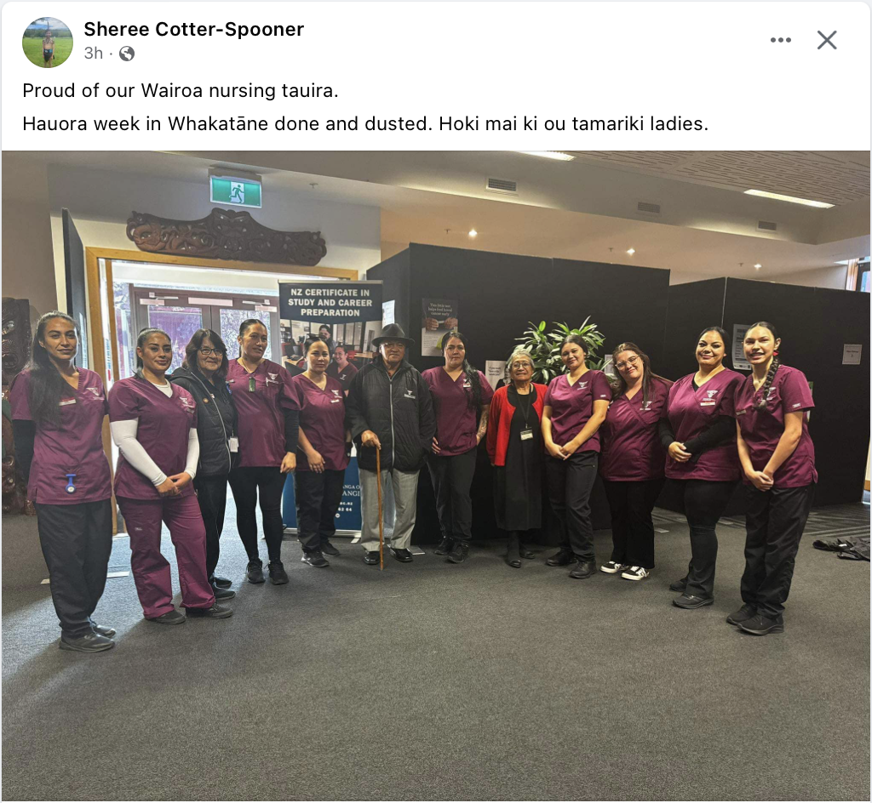

Te Whare Wānanga o Awanuiārangi (TWWOA) committed to increasing nurses in Te Wairoa. After discussions with Wairoa Hospital staff, the deputy mayor, Denise Eaglesome, local health providers, and the public, it became very clear that Wairoa was struggling to entice registered nurses to the district. The removal of local residents from Glengarry Lifecare Rest Home - Age Concern - was the catalyst in starting the discussions. A lack of registered nurses meant that residents had to be placed in Age Concern facilities across the country. The impact of COVID-19 and cyclone Gabrielle magnified the lack of health care workers especially in small, isolated areas such as Te Wairoa.

TWWOA provided the New Zealand Study and Preparation certificate to the local community. 14 students from Te Wairoa engaged in this programme that focused on bridging students directly into Te Ōhanga Mataora: Bachelor of Māori Nursing.  Of the 14 students, nine have enrolled and started their study journey (pictured above).

TWWOA are also in discussions with a Napier based trust, exploring the options of delivering the Bachelor of Nursing to Philippine based tauira.  This initiative will bring a larger workforce to New Zealand.

# Mary Schnackenberg(Tāmaki Makaurau)

**Environmental scan/real time monitoring and services**

The need for all of us to remain healthy is not adequately supported by the current stressed health system. In particular, accessible information is not generally available in preferred formats. This is about the language of the health system for print disabled people and others who do not have English as their first language as well as the formats of the documents to be read.

One colleague had a pacemaker fitted in March 2023. Still, she has not received clear instructions in Braille about diet and so on.

Another colleague has chronic reflux. A computer attached to a tube fed through the nose was to be fitted for a 24-hour monitoring process prior to future decisions about treatment. A fully accessible pamphlet which she read with her speech laptop assured her the computer was fully accessible. During the fitting of the nasal tube and the computer, she discovered the computer had an inaccessible touchscreen with no verbal prompts. The procedure was stopped. Later the specialist apologised and said he had to update the pamphlet she had been given which contained incorrect information about the computer.

**Services**

At my most recent meeting of the Pharmac Consumer Advisory Committee I helped Pharmac to consider accessible information relating to their medical devices as well as their medicines.

Responsible use of medicines is an ongoing theme for Pharmac. Only one underlying barrier is a lack of access to information about the medicines, dosages and possible side effects.

**Recommendations**

At a time when no sector of the health system has adequate resources, prioritising collaboration and networking is, for me, a key to improving quality services.

**Lisa Lawrence (**Whakatū)

**Environmental scan/real time monitoring**

The unplanned transitions under the current government settings are opening information gaps. The relationship structure with consumers, whether that’s mandated consumer councils, PHO initiated committees or NGO health services is unclear and feedback loops appear to have dissolved under changes to contracting arrangements. There doesn’t appear to be clear line of sight on what the newly created systems are intended to look like and how consumer feedback will the incorporated into health structures.

**Services**

Provision of diabetes support services for those that are homeless is proving tricky to improve. The need for refrigeration of medicines is a continual challenge with natural waterways being employed to try and address this.

**Positive stories and exemplars**

The Te Tau Ihu a Waka a Maui rohe hosted the secondary schools kapa haka competitions, with over 15,000 kaihaka, Kaiako and ringawera descending on the rohe and bringing the ihi, the wehi and pukana galore to the stage. All of those that stood did their whānau proud.

All local health services hosted stalls at the market that ran for the duration of the competition. Auahi kore and other Māori health promotion kaimahi canvassed tauira and their whānau on what helped them with their quit smoking and vaping decisions.

This information is being applied to the reformation of auahi kore and pepi first (quit smoking) for hapu māma services to explore how to overlap the brief with content that whānau said were important to them.

**Delphina Soti** (Tāmaki Makaurau) (St Vincent de Paul- General Manager)

**Emerging Trends/Issues/ Services:**

**Concerns or Issues:**

* + Extended wait times (6-8 hours) observed at Emergency Departments (EDs), impacting patient care.
  + **Treatment of LGBT+ Individuals in Hospitals:** Distressing reports indicate verbal and emotional abuse towards transgender and LGBT nurses and staff and lack of recognition or acknowledgment of LGBT+ individuals, leading to feelings of invisibility. It would be good to know what programmes and support is available.
  + **District Nurse shortages:** Appointments rescheduled due to staff shortages, particularly problematic during flu season and exceptionally cold winters with increased sickness.
  + **Housing conditions:** Extra cold winter. Dampness and mould remain prevalent issues for Pacifica and Māori, exacerbated by larger households combining due to economic pressures. Cold and damp homes have significant social and health impacts on families. Families opting to not heat homes due to high cost.
  + **Cost of Living:** High living costs forcing families to combine households to manage expenses, impacting health and wellbeing.
  + **Food insecurity:** Growing number of new working families seeking support each week, facing difficult choices between basic needs and health care visits.
  + **Access to GP appointments:** Difficulty in securing timely appointments, exacerbated by economic pressures and seasonal demands. Waiting 2 -7 days for an appointment so patients revert to going to ED or paying $100 at Whitecross.

**Positive Stories and Exemplars:**

**Exemplary Patient Care:** Highlighted areas include breast care clinics, oncology, cardiology, and the Hospital in the Home program, demonstrating excellence in patient-centred care and consumer engagement.

**Hospital in the Home Program:** Positive feedback on efficiency, wrap-around support from nurses, and accessibility of services. Patients and families appreciate the flexibility in choosing treatment locations. Also appreciate the efficiency of communication from nurses and accessibility to resources and also doctors when issues arise.

**Boyd Broughton** (Te Hā Oranga, Tāmaki Makaurau and Te Tai Tokerau)

**Environmental scan/real time monitoring**

The Minister has announced his continued intentions for IMPB to evolve strategic commissioning and monitoring functions with no extra funding.

A central hiring freeze within Te Whatu Ora is costing the region being able to employ GPs in a timely manner contributing to continued workforce challenges impacting on GP access.

Some high profile housing challenges and accessing childhood immunisation challenges in the north with GP books ‘closed’.

There are anecdotal reports emerging that ‘cost-of-living’ challenges are being eased on some fronts and in some parts of our Tāmaki and Te Tai Tokerau, such as fuel and kai prices slowly decreasing. Eased does not necessarily mean prices are lowering, it can also mean that prices are rising but the rate of that rise has slowed down recently.

New 150 bed hospital wing opened at North Shore hospital Tōtara Haumaru, at full capacity there will be a significant increase in surgeries on offer, currently well below full capacity with staffing challenges impacted by a ‘hiring freeze’ with all roles requiring centralised sign off causing delays and/or loss of new staff onboarding. It is planned to offer over 2,000 elective surgeries in year one and projected to grow to over 8,000 elective surgeries and 7,500 endoscopic surgeries annually. The challenge will remain to ensure those surgeries are allocated equitably.

Government Policy Statement on Health 2024-2027 released, with significant erasure of any reference to Te Tiriti o Waitangi, one reference to The Treaty, and one reference to equity.

An announcement today with the Minister of Health installing a commissioner (Professor Lester Levy) to replace the entire Te Whatu Ora Board with his letter of expectations to Mr. Levy found [here](https://454f39ce-282d-4767-85c2-7c8cb75cd93f.usrfiles.com/ugd/454f39_80a8c70425284293801e04c475e1e0ef.pdf). This follows a series of resignations from the previous Board and the Minister setting out his expectations clearly to the newly installed commissioner. From our point of view it will be interesting to see the focus on hospitals, primary care, and community health provision. He has been instructed to work closely with the Hauora Māori Advisory Committee.

**Services**

Local workforce development progress in the northern region:

* As per the last scan, one long-term solution to chronic and acute workforce challenges with a Bachelor of Nursing Māori planned to start in Te Tai Tokerau in February 2025 pending NZNO and NZQA approval.
* Some well-publicised access challenges in Te Tai Tokerau, even for those who are willing and able to get childhood immunisations facing barriers due to GP books closure. [Click here](https://www.teaonews.co.nz/2024/07/20/tessa-taurere-is-forced-to-drive-five-hours-if-she-wants-to-see-her-gp/?fbclid=IwZXh0bgNhZW0CMTEAAR3Duk2kDzLW5YtbybS45q50rx0Wm5faK6j79Ig-VBSZZHX0IDBOHutfLe4_aem__5bl9XwKt0Z2Brqfig1xmw) for media coverage of one such instance.
* IMPB, Te Whatu Ora, PHO, and others have a commitment to implementing solutions.
  + Some solutions being offered are upskilling student nurses to undertake immunisations.
  + Outreach capability of Māori providers being utilised in parts of Te Tai Tokerau.
  + Other workforce expansion of roles being discussed across the region to identify opportunities that are clinically safe.
* Whānau Ora Commissioning funding potentially up for tender. Iwi and Iwi-Māori Partnership Boards will await further information and remain interested if there are any improvements that would impact positively on whānau outcomes.

**Positive stories and exemplars**

Hard to recall a positive story in the health sector within our region in recent times.

**Recommendations**

That HQSC NZ continue to challenge hospital and primary care for greater investment in whānau Māori who are currently enrolled and unengaged, for solutions for whānau Māori who are unenrolled and unengaged, and if PHO are to remain then they compete to provide equitable access and outcomes for whānau Māori, not on their business or profit.

**General Comments:**

Continued challenges across the health sector.

It will be interesting to gauge the focus of HQSC during this time of austerity and the opportunity to utilise data to drive positive change for whānau Māori and others.