Minutes of the Te Tāhū Hauora
Young Voices Advisory Group
15 February 2024

Members | Natasha Astill, Naomi Vailima, Ataahua Hepi, Joshua McMillan, Tiare Makanesi, Jaden Hura-White
Chair | LJ Apaipo
He Hoa Tiaki | Partner in Care team | Anne Buckley, DJ Adams (part meeting)
Apology | Ciccone Hakaraia-Turner

1. Welcome and karakia
Jaden opened the meeting with a karakia on behalf of the group.

2. Minutes of previous meeting and matters arising
Minutes of the meeting on 28 November were accepted with no amendments and no matters arising.

Te reo Māori name
Jaden offered 2 te reo options he had considered for the group as a name:
- Ngā Mahuri Kōrero
- Te Rōpu Whakamana Taiohi

There was a lot of support for his suggested names with a general preference for the first option.

Action: LJ will take the idea to the Director of He Hoa Tiaki to see what/if any other process may need to be followed.

Bios
No changes to the bios requested by those at the meeting (Ciccone not present).

Action: Bios will go up on the Te Tāhū Hauora website once reviewed by all members.

Interests register
Members were asked to forward any information for the members’ Interests Register to Dez McCormack.

3. Regional workshops
Planning for the regional consumer workshops in Northland and Hastings continues. The workshops will be run by the consumer advisor team. The poster promoting the regional workshops will be sent out with the minutes. See also the He Hoa Tiaki report circulated with the agenda and included in Appendix 1.

The planned workshop activity on lived experience sharing my story was introduced by DJ.

Questions groups will be considering as part of the activity include:
- What is the importance of sharing our lived experience?
- How can I share my story in a way that keeps both myself and others safe?

The worksheet sent out to members is planned to be used as a ‘takeaway’. A list of support organisations was also sent with the agenda.

Some members had tested the worksheet thinking about their own experiences and provided feedback on their use of the worksheet to inform the advisor team.

Action: Josh will forward CanTeen resources on how to share your lived experience to LJ

4. Consumer health forum Aotearoa – Auckland 15 May
As part of the update, members were advised that one of the afternoon workshops will now be on the topic discussed in 3) above. A further workshop will be held on digital health equity. Members are invited to share any thoughts about what could be included in this workshop.

LJ outlined the role of the telehealth, digital health equity network and invited anyone interested to join up to this network: join here. Find out more: here.

For more about the forum in Auckland 15 May see also the He Hoa Tiaki report circulated with the agenda and included as Appendix 1.

5. Other business
Zoom meeting length
It was decided to make the next Zoom meeting 1.5 hours to allow more discussion time if needed.
There was no other general business.

6. Karakia and close of meeting
Jaden offered a karakia to close the meeting.
Next hui: Waipuna Conference Centre Auckland 14 May Clifton Room 10.45 am–5.00 pm

Action list
Date | Action | Responsibility
15 February 2024 | Te reo name – process to confirm the name to be finalised | He Hoa Tiaki staff
15 February 2024 | Bio to be approved for publishing on website | Ciccone Hakaraia-Turner
15 February 2024 | 2024 next zoom hui to be extended from 1 hour to 1.5 hours | He Hoa Tiaki staff

Appendix 1

He Hoa Tiaki report for Young Voices Advisory Group 15 February 2024
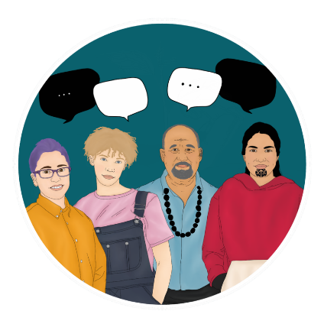
The following are highlights from the past few months with a focus on the second quarter of the financial year (1 October–31 December).

Consumer health forum Aotearoa

Consumer health forum Aotearoa events
Our Voices: Shaping health care together | Ō mātou reo: He tārai tahi i te tauwhiro hauora will be held on 15 May in Auckland at Waipuna Hotel and Conference Centre. The programme for the day is shaping up with the first 100 tickets sold and all early bird spots allocated.
The objectives of the forum are to:
- increase your confidence and learn more about taking part in consumer and whānau engagement health initiatives
- explore how the code of expectations is impacting the health sector
- hear how consumers, whānau and community perspectives are shaping the design and delivery of health services
- connect with others involved in consumer and whānau engagement in the health sector and share best practice
We are pleased to confirm our MC for the event, Ma’a Brian Sagala, QSM.
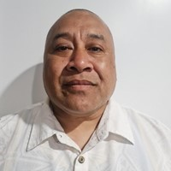
Brian has 30 years’ experience in public speaking, radio and facilitation. He has been a producer and presenter of 531pi with the Pacific Media Network since 2015 and has used his profile to support various causes within Pacific communities. Brian has helped host community fono with Pacific church leaders on a number of health and wellbeing issues. He was MC of Pasifika Festival from 2011 to 2019. He helped the then-Northern district health board with the Prepare Pacific COVID-19 campaign to communicate with harder-to-reach segments of the Pacific population during the pandemic, relaying key messaging to the community. While travelling the Pacific region for work, Brian has performed outreach work in local communities in his own time.
Figure 1- headshot of Ma'a Brian Sagala, QSM in front of a white background
Event webpage: Our voices: Shaping health care together | Ō mātou reo: He tārai tahi i te tauwhiro hauora | Te Tāhū Hauora Health Quality & Safety Commission (hqsc.govt.nz)

Registrations: https://hqsc.eventsair.com/cmspreview/ourvoices2024/

North Island consumer workshops

In addition to our national consumer health forum event, we are holding three regionally based workshops for consumers interested in helping the health system design services for the communities they serve. These workshops are aimed at those new to consumer and whānau engagement and those who have some experience with it. They will take place over two weekends in March. Below are the locations and timings:
- Friday 15 March 2024, 10.00 am–1.00 pm, Terenga Paraoa Marae, Whangārei
- Saturday 16 March 2024, 10.00 am–1.00 pm, Te Ahu, Kaitaia
- Saturday 23 March 2024, 10.00 am–1.00 pm, Te Taiwhenua o Heretaunga, Hastings

There will be an afternoon workshop in Hastings on Saturday 23 March 2024 hosted by the Office of the Health and Disability Commissioner about the Code of Rights (www.hdc.org.nz).

We encourage both Te Kāhui Mahi Ngātahi and Kōtuinga Kiritaki members to share information about the upcoming regional events with their networks.
For more information visit: https://hqsc.eventsair.com/ourvoices2024/north-island-consumer-workshops.

Consumer opportunities
Since 1 Jan 2023 we have seen a growing interest in consumer opportunities through the consumer health forum Aotearoa. To date, we have been able to assist 24 organisations to recruit over 199 consumers to share their expertise via joining consumer councils and networks focus groups, and/or advisory, steering or governance groups. Examples of these include:
- consumer advisors recruited by Pharmac,
- consumer advisory committee and panels with Manatū Hauora,
- working groups and consumer councils with Te Whatu Ora,
- advisory groups with ACC and
- focus groups led by HDC.
In addition, consumer health forum members have been given opportunities to share their thoughts and experiences through several surveys and consultation activities on areas of health such as mental health and addictions, advanced care planning and alternative medicines. The following table provides a breakdown of consumer opportunities by category.

Type of opportunities | Number of opportunities advertised | Participation figures
Advisory, steering and/or governance group | 27 | 81
Focus groups | 9 | 118
Surveys, (including user-testing IT solutions) | 6 | n/a due to confidentiality
Totals | 43 | 199+

As the Consumer health forum Aotearoa gains membership and awareness these opportunities are only expected to increase. Each opportunity listed and promoted is the result of a thorough engagement process between the health sector and He Hoa Tiaki. Through each of these engagements, we take the opportunity to share resources, best practice examples, and advice about genuine engagement practices, the code of expectations, and co-design.
Since 1 Jan 2023 we have had 5,037 views to our consumer opportunities webpage. Please keep sharing these with your networks as they come through our website, newsletters and media channels.

Forum membership
The total number of individuals who have signed up to the consumer health forum Aotearoa forum members is 899 (as of 31 December). We continue to encourage new membership, and work towards our goal of 1,000 members this year. Help the forum grow by sharing this sign-up link with those in your network.
The following table shows the breakdown of members by ethnicity from end of quarter 4 2022–23 through end quarter 2 (31 December 2023).
Ethnicity | Quarter 4 2022–23 | Quarter 1 2023–24 | Quarter 2 2023–24
Māori | Quarter 4 total: 153 (18.4%) | Quarter 1 total: 170 (19.0%) | Quarter 2 total: 174 (19.4%)
Pacific | Quarter 4 total: 87 (10.1%) | Quarter 1 total: 91 (10.2%) | Quarter 2 total: 91 (10.1%)
Asian | Quarter 4 total: 39 (4.5%) | Quarter 1 total: 42 (4.7%) | Quarter 2 total: 43 (4.8%)
Pākehā/Caucasian | Quarter 4 total: 482 (56.0%) | Quarter 1 total: 494 (55.3%) | Quarter 2 total: 494 (54.9%)
Middle Eastern/ Latin American/ African | Quarter 4 total: 17 (2.0%) | Quarter 1 total: 18 (2.0%) | Quarter 1 total: 18 (2.0%)
Other ethnicity or ethnicity not specified | Quarter 4 total: 77 (9.0%) | Quarter 1 total: 78 (8.7%) | Quarter 2 total: 79 (8.8%)
Total | Quarter 4 total: 860 | Quarter 1 total: 893 | Quarter 2 total: 899

Young Voices Advisory Group
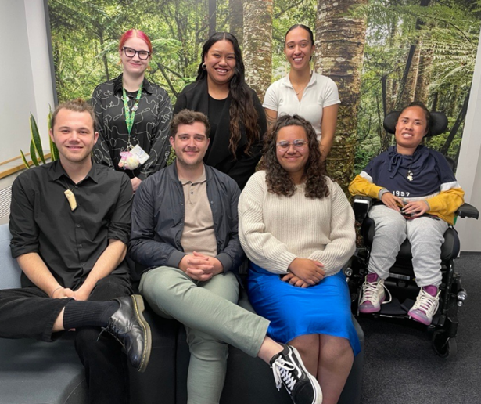
The Young Voices Advisory Group join Te Kāhui Mahi Ngātahi Consumer Advisory Group (CAG) and Kōtuinga Kiritaki Consumer Network (CN) in bringing the consumer and whānau perspective to the work of Te Tahu Hauora and He Hoa Tiaki, representing the voices of young people.
Figure 2-Members of Young Voices advisory Group standing in front of a forest background. Back row L-R: Natasha Astill, Tiare Makanesi, Ciccone Hakaraia-Turner. Front row L-R: Jaden Hura-White, Joshua McMillan, Ataahua Hepi and Naomi Vailima.

In November, the group of seven members met first by Zoom and then again in person in Wellington. The advisory group provided additional input on our planned regional workshops and developing consumer engagement resources. They were introduced to the roles of Te Kāhui Mahi Ngātahi and Kōtuinga Kiritaki were able to learn more about the work of He Hoa Tiaki and more broadly, the work of Te Tāhū Hauora. We look forward to working with these inspiring young people!

Welcome Lisa Lawrence to Te kāhui mahi ngātahi

In November, Lisa joined Te kāhui mahi ngātahi and was able to join the final meeting for 2023. Her experience as a consumer advisor includes lay representative on the New Zealand Psychologists Board, a Māori consumer representative for specific New Zealand College of Midwives audit/review projects, a member and chair of the Pharmac consumer advisory committee and a current member of the Māori advisory committee to the Nelson Bays Primary Health board. We are delighted to welcome Lisa to the team. Lisa’s full bio is available on our consumer advisory group webpage.

Code of expectations and implementation guide

The team’s work socialising the code of expectations and implementation guide continues through a wide range of engagements across the sector. As the implementation guide has now been available online for 6 months, we are focused on identifying which areas of the guide need amending, updating or expanding. Consumer Voice Reference Group (CVRG) members have been invited to complete a survey and there is an offer to hold focus groups within some of the health entities to identify further practical changes for the guide. Website traffic statistics, similar to the table below are prepared regularly for the CVRG group and used to determine public engagement with the guide’s content.
The table below provides a summary of website traffic to the code of expectations, implementation guide, Co-design, Consumer health forum Aotearoa consumer opportunities and other forum- focused webpages over the Q1 and Q2 periods (July 1–31 December) More details, including social media engagement are available in Appendix a.

Tabe 1 Summary of website traffic
Description of content and link to web page | Quarter 1  1 July-  30 September | Quarter 2  1 October- 31 December
Understanding co-design | Kia mārama ki te hoahoa tahi here | Views: 667  Users: 426 | Views: 518  Users: 375
Consumer health forum Aotearoa | Wāhi whakawhiti kōrero hauora (landing page) here | Views: 930  Users: 656 | Views: 767  Users: 542
Consumer opportunities Tā te kiritaki whai wāhi here | Views: 1619  Users: 964 | Views: 1840  Users: 1010
Code of expectations for health entities’ engagement with consumers and whānau | Te tikanga mō te mahi tahi a ngā hinonga hauora ki ngā kiritaki me ngā whānau here | Views: 2011  Users: 1117 | Views: 1594  Users: 961
Code of expectations for health entities’ engagement with consumers and whānau here  (This page hosts the code translations and accessible formats) | Views: 1395  Users: 820 | Views: 1267  Users: 821
Code of expectations implementation guide |  Te aratohu tikanga (landing page here) | Views: 1862  Users: 940 | Views: 578  Users: 320
Co-designing with consumers, whānau and communities | Hoahoa tahi me ngā kiritaki, ngā whānau me ngā hapori here | Views: 793 Users: 447 | Views: 328  Users: 217
Using lived experience to improve health services | Te whakamahi wheako mātau hei whakapai ake i ngā ratonga hauora here | Views: 389  Users: 243 | Views: 245  Users: 165
Improving equity through partnership and collaboration | Te whakapai ake i te mana taurite mā te mahi tahi here | Views: 276  Users: 176 | Views: 107  Users: 76
Accessibility and resourcing for consumer, whānau and community engagement | Te whai wāhi me te whai rauemi mō te mahi tahi ki te kiritaki, te whānau me te hapori here | Views: 269  Users: 146 | Views: 107  Users: 58

Quality and Safety Marker for consumer engagement (QSM)
Due to the large-scale changes in the wider health sector we offered some flexibility for this past reporting period, ending 30 September. We extended the due date for submissions, reached out to each district individually, and offered support and guidance. Once received, the moderation team offered detailed feedback on each submission and indicated where stronger background evidence and or examples could be more explicitly linked to the code of expectations. This activity has allowed us to establish a number of new relationships and strengthen some existing connections within the districts. Nineteen out of twenty-four submissions have been published, including best practice examples. The next QSM reporting period ends 29 March 2024.
The Quality and Safety Marker for consumer engagement framework can be viewed in PDF or MS word formats on our website. Work is progressing to add further accessibility options and/or functions. The team would like to thank consumer network member, Oliver Taylor for his time and advice with moderating the submissions.

Engagements
For the period of 1 October–31 December, He Hoa Tiaki team took part in 148 separate events, engaging widely across the sector and at multiple levels.
Key aspects of these engagements included:
- supporting organisations with the consumer quality and safety marker (QSM) submissions
- helping services to develop opportunities and recruit consumer forum Aotearoa members to projects
- discussions with Te Whatu Ora districts, other health entity representatives, NGO’s and foundations
- hosting the multi-agency Consumer voice reference group (CVRG).
- presentations on the code of expectations and other pillars of our work programme. More details of key presentations are below:
- BMJ international conference (Melbourne): Deon York presented on the code of expectations for health entities’ engagement with consumers and whānau and its role in the reforming health system.
- Te Whatu Ora Te Pae Hauora o Ruahine o Tararua Midcentral: DJ Adams presented at the consumer information day on the code, the code implementation guide and the consumer engagement quality and safety marker
- Designated Auditing Agency (DAA) auditor update conference: Anne and DJ gave a presentation on the code of expectations, the code implementation guide and the QSM.
Engagement with Te Whatu Ora consumer and whānau engagement team

Our team is building a collaborative working relationship with the consumer and whānau engagement team of Te Whatu Ora. Many of the Te Whatu Ora team were previously known to us, and we are looking forward to getting to know the new members of the team. We will be sharing our forward work plans, and from a Te Tāhū Hauora perspective, we will be closely focusing on our role and functions as set out in the Pae Ora Act 2022 and this will complement the work of Te Whatu Ora and minimise duplication. Collaboration will be important to achieve this.
We know that there is uncertainty about the structure of consumer advisory groups at the district or regional level. The Te Whatu Ora team will be looking at these former DHB structures. Te Tāhū Hauora recognised the significant changes and pressures of the reforming system and wanted to do our part to reduce barriers for the continuation of consumer council chairs meeting regularly and supported those who required it throughout the formation of Te Whatu Ora and the roll out of the Pae Ora Act (ie, over two years).
It was signalled that from 1 July 2023 that we would continue to support the consumer councils according to our functions. This does not change the ongoing relationship with the consumer councils/advisory groups as they evolve, but the infrastructure to support consumer councils and advisory groups, and how policies will be rolled out to support these structures is now managed by Te Whatu Ora in place of DHBs. We will continue to champion consumer engagement at all levels of the system.

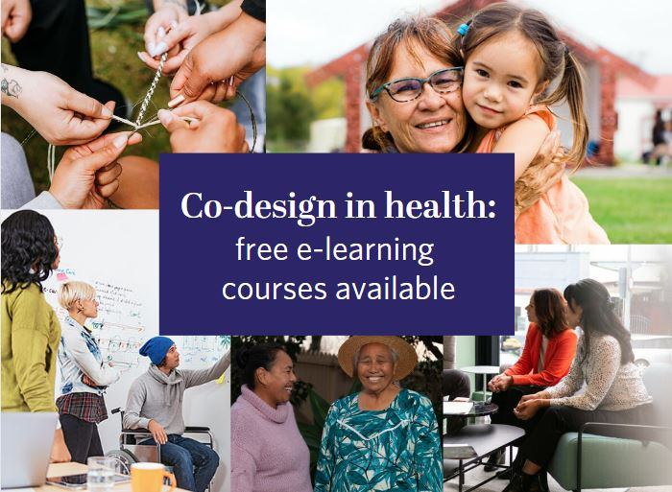
Co-design courses
Our co-design courses continue to be well-used and recommended by health organisations, staff and consumers alike.
This resource has now been accessed 1404 times compared with 1277 in Quarter 1 and 1093 times in Q4 last financial year.
If you haven’t had a chance to complete the courses, this is a reminder that they are available anytime at no cost. First-time LearnOnline users need to create a login. For more information, please visit the co-design course webpage.

Appendix A: Website analytics
Our website remains our main engagement tool and is used widely. In 2023, we recorded 921,000 views across the website by 162,000 users. Our analytics show that 39 percent of users scrolled 10–90 percent of the pages they visited, showing good engagement with the content. We also recorded 155,000 file downloads.
Te Tāhū Hauora Health Quality & Safety Commission’s website analytics now collects data differently as ‘users’ rather than ‘unique views’. The website data shows varied engagement across different sections in quarters 1 and 2. Key highlights include:

- ‘Understanding co-design’ with 667 views (quarter 1) and 518 views (quarter 2),
- Consumer opportunities has seen a significant increase in traffic with 1840 views I quarter 2 and
- ‘Code of expectations for health entities’ with 2011 views (quarter 1) and 1594 views (quarter 2).

Summary of website traffic

Description of Table 1
Understanding co-design had 667 views (426 users) in quarter 1 and 518 views (375 users) in quarter 2. Consumer health forum Aotearoa landing page had 930 views (656 users) in quarter 1 and 767 views (542 users) in quarter 2. Consumer opportunities had 1619 views (964 users) in quarter 1 and 1840 views (1010 users) in quarter 2. Code of expectations for health entities’ engagement with consumers and whānau had 2011 views (1117 users) in quarter 1 and 1594 views (961 users) in quarter 2. The code of expectations translations and accessible formats page had 1395 views (820 users) in quarter 1 and 1267 views (821 users) in quarter 2. The code of expectations landing page had 1862 views (940 users) in quarter 1 and 578 views (320 users) in quarter 2. Co-designing with consumers, whānau and communities had 793 views (447 users) in quarter 1 and 328 views (217 users) in quarter 2. Using lived experience to improve health services had 389 views (243 users) in quarter 1 and 245 views (165 users) in quarter 2. Improving equity through partnership and collaboration had 276 views (176 views) in quarter 1 and 107 views (76 users) in quarter 2. Accessibility and resourcing for consumer, whānau and community engagement had 269 views (146 users) in quarter 1 and 107 views and 58 users in quarter 2.

Social media
Our content featured in the reshared most popular posts from 2023. These include Our voices and the code of expectations implementation guide and co-design modules.
We generated new context to re-promote accessibility videos featuring Mary Schnackenberg. This post had successful engagement including reshares from Paula Tesoriero MNZM, Carmela Petagna and Whaikaha, Ministry of Disabled People.
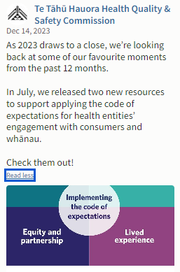
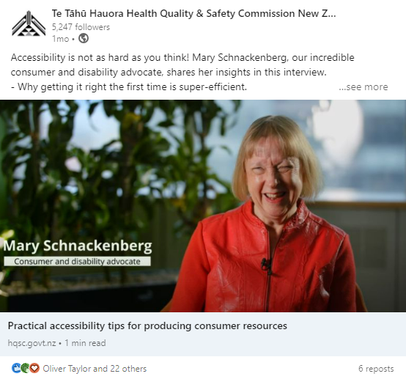

LinkedIn
Out of the top ten best-performing organic posts for Te Tāhū Hauora, only one of posts featured. Ranked #3 across the organisation was the Young Voices Advisory Group:
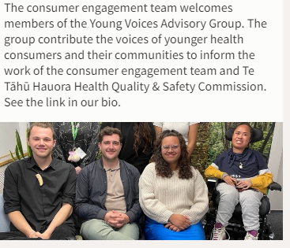
- Clicks: 25
- Engagement: 10 percent
- Impressions: 704
- Reactions: 42
- Shares: 5

Facebook
Out of the top ten best-performing organic posts for Te Tāhū Hauora, three were content from He Hoa Tiaki. The top posts across Te Tāhū Hauora were for the Young Voices Advisory Group with an engagement rate of 10.24 percent and new consumer opportunities with an engagement rate of 8.01 percent. The third best performing post was the Te Tāhū Hauora Health Quality & Safety Commission newsletter which has an engagement rate of 7.84 percent.
Our top posts ranked first, second and sixth across the organisation.

Instagram
60 percent of the top ten best-performing organic posts for Te Tāhū Hauora were He Hoa Tiaki content. The top post ranked first for Te Tāhū Hauora was our post for the Young Voices Advisory group with an engagement rate of 10.24 percent.
Our top posts ranked first, fifth, sixth, eighth, ninth and tenth across the organisation. These included Our voices, featured consumer opportunities, #RACMA2023 and Aotearoa Patient Safety Day.
The top post ranked #1 across the organisation was young voices on 27 November 2023:
- 126 impressions and 29.57 engagement rate.
- Engagement: 24
- Comments: 2
- Likes: 24

