

**Minutes of the Kōtuinga Kiritaki / Consumer Network**

|  |  |
| --- | --- |
| Chair | DJ Adams |
| Members | Mary Schnackenberg Joanne Neilson, Oliver Taylor, Ricky Ngamoki, Jennie Harré-Hindmarsh, Zechariah Reuelu, Tyson Smith, Toni Pritchard, Amanda Stevens, Vishal Rishi |
| Māori health & Consumer Team | Jim Wiki, Dez McCormack |
| Te Tāhū Hauora staff: | Arana Pearson |
| Guests | Peter Jansen, CE; Caroline Tilah, Senior Manager System Safety |
| Apology | Mark Rogers |

The hui was held at Rydges Wellington Airport, on **22 August 2024**.

The hui began at 9.00 am.

### 1. Welcome and karakia

DJ welcomed the group and opened the meeting with a karakia.

### 2. Whakawhanaungatanga

### This was the first Kōtuinga kiritaki consumer network hui Jim has attended, and time was taken for whanaungatanga.3. Standard business

Previous minutes: these were accepted as correct.

Action items:

One action completed.

|  |  |  |
| --- | --- | --- |
| 16 May | Letter of thanks go to the kapahaka group and acknowledge their whakamana of the kaupapa. **Completed** | DJ Adams |

One item not complete and carried forward. See actions list below.

Interests register:

Previous updates circulated prior to the meeting. (One extra to include in November (Oliver))

### 4. Feedback on previous Te Kāhui Mahi Ngātahi CAG hui –

Mary gave the update on the last Te Kāhui Mahi Ngātahi hui and provided a written report as follows:

HQSC has four groups of consumer advisors across the organisation:

• today's Consumer Network, Kōtuinga Kiritaki;

• Consumer Advisory Group (CAG) Te Kāhui Mahi Ngātahi – I am a member of both groups;

• Te Kāhui Piringa which represents the Māori consumer voice; and

• Young Voices Advisory Group, formed in November 2023.

There are consumer advisors on other groups in HQSC. HQSC promotes consumer advisor roles in other health-related entities through its emails, newsletters and its website.

The Consumer Advisory Group met on 31 May. I was not able to attend as I was caught up in May with two conferences in Perth and Auckland about accessible format publishing.

The 31 May minutes reported updates on changes at HQSC. There was considerable discussion about the need to support clinicians from overseas to acquire cultural competency in the New Zealand context. Difficulties in achieving consumer engagement at the regional level were raised. There will be fewer mortality reviews because of budget cuts.

We met again on 25 July. In the morning, we had a joint hui with Te Kāhui Piringa. Here we discussed the HQSC restructure and honoured those who have left the Commission. Peter Jansen said that in discussions with Health New Zealand he was repositioning HQSC to support Health New Zealand with more data and research.

In the afternoon the Consumer Advisory Group worked through our own agenda. We run a consumer lens over some Board papers although there were no papers on this agenda for us to review. Our co-chairs take turns to attend HQSC Board meetings. To save money our chairs had been asked to attend the Board meetings via Zoom. We asked that this request be reviewed as face-to-face contact at these meetings is crucial for our co-chairs as it is for the Board members themselves.

Our environmental scans included comments about a breakdown in consumer advisor feedback in the health system restructure and upheaval. Diabetes medicines are being stored in local waterways by some homeless patients who are unable to access refrigerator storage. This health and safety issue has been brought to the attention of the HQSC Board.

Warm thanks to those of you who were able to attend the 15 May Our Voices: Shaping health care together event. While there are always lessons to be learned, much information was exchanged and enthusiasm for HQSC work was shared. Make sure you are on the HQSC Consumer Health Forum Aotearoa email list to receive newsletters and visit the website for resources which are regularly added.

### 5. Māori Health & Consumer report and update

DJ provided this update. This Māori Health and consumer report is tabled as Appendix 1.

DJ spoke about increases in CHFA numbers and changes in ethnicity membership data. The team will look at ways we can further promote the forum and the new regional consumer councils.

Mention made of telehealth funding being removed and what effect this may have on consumers and services.

QSM for consumer engagement. Reporting for Health New Zealand Te Whatu Ora has changed to regional. We will work closely with regional leads on maintaining fair and equitable input for their whole geographical regions. The website will be changed to reflect this.

DJ gave an update on the new regional council structure and congratulated Kōtuinga Kiritaki members who are on the councils.

We will follow-up further in November re the new Aotearoa New Zealand Rare Disorders strategy with Mark Rogers who was involved in development of the strategy and discuss what involvement Te Tāhū Hauora will have.

### 6. Members reports

DJ mentioned the new monthly insights reporting up to the minister and that a questionnaire is being developed to send to our consumer groups. Keep a look out for this email.

Also mentioned that we will seek video from members for the Board’s consumer story, which they have now at the start of each board hui. This is a 5-minute video focusing on consumer experiences/stories in the health sector.

Members reports are at Appendix 2.

Reports were taken as read and all members provided with the opportunity to highlight an item from their reports.

Toni - spoke of the importance of telehealth in her area and the benefits for rural people. Hope the lack of funding does not affect this.

Joanne – spoke of misgendering for a staff person at work. There has been a rainbow workshop held to try and explain terms etc.

Amanda – in hui, being blind, if someone is interpreting for a deaf person, they need to explain how the person identifies - female/male etc.

Deaf blind working towards definitions for deaf/blind. A lot of work required here. i.e. tactile communication standards.

Zechariah – positive story from report re communicating in a person’s language so they understand the effects of conditions and illness.

Vishal – surveys don’t always reflect what is happening on the ground. Particularly for Asian. The information needs better analysis of Asian respondents against the general data. There is a rise in obesity and mental health issues, and a greater need for access to public health The Asian Health report will be launched at parliament next week (Tuesday 27 August 2024).

Mary – and her partner dealing with an older family member with memory loss. They have a worry as age progresses that she will revert to her mother tongue. Hard to get families to agree with best way to support and who gets enduring power of attorney. Many families are facing these issues and support for the older person is often a 2nd consideration. Safe language is important around decision making.

Ricky – funeral costs particularly burial is way too expensive and community struggling with expense Presenting at ED is challenging. If someone needs urgent help, it better to go to ED in an ambulance.

Tyson – disappointment in specialist mental health clinician who didn’t communicate at all very well and wasn’t able to speak clearly and appropriately to a person seeking help.

Oliver – Kōrero Mai being restarted at Lower Hutt hospital. Good to see support from consumers who were interviewed. Valuable insights gained for the implementation of this project at Hutt Hospital, which will be analysed at an upcoming workshop.

Jennie – reiterated her frustration about the chaotic health system and how it is politically driven. Also to take seriously the report from the Royal commission of inquiry into historical abuse in state and faith-based care. There is more awareness needed. Also noted the proposed repeal of section 7AA of the Oranga Tamariki act is dangerous and not evidence based or logical.

Arana - acknowledged that the written word doesn’t reflect the lived experience. Pleased to see a medication change for a person who he represented. Sometimes community representation on behalf of someone is required.

### 7. Future direction for Te Tāhū Hauora and questions

Peter Jansen mentioned the recent restructure, and the new teams. Smaller ELT, teams and some joined together. Appointment soon made to new Director of Māori Health & Consumer.

We have less money to do things. We need to change focus to what we must do. Go back to what the legislation says. We must have intelligent analysis by receiving lots of info and sending out reports and making appropriate recommendations. This heavily involves consumers, whom we must listen to.

The Board requires real life consumer stories – which are at the start of their hui. It needs to be direct and can be whatever you want to say.

Remember the 3- legged stool of intelligent analysis – experts in data, clinical and consumer.

We need to see what can be handed over to other entities – i.e. ACP, IPC, Trauma health.

Mental Health and Addictions (MH&A) will continue with Te Tāhū Hauora for another year. Some real gains in “zero-seclusion”.

Reset of Health New Zealand Te Whatu Ora – acknowledged a lot of information in the public space including some misinformation. Peter Jansen and Rae Lamb (Te Tāhū Hauora board chair) had a very constructive hui with Professor Levy (Health New Zealand Te Whatu Ora commissioner) around how we can help.

The Minister of Health has asked Te Tāhū Hauora to provide a monthly report while the re-set to Te Whatu Ora is underway. The commission is tasked with this to represent the public and staff’s feedback. Critical info will come from consumers and clinicians. An invitation for volunteers (un-paid) to complete a quick questionnaire will be sent.

An expert group will look at the data and information to develop an Insights report for the minister with thefirst being due on 18 September.

Q. How can the consumer team do everything under new structure? It will be referring to other teams to involve consumers first, and those other teams will then do the work.

Q. Will reports be given their due attention and action? There is always that risk, but we need to continually provide and push information, to get the changes needed for improvement. Ask questions around why things are a certain way.

Q. Will the analysis framework include specific approaches such as holistic for Pacific people?. If data is provided without action, people will stop providing. Yes agree - we need to respect the data and define analysis.

Q. What are the questions for insights report? 1. What’s working well in system. 2. Can you advise what areas we need to work on. These are quite broad but can be refined over time.

We will protect informants and legal advice has been obtained on this.

We will need to consider any support (counselling) for those providing sensitive information.

### 8. Final SPE confirmed.

DJ spoke to our two SPE deliverables.

SPE deliverable 1: up to four case studies including Primary care and community care:

DJ shared the example of Carterton Community Health Forum, the local medical centre establishing a local health consumer forum, using the code of expectations as a framework.

Discussion around what the spread of primary care maybe – it can involve local NGO’s and Iwi and Māori providor organisations. Suggested we talk to College of GPs for getting in touch with primary care providers.

Community pharamacies maybe another source.

Primary care providers at medical centres.

SPE deliverable 2: increase impact of Consumer Health Forum Aotearoa (CHFA). How can we increase engagement and measure this.

Consumers want to know how to advocate. Perhaps workshops and tools on how and where to do this. How can all consumer groups feed in and be supported by the CHFA

### 9. Regional workshops – locations and content

Content – Advocacy tools – explaining primary care/clinical services and other support services. Teach the benefit of taking support people to appointments.

Where – Tairāwhiti (due to impact of cyclone Gabriel), will need to check with the community if they are ready. Te Wai Pounamu was identified as a region that we need to consider.

There was also a wide ranging conversations about access to doctor surgeries.

### 10. Discuss ways in which we can better utilise the CHFA

This discussion was covered in topics above and will be an ongoing question to ask.

It is important to understand how we currently engage with the members of the CHFA – a regular ‘Update and news’ email, sharing work in in the health consumer space and highlighting consumer opportunities (Expression of Interests (EOIs).

Identifying areas of membership that need development – priority populations and geographical spread.

Workshops and forum are ways we can engage with the members, but how else can we increase and improve engagement opportunities.

### 11. Discuss approach to the Aotearoa New Zealand System Safety Strategy

Caroline Tilah presented a PowerPoint. A literature review was undertaken to determine the approach to the strategy. Major points from the review:

* No national strategy incorporates all system safety concepts
* An opportunity for Aotearoa New Zealand to integrate these elements into a principles-based strategy.
* Patient and whānau involvement is crucial
* Healthcare workers also play a crucial role in system safety strategies.

The approach to the strategy will be a principles-based system safety strategy facilitated by a Aotearoa New Zealand systems safety strategy rōpū, connecting multiple health care stakeholders to establish a combined understanding of system safety and a collective statement of commitment for system learning.

There was a question-and-answer session re stakeholders, challenges to getting the strategy off the ground, and how changes will be measured. Consumers will be involved at all stages and will be on the main working group.

### 12. Acknowledge He Hoa Tiaki Partners in Care and staff who have left

### Dez and DJ acknowledged members of He Hoa Tiaki Partners in Care (disestablished) who are no longer with Te Tāhū Hauora and the impact they had brought to our mahi over the years. Mention was also made of Gillan Bohm who regularly attended Kōtuinga Kiritaki consumer network hui.

### 13. Comments and wrap on today. Other business

Tyson provided a link to Convergence Aotearoa website, and the group navigated through the Information hub. The information here is very useful including various contacts and documents with ‘easy read summaries’: [https://cpsle.org/information-hub/](https://aus01.safelinks.protection.outlook.com/?url=https%3A%2F%2Fcpsle.org%2Finformation-hub%2F&data=05%7C02%7CDez.McCormack%40hqsc.govt.nz%7C74d1898b2ab04a1894eb08dcc24c66c5%7C701cefdf35f44444863855f0e12ab1c4%7C0%7C0%7C638598880663001714%7CUnknown%7CTWFpbGZsb3d8eyJWIjoiMC4wLjAwMDAiLCJQIjoiV2luMzIiLCJBTiI6Ik1haWwiLCJXVCI6Mn0%3D%7C0%7C%7C%7C&sdata=PcgTbYnuFatBMRzq%2Bu0zlWGlSwaGjeRcl%2F2%2FMTnZo0k%3D&reserved=0). This link was shared with all Te Tāhū Hauora staff.

All members commented positively on the day and the benefit of having Peter speak to the group. There was a general feeling on invigiration.

### 14. Karakia and close

DJ closed with karakia

**Next hui:** 7 November 2024 – Rydges Wellington Airport. Join hui with Te Rēo Māhuri Young Voices Advisory group.

### Actions list

|  |  |  |
| --- | --- | --- |
| **Date** | **Action** | **Responsibility** |
| 16 May | Letter of thanks go to the kapahaka group and acknowledge their whakamana of the kaupapa. **Completed** | DJ Adams |
| 16 May | **Carried forward** - Work with Te Whatu Ora re promotion of local voices after the shift to Regional Consumer Councils | DJ Adams |
| 22 August | further discussion at November hui re Rare Disorders strategy | For agenda |
| 22 August | Share telehealth link **(actioned)** | DJ |

### Appendix 1

Māori health and consumer team report 22 August 2024

The following are highlights from the past few months with a focus on the fourth quarter of the financial year (1 April - 30 June 2024). At the time of this report the Māori health and consumer team has been established and operating. The total number of the new team will be six, with three vacancies yet to be filled.

***Consumer health forum Aotearoa***

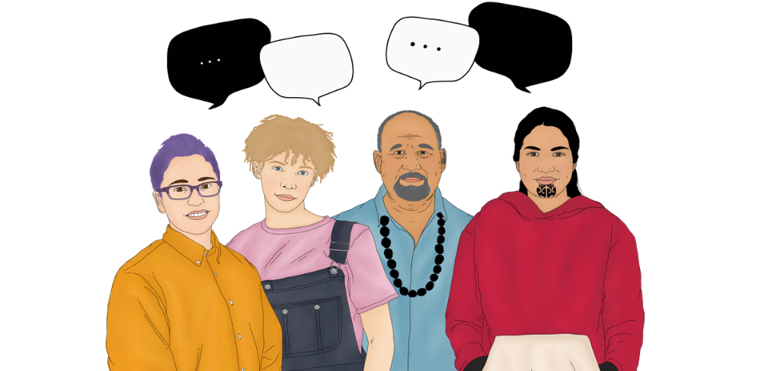

Consumer forum opportunities

Consumer opportunities - EOIs and events and sharing these through the membership of the consumer health forum Aotearoa continues to be important activity.

All current opportunities are listed on our website here: [https://www.hqsc.govt.nz/consumer-hub/consumer-health-forum-aotearoa/consumer-opportunities/.](https://www.hqsc.govt.nz/consumer-hub/consumer-health-forum-aotearoa/consumer-opportunities/)They are updated regularly and are also promoted via our newsletters and via social media. Please share widely any opportunities your networks may be interested in.

This year (2024/25) we will concentrate on the impact these opportunities provide to consumers, whānau and the sector. We will have discussions with consumers and project teams to understand more about their experience of working together. We will need to track the contribution consumers make and examine the impact that consumers are having on shaping design, delivery and evaluation in the health sector.

Our Voices: Shaping health care together | Ō mātou reo: He tārai tahi i te tauwhiro hauora

Thank you for attending and contributing to the national event on 15 May in Auckland at Waipuna Hotel and Conference Centre. We were pleased with the support for, and attendance on the day by consumers, whānau, NGOs and the health sector.

The day was appropriately opened with haka powhiri, and we are grateful for the opportunity to work with Ngāti Paoa in delivering a stirring and enlightening ceremony and guidance throughout the whole event. A privilege to support the Tāmaki college kapahaka rōpū and their public debut.

Many thanks for an inspirational performance presented by young Pacific people who live with disability.

Both the consumer and whānau voice, and leaders of the sector panel discussions were well received. Particular recognition and thanks to our Kōtuinga kiritaki members Edna Tu'itupou-Havea, Tofilau Bernadette Pereira, Toni Trinick-Pritchard and Zechariah Reuelu. Also, we acknowledge Jaden Hura-White member of Ngā reo māhuri young voices advisory group.

The four workshops received mixed reviews and provide opportunity for improvement.

* Digital health equity: What it is and how you can help
* Honouring our stories, a workshop for consumers
* How whānau voice can drive improvements: Introducing the new Te Whatu Ora Consumer Engagement and Whānau Voice team
* Reframing disability in health: Disability capability framework.

Our event would not have been a success had it not been for our talented and energetic MC Brian Salaga.

The Our Voices feedback survey has informed our reporting against the SPE deliverables associated with the consumer health forum Aotearoa. Learnings will be used in the development of future events.

L to R – Brian Sagala, Zechariah Reuelu, Edna Tu'itupou-Havea, Tofilau Bernadette Pereira, Jaden Hura-White, Toni Trinick-Pritchard

Forum membership

The total number of individuals who have signed up to the consumer health forum Aotearoa forum members is 940 (increase of 19) We continue to encourage new membership. You can keep the forum growing by sharing [this sign-up link](https://www.hqsc.govt.nz/consumer-hub/consumer-health-forum-aotearoa/join-the-forum/)  with those in your network:

The following table shows the breakdown of members by ethnicity from end of quarter 1 2023-2024 through end quarter 4 (30 June 2024).

|  |  |  |  |  |
| --- | --- | --- | --- | --- |
| **Ethnicity** | Quarter 1 2023-24 | Quarter 2 2023-24 | Quarter 3 2023-24 | Quarter 4 2023-24 |
| Māori | Quarter 1 total: 170 (19.0%) | Quarter 2 total: 174 (19.4%) | Quarter 3 total:  181 (19.7%) | Quarter 4 total: 190 (20.2%) |
| Pacific | Quarter 1 total: 91 (10.2%) | Quarter 2 total: 91 (10.1%) | Quarter 3 total:  91 (9.9%) | Quarter 4 total: 91 (9.6%) |
| Asian | Quarter 1 total: 42 (4.7%) | Quarter 2 total: 43 (4.8%) | Quarter 3 total:  46 (5.0%) | Quarter 4 total: 53 (5.6%) |
| Pākehā/Caucasian | Quarter 1 total: 494 (55.3%) | Quarter 2 total: 494 (54.9%) | Quarter 3 total:  504 (54.7%) | Quarter 4 total: 507 (53.9%) |
| Middle Eastern/ Latin American/ African | Quarter 1 total: 18 (2.0%) | Quarter 2 total: 18 (2.0%) | Quarter 3 total:  19 (2.1%) | Quarter 4 total: 19 (2.0%) |
| Other ethnicity or ethnicity not specified | Quarter 1 total: 78 (8.7%) | Quarter 2 total: 79 (8.8%) | Quarter 3 total: 80 (8.7%) | Quarter 4 total: 80 (8.5%) |
| Total | Quarter 1 total: 893 | Quarter 2 total: 899 | Quarter 3 total:  921 | Quarter 4 total: 940 |

Engagements

External engagements for quarter 4 were numerous, continued focus on planning and execution of our national forum and connecting with the national consumer and whānau voice team at Health New Zealand Te Whatu Ora.

The PIC team met with varied organisations in relation to the code of expectations, clinical networks, EOI development for consumer opportunities and supporting the QSM submission process across the health entities. The following workshops or presentations are a sample for this quarter:

* Surgical Mesh
* Consumer voice reference group April meeting
* Ao Mai Te Ra (anti racism programme) – Te Tāhū Hauora as a pilot organisation
* Anticoagulation Stewardship programme

Code of expectations, implementation guide and the code review.

It has been two years since the launch of the code of expectations in August 2022 and a first review is required. The review will occur over the 2024-25 financial year and will focus on improving understanding of the code.

Consumers and whānau input and feedback is necessary through the review process. The plan is to engage Kōtuinga kiritaki, Ngā reo māhuri and Te kāhui mahi ngātahi as well as other consumer groups who are interested in the work.

The Consumer voice reference group (CVRG) will provide a mechanism for health entities to contribute to the review, along with ensuring the implementation guide is updated as necessary.

Quality Safety Marker for consumer engagement (QSM)

The QSM submission for March were published in May. There were a number of districts that did not submit. On behalf of Te Whatu Ora (national) thank you for providing the necessary consumer feedback to their submission.

The 2024-25 quarter 1 report with update the upcoming September submissions.

Website analytics & Summary of consumer hub website traffic

There is a need to work with the incoming comms advisors on a comms plan, including reporting the impact the website and social media has. There are no specific details to include in this report.

### Appendix 2 - Summary of Kōtuinga Kiritaki Consumer Network member reports for 22 August 2024 hui

# Mary Schnackenberg (Tāmaki Makaurau)

**Environmental scan**

**Input / involvement in Te Tāhū Hauora meetings/groups**

25 July morning, joint hui of Te Kāhui Piringa and Te Kāhui Mahi Ngātahi | Consumer Advisory Group (CAG)

25 July afternoon, Te Kāhui Mahi Ngātahi/ Consumer Advisory Group (CAG) to the Te Tāhū Hauora Board

**Activity (since last report)**

10 July, my final meeting with the Pharmac Consumer Advisory Committee.

**Services**

The need for all of us to remain healthy is not adequately supported by the current stressed health system. In particular, accessible information is not generally available in preferred formats. This is about the language of the health system for print disabled people and others who do not have English as their first language as well as the formats of the documents to be read.

One colleague had a pacemaker fitted in March 2023. Still, she has not received clear instructions in Braille about diet and so on.

Another colleague has chronic reflux. A computer attached to a tube fed through the nose was to be fitted for a 24-hour monitoring process prior to future decisions about treatment. A fully accessible pamphlet which she read with her speech laptop assured her the computer was fully accessible. During the fitting of the nasal tube and the computer, she discovered the computer had an inaccessible touchscreen with no verbal prompts. The procedure was stopped. Later the specialist apologised and said he had to update the pamphlet she had been given which contained incorrect information about the computer.

At my final meeting of the Pharmac Consumer Advisory Committee I helped Pharmac to consider accessible information relating to their medical devices as well as their medicines. Responsible use of medicines is an ongoing theme for Pharmac. One of the underlying barriers is a lack of access to information about the medicines, dosages and possible side effects.

**Positive stories and exemplars**

I am super pleased that we have in braille and audio two very recent health documents:

Cervical Screening Your test your choice; and

Cervical Screening How to do the HPV self-test.

Also available in Braille is the Executive Summary of the Royal Commission of Inquiry into Abuse in Care. Five of their short documents are also in Braille, namely, Cauldron of violence Hokio Beach School and Kohitere Boys' Training Centre; Jehovah's Witnesses; Out of sight, out of mind Kimberley Centre; Boot Camp Te Whakapakari Youth Programme; and Our hands were tied Van Asch College and Kelston School for the Deaf.

**Recommendations**

Please advocate for more personal health information in accessible formats and languages. I realise HQSC is doing its best to advocate in very testing times. However, I will keep reminding you of the challenges getting timely, accessible health and wellbeing information.

# Jennie Harré Hindmarsh(Tairawhiti)

**Environmental scan**

Widespread concern is being expressed about the latest round of politicised tinkering with our health system, which is negatively impacting on more peoples’ health and wellbeing, wasting funds and has generated a serious loss of confidence and trust in ministerial leadership which appears to be increasingly disingenuous, disengaged, and disrespectful. National consistency in equity of access to health services has once again become an unachievable pipe dream. At the same time, people continue to express sincere gratitude to those soldiering on to provide direct care as best they can in this currently chaotic context.

Access to timely primary care and many specialist hospital services continues to be an issue, exacerbated by primary care no longer providing an after-hours service in Te Tairāwhiti given the escalating shortage of GPs and related primary care funding model issues that are still not being addressed despite warnings for decades.

The release of the final report from the[Royal Commission of Inquiry into Historical Abuse in State and Faith-Based Care](https://www.abuseincare.org.nz/) has documented many very serious failings in our systems of care - including in the health system, as highlighted in this University of Otago article about complicity in abuse through inaction as well as actions… <https://newsroom.co.nz/2024/07/26/health-system-must-be-accountable-for-complicity-in-abuse/>

Iwi and primary community health providers continue to collaborate to host community vaccination events combined with whānau health ‘fun-days’ to chip away at addressing the recent significant and worrying decrease in childhood vaccination rates and to encourage ‘flu and covid vaccinations amongst those at risk.

It continues to be frustrating to watch the ongoing escalation of vaping and related addictions amongst rangatahi in our communities, for example <https://www.gisborneherald.co.nz/news/stage-play-tackles-teen-vaping-principals-say-its-an-epidemic-trust-ceo>. Politicians urgently need to take bold, decisive, evidence-based action to restrict vapes to prescription-only for those needing such support to quit smoking tobacco.

**Input / involvement in Te Tāhū Hauora meetings/groups**

*Advisory Group member - HQSC ‘Clinical Governance Framework: Collaborating for Quality’ Project*

*1 July 2024:* Reviewed and provided written feedback to Te Tāhū Hauora on the final draft of new Clinical Governance Framework (a work-in-progress over the last two years, the purpose of which is to embed the Pae Ora Act principles of equity, tino rangatiratanga, and engagement with Māori and other population groups into clinical governance). The launch plan for this new Framework remains unclear.

**Other Activity (since last report)**

*10 June 2024: Genomics Aotearoa Māori Variome He Kākano* Governance Roopuzoom meeting, including to progress plans to ‘launch’ the Māori variome resource for use to increase the precision of clinical services and for further research. <https://www.genomics-aotearoa.org.nz/our-work/health-projects/aotearoa-nz-genomic-variome>

*June-July 2024:* Made a *written and oral submission* to the Social Services and Community Select Committee strongly opposing the dangerous *Oranga Tamariki (Repeal of Section 7AA) Amendment Bill,* drawing on my experience 36 years ago as a co-leader of an Independent Inquiry Team reporting to the Director-General Social Welfare and John Te Rangi-aniwaniwa Rangihau (chair of the committee who wrote Puao o Te Ata Tu) – and similar evidence and recommendations by countless inquiries and reviews since, which underpin the importance of retaining (and strengthening), not repealing, section 7AA. In a nutshell, the Bill is dangerous as it is not based in evidence, nor in logic; back-tracks on and undermines recent improvements in child protection legislation; dishonours Te Tiriti o Waitangi and misrepresents & undermines tikanga Māori.

*8 July 2024:* Met with the *Ngāti Porou Oranga* *Director of Research & Population Health and Research Coordinator* to discuss plans for a fourth iwi & community-focused Health Research Symposium to be held in Kaiti, Gisborne on 19-20 Nov 2024. Many community members, as well as researchers & policy leaders from around te motu, will be participating kanohi ki te kanohi and via live-streamed sessions.

*24 July to 28 August*: Attending (remotely) the excellent series of weekly seminars on the theme of *Poverty by Design: Systems that hold families in poverty and what needs to change,* hosted by the Stout Research Centre and livestreamed from VUW. Recordings are available online, and so far provide in-depth evidence and analysis of the links between health and poverty in Aotearoa, including housing and food poverty, and what needs to change.This seminar series is a precursor to the *first* *Conference* to analyse the interconnected web of economic, governmental, legal and institutional systems that have created poverty and continue to lock too many whanau *in poverty* to be held in Wellington, 21-23 Nov 2024 <https://www.wgtn.ac.nz/stout-centre/about/events/poverty-by-design-addressing-the-systemic-causes-of-poverty-and-options-for-change>

*May-Aug 2024:* Participated in another three Advisory Group meetings to inform Gisborne District Council’s development of the Waimatā-Pakare Catchment Plan to *improve ‘Te Mana o te Wai’* freshwater quality and quantity*,* a key component of environmental & human health. Also co-led the mobilisation of our community-led Wainui Beach Catchment Kaitiaki initiative to improve the health & wellbeing of our wai and community.

**Positive stories and exemplars**

Some Gisborne Hospital patients who live in Gisborne city are now able to receive treatment at home under medical supervision, with the introduction last month of the *Āhuru Mōwai Hospital in the Home (HitH)* - an acute clinical service that takes hospital staff, equipment, technologies, medication and skills to selected patients at home (modelled on successful implementation in Australia and Counties Manukau) <https://www.gisborneherald.co.nz/news/care-model-brings-hospital-to-the-home>. Patients with manageable heart failure, respiratory conditions or infections will receive acute care at home, including daily review by a specialist nurse and virtual medical consultation.

Following a covid vaccination booster, I was interested to be randomly selected to participate in the Post Vaccine Symptom Check process – an example of current Te Whata Ora ‘consumer engagement in action’ <https://www.tewhatuora.govt.nz/health-services-and-programmes/vaccine-information/vaccine-service-delivery/vaccine-safety-monitoring/active-monitoring-post-vaccine-symptom-check/>. Randomly selected participants are invited by text to complete a short survey about their recent vaccination experience, the collated results of which are used to quantify non-serious adverse reactions, encourage participation through direct engagement with consumers, provide public confidence in vaccine safety, and increase transparency and communicate expectations of a consumer’s vaccination experience.

In response to the question, “how should NZ’s health social and community systems be organised in the context of a climate emergency?”, the final report of a local research project investigating the impacts of the extreme weather events in January and February 2023 on the health and wellbeing of communities in Tairāwhiti and Hawkes Bay was published by the Ministry of Health Manatū Hauora in July 2024. The full report, *Te Weu me Te Wai – Research into health and wellbeing impacts of adverse weather conditions* and slides summarising key findings are available on <https://teweu.nz/extreme-weather-events-impact-on-health-wellbeing-in-tairawhiti/>

**Recommendations** *that* *Te Tāhū Hauora*

* *Respond to the clarion call* issued by the Royal Commission of Inquiry into Historical Abuse in State and Faith-Based Care by giving priority to co-leading actions to ensure the health system is safe for all ‘in care’.
* *Collaborate and advocate* with iwi and community leaders, health researchers, and national entities to retain Te Tiriti o Waitangi 1840 as well as whānau & consumer engagement as explicitly central and inextricably linked in implementing the Pae Ora Act throughout the health and disabilities sector, including through Pharmac’s services.
* *Advocate*, urgently and effectively for both the reinstatement of the Smoke Free legislation, which was to be implemented in 2024, and making vaping products prescription-only as part of that legislation.
* *Collaborate* with consumers, health service providers and genomic health researchers to co-developquality & safety guidelines and related education resources for the informed use of safe genetic testing services and genetic/genomic information by whanau/families, individuals, and health professionals to improve prevention, decrease risk, and management of health conditions.

**Oliver Taylor** (Wellington)

**Environmental scan**

There appears to be a real struggle to access GP services, and this has been ongoing for years now. There are increasing pressures that aren’t being addressed at all levels, and policy does not appear to be finding solutions to many health issues.

**Activity (since last report)**

**Kōrero Mai: Lower Hutt:** I attended an initial hui and then did 5 bedside consumer interviews at Hutt Valley Hospital in their General Medical ward. It was fascinating to hear the stories of those who I interviewed, and were warmly supportive of what the project was doing and aiming to achieve. There were valuable insights that will inform the implementation of the project at Hutt Valley Hospital. We will analyse this at an upcoming workshop.

**AI in Health:** The Wellington Simulation Centre at the Wellington Regional Hospital are hosting a hui to engage consumers on engaging AI for health purposes. The aim of the project is to investigate the feasibility of tackling known communication issues in healthcare by using AI to give clinicians feedback on how they have a discussion with or explain things to patients and whānau. Please chat to me for further information (not attended yet at time of writing).

**Front of Whāre Steering Group:** Significant changes are being made to the project’s delivery, which I questioned extensively. I am concerned that consumer issues aren’t being prioritised, and I therefore will be pushing to bake these into the project more. This will include consumer hui to advise on the current direction of the project, and a risk that consumers will not experience better emergency care following the project.

**Services**

I am aware that some people cannot access certain medicines due to the Israel-Palestinian war. Doctors are attempting to prescribe alternatives, but this is concerning. I am also concerned that Government directives may be reducing the ability for services to improve generally.

**Positive stories and exemplars**

I am pleased to announce that I am now a Private Secretary for the Minister of Resources, Regional Development, and Associate Energy, Hon Shane Jones. I am in a politically neutral role that will facilitate effective cooperation between the Minister, the Ministry of Business, Innovation and Employment, and the public. I work in the Beehive!

**Mark Rogers** (Timaru)

**Environmental Scan**

Local (Timaru) hospital services continue to be well resourced. This is a real credit to local clinicians.

Consumers are not happy with the delays at HDC level. It has been reported in the media that complaints have increased significantly, and these delays do not help with ‘consumer wellbeing’. In aged care alone, complaints to HDC have risen 30% over the past 2 years.

It’s really disappointing to see Consumer Engagement being cut. The number of Consumer representatives nationally and staff connected with consumer engagement have been reduced significantly. In our area (280km by 300km) there’s only one consumer on a Consumer Engagement Team.

**Activity**

DEWS Expert Advisory Group (Deterioration Early Warning System) for those in Aged Residential Care. I assisted in development of the poster that will appear in Aged Care Facilities.

Adult Decision Making Capacity Law independent review panel.

AI in Healthcare interactive webinar facilitated by CHFA (Australia).

Our Voices Event at Waipuna Conference Centre, Auckland.

The Aotearoa New Zealand Rare Disorders Strategy was publicly released on 25 July 2024. It was a privilege to be a member of the Rare Disorders’ Sector Reference Group for this project. Details can be found https://www.raredisorders.org.nz/about-rare-disorders/aotearoa-new-zealand-rare-disorders-strategy/

**Joanne Neilson** (Tairawhiti)

**Environmental scan**

It will come as no surprise the hospital and wider community are struggling under the changes this Government has put in place, it is amazing to hear once you mention Health everyone says “oh since this government …” things are pretty much the same here understaffed and under resourced. One highlight was that I was invited to be on the interview panel for the Consumer Council for Te Manawa Taki that was an exhausting but rewarding experience seeing so many people with a passion for the region, equity and health.

The hospital is doing some training on diversity, which is well overdue. I am also speaking at the PSA Women’s Conference on Diversity at the end of August.

**Your activity (since last report)**

I have been flat out at work I still hold the Cardiology Administration role but because of staff shortages I now hold Neurology and Therapy as well. However, this is what happens once they see you are capable, they just load more work on.

Personally, I have started rehearsals for Priscilla and I am excited and terrified I have been overwhelmed by my friends who have booked to come to Gisborne and see the show.

I lost a dear friend of over 30 years last week, she had been very secretive about how ill she was and so her death came as a shock to us. Her body was donated to science so no funeral.

House renovations keeps us busy and sane … no time to think about much else, sometimes that is a good thing.

I look forward to seeing everyone at our upcoming meeting.

**Toni Pritchard** (Te Kaha)

**Environmental scan**

Access to quality Health Services, other than GP services, inc Specialists, Radiologists Physios etc is slowly improving, with some services being accessible in Ōpōtiki – a 2 hour round trip but less than the previous 4.

Mental Health services continue to be under pressure in our Rural District, although we’ve seen some improvement which, while small steps in terms of the need, is working toward the overall goal of growth, which in this unstable environment is a positive thing (see previous ES) this initiative is still progressing and continues to yield positive results.

**Services**

Lack of access to Health Services other than GP’s (as above)

Lack of Mental Health Clinicians/Practitioners, and quality Mental Health Services in our Rural area.

**Positive stories and exemplars**

*This initiative continues to work REALLY well.*

Further to my last scan, I would like to provide more feedback on our pilot to address Complex/High medical needs, with the outcome of improving the quality of life for suffering patients, bringing down hospital admissions, preventable surgeries, and avoidable long term medical care, which aside from all the Individual issues and Impacts is also a major financial issue for health budgets.

As the Iwi Social Service, we’ve partnered with our Te Whatu Ora GP Clinical Services, and provided a ‘Health Navigator’ for whānau with high/complex medical needs. This is a collaborative (and equal) partnership between the 2 organisations and an adherence to the Pae Ora framework with this role built on Māori values and catering to our 99% Māori demographic.

The biggest contributing factor to the success in this role is the emphasis on Kanohi ki te Kanohi (time spent on face-to-face interaction with these patient’s) where values are built on such as Whakawhānaungatanga (connection/trust) Manaakitanga (kindness) and Mana Motuhake (self-determination) and Tautoko (support with advocacy) among others.

What we’ve found with these high risks/complex medical patients is the lack of engagement is the main barrier also present with complex social issues – particularly fear and intimidation and lack of understanding around medical language and effects.

Having a Hauora (health) Navigator who is Māori, a Medical Professional, working alongside these high needs whānau has helped overcome these barriers with significant success – this role has been operating for a period of 8 months so far.

**Positive Story/Exemplar**

*This also continues to be a successful venture* –

Phycologists from Community Mental Health Services in Whakatāne are now coming to our GP Clinic, to provide their service to our Rohe. This has been very well received and is a major breakthrough for our whānau in terms of the barriers to their mental health and healing.

We also have Voyagers – Child and Adolescent Mental Health Services travelling to our area and making home visits to high needs tamariki which is also a major step towards better hauora for our people.

**Tyson Smith** (Te Puke)

**Environmental scan**

**Activity (since last report)**

**Convergence Aotearoa**

**CPSLE Workforce Forum**

[**www.cpsle.org**](http://www.cpsle.org)

**Convergence Tauranga**

* + - 1 meeting cancelled, have noticed a trend of a busy tired workforce, funding pressures are also evident at an organisational level (less staff able to attend)

**Convergence Hamilton**

* + - Regular meetings, self-sustaining/growing.
    - Been given a strategic plan to include on our website

**Te Hiringa Mahara Lived Experience Reference Group**

* Joined the lived experience reference group to support the Te Hiringa Mahara’s monitoring of the Access and Choice programme.

**Te Whatu Ora**

* Invited to be a member of the new Regional Consumer Council in Te Manawa Taki,

Completing internal processes is taking more time than Te Whatu Ora expected, as such no meetings have taken place or been scheduled

* Te Whatu Ora (National entity) **still** does not have an internal complaint pathway. (send complaints to external advocacy) [*https://fyi.org.nz/request/25181-complaint-process#incoming-95572*](https://fyi.org.nz/request/25181-complaint-process#incoming-95572)

**MHA Lived Experience Knowledge Network**

**Sector Updates & Discussion**

* **How important is peer/ lived experience governance of peer support services?**

“Peer Governed organisation are feeling vulnerable.” “Peers and Lived Experience advisors in governance roles/positions are facing challenges.”

“Reframe question from how LE do roles add value, to how are the other members adding value?”

* **CPSLE National Body / Independent Home**

Saskia from Te Hiringa Mahara is going to facilitate a cross-org conversation around this

* **Royal Commission of Inquiry into Historical Abuse in State and Faith-Based Care Report**

Te Hiringa Mahara is currently collating a response on their perspective

* **Code of Expectations Update**

Following consultation around difficulties/issues with implementation and monitoring of the Code, recommendations have been made to our Ministry colleagues, and a Weekly Report has been written and sent to Minister Doocey.

**CPSLE Independent Home hui**

Various leaders from across New Zealand came together (Microsoft Teams) to try and progress the establishment of a National Lived Experience Professional Body (Consumer),

“An independent home with many rooms.”

Previously Te Pou have done research regarding this, but are unable to progress this any further (need to be an independent body)

Further reading - <https://www.tepou.co.nz/resources/cpsle-national-body-options-paper>

I am part of a working group to create an EOI to be circulated to progress the establishment of an independent home/professional body for the CPSLE workforce.

**Te Wheke**

**Te Moana a Toi Lived Experience Network Hui**

**General Narrative**

* **Group disestablished itself**

Promised funding from Hauora a Toi never eventuated

Late offer of potential washup funding – unable to finalize before end of financial year

Rebranded the Facebook page can continue to support this independently



* Policies **are still** collectively 34 years behind documented review dates

Does not seem to be a service priority (raised internally)

* **Still has** a confusing treatment pathway

(7 different MH treatment plans, only 2 that include the individual), confusing the person/whanau at the centre.

**National Association of Mental Health Service Consumer Advisors**

Volunteered my time and built a website for the association <https://www.namhsca.org.nz/>

**Recommendations**

* Request Te Whatu Ora (head office) Complaint Policy
  + Outcomes uphold HDC Code – Complaints
* Advocacy regarding transparent contracts (community visibility) what should providers be delivering?
  + Outcome increased health literacy (population)
  + Outcome Places people at the centre (can make informed choices)
* Advocacy for clear comms between agencies (don’t refer people when they are outside of acceptance criteria)
  + Outcome places people at the centre (limit wasted consumer/persons time/hope/energy)
* Advocacy for structural resourcing and funding for local and regional lived experience networks (told we are valued but find out it doesn’t include funding – (one L.E Role in an organisation does not represent the diversity of lived experiences within our health system).
  + Outcome gives the community the structure in which to share leadership as per the code of expectations.

**Zechariah Reuelu** (Porirua)

**Environmental scan**

I am pleased to submit the Consumer Network Report. The reporting period covers the months of June to August 2024. The below mentioned activities are the key activities for the reporting period.

Constant struggles of various practices with GP workforce. Families expressing frustration over long wait times, limited access to specialists, and inadequate coverage for certain treatments.

Since the reporting, ongoing concerns have been raised regarding the accessibility and affordability of health services

Ongoing closure media issues to the overnight Kenepuru Hospital after hours is increasing anxiety.

Status of PHOs and Te Whatu Ora - Political landscape and possible changes to funding and services

Due to political landscape, Pasifika Futures advise some Whānau Ora providers will no longer be funded. The impact to Pasifika families will be affected by constraint pressure to other providers.

Socialising the idea of telehealth in communities as an available avenue available. Pasifika prefer face to face interaction.

**Input / involvement in Te Tāhū Hauora meetings/groups.**

Te Hiringa Mahara Mental Health & Addiction Report

**Activity (since last report)**

Wealth is Health Conference Mangere Auckland

Samoan Catholic Church Health Fono where 300 people attended

The Te Mana Ola Update Fono hosted by Pacific Health Plus and the Ministry of Health

Community to hear feedback and to report back on the progress of Te Mana Ola, New Zealand's first Pacific Health Strategy. The fono to hear how their voices and insights have shaped the strategy.

Taineke Rehabilitation Service in Porirua

Meet with Colin Webster to better understand the service for people who don’t qualify for ACC funded related pain and discomfort treatment. Capacity service with Pasifika & Māori participants.

* Tane Mana Men Health Launch

A network collective of Health providers to design and implement a range of men’s health initiatives

* Gout Equity Arthritis NZ Pacific Health Te Whatu Ora Talanoa

Te Whatu Ora Northern Region to establish Pacific Gout Network

* Launch Tai Ora' at the Ora Toa Health Service in Porirua.

This service provides healing traditions of Mirimiri (Māori) and Fofō (Pacific). These practices are aimed at restoring and balancing the body, mind, spirit, and emotional well-being. The Māori and Pacific practices restore and balance body, mind, spirit, and emotional well-being, addressing energetic blocks from trauma.

* Kamatua Korero

Maraeroa Health Service – matua weekly group gout talanoa

* Tamaki Health Auckland – Professional development

Online gout educational with health coaches

* Kapiti Kaumātua Older/ Persons Hui

Network of health services/providers

* Te Whatu Ora Regional Wayfinders.

The Regional Wayfinders will be responsible for providing rangatiratanga leadership to multiple locally based Commissioning teams to support local communities and whānau in the pursuit of Pae Ora.

Meet with Central Regional Wayfinder - Tricia Keelan to explore opportunity for gout model of care approach.

* Positively Pasifika

Holona Lui talanoa to design new gout educational video to improve health literacy

* Atafu Tokelau Community Group

Implement the 1st monthly elderly programme for 2024

* Pasifika Futures – 2024 Whānau Ora Conference Auckland

One of the keynote speakers to share community connection with educational outcomes

* Tu Tagata Festival Wellington

Cultural celebration of identify and heritage with Wellington College’ students. A strong cultural well beings’ outcome.

* Wellington Gagana Tokelau NCEA programme

Facilitated a community programme to improve NCEA achievements for student learning Gagana Tokelau Language. Up to 52 students participating

* Te Kiwa Nui Porirua

Te Kiwa Nui – formerly Polyfest – Te Rauparaha Arena - The festival aims to create an environment for students to be confident in their own identity and creativity, fostering expression through performance and carrying on the traditions that have come before to strengthen language, song and dance from all cultures in our city.

This year event had 38 groups from 21 schools and with expected audience of up to 8000 in the Arena.

**Positive stories and exemplars**

HEALTH IS WEALTH COMMUNITY CONFERENCE

Saturday 8th June 2024

St Theresa Samoan Catholic Church

I am deeply grateful for the opportunity to speak at the "Health is Wealth Community Conference" to share insights on gout arthritis.

It was humbling to be able to connect with such an engaged audience and share gout education to health outcomes. I hope that the visual message I conveyed resonated with the attendees and inspired positive changes in their approach to gout management.

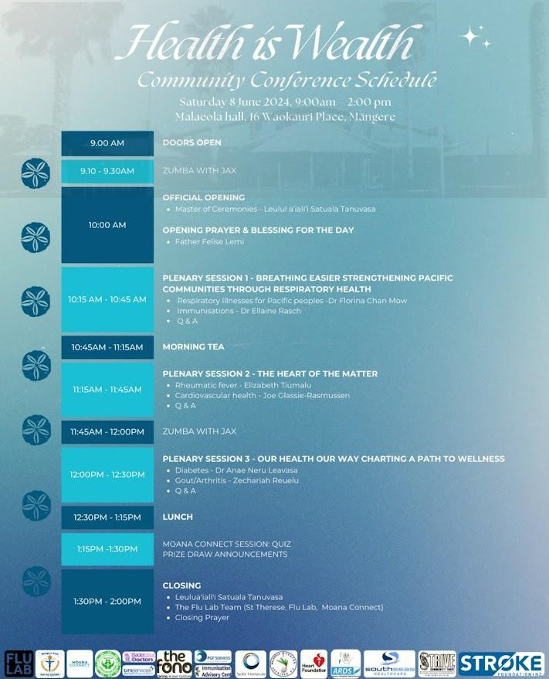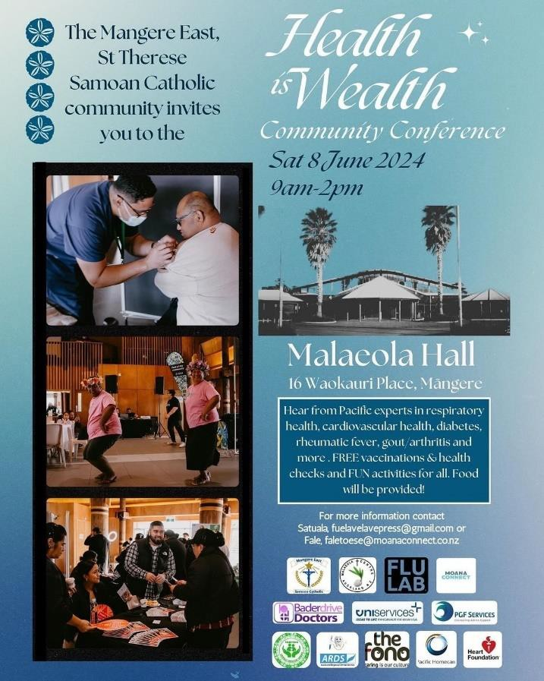

Thank you Dr Samuela Ofanoa for your input to allow the chance to contribute to the conference, Fakafetai ni. The event was invaluable, and I am thankful for the platform for Arthritis NZ to spread awareness and knowledge on this important topic.

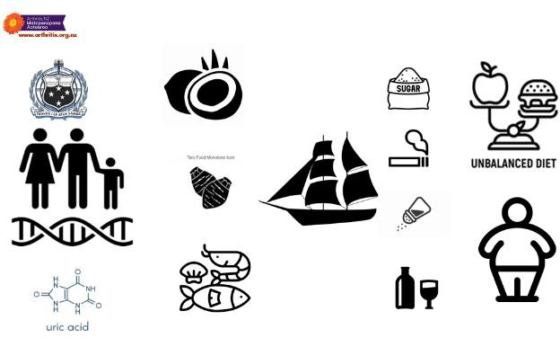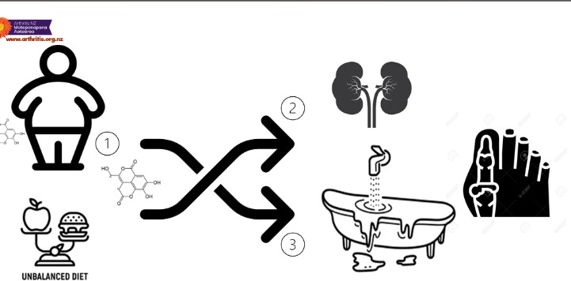

The event had up to 300 people throughout the day resulting in great numbers during the speakers’ deliveries. The gout presentation was delivered with the use of visual aid, water bottles and scissors to demonstrate the uric acid and crystals. Following the presentation, Jeremiah Aukustino, Samoan aged 33 years together with his agia, expressed their sincere gratitude for the manner the presentation was given. He shared his journey since his childhood living with gout and how no one explained uric acid in a way they

understood. Jeremiah explained how he understood the message because of the simple language and use of visual aids.

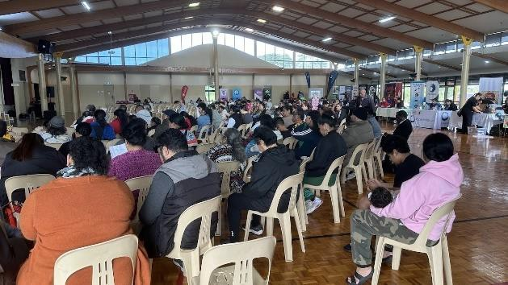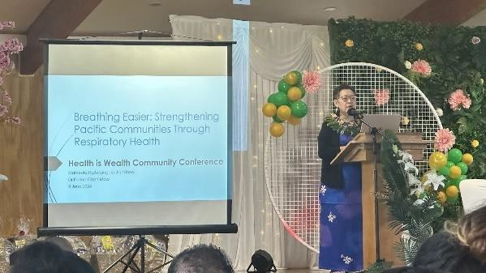

Fakafetai lahi lele, I look forward to supporting your mahi with any future opportunities to continue making a positive impact in improving Pacific health outcomes.

Email Received Monday 10 June 2024

*Mālō ni Zechariah,*

*Heartfelt Thanks for Your Contribution to the Health is Wealth Community Conference.*

*On behalf of Moana Connect, we extend our deepest gratitude for your invaluable contribution to the "Health is Wealth Community Conference." Your presentation on gout arthritis was truly enlightening and impactful.*

*It was an honour to have you share your insights with such an engaged audience. Your ability to convey complex information about gout in a relatable and understandable manner resonated profoundly with our attendees. Jeremiah Aukustino and his family, in particular, were deeply moved by your explanation and shared their heartfelt gratitude for the clarity you brought to understanding uric acid and managing gout.*

*We are immensely grateful to our colleague, Dr. Samuela Ofanoa, for connecting us and facilitating your involvement in the conference. Your participation not only educated but also inspired our community to adopt better health practices.*

*Thank you once again, Zechariah, for your dedication and for the positive impact you have made. We look forward to future opportunities to collaborate and continue our shared mission of improving Pacific health outcomes.*

*Fa'afetai tele lava, Mālō 'aupito, Vinaka vakalevu, Meitaki ma'ata, Fakaaue lahi, Ko rab'a, Ngā mihi nui, Mauruuru roa, Fakafetai lasi, Ko rabwa, Mahalo nui loa, Faiåkse’ea, Fakamanuia,*

*Fale, Dr Samuela Ofanoa, Hereine & Mary*



**Ricky Ngamoki –** Ōtepoti

**He Mihi Aroha mo Winsome Skerrett**

*E te rangatira, e te kaumatua no Ngai Tahu, kua hinga te totara i Te Waonui-a-Tane. Kua wehe atu koe i te ao marama, kua hoki atu koe ki te ao wairua. E te pou tokomanawa o to whanau, o to hapu, o to iwi, moe mai ra i rota i nga ringa o te Atua.*

*E te kaumatua, e Winsome Skerrett, nau i arahi, nau i manaaki, nau i tiaki i a matou. Nau i whakaako i nga tikanga, i nga kawa, i nga korero tuku iho. Kua ngaro koe i te tirohanga kanohi, engari kei te mau tonu koe i rota i nga ngakau o te hunga ora.*

*Ko tau taonga tuku iho mote hauora wahine i Murihiku, he tino taonga, he tino whakahirahira. Nau i whakatakoto te ara mo nga wahine, nau i whakapakari, nau i manaaki i a ratou. Kua ngaro koe, engari kei te mau tonu tau mana me tau aroha i rota i a matou katoa.*

*Haere atu ra ki* o *matua fipuna, ki* o *tupuna kua haere ki tua o te arai. Haere atu ra ki te kainga tuturu mo tatou te tangata. Haere, haere, haere atu ra.*

*Ki te whanau pani, kei te noho tahi matou i rota i te aroha me te mamae. Kia kaha, kia maia, kia manawanui. Kei konei matou hei tautoko, hei awhi i a koutou i tenei wa pouri.*

**A Loving Tribute for Winsome Skerrett**

To the esteemed leader, the elder of Ngai Tahu, a great tree has fallen in the great forest of Tane. You have left the world of light and returned to the spiritual realm. As the central pillar of your family, your sub-tribe, and your tribe, rest now in the hands of the Creator.

Elder, Winsome Skerrett, you guided us, you cared for us, you protected us. You taught us the customs, the protocols, and the ancestral stories. Though you are no longer seen, you remain in the hearts of the living.

Your incredible legacy in women's health in Murihiku is a precious and significant treasure. You paved the way for women, you strengthened them, you cared for them. You are gone, but your influence and love remain with us all.

Go now to your ancestors, to those who have gone beyond the veil. Go to the true home for all people. Farewell, farewell, farewell.

To the grieving family, we stand with you in love and sorrow. Be strong, be brave, be steadfast. We are here to support and embrace you in this time of mourning.

**He Mihi Aroha me te Whakamihi**

*E hiahia ana miitou kite mihi atu ki a riitou kua wehe atu i te tari o te Tahu Hauora.*

*Ahakoa kua mutu ta riitou mahi i konei, e kore e warewaretia te piinga nui o ii riitou mahi i rota i te Komihana. Ko riitou ngii hoa mahi i tautoko, i manaaki i a miitou i ngii wii katoa.*

*Ahakoa kua wehe atu riitou, ka mau tonu ngii taonga i waihotia mai e riitou. Ka nui te aroha me te whakamihi ki a riitou katoa, ii, ka maumahara tonu miitou ki ngii mahi pai i tutuki ai i a riitou.*

**A Loving and Grateful Acknowledgment**

We wish to acknowledge those who have left Te Tahu Hauora. Although their work here has ended, the significant impact of their contributions to the Commission will never be forgotten. They were colleagues who supported and cared for us at all times. Deon, Anne, LJ, Lauagaia, Robbie, Allison and Zelda.

I would like to make special mention also, of Dr Chris Walsh and Deon for the time that they allowed LJ to be able to tautoko me, in my journey on Kōtuinga Kiritaki, in the manaakitanga of ensuring that I had awhi for reports, and for the understanding of papers that were submit. This meant a lot to me, and allowed me to fully participate.

I also with to acknowledge Tofilau Bernadette Pereira and Marlene Whaanga­ Dean for their contributions to Kōtuinga Kiritaki. I always appreciated the kōrero and the laughter, you both have great mana and have an affinity for supporting our people. Thank you.

Even though they have departed, the treasures they left behind remain with us. We hold great love and gratitude for them all, and we will always remember the good work they achieved.

**Environmental scan**

On June 14th, 2024, the Dunedin Oncology Department unveiled a new carving created by Te Whanau Arohanui Trust and carver Alex Whittaker.

Originally produced in 2020, the installation was delayed due to the COVID-19 pandemic.

"The inspiration for this project came from Ricky Ngamoki, who, during his cancer treatment, found the Oncology Department's environment stark and uninviting. He envisioned a more uplifting space for patients awaiting potentially frightening results. The carving aims to provide a sense of comfort and positivity, transforming the atmosphere of the department.

The Carving represents Ranginui me Papatuanuku. It is about Health, Wellbeing and adorning the area of the Oncology Department which for those who are suffering with cancer and their whanau members can be a bleak outlook for some. The carving is to acknowledge those challenging journeys and the attempt is to brighten up the area while people are waiting.

This initiative highlights the importance of creating healing environments in healthcare settings, recognizing the emotional and psychological needs of patients alongside their physical treatment.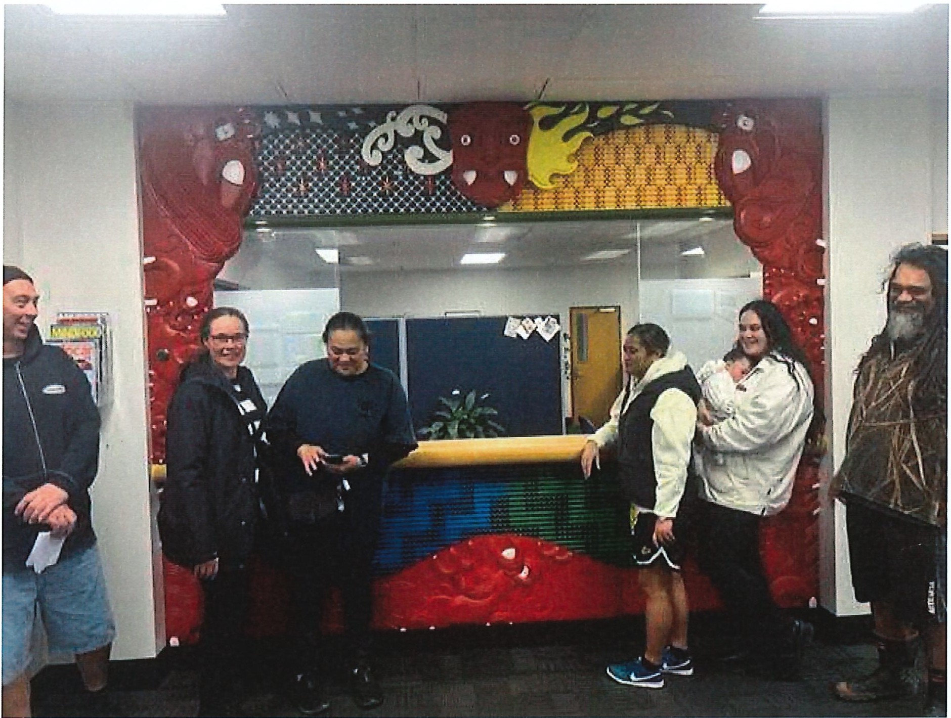

**The healthcare system in Dunedin is currently facing significant challenges, particularly in the Accident & Emergency (A&E) department at Dunedin Hospital.**

Patients visiting the A&E department at Dunedin Hospital are experiencing wait times ranging from a few hours to over eight hours before being seen by a healthcare professional. This issue is not isolated to the A&E department but is prevalent across various areas of healthcare in Dunedin.

Contributing Factors:

**Increased Patient Volume**: There has been a notable increase in the number of patients visiting the A&E department. This surge is partly due to General Practitioners advising patients to seek emergency care when they are unable to provide timely appointments.

**Staff Shortages:** The hospital is experiencing staff shortages, which exacerbates the problem. The shortage of medical professionals means that fewer staff are available to attend to the growing number of patients.

**Resource Limitations**: Limited resources, including beds and medical equipment, further strain the hospital's capacity to handle the influx of patients.

Impact on the Community:

**Patient Frustration**: Patients and their families experience significant frustration and distress due to the long wait times.

**Delayed Care**: Critical care is delayed, potentially worsening patient outcomes.

**Strain on GPs:** GPs are under pressure as they struggle to manage their patient load, leading them to refer more patients to the A&E department.

**Community Health:** The overall health of the community is impacted as individuals may avoid seeking necessary medical care due to anticipated long wait times.

**There is a need in Dunedin to address the critical gap in specialised mental health services for individuals over 30 living with psychosis in Dunedin.**

While there are organisations providing moderate to severe mental health care, there is a pressing need for dedicated services that cater specifically to this demographic, with a particular focus on supporting Māori whānau.

In Dunedin, there are no specialised organisations that exclusively cater to individuals over 30 who are living with psychosis. Existing services, such as the Adult Community Mental Health Services provided by Te Whatu Ora, offer support for a range of mental health issues but do not have specific programs tailored for older adults with psychosis.

Contributing Factors:

**Age-Specific Needs**: Individuals over 30 with psychosis have unique needs that differ from younger populations. These include managing long-term symptoms, addressing co-occurring physical health issues, and providing support for social and occupational functioning.

**Cultural Considerations:** For Māori whānau, culturally appropriate care is essential. This includes incorporating Māori values, practices, and language into treatment plans to ensure holistic and effective care.

**Resource Allocation:** Limited resources and funding often result in a focus on broader mental health services rather than specialised care for specific conditions like psychosis in older adults.

Impact on the Community:

**Inadequate Care:** Patients may not receive the comprehensive and tailored care they need, leading to poorer health outcomes.

**Increased Burden on General Services:** General mental health services become overburdened, impacting their ability to provide timely and effective care to all patients.

**Cultural Disconnection:** Māori individuals may feel disconnected from services that do not incorporate their cultural needs, leading to lower engagement and adherence to treatment.

**There is a new Pasifika Mental Health Service that has joined our Ōtepoti community called Ke Tatala Mental Health Service.**

The recent establishment of Ke Tatala Mental Health Service in Otepoti marks a significant milestone for the Pasifika community. This new service is designed to provide culturally significant and tailored mental health support, addressing a critical need within the community.

Ke Tatala Mental Health Service, launched by Pacific Trust Otago (PTO) in partnership with WellSouth and Ashburn Clinic, aims to "lift the dark clouds" over Dunedin's Pacific communities. The name "Ke Tatala" is derived from the Tongan saying "ke tatala e pulonga," meaning to "lift the dark clouds," symbolising the service's mission to bring light and support to those in need.

Importance for the Pasifika Community:

**Cultural Significance**: Ke Tatala provides a culturally attuned environment where Pasifika individuals can receive mental health care that respects and incorporates their cultural values and practices.

This is crucial for effective treatment and engagement.

**Tailored Support:** The service offers a range of support options, including family therapy, group therapy, and individual therapy, all designed to meet the specific needs of the Pasifika community. This holistic approach ensures comprehensive care.

**Accessibility:** Ke Tatala is committed to being easily accessible, removing social and monetary barriers to ensure that all members of the community can receive the help they need.