

**Minutes of the Kōtuinga Kiritaki / Consumer Network**

|  |  |
| --- | --- |
| Chair | Deon York |
| Members | Joanne Neilson, Oliver Taylor, Ricky Ngamoki, Jennie Harré-Hindmarsh, Zechariah Reuelu, Mark Rogers, Marlene Whaanga-Dean, Tofilau Bernadette Pereira MNZM, Tyson Smith, Toni Pritchard,  Edna Tu’itupou-Havea, Amanda Stevens, Vishal Rishi |
| He Hoa Tiaki | PIC Team | DJ Adams, Anne Buckley, LJ Apaipo, |
| Te Tāhū Hauora staff: | Arana Pearson |
| Apology | Mary Schnackenberg, Allison Anderson, Gillian Bohm, Dez McCormack |

The hui was held at Waipuna hotel and conference centre, Auckland on **16 May 2024**.

The hui began at 9.00 am.

### 1. Welcome and karakia

Deon welcomed the group and DJ opened the meeting with a karakia.

### 2. Standard business

Previous minutes:

Action items:

These have been actioned.

Interests register:

Previous updates circulated prior to the meeting.

### 3. Feedback on Our Voices Forum

There was round table feedback on the Our Voices Forum. Members had a lot of positive comments about the content of the forum and specific aspects. HQSC staff were complimented on their work and leadership demonstrated by the forum and noted that the programme went according to plan.

A general summary of feedback comments is included.

**Ngāti Paoa - Mihi whakatau**

* Mihi whakatau gave a great start to the day.
* Appreciated the opportunity to participate.
* The use of te reo and waiata was appreciated.
* Inclusion of mihi whakatau demonstrates Te Tāhū Hauora commitment to Te Tiriti o Waitangi.
* Korero from mana whenua appreciated - good to hear about the history of the whenua.
* Pleased to hear and support the kapahaka group, the haka pōwhiri was their first public performance. Suggested that a letter of thanks go to the group and acknowledge their whakamana of the kaupapa. (action item)

**MC – Brian Sagala**

* Considered a great choice for the event.
* Able to connect with a wide range of people.
* Given length of morning session suggested an opportunity for people to get up and move was needed.

**Presentations**

* Code of expectations – good to see how many people in the audience reported knowing about the code.
* ‘Code presentation great’.

**Panel discussions**

* Valued by the group as a whole.
* Consumer panel inspiring and good to include young speaker in it.
* Suggestion that panel discussions could be followed by a ‘break out’ room for people to put their questions.
* Health entity panel - valued the inclusion. Comments included that hard to understand some content, and that ‘messaging was as expected’. Questions from audience useful. Examples given did not always illustrate consumer engagement.
* Setting up the panels on the right side only of the stage made it harder for audience as a whole to engage with panel discussions.
* For the future, consider more on mental health, disability and youth.

**Workshops**

**Overall comments**

* May need more briefing about how workshops should be run to ensure all are interactive sessions.

1. **Digital health equity**

* The workshop was great – captured participants input.
* Noted that health professionals not focused on the issue of consent in the digital space.
* Interesting divergence of opinions in workshop on access to ‘digital rooms’ – whether or not they should be available on marae and in churches.

1. **Honouring our stories**

* Good workshop with He Hoa Tiaki advisors (Lauagaia Cat Jeffries & DJ Adams). Attended and appreciated by several in the group.
* Query whether resource used would be available to share – Deon advised need to check sources etc. before sharing outside workshop.

1. **Health NZ Consumer engagement and whānau voice team**

* Presentation on engaging rainbow community a highlight and of relevance to any group.
* Dissatisfaction with shortened second workshop and with response to Bernadette’s attempt to ask a question of presenter.

1. **Disability Capability framework**

* Workshop not delivered in accessible way. Turned captions off video as example.
* Concern about some of the content – felt not inclusive of all disabled community (particularly intellectually disabled). Also, that the workshop was not whānau focused despite the role of whānau in supporting disabled people.

**Other comments:**

* Appreciated the Pacific performing group and important to have them there.
* Networking opportunities good. Opportunities for engagement through the day including in breakout sessions.
* Consider the timing of the event – important to have policy makers etc. in the room as well as the ‘converted’.
* Expectation that there would be more Pacific representation in attendances than noted.
* Would be good to have a combined CN and Young Voices Advisory Group meeting in the future.
* The network wanted to acknowledge the mahi of He Hoa Tiaki in planning and delivery of the event. The CE has shared his thanks in other correspondence.
* Moved by Joanne seconded by Tofilau that Te Whatu Ora is contacted about the potential loss of local voice from the shift to regional Consumer Councils. (action item)
* All members wanted to make special mention, and thanks to Dez for his organisation and attention to every detail, for their travel and attendance at Te Tāhū Hauora kaupapa.

### 4. Feedback on previous CAG hui – 5 April 2023

Mary provided a report and DJ shared as follows:

“My apologies to you for not being at the Consumer Network meeting or the National Forum. I am confident HQSC staff in your meeting will be able to answer your queries.

HQSC has four groups of consumer advisors across the organisation:

• today's Consumer Network, Kōtuinga Kiritaki.

• Consumer Advisory Group (CAG) Te Kāhui Mahi Ngātahi – I am a member of both groups.

• Te Kāhui Piringa which represents the Māori consumer voice; and

• Young Voices Advisory Group, formed in November 2023.

There are consumer advisors on other groups in HQSC. HQSC promotes consumer advisor roles in other health-related entities through its emails, newsletters and its website.

On 22 February the Consumer Advisory Group attended in person the HQSC Te Tāhū Hauora Board strategy day with HQSC Board members and also members of Te Kāhui Piringa, HQSC's Māori consumer voice. Some HQSC senior staff were also present. The invitation to CAG to attend came from the Board. The day was very successful as we discussed a number of challenges facing HQSC as the team was working to develop plans for the coming years with a reduced budget. The importance of the consumer advice role was stressed.

On 28 March the HQSC CE Dr Peter Jansen discussed with CAG a “proposal to support our financial future”.

On 5 April the Consumer Advisory Group met over Zoom. We discussed the draft of the Perinatal and Maternal Mortality report. The frequency of Mortality Reviews is likely to be reduced because of budget constraints. The sadness of these reports is immense. However, if we don't learn from, then implement changes as a result of the reports, those who have passed away will have died in vain.

On 2 May Dr Jansen shared with CAG over Zoom proposed changes at HQSC because of the budget reduction. These proposals are out for consultation with staff.

As you can see, Peter Jansen is taking internal stakeholders, including CAG, with him during the challenging times for the Commission. And he continues to stress in his meetings with us the priority role of consumer advisors at HQSC and in the wider health sector.”

### 5. Regional workshops – update & reflections

LJ, DJ, and Anne provided a brief update on the regional workshops held in March in Whangarei, Kaitaia and Hastings.

Anne acknowledged the work of all the advisors in the success of the regional workshops, including Lauagaia (Cat) Jeffries who was not present at the meeting. Anne commented on the welcome of kaumatua and others at the Whangarei and Heretaunga venues and that the venues were great choices – Terenga Paraoa marae in Whangarei, Te Ahu in Kaitaia, and Te Taiwhenua o Heretaunga in Hastings. DJ and LJ were the key liaisons for the venues and catering.

The Northland workshops were back-to-back (Friday 15 March and Saturday 16 March) and this made for a very busy time with pack in and pack out and travel time. LJ commented on how much participants appreciated the team travelling out to run the workshops and specific feedback on that was shared from the evaluation surveys:

“*Appreciated this hui being available in Kaitaia.”*

*“Appreciate you bringing this to Heretaunga”.*

DJ spoke about the activities completed within workshops, which included use of the health system gameboards trialled in a previous CN meeting, and an activity on sharing lived experience safely and effectively when engaging with the health sector for health sector improvement work. DJ commented that the ‘Telling your story’ activity used in the regional workshops was the basis of the workshop he and Lauagaia offered at Our Voices, enriched by the thoughts and comments shared by those who attended the regional workshops.

It was noted that further regional workshops are planned for the 2024/25 financial year.

The He Hoa Tiaki team acknowledged Kōtuinga Kiritaki for their input and support for regional kaupapa.

### 6. Comments/questions on members reports submitted.

The reports were acknowledged and accepted as read.

A summary of reports is at Appendix 2

### 7. Farewells to Edna, Marlene &Tofilau

Deon thanked the outgoing members and acknowledged them for their commitment, dedication and passion that each of them have contributed to Kōtuinga Kiritaki and any of the extra kaupapa that they have been part of, across the work programmes of Te Tāhū Hauora. Members were presented with a gift each and a letter of thanks from the commission.

### 8. He Hoa Tiaki | Partners in Care report. & update on 24/25 SPE/Programme plan.

The report is listed under Appendix 1

### 9. Closing comments/other business

There were no closing comments or other business.

A group photo was taken.

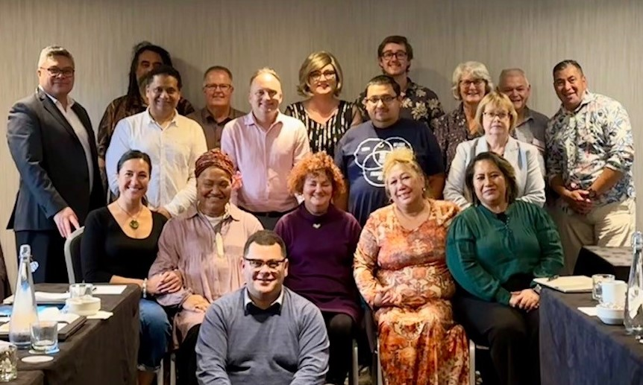

### 10. Karakia & close

DJ closed with a karakia.

**Next hui:** 22 August 2024 – Rydges Wellington Airport

### Actions list

|  |  |  |
| --- | --- | --- |
| **Date** | **Action** | **Responsibility** |
| 16 May | Letter of thanks go to the kapahaka group and acknowledge their whakamana of the kaupapa | DJ Adams |
| 16 May | Contact Te Whatu Ora about the potential loss of local voice from the shift to regional Consumer Councils | Deon York |

### Appendix 1

He Hoa Tiaki report for Kōtuinga Kiritaki Consumer Network-16 May 2024

The following are highlights from the past few months with a focus on the third quarter of the financial year (1 January-31 March).

***Consumer health forum Aotearoa***

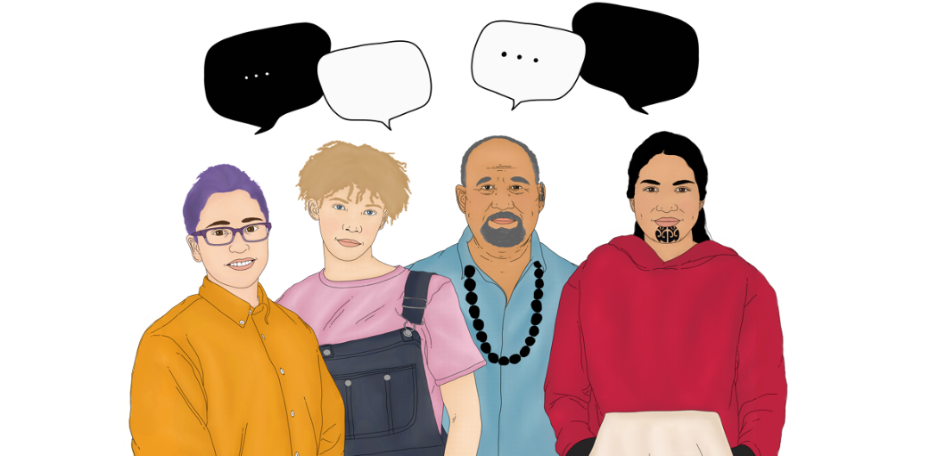

**North Island consumer health forum workshops March 2024**

Three consumer workshops were hosted by He Hoa Tiaki in the North Island in March with a view to building consumer interest in and capability to engage in health service improvement. The workshops took place on Friday 15 March 2024 at Terenga Paraoa Marae in Whangārei and on Saturday 16 March 2024 at Te Ahu in Kaitaia. The following weekend, the workshop was held on Saturday 23 March 2024 at Te Taiwhenua o Heretaunga, Hastings followed by an afternoon session hosted by the Office of the Health and Disability Commissioner about the Code of Rights (www.hdc.org.nz).

Consumer forum opportunities

We continue to see a growing interest in consumer opportunities being made available through the consumer health forum Aotearoa. For the period of 1 July 2023 to the present we have been able to assist organisations to recruit over 410 consumers to share their expertise through joining consumer councils and networks, participating in focus groups, joining advisory, steering or governance groups and participating in surveys. Some examples of these include:

* Recruitment drives for Health New Zealand Te Whatu Ora programmes including work focused on palliative care, cardiovascular disease, and cancer care.
* New opportunities for consumers to work with Te Tāhū Hauora Health Quality and Safety Commission including focus and advisory groups in areas of aged residential care, a national medicines steering group and the recruiting of 2 members to our consumer network.
* Testing of IT services for the National Screening Unit
* focus groups led by HDC, University of Auckland School of Pharmacy and Health Navigator

All current opportunities are listed on our website here: <https://www.hqsc.govt.nz/consumer-hub/consumer-health-forum-aotearoa/consumer-opportunities/> .They are updated regularly and are also promoted via our newsletters and via social media. Please share widely any opportunities your networks may be interested in.

Next year’s programme plan includes surveying both organisations and consumers and whānau to understand more about experience and tracking the impact that consumers are having on shaping design delivery and evaluation in the health sector.

Our Voices: Shaping health care together | Ō mātou reo: He tārai tahi i te tauwhiro hauora

Our national event will be held on 15 May in Auckland at Waipuna Hotel and Conference Centre. We are happy to announce that our four workshop sessions are confirmed. You can read about the workshops below. Participants at the forum event may choose two of the four to attend.

* Digital health equity: What it is and how you can help: At this workshop, you can contribute to a paper on digital health equity, following an ‘unconferencing’ style. The important themes and messages for the paper will be developed by the group and inform the work of the Digital Health Equity Network that sits within the Telehealth Leadership Group ([www.telehealth.org.nz](https://www.telehealth.org.nz/)). Presented by: Dr Ruth Large, Telehealth NZ and Dr Amio Matenga Ikihele (Niue | Te Whānau-ā-Apanui) is a registered nurse, and GM at Moana Connect.
* Honouring our stories, a workshop for consumers: This workshop is for consumers and whānau who are new to being involved in improving health services. Learn about opportunities to bring your voice to these improvements and preparing to share your lived experience safely and effectively in different settings. Presented by the He Hoa Tiaki Partners in Care consumer engagement team.
* How whānau voice can drive improvements: Introducing the new Te Whatu Ora Consumer Engagement and Whānau Voice team from Service Improvement and Innovation with kōrero from the Group Manager Communities, National Lead PREMS, PROMS and Insights, and National Lead Rainbow Communities, who will give you an overview of their priorities and how their lived experience will influence their mahi and how experience data can impact change. Presented by Presented by Akira Le Fevre, Suzanne Corcoran, Laura Ellis, Health New Zealand consumer engagement and whānau voice team.
* Reframing disability in health: Disability capability framework. Aotearoa New Zealand's health system does not always work for disabled individuals. Health New Zealand prioritises them in the Te Pae Tata plan. This workshop introduces the disability capability framework to help you assess the strengths and areas needing improvement for your organisation to be equitable for disabled people. Presented by: Rachel Noble MNZM and Leo Goldie-Anderson, Health New Zealand – Te Whatu Ora and Jonathan Tautari, Te Tāhū Hauora Health Quality & Safety Commission

The Our Voices [event information page](https://hqsc.sharepoint.com/sites/dms-mho/Advisory%20Groups/Kōtuinga%20Kiritaki%20Consumer%20Network/Consumer%20Network%20Meetings/Consumer%20Network%20meetings%202024/3.%2022%20Aug-Rydges/Event%20webpage:%20Our%20voices:%20Shaping%20health%20care%20together%20|%20Ō%20mātou%20reo:%20He%20tārai%20tahi%20i%20te%20tauwhiro%20hauora%20|%20Te%20Tāhū%20Hauora%20Health%20Quality%20&%20Safety%20Commission%20(hqsc.govt.nz)) contains more details, including programme timing and other event and venue specifics. We still have space, so please continue to spread the word with your networks.

Forum membership

The total number of individuals who have signed up to the consumer health forum Aotearoa forum members is 921. We continue to encourage new membership. You can keep the forum growing by sharing [this sign-up link](https://www.hqsc.govt.nz/consumer-hub/consumer-health-forum-aotearoa/join-the-forum/)  with those in your network:

The following table shows the breakdown of members by ethnicity from end of quarter 4 2022-2023 through end quarter 2 (31 December 2023).

|  |  |  |  |  |
| --- | --- | --- | --- | --- |
| **Ethnicity** | Quarter 4 2022-23 | Quarter 1 2023-24 | Quarter 2 2023-24 | Quarter 3 2023-24 |
| Māori | Quarter 4 total: 153 (18.4%) | Quarter 1 total: 170 (19.0%) | Quarter 2 total: 174 (19.4%) | Quarter 3 total:  181 (19.7%) |
| Pacific | Quarter 4 total: 87 (10.1%) | Quarter 1 total: 91 (10.2%) | Quarter 2 total: 91 (10.1%) | Quarter 3 total:  91 (9.9%) |
| Asian | Quarter 4 total: 39 (4.5%) | Quarter 1 total: 42 (4.7%) | Quarter 2 total: 43 (4.8%) | Quarter 3 total:  46 (5.0%) |
| Pākehā/Caucasian | Quarter 4 total: 482 (56.0%) | Quarter 1 total: 494 (55.3%) | Quarter 2 total: 494 (54.9%) | Quarter 3 total:  504 (54.7%) |
| Middle Eastern/ Latin American/ African | Quarter 4 total: 17 (2.0%) | Quarter 1 total: 18 (2.0%) | Quarter 2 total: 18 (2.0%) | Quarter 3 total:  19 (2.1%) |
| Other ethnicity or ethnicity not specified | Quarter 4 total: 77 (9.0%) | Quarter 1 total: 78 (8.7%) | Quarter 2 total: 79 (8.8%) | Quarter 3 total: 80 (8.7%) |
| Total | Quarter 4 total: 860 | Quarter 1 total: 893 | Quarter 2 total: 899 | Quarter 3 total:  921 |

***Engagements***

External engagements for this quarter were numerous, focusing much of the activity on planning and execution of our national and regional forums and connecting with the national consumer and whānau voice team at Health New Zealand Te Whatu Ora.

The PIC team met with varied organisations in relation to the code of expectations, clinical networks, EOI development for consumer opportunities and supporting the QSM submission process across the health entities. The following workshops or presentations are of note this quarter:

* Deon presented to the Australian Medical council on the development of indigenous presence and scholarship within Te Tāhū Hauora.
* Launch of Rare disorders report at Parliament.
* Lauagaia (Cat) attended the Surgical Mesh roundtable bi-monthly workshop.
* DJ presented to the national Anticoagulation quality improvement group in Auckland re: engaging consumers.

***Code of expectations and implementation guide update***

The implementation guide for the code of expectations was launched in July 2023 as a ‘living guide’ with an aim to update the guide 6-monthly. Feedback on the implementation guide can come through a number of sources including through presentations on the code and guide, the feedback option provided on each webpage, and from health entities through the consumer voice reference group (CVRG). The code of expectations and implementation guide webpages are also monitored to review the traffic to specific webpages.

In December, members of CVRG were asked to complete a survey on behalf of their entity about the current implementation guide webpages and any key changes needed. Te Whatu Ora also shared the survey with consumer engagement leads at national level. Survey responses were then used to plan immediate and later updates to the guide. For example, a few specific resources were suggested as additions, and these have now been added to the guide and further feedback is being reviewed by the team for actioning. A request for further training resources is being taken forward into planning for the coming financial year and the development of additional practical tools is ongoing in collaboration with the sector and with consumer groups.

Overall, there was appreciation of the wide range of resources included in the guide and the ‘Accessibility’ videos featuring Mary Schnackenberg were singled out for positive comment in the survey.

Quality and Safety Marker for consumer engagement (QSM)

The QSM submission date this period falls on 29 March. Due to the Easter holiday coupled with staff shortages, some organisations have requested more and/or assistance with this submission period. He Hoa Tiaki plan have all submissions we receive reviewed, moderated and uploaded by 21 May. We will announce the publication of these closer to the date.

***Website analytics (1 June 2023 to 21 March 2024)***

Our Te Tāhū Hauora website remains our main engagement tool and is used widely.

Highlights from 1 Jan to 21 Mar 2024:

* 7.2 percent of users scrolled to a depth of 90 percent on the pages they visited
* We recorded 22,367 file downloads
* There were 63,977 users that viewed 179,877 pages, and stayed for an average of 1 minute 14 seconds
* There were 2,929 users that viewed 7,897 consumer hub pages, for an average of 1 minute and 28 seconds (18 percent more that the average across the website).

Summary of consumer hub website traffic

Description of Table 1.

[Understanding co-design](https://www.hqsc.govt.nz/consumer-hub/engaging-consumers-and-whanau/co-design/#:~:text=Co%2Ddesign%20is%20often%20used,gathered%20(Ko%20Awatea%202022).) had 667 views (426 users) in quarter 1, 518 views (375 users) in quarter 2 and 347 views (256 users) in quarter 3.

[Consumer health forum Aotearoa landing page](https://www.hqsc.govt.nz/consumer-hub/consumer-health-forum-aotearoa/our-voices/) had 930 views (656 users) in quarter 1, 767 views (542 users) in quarter 2 and 663 views (332 users) in quarter 3.

[Consumer opportunities](https://www.hqsc.govt.nz/consumer-hub/consumer-health-forum-aotearoa/consumer-opportunities/) had 1619 views (964 users) in quarter 1, 1840 views (1010 users) in quarter 2 and 983 views (537 users) in quarter 3.

[Code of expectations for health entities’ engagement with consumers and whānau](https://www.hqsc.govt.nz/consumer-hub/engaging-consumers-and-whanau/code-of-expectations-for-health-entities-engagement-with-consumers-and-whanau/) had 2011 views (1117 users) in quarter 1, 1594 views (961 users) in quarter 2 and 843 views (558 users) in quarter 3.

[The code of expectations translations and accessible formats resource page](https://www.hqsc.govt.nz/resources/resource-library/code-of-expectations-for-health-entities-engagement-with-consumers-and-whanau/) had 1395 views (820 users) in quarter 1, 1267 views (821 users) in quarter 2 and 522 views (385 users) in quarter 3.

[Co-designing with consumers, whānau and communities](https://www.hqsc.govt.nz/consumer-hub/engaging-consumers-and-whanau/implementing-the-code/co-designing-with-consumers-whanau-and-communities/) had 793 views (447 users) in quarter 1, 328 views (217 users) in quarter 2 and 398 views (202 users) in quarter 3.

[Using lived experience to improve health services](https://www.hqsc.govt.nz/consumer-hub/engaging-consumers-and-whanau/implementing-the-code/using-lived-experience-to-improve-health-services/) had 389 views (243 users) in quarter 1, 245 views (165 users) in quarter 2 and 218 views (159 users) in quarter 3.

[Improving equity through partnership and collaboration](https://www.hqsc.govt.nz/consumer-hub/engaging-consumers-and-whanau/implementing-the-code/improving-equity-through-partnership-and-collaboration/) had 276 views (176 views) in quarter 1, 107 views (76 users) in quarter 2 and 129 views (95 users) in quarter 3.

[Accessibility and resourcing for consumer, whānau and community engagement](https://www.hqsc.govt.nz/consumer-hub/engaging-consumers-and-whanau/implementing-the-code/accessibility-and-resourcing-for-consumer-whanau-and-community-engagement/) had 269 views (146 users) in quarter 1, 107 views (58 users) in quarter 2 and 86 views (56 users) in quarter 3.

Social media

Popular content was from reflection on our voices and sharing new consumer opportunities. He Hoa Tiaki social media content have the highest engagement across all social channels.

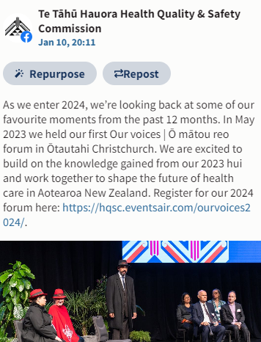LinkedIn

50 percent of the top ten best-performing organic posts for Te Tāhū Hauora were from the He Hoa Tiaki team. Ranked #1 across the organisation was resharing an Our voices post ‘Looking back at our favourite moments in the past 12’

* Clicks: 28
* Engagement: 63.27%
* Impressions: 49
* Reactions: 3

Facebook

60 percent Out of the top ten best-performing organic posts for Te Tāhū Hauora, six were content from He Hoa Tiaki. The top post ranked #1 across the Te Tāhū Hauora was our post for Our voices

* Engagement rate: 6.32%
* Reach: 233
* Reactions: 1

Our top posts ranked: 1, 2, 4, 5, 7 and 8 across the organisation.

Instagram

60 percent of the top ten best-performing organic posts for Te Tāhū Hauora were He Hoa Tiaki content.

Our top posts ranked: #1, 4, 5 and 8 across the organisation.

The top post ranked #1 across the Te Tāhū Hauora was A featured consumer opportunity at with Te Whatu Ora for the female pelvic mesh service business group with an engagement rate of 10.53% on 5 February 2024.

* 10.53 engagement rate.
* Reach 76
* Likes: 8

### Appendix 2 Summary of Kōtuinga Kiritaki Consumer Network member reports for 16 May 2024 hui

**Summary of Kōtuinga Kiritaki Consumer Network member reports - 16 May 2024**

# Mary Schnackenberg (Auckland)

**Environmental scan**

**Input / involvement in Te Tāhū Hauora meetings/groups**

22 Feb Board strategy day;

19 March QSM submission hui with Consumer Network;

28 March CAG zoom with CE re financials;

5 April CAG zoom;

2 May CAG Zoom with CE about HQSC restructure.

**Activity (since last report)**

13 March, Pharmac Consumer Advisory Committee;

17 April, Pharmac Consumer Advisory Committee.

**Services**

Ongoing frustration.

**Positive stories and exemplars**

I am super pleased that we have in braille and audio two very recent health documents:

Cervical Screening Your test your choice; and

Cervical Screening How to do the HPV self-test.

**Recommendations**

Please advocate for more personal health information in accessible formats and languages.

# Jennie Harré Hindmarsh(Tairawhiti)

**Environmental scan**

No primary care after hours now available in Te Tairāwhiti given escalating shortage of GPs and related primary care funding model issues which continue not to be addressed. <https://www.gisborneherald.co.nz/news/lack-of-after-hours-gp-service-shocks>

Urgent restructure of the primary care operational model is required, as recommended for decades (eg, by the Sapere Report which recommended capitation rates be increased & fine-tuned, additional funding to enable providers to meet unmet needs and achieve at least 80% continuity of care which would contribute significantly to reducing health inequities and ongoing ‘post-code lottery’ issues).

Decreased rates in childhood vaccinations (which were comparatively high on Tairāwhiti Coast pre-Covid) continue to be of concern, as is the challenge to sustain relatively high rates of Covid and flu vaccination rates amongst older and more vulnerable adults. Thus Iwi & other local providers are again rolling out vaccination events in rural communities, as well as the city.

**Input / involvement in Te Tāhū Hauora meetings/groups**

Second HQSC Consumer & Whanau Engagement QSM Submission

*19 March & 4 April 2024:* Zoom meetings to provide feedback on draft QSM Submission.

First Te Whatu Ora Consumer & Whanau Engagement QSM Submission

*11 April 2024:* Reviewed range of documents (2 hrs) and participated inzoom to provide feedback to William Robertson and Vanessa of Te Whatu Ora on their draft of their QSM submission (1.5hrs).

*Advisory Group, HQSC ‘Clinical Governance Framework: Collaborating for Quality’ Project*

The aim of this Te Tāhū Hauora HQSC project (begun in September 2022 and initially led by Synergia with the Whanau Ora Commissioning Agency) is to embed the Pae Ora Act principles of equity, tino rangatiratanga, and engagement with Māori and other population groups into a new *‘Pae Ora Quality Framework: Guidelines for clinical and cultural quality and safety in Aotearoa New Zealand’*. The new Framework will replace the current ‘Clinical Quality and Safety Governance Framework’.

*16 April 2024:* In response to a query about the status of the new Framework (when HQSC cancelled the zoom scheduled by Te Tāhū Hauora and FrankAdvise with the Advisory Group, 2-5pm 17April)*,* Dr Martin advisedthey had been asked to incorporate more feedback from the HQSC Board and had engaged FrankAdvise to help with the final edit, about which the Advisory Group will probably now be communicated with via email. Te Tāhū Hauora now hopes the new Quality Framework will be provided to the sector in a few weeks, implementation of which will be up to individual organisations. This is being driven within Te Whatu Ora already.

**Other Activity (since last report)**

*8 March 2024: Genomics Aotearoa webinar* led byAndelka Phillips (University of Oxford) and Jan Charbonneau (University of Tasmania) on *Privacy and the world of Direct to Consumer (DTC) genetic testing: Data breaches are already happening.* It’s a priority to ensure the public, including health consumers, are better informed about current privacy breaches and risks of misuse of personal genetic & health data when using Direct-to-Consumer DNA testing (eg Ancestry, 23andMe, et al) and wearable tech for health or genealogical purposes <https://www.youtube.com/watch?v=37VDaPG3keY>

*15 March 2024:* Provided written feedback and recommendations to the *BreastScreen Aotearoa ICT Replacement Project* after testing, as a consumer, the *National Screening Unit’s new online enrolment and booking functions.* Main themes in my feedback were about ethical improvements needed to enable people to provide fully informed consents (plural) or to decline consent to various proposals in the new online enrolment & booking tool for various parties to access, store and/or use their personal breast-screening and medical records.

*18 March 2024:* Webinar with *Dr Ayesha Verrall, Labour's health spokesperson, previously Minister of Health,* about reflections on her Ministerial work to strengthen public health through the Pae Ora Healthy Futures Act with an emphasis on improving patient/consumer co-design and engagement (“making sure the patient voice is at the heart of the system”) and Māori health and developing New Zealand's Smokefree 2025 Action Plan. She also talked about six current priorities and opportunities to now focus on, and what to look for in the Coalition Government’s first budget this month. See [(1025) Ayesha Verrall - Dealing with an unhealthy government - YouTube](https://www.youtube.com/watch?v=y6ObT_W6yUA)

*21 March 2024: Genomics Aotearoa Māori Variome He Kākano* Governance Roopuzoom meeting, including to start planning a series of events to ‘launch’ the Variome resource during 2024 for precision health services and research. <https://www.genomics-aotearoa.org.nz/our-work/health-projects/aotearoa-nz-genomic-variome>

*24 March 2024:* Family *submission to the Royal Commission of Inquiry into COVID-19 Lessons Learned | Te Tira Ārai Urutā* re Covid pandemic experiences and a personal submission re their Terms of Reference. <https://www.covid19lessons.royalcommission.nz/news/13000-stories-received>

*26 March 2024:* Met with the *Ngāti Porou Oranga* *Director of Research & Population Health and Research Coordinator* to discuss their plans for another iwi & community-focused Health Research Symposium later in 2024. (The third such hui was held in Oct 2021. Many community members, as well as researchers & policy leaders from around te motu, participated in the previous research symposia/hui and sessions were live streamed by Radio Ngāti Porou.)

*27 March 2024: Asia-Pacific Genetics* webinar about *surveillance and countermeasures against coronaviruses with potential spillover from wildlife* presented by Dr Shi Zhengli (Director of the Center for Emerging Infectious Diseases at the Wuhan Institute of Virology and Group Leader for Emerging Virus Team) whose experience with bat coronaviruses led to the rapid identification of the pathogen COVID-19 and its probable bat origin.

*3 April 2024:* *Helen Clark Foundation* webinar with panel of experts *about Long Covid* (Michael Baker, UoO Professor of Public Health; Paula Lorgelly, UoA Professor of Health Economics and Population Health, Jenene Crossan, Patient advocate Long Covid Support Aotearoa, and Warren Tate, UoO Emeritus Professor of Biochemistry) <https://helenclark.foundation/event/webinar-long-covid/>

They discussed concerns about how Covid and Long Covid are now being trivialised and not taken seriously enough (since becoming a political football), and the urgent need for evidence-based policies and procedures to respond to the increasing number of people with Long Covid - of whom there are now 150,000 to 200,000 in Aotearoa. These people are encouraged to participate in a research project which is establishing a Long Covid registry to provide data to better understand the burden of the condition on patients and their whānau, as well as on our wider health and economic system and improve support for those coping with its impact, the effects of which were likened to MS or cancer <https://www.lcregistry.auckland.ac.nz/>

*18 April 2024 –* Submitted to Select Committee about the *Fast Track Amendment Bill,* including its threats to our public health and environmental health (which are inextricably linked), democracy, and recent FTAs.

*19 April 2024 –* Participated in opening the *Mātai Medical Imaging Research Institute’s purpose-built facility* (see below) as one of the many advisors who supported the leaders of this initiative to develop the concept, business case, funding & community relationships strategies, and campus plan over the last five years.

*27 Feb and 10 April 2024:* Contributed to Gisborne District Council’s Advisory Group meetings to inform the development the Waimatā-Pakare Catchment Plan to *improve ‘Te Mana o te Wai’ freshwater quality and quantity,* a key component of our environmental & human health.

**Positive stories and exemplars**

*Mātai Medical Imaging Research Institute’s purpose-built facility opened* in Gisborne on 19 April, and a community open day was held the following weekend. <https://www.matai.org.nz/> This is the first stage of a new campus in Gisborne which, in addition to the state-of-the art medical imaging service, provides facilities for medical & trans-disciplinary research and health service students. Future development plans include accommodation and café facilities, an educational science centre and community outreach centre. The initial facility was funded by the Lottery Significant Projects Fund, Kānoa Regional Strategic Partnership Fund, grants from many local Trusts, and community donations. <https://www.gisborneherald.co.nz/news/matai-welcome-mat-to-be-rolled-out-for-grand-opening>

**Recommendations**

*That* *Te Tāhū Hauora*

* *Collaborate* with iwi and community leaders, health researchers, and national entities to retain Te Tiriti o Waitangi 1840 as well as whānau & consumer engagement as central and inextricably linked in ongoing implementation of Pae Ora.
* *Collaborate* with iwi and community leaders, health researchers, and national entities to advocate for: reinstating the Smoke Free legislation which was to be implemented in 2024; and making vaping products prescription-only as part of that legislation.
* *Collaborate* with consumers, health service providers and genomic health researchers to co-developquality & safety guidelines and related education resources for the informed use of safe genetic testing services and genetic/genomic information by whānau/families, individuals, and health professionals to improve prevention, decrease risk, and management of health conditions.

**Oliver Taylor** (Wellington)

**Environmental scan**

Changes to Te Whatu Ora’s consumer engagement structure were announced on 19 April by Margie Apa, to the Chair of the Chairs of district consumer groups. The announcement stated that consumer governance groups will move from local to regional and include local representation. It will align with the way Iwi-Māori Partnership Boards operate to provide influence. This is expected to be in place from 1 July. While there is no further clarity, it will be interesting to understand how changing governance functions will influence where are how consumers should expect to be engaged, both locally and regionally.

Consumer work has continued to progress on various projects, including the Front of Whare Emergency Department Project in Wellington, and the QSM reporting schedule for consumer engagement in health entities. The Front of Whare project is progressing, however changes to fitouts and models of care are causing difficulties in moving services into new places, while maintaining the aim of increasing beds in Wellington Regional Hospital. The QSM work is slowing down on the district side, with only 8 submissions received on time. We expect more submissions to flow in over the next month, however, districts will continue to be reminded of their expectations for the work.

**Input / involvement in Te Tāhū Hauora meetings/groups.**

***4 April:*** *Te Tāhū Hauora QSM Submission review meeting:* There was a review session for Commission consumers to engage with their submission for the next QSM round. Despite the difficulties and capacity issues the Commission has faced, the submission was well-received, and Deon committed to further work before entering it into the system. We look forward to reviewing the full submission.

***19 April:*** *QSM Submission Moderation Meeting 1:* As a consumer who has directly worked on both reviewing the QSM itself and entities’ submissions, moderating the QSM has been an exciting opportunity for me to understand how consumer engagement is being promoted and celebrated in Aotearoa. It was somewhat disappointing to see only 8 of the 24 entities had submitted by our first moderation session, however, we expect to see more submit in the next month. After moderating the submissions so far, there seems to still be work needed to understand how the scoring system works, and what counts towards consumer engagement and the QSM. Many entities would refer to documents that did not demonstrate service design worked on by consumers specifically, but work that would eventually apply to them. Ongoing promotion of the QSM will continue to improve our collective understanding of what is expected under the QSM and the Code.

**Activity (since last report)**

***1 March:*** *Capital, Coast and Hutt Valley**District Consumer Advisory Group meeting & Better CPR Conversations project workshop:* Tammie Pegg – Head of Cardiology, Nelson Marlborough, and Cheryl Ford – Change Implementation Manager. The Tō tātou Reo Advance Care Planning and Clinical Communications programme (**the Programme**) aims to produce resources for consumers and clinicians to better discuss CPR in hospital environments, and what options may be available if resuscitation may be needed. It was made clear to Wellington consumers that CPR does not have better outcomes in hospitals than it does in the community and does not always present a desirable solution. CPR may “work” but lead to a poor quality of life for a consumer. Consumers mostly worked on wording for the patient pamphlet to be sensitive, but also direct, about what options may be available to a consumer. It was a constructive workshop, but also somewhat distressing and personal for some. We hope that consumers are provided with better communications in the future around CPR conversations, following the project.

***13 March:*** *Te Whatu Ora Head Office work on patient communication and planned care wait times meeting:* Tracey Reason - Project Lead Patient Communication, Planned Care. Tracey kindly provided a very clear, specific document with relevant information and specific questions relating to it. It was thorough and concise, and we thanked her for that. The project aims to provide consumers an idea of how long they may expect to wait for specific planned care. It will be based on 95% of consumers’ average wait time and will include a letter that apologises for waiting after 4 months, and again in another 4 months, while requesting any updates to consumer contact information. Wellington consumers provided a range of advice that included using a range of communication methods for consumers, a clear description of the expectation wait time methodology, and direct questions to consumers about action required for updating contact information. The project will go live in July in stages, starting with providing wait time information to GPs, who can then pass this on to consumers expecting planned care. It will eventually allow all consumers of planned care services to directly access this dashboard of wait times.

***11 April:*** *Te Whatu Ora Head Office QSM Submission review meeting:* Vanessa Duthie - Group Manager Consumer Engagement and Whānau Capability, and William Robertson – National Manager Engagement Capability. The meeting was initially provided with document evidence to support the ratings, however, it was the view of consumers who attended this meeting that the evidence did not make clear where consumer engagement was happening, or where consumers were involved in the development of the work. Further, Head Office provided a submission often referenced district work, not central work. This was acknowledged as a difficult area, as making a distinction is challenging. It was also clear that in using Consumer Network as the consumer review group for their QSM submission, Head Office did not have a central informed consumer group to provide feedback on the QSM. Advice to create a central consumer group was provided to Head Office. A commitment was made to provide consumers with an update on this submission, and work appears to be ongoing to submit to Te Tāhū Hauora.

***12 April:*** *Capital, Coast and Hutt Valley District Consumer Advisory Group meeting:* Meeting was fruitful as consumers got to meet our new line manager, Madeleine Matthews – Director of Nursing. We shared our experiences and learned about hers, and then discussed the future of consumer engagement for Aotearoa. We shared district consumer work, and I discussed work on the QSM. We committed to furthering our work in all services and have a constructive and positive relationship with all who work on the project.

**Services**

Pressure on all services continue to be an issue, however GP practices are particularly difficult to access. Staffing for health is an issue and of course the recent Te Whatu Ora Head Office guidance on permanently removing staff if not needed does not give consumers confidence.

**Positive stories and exemplars**

Consumer engagement is appearing to be more standardised within the Wellington region and consumers are being increasingly engaged in projects earlier on. This is a positive sign and I hope will continue.

**Recommendations**

* Advise Te Whatu Ora Head Office to create their own consumer group / network to review their work and support national projects / services.
* Remind Te Whatu Ora Head Office that consumer engagement locally is very important for local delivery, and that local engagement must continue under a regional consumer advisory structure.

**Mark Rogers** (Timaru)

**Environmental Scan**

Pressure on our health system clearly exists and leads to mistakes and misdiagnosis. A recent example of this resulted in surgery for a consumer due to a sporting injury. Staff at the public after hours facility first visited were all very friendly, but with 60 waiting patients, errors are going to occur. An ED visit later was okay, but in the end, it was Private Surgical Services who came to the rescue and demonstrated the professionalism to achieve what should have been done correctly in the first place.

A poor health outcome can affect any New Zealand citizen.

Concerns exist over the cost saving requirements of hospitals and how this may affect elective surgery. It’s easy to save costs by doing no surgery work, but that’s not what our health system needs right now.

It is disappointing that Consumer Councils don’t appear to be as active as in the past. Few, if any minutes are reported.

It is unfortunate that carers of those with disabilities are often overlooked. The cost, both in financial terms, lifestyle and general wellbeing is enormous for many New Zealand carers.

The announcement of a large increase to Pharmac’s budget is welcomed, especially for those with cancers and rare disorders. Funding and access to medicines has deteriorated over the past few years, so this review will have a positive impact for many consumers.

**Activity**

DEWS Expert Advisory Group (Deterioration Early Warning System) for those in Aged Residential Care. 3 x Zoom meetings with our Expert Advisory Group.

Te Whatu Ora Consumer Engagement Quality Safety Marker review meeting (Zoom)

**Services**

Fewer elective surgeries are being done. With an ageing population and less capacity to do elective surgery for those getting on in years, our health system is far from desirable at present.

The Elective Planning Services Patient Flow Indicators Web Tool on Te Whatu Ora’s website makes for interesting reading. Far too many electives not being done or not being able to be done due to workforce pressures.

The Governments expectations are great, but a lot needs to be done to achieve the “95% in 4 months” target.

Expensive as it may be, private surgical insurance needs to be held by as many people as possible.

**Feel Good Stories**

The Serious Traumatic Brain Injury summary publication and resources developed during phases 1 and 2 are now on HQSC website. Working on this project was a highlight over the past 2 years and shows what can be achieved with excellent clinical and consumer collaboration.

All details can be found via the following link:

https://www.hqsc.govt.nz/resources/resource-library/serious-traumatic-brain-injury-in-aotearoa-new-zealand-summary-of-improvement-work/

# Amanda Stevens (Nelson) - Deafblind Association NZ Charitable Trust

**Environmental scan**

Some in the deafblind community are still reporting Tactile Sign Interpreters are still not available during hospitalisation or for GP visits.

**Input / involvement in Te Tāhū Hauora meetings/groups.**

Since my last report four more Peer to Peer Support groups for deafblind have been launched in Te Ika A Maui.

**Activity (since last report)**

We have launched a Pilot Programme, four months, to gather information to be themed around what is not going well, and what is, for deafblind people right now. This is already bringing up some information regarding the health sector. One deafblind man is noted on hospital records as being his wife’s main carer. His wife has dementia. No interpreter is available for staff to communicate with the man regarding his wife’s care or need for particular support when she returns home so he is feeling excluded and feels the situation is unsafe.

**Hui**

Initial meetings with both Paula Tesoriero, CE Whaikaha, and Andrea Midgen, CE Blind Low Vision NZ. Both are now supporting research into the prevalence of deafblindness in Aotearoa, global connections to support research, and interest in tactile communication methods. With reference to health the following actions have been agreed:

* Bringing together key organisations to identify actions which could be taken to improve Deafblind people’s lives;
* Identifying overseas deafblindness prevalence data and actions other jurisdictions are taking to improve outcomes (including Germany, the Netherlands, Norway, and Australia)
* Both CE’s have committed to quarterly meetings.
* Meeting with the Convenor of the Independent Audiologists Society – discussion on how audiologists professional development opportunities can include sight and hearing loss combination for better outcomes.

**Positive stories and exemplars**

|  |  |
| --- | --- |
| |  | | --- | | In exciting news, Pharmac proposes to commence FreeStyle Libré 2 subsidy for all people living with type 1 diabetes in New Zealand, from 1 July 2024!  On 11 July 2023, Pharmac released a Request for Proposals (RFP) for the supply of insulin pumps, consumables and CGMs. As a result of the RFP, Pharmac has entered into provisional agreements with preferred suppliers (including Abbott) to fund a range of devices. | |
| |  | | --- | | From 1 October 2024, an additional Abbott brand of CGM is also proposed to be subsidised that will be compatible with funded insulin pumps and can be used to create an automated insulin delivery system. | |

This is fantastic news for deafblind and all disabled who are disproportionately underrepresented in

the work force as the Blood Glucose Monitoring, Libré, has been around $100 per fortnight. Diabetes is one of the top four causes of sight loss in Aotearoa according to Blind Low Vision NZ.

**Toni Pritchard** (Te Kaha)

**Environmental scan**

Access to quality Health Services, other than GP services, inc Specialists, Radiologists, Physios etc. continues to be a barrier to better healthcare in our rural area.

Mental Health services continue to be under pressure in our rural district, although we’ve seen some improvement which, while small steps in terms of the need, is a first, and a huge breakthrough in overcoming barriers around access and isolation (more detail in Positive Exemplars)

**Input / involvement in Te Tāhū Hauora meetings/groups.**

Hūi to Prep for Ō Mātou Reo

Hūi to provide feedback for Te Tāhū Hauora submissions

**Activity (since last report)**

Hosted Habitat for Humanity Roadshow for critical housing repairs with a record attendance, resulting in over 70 assessments. I realise this isn’t a QSM monitored Kaupapa, but I firmly believe, and data proves that warm, dry housing contributes massively to overall better Health outcomes, including Mental Health. In our rural area, majority of our population are in sub-par unhealthy homes exactly like our Prime Minister referred to as Third World Housing he saw in rural Northland. To have this service come into our area and offer the much-needed repairs and stability whānau need, will lead to huge improvement in Health Outcomes in our area.

**Puawai for Kaimahi -** [**https://www.manawaroa.com/pu%C4%81wai-4-kaimahi**](https://www.manawaroa.com/pu%C4%81wai-4-kaimahi)

Our team recently completed this 2 day workshop, and I wanted to share this, because of the positive impact it had not only for us that work in the Mental Health sector but for our organisation. In all the wānanga I’ve done in terms of wellbeing and health, this was outstanding. It focused on Neuroscience and how we can map pathways in our brain to better deal with situations we don’t have control over that can often lead to stress and burnout. It also covered a section on Tangata Whenua and Tangata Tiriti, and gives value to both parties, and how to navigate these spaces with respect to all people. It’s been hugely beneficial in both my mahi and personal life and well worth sharing. Especially in this political climate that can be very dangerous and can fuel ideas that can create more division instead of understanding and collaboration. Not to mention that in true adherence to the Pae Ora framework, and commitment to positive outcomes for Māori, there needs to be an element of understanding and empathy as opposed to just ticking the boxes. This training would be massively helpful for all organisations to work towards that understanding. As my positive exemplar highlights, true understanding and collaboration works all round towards better health outcomes, not just for Māori, but for all.

**Services**

Lack of access to Health Services other then GP’s (as above)

Lack of Mental Health Clinicians/Practitioners, and quality Mental Health Services in our rural area.

**Positive stories and exemplars**

Further to my last scan, I would like to provide more feedback on our pilot to address complex/high medical needs, with the outcome of Improving the quality of life for suffering patients, bringing down hospital admissions, preventable surgeries, and avoidable long term medical care, which aside from all the individual issues and impacts is also a major financial issue for Health Budgets.

As the Iwi social service, we’ve partnered with our Te Whatu Ora GP Clinical Services, and provided a ‘Health Navigator’ for whānau with high/complex medical needs. This is a collaborative (and equal) partnership between the two organisations and an adherence to the Pae Ora framework with this role built on Māori values and catering to our 99% Māori demographic.

The biggest contributing factor to the success in this role is the emphasis on Kanohi ki te Kanohi (time spent on face-to-face interaction with these patient’s) where values are built on such as Whakawhānaungatanga (connection/trust), Manaakitanga (kindness),Mana Motuhake (self-determination), and Tautoko (support with advocacy) among others.

What we’ve found in these high risks/complex medical patients is the lack of engagement being the main barrier along with presenting with complex social issues – particularly fear and intimidation and lack of understanding around medical language and effects.

Having a Hauora (Health) Navigator who is Māori, a Medical Professional, working alongside these high needs whānau has helped overcome these barriers with significant success – this role has been operating for a period of 5 months so far.

Some of the ‘success’ stories here.

Patient 1 – Male – 44 years old. Type 2 Diabetes with complications involving near double amputation of lower legs, severe congestive heart failure rendering him moderately bedridden. No regular engagement with doctors/nurses or other health professionals. After our Health Navigator spent 4 months working alongside him, educating him about his illness, helping to navigate the health system and advocating for him, understanding ‘his language’ and medical language, understanding nutrition and impacts on the body, helping him to make his own smoothies and juices, he has now reversed his illness, avoided double amputation, has lost 15kgs, regularly exercises and attends his medical appts. He also engaged with Support Net and has a Community Support worker alongside him to continue to help him navigate the challenges he faces daily and to give him the ongoing support he needs with dietary changes. He has a new lease on life and is doing really well.

Patient 2 – Female – 62 years old. Schizophrenia, Severe Type 2 Diabetes, congestive heart failure and a recently discovered renal tumour requiring investigation – she has infrequent engagement with medical team and poorly controlled medication regime. Was living in very unhealthy conditions with her whare being cold and damp with no running water. Our Health Navigator helped get her a cabin by advocating through MSD, and our local pilot Iwi housing initiative to set up her infrastructure. She visited her daily at one stage to provide medication prompting, and patient is now taking her medication regularly on her own. She coordinates online phone calls between her patient, her whānau supports and her specialist. They have now moved to a stage where they have had a conference telephone call involving whānau, the patient and the health navigator with her surgeon for upcoming surgery issues and complications.

Patient 3 – 51 Yr old male – sudden seizure manifestation post brain tumour removal some years ago, pre-diabetic and social isolation due to a loss of drivers licence post seizure. A raft of issues relating to debt management and income support from MSD was needed, along with encouraging medication compliance. The Health Navigator advocated for patient with MSD and finance companies regarding debt, with very successful outcomes, patient is now building friendships and engaging in community social activities.

**Positive Story/Exemplar**

Phycologists from Community Mental Health Services in Whakatāne are now coming to our GP Clinic, to provide their service to our rohe. This has been very well received and is a major breakthrough for our whānau in terms of the barriers to their mental health and healing.

We also have Voyagers – Child and Adolescent Mental Health Services travelling to our area and making home visits to high needs Tamariki which is also a major step towards better Hauora for our people.

**Tyson Smith** (Te Puke)

**Environmental scan**

**Activity (since last report)**

**Te Wheke**

**Te Moana a Toi Lived Experience Network Hui**

* + **General Narrative** 
    - Discussions have started regarding disestablishment, none of the resourcing (Te Whatu Ora Bay of Plenty) eventuated
    - Asked by the commissioning team to wait for a few months to see if they can come up with anything – Rōpū agreed to wait

**Convergence Aotearoa**

**CPSLE Workforce Forum**

[**www.cpsle.org**](http://www.cpsle.org)

* + **General Narrative** 
    - “I’m as tired as I was at Christmas, and its only March” – Concern regarding workforce sustainability
    - Funding Commitment from Te Whatu Ora Bay of Plenty did not eventuate.
    - Individual from Hawkes Bay has reached out – wants to setup a group in Hawkes Bay
  + **Convergence Hamilton** 
    - Regular meetings, self-sustaining/growing.
    - Te Whatu Ora Hamilton MHA Policies are now listed on the convergence website (OIA request successful)

**Te Hiringa Mahara Lived Experience Reference Group (Monitoring Report 2024)**

* Peer reviewed the next report (access and choice) to be released
* Contributed to a working groups
  + Strategic Plan refresh
  + Lived Experience Position Statement refresh

**Noku Te Ao**

**Nationwide programme to end prejudice and discrimination against people with experience of mental distress.**

Invited to a series of governance hui, have not attended (no resourcing)

**Nga Hau e Wha**

**National Forum of Consumers With Lived Experiences.**

Disestablished

**MHA Lived Experience Knowledge Network**

Contributed/participated in a discussion regarding the implementation/monitoring of the Code of Expectations.

* Hannah Whittaker Komatsu - Principal Advisor Lived Experience has brought together a PowerPoint with the collective narrative.
* See the need to give the code “teeth”

**Services**

**Te Whatu Ora, Hauora a Toi Bay of Plenty - Mental Health and Addiction Services**

* Policies are collectively 34 years behind documented review dates
  + Does not seem to be a service priority (raised internally)
* Increasing narrative (from the community) of declined referrals
* Te Whatu Ora Bay of Plenty **still** have no visible mechanism that ensures the lived experience perspective is included in planning and funding (contracts).
* Still have a confusing treatment pathway (7 different MH treatment plans, only 2 that include the individual), confusing the person/whanau at the centre.
* Health Consumer Council has stopped meeting

**Te Whatu Ora**

Te Whatu Ora (National entity) **still** does not have an internal complaint pathway. (send complaints to external advocacy) [*https://fyi.org.nz/request/25181-complaint-process#incoming-95572*](https://fyi.org.nz/request/25181-complaint-process#incoming-95572)

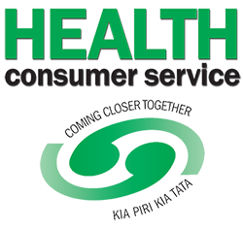 **Health Consumer Service (Independent Advocacy Service)**

Bay of Plenty has two independent advocacy services, one has stopped operating (no comms, just disappeared)

**Recommendations**

* Request Te Whatu Ora (head office) Complaint Policy
  + Outcomes uphold HDC Code – Complaints
* Close the feedback loop (Consumer Engagement QSM) between the reporting organisation, The community they engage with and best practice.
  + Outcome increased health literacy (individual communities)
* Request/socialise what the Minister of Mental Health is responsible for
  + Outcome increased health literacy (population)
* Advocacy regarding transparent contracts (community visibility) what should providers be delivering?
  + Outcome increased health literacy (population)
  + Outcome Places people at the centre (can make informed choices)
* Advocacy for Clear comms between agencies (don’t refer people when they are outside of acceptance criteria)
  + Outcome Places people at the centre (limit wasted consumer/persons time/hope/energy)
* Advocacy for structural resourcing and funding for local and regional lived experience networks (told we are valued but find out it doesn’t include funding – (one L.E Role in an organisation does not represent the diversity of lived experiences within our health system).
  + Outcome gives the community the structure in which to share leadership as per the code of expectations.

**Ricky Ngamoki** (Ōtepoti)

**Environmental scan**

In our hapori, the pursuit of affordable housing remains an ongoing challenge. As rents and market prices continue to soar, finding suitable homes has become increasingly difficult for both renters and potential buyers. The scarcity of affordable housing options exacerbates inequality, affecting individuals and whānau alike. At house viewings for rental properties, a concerning trend emerges as large groups of people are showing up, highlighting the severity of this issue. These gatherings signify that many families are grappling with the same struggle—trying to secure housing that fits their needs and budget.

In our community, the soaring cost of living has placed immense strain on whānau. One of the most critical areas affected is food affordability. The prices of essential groceries have skyrocketed, making it increasingly challenging for families to meet their nutritional needs. As the cost of food continues to climb, some whānau are forced to make difficult choices—sacrificing quality and variety in their meals. Fresh fruits, vegetables, and other nutritious options often take a backseat due to budget constraints. Whānau are finding themselves caught in a cycle where they must prioritize basic sustenance over optimal nutrition. This struggle not only impacts physical health but also contributes to stress and anxiety within households.

Amid the current political climate, Māori service providers and job positions face unprecedented strain and fear. The landscape is marked by budget cuts and funding changes, which have a profound impact on the well-being of both providers and the communities they serve. These changes are creating an atmosphere of uncertainty, as essential services grapple with reduced resources. For Māori providers the pressure is immense and the fear of losing critical positions and the ability to provide holistic care weighs heavily on their shoulders. The ripple effect extends beyond the professional realm—stress and anxiety permeate households, affecting whānau and individuals seeking support. As we navigate these challenging times, it is crucial to recognise the vital role Māori providers play and advocate for stable funding and sustainable job positions.

**Activity (since last report)**

Attended a hui about Rongoa Māori practitioners in Ōtepoti at the Local Rūnaka, Huirapa ki Puteraki – the hui was about seeing which Rongoa Māori practitioners there are in the area, the services they offer and whakawhanaungatanga.

The local Rūnaka at Huirapa ki Puketeraki local mahika kai project that was spoken about at the last hui has been confirmed to open on 2 May which is exciting for the community!

**Services**

In the current political climate, professionals across various fields find themselves under immense pressure. This strain has a direct impact on how practitioners engage with whaiora—those seeking support for their well-being. The heightened expectations, resource constraints, and policy changes create a challenging environment for professionals. As they navigate this landscape, the urgency to meet targets, comply with regulations, and manage limited resources can overshadow the empathetic and holistic care that individuals truly need.

The disconnect between mental health services and AOD support remains pronounced. These two critical aspects of well-being are often being treated as separate silos within services, leading to missed opportunities for holistic care. Individuals grappling with mental health challenges frequently encounter barriers when seeking help for substance use disorders, and vice versa as the organisation they are with may only focus on one rather than both, causing whaiora to contend with different services at a time.

The prolonged waitlist times within mental health and addiction services have become a critical issue, significantly impacting individuals seeking help. These challenges act as barriers, making it incredibly difficult for individuals to access the care they urgently need. The situation worsens while they wait - permanent damage occurs, and personal distress escalates.

**Zechariah Reuelu** (Porirua)

**Environmental scan**

Since the reporting, ongoing concerns have been raised regarding the accessibility and affordability of health services:

* Implications with concerns with approximately 2,100 Pacific unrolled population living in Porirua.
* Ongoing closure issues to the overnight Kenepuru After Hours increasing anxiety.
* Families expressing frustration over long wait times, limited access to specialists, and inadequate coverage for certain treatments.
* We have families on the Tokelau Patient Referral Scheme to New Zealand, expressed their frustrations with the long delays of accessible healthcare options further compounds and compromises their recovery and cultural well-being.
* Some families exploring new open access to healthcare via online tools and services to take control of their health to overcome barriers to access GP. While digital services aims to improve equity for Māori and Pacific there are potential areas of concern, where inequity may widen instead of improve.

# Te Tāhū Hauora Health Quality & Safety Commission

* Our Voices panel discussion
* Review of Te Tahu Hauora 2nd QSM submission
* Provide feedback on Te Whatu Ora submission

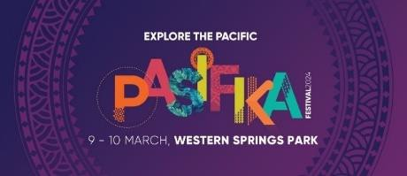

# Background

Last September 2023, Philip Kearney CEO Arthritis NZ together with Zechariah meet with Viv Pole, Head of Pacific Health and Mihi Blair, General Manager, Māori Health and Equity to discuss, key areas such as health literacy, training and education opportunities and partnering that would support both strategies to positive health outcomes for our Māori and Pasifika peoples living in the Auckland region.

# Summary - ProCare FB Post:

What a weekend we had at the Pasifika Festival with our friends from Arthritis New Zealand! We focused on providing gout testing and education for our Pacific and Māori whānau. Gout can be genetic - it’s not always about the kai!

There was steady flow of visitors to our tent, with our team screening close to 200 people for gout and having a talanoa (conversation) with many more!

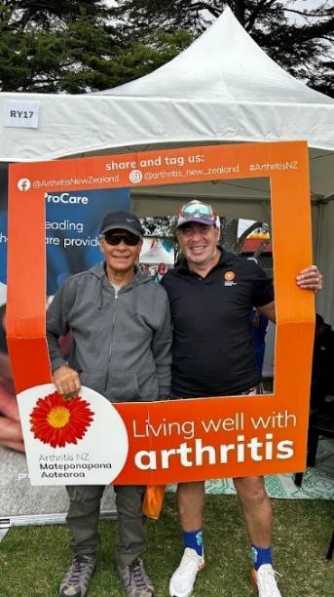

## *"I learnt more about gout today than in the 10-15 years of* struggling with it."

It is feedback like this that makes it all worthwhile, taking the service to our communities and helping them to improve their health and wellbeing. We also believe in the positive ripple effect from those who were engaged at the event, sharing their new knowledge with family and friends.

For those who have gout, it’s important you keep taking your preventative medication – gout is not ‘cured’ when the pain goes away! What a great day and plenty of illuminating talanoa.

Thanks for all your team's hard work!

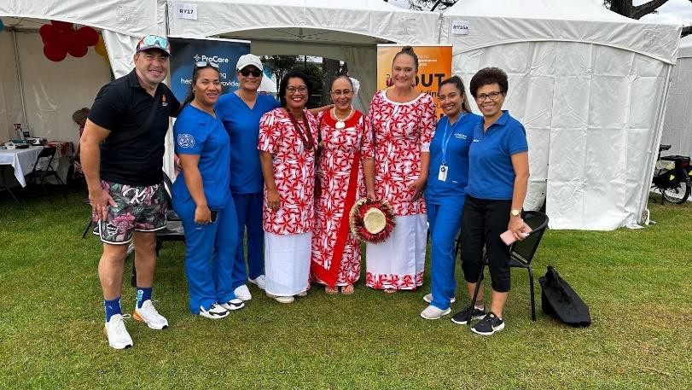**Viv Pole -Head of Pacific Health**

Morena team

What a successful partnership at Pasifika!! I wanted to humbly thank each and every one of you (and the others who assisted) for your passion, commitment and heart to be there and help our people who so need the support. I feel for those who did both days – much aroha/alofa/ofa to you Tui, Niwa and Valita. Tui and Valita.

We have an awesome team and I’m so proud and grateful for you all. Zechariah – we want to clone you.

It warmed my heart to hear the comments and feedback:

***“I learnt more than I ever had from my doctors/nurses in the 10-15 years of having gout”***

***“You teach gout differently (more clearly) than we had at university studies”***

***“Imagine giving this type of talk to our staff (Corrections) and the community”***

I posted on FB, and someone asked me to share more.

I’m sure you heard a lot more of these encouraging comments! No doubt Tui will provide an update on the data, and we’ll look at collating the data soon but am sure we did close to 200 tests? plus a number engagements (without a test) but more importantly is the ripple effect on friends and families from those who received education on the day.

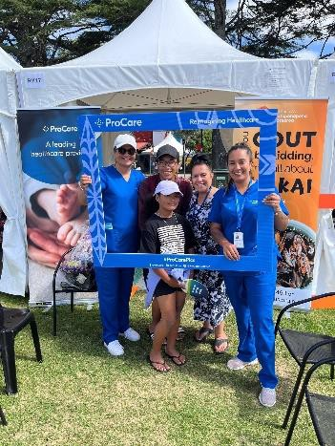 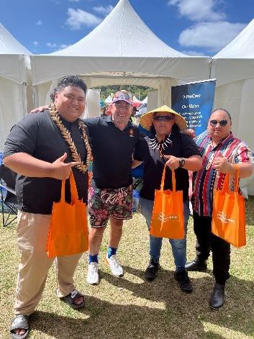 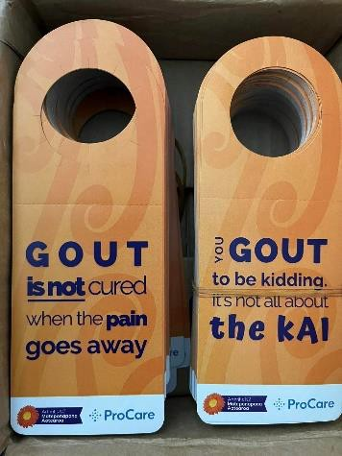 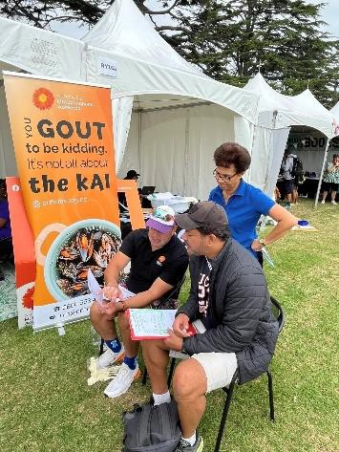

# Te Kanava Health & Social Services Team

The Atafu Tokelau Porirua continue to implement its health responsive plan to improve the well-being of Atafu and Tokelau families, particularly the vulnerable (young people), with activities and information.

# Kilikiti at the Basin Reserves

The Atafu Tokelau Community Group Inc was invited to be part of special Kilikiti event.

A seed planted a few years ago during filming for NZC’s 100 year celebration, the Valley Bears, in collaboration with Cricket Wellington, are excited to host the first ever Kirikiti games to be played at the Basin Reserve, the home of New Zealand Cricket, on Saturday 9th March.

The event strengthened the wellbeing of the Atafu players with health and cultural well- being. The team comprised up to 25 players ranging from young teenage to grandfathers. It important to note that a number of players participating are living with long term morbidity condition, such as gout, and diabetes. Their participation is part of their cultural wellness to their holistic wellbeing.

 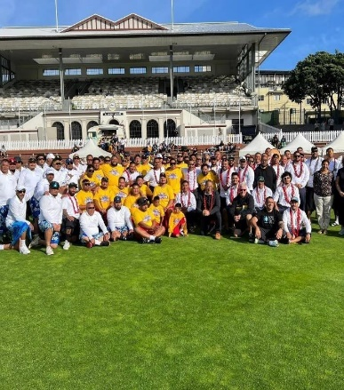

# 

# The Atafu Tokelau Community Group Inc “Te Kanava Strategy Statement”

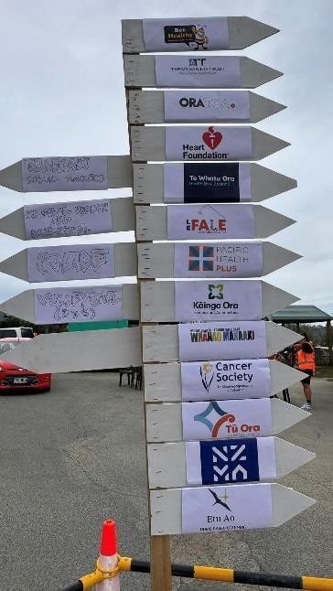

To provide educational programmes, support services that lift the academic, career pathways, employment, health, cultural and social wellbeing of the Tokelau people and their families, with a particular focus on the most vulnerable families.

Te Kanava Health Komiti held the **Takai o te Ola - Tokelau Family Holistic Wellbeing Expo** on Saturday 23rd March 2024 at Matauala Hall from 1:00 pm to 7:00 pm.

The Family Well-Being Expo Objectives:

* Improve health & well-being among Tokelau and Pasifika communities in Eastern Porirua.
* Promoting social services from our local community
* Improving immunisation and screening uptake amongst Tokelau &

Pasifika people,

* Gain improved and new knowledge via connections and awareness of local services.
* Focus on health education, Health literacy, improving access to healthcare services and cultural awareness.
* Empower individuals/families to take ownership and responsibilities to improve their personal and family/community wellbeing.
* Maintain strong connections to our Tokelau cultural heritage with traditional concepts and knowledge, to be open to discussion and learnings.

We have partnered Tu Ora Compass Health to promote their services:

Immunisation team to give vaccinations.

Diabetes team to information

Pacific Navigation Team - health promotion

School Health Service - targeted youth health

The expo is responding to the request from our community with ongoing strategy engagements. The goal is to have a transformative event that fosters holistic engagement for improved health & well-being outcomes.

The expo was a priority to deliver education and link health and social services to vulnerate Tokelau families. Early preliminary findings from the family expo indicate exceeding numbers of Tokelau families with child immunisation and COVID vaccination.

The outcome of the family expo resulted with high rates of Tokelau people undertaking COVID vaccination, child immunisation and breast screening in one day than over 5 month period.

Below is couple of providers social media posted:

# Piri'anga Alofa Pacific and Community Services

Tākai O Te Ola

Over the weekend our Piri’anga Alofa services, Etu Ao, Le Fale Job and Skills Hub, Toru Fetu Kindergarten, and Nuanua Kindergarten, along with other amazing services attended Tākai O Te Ola in support of our Tokelau Community.

So awesome to be a part of this event to showcase our services from jobs and skills to education, to support our wonderful Tokelau Community. Special thanks to the Atafu Tokelau Community Group Inc for your hospitality and organising this awesome event.

Fakafetai lahi lele 🌺

https://fb.watch/rkPT2BrZx7/

# Positively Pacific

Yesterday, we had the privilege of chatting with Ioana Viliamu-Amusia, a respected member of the Tokelau community, who shared captivating insights about the Takai O Te Ola Expo held at Matauala Hall in Cannons Creek. Ioana passionately discussed the event's organisation and objectives. She highlighted how the Matauala community of Atafu, Tokelau, collaborated to create a space promoting holistic family health and wellbeing. Ioana emphasised the importance of fostering connections within the community while providing access to valuable health resources.

Ioana also expressed gratitude to the 500+ attendees who actively participated in workshops, engaged with health providers, and contributed to the event's success. Their presence and enthusiasm underscored the significance of prioritising health and unity within the community.

Let's extend our appreciation to Ioana and the entire Tokelau community for their dedication to promoting wellbeing and bringing people together!

https://fb.watch/rkQBj13rn1/

# CULTURAL AND IDENTITY

We will continue to improve knowledge and understanding of target kaiga and communities about Tokelau culture, identity, history, and language.

**Kaiga Family Wellbeing Summer Camp Foxton Bible Camp**

**“Toku kãiga he kãnava he fau e hē uia"**

**My community,my heritage, a gift that is forever treasured**

The Atafu Tokelau Community Group Inc held its cultural wellbeing camp that offer opportunities for individuals to reconnect with their Tokelau cultural roots, strengthen family bonds, and enhance overall well beings. The camp is immersing participants in traditional practices, such as storytelling, genealogy, cultural fatele and teachings from elders, these opportunities provide a platform for intergenerational knowledge transfer.

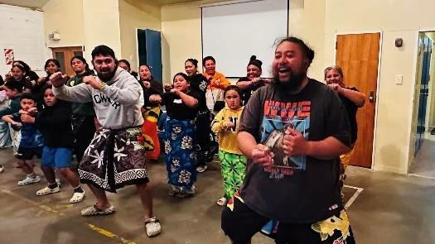

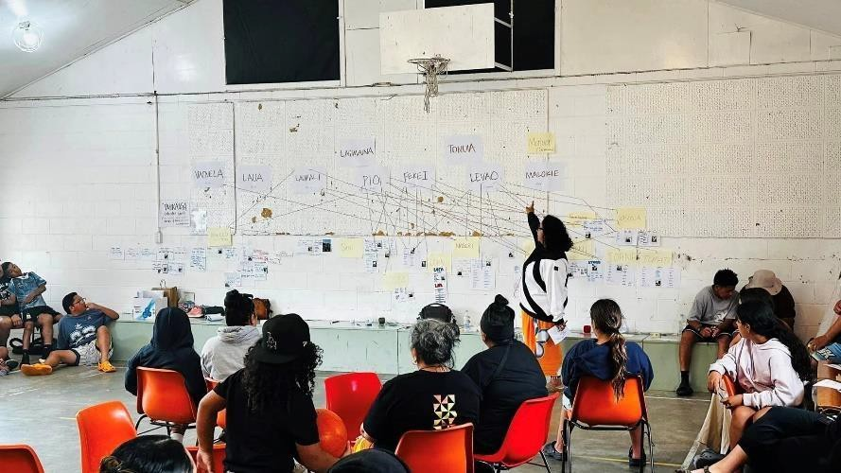Through activities like genealogy study of families, family history, and the tracing of their lineages, traditional cultural dances, communal meals, families fostered a sense of community and belonging. Additionally, the camp settling encourages physical activity and connection with the natural environment, promoting both mental and physical health.

Camp participants left the camp experienced with a deeper appreciation for their Atafu heritage, improved communication within families and a renewed sense of identify and purpose. Ultimately, our families wellbeing at camp served as a vital space for cultural preservations, holistic relaxation, and the promotion of overall wellness among our kaiga and communities.

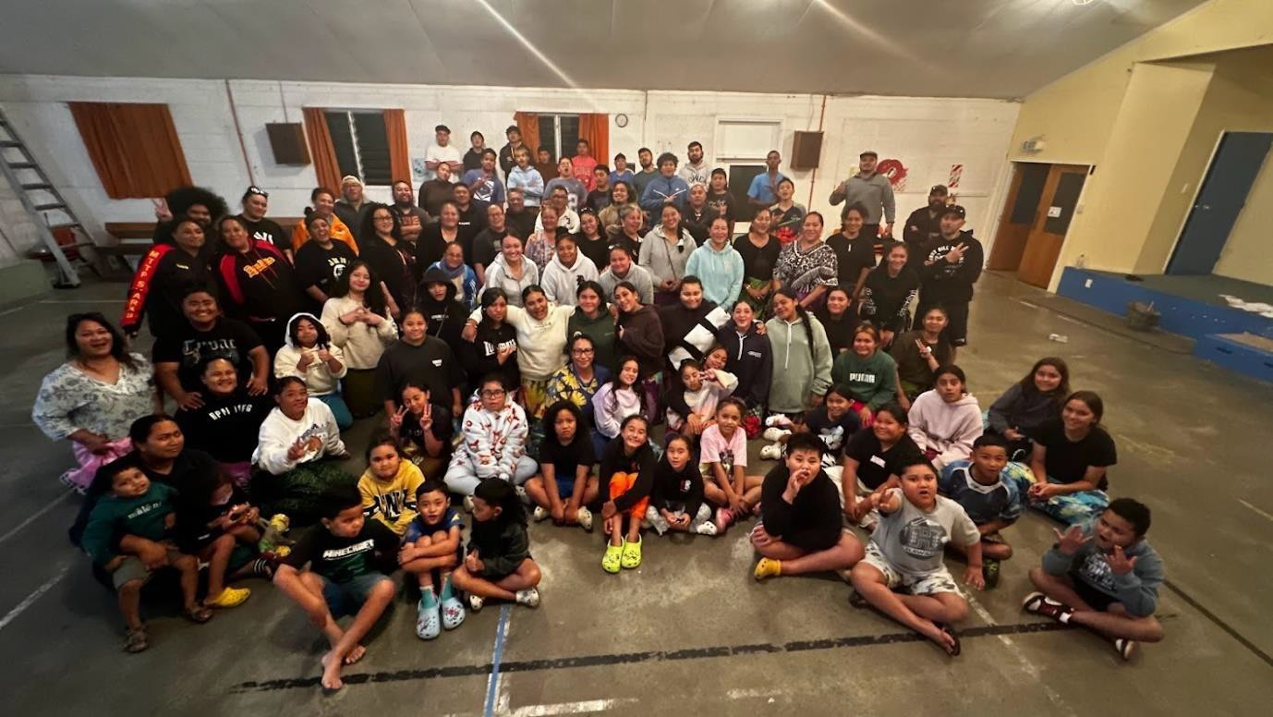

# Blessing of the Fakanauga mo te 2024 – Gagana Tokelau Planner

The Fakanauga mot e 2024 Gagana Tokelau Planner was blessed at the Kaiga Family Camp at Foxton Bible Camp.

The journal planner plays a significant role in Tokelau youth development by incorporating Gagana Tokelau knowledge, culture, and traditions into the academic journey. It provides a platform for students to connect with and honour their heritage while navigating the demands of educational life, fostering a sense of belonging and identity.

The journal planner becomes a valuable tool in promoting holistic student development by integrating Tokelau perspectives into goal setting, time management, and self-reflection.

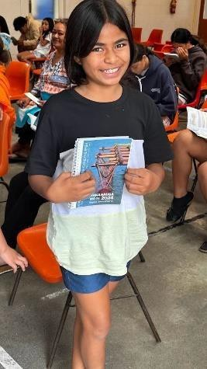

The holistic approach supports Tokelau students in finding harmony between their academic pursuits and cultural values, enhancing their overall well-being. The journal planner also serves as a means of empowerment and self-expression. Through personalized sections for storytelling, artwork, and reflections on cultural experiences, students can articulate their unique narratives and celebrate their heritage.

We are proud to have a codesign process of youth, cultural advisors, and cultural expert to develop the Gagana Tokelau Planner. By embedding Tokelau perspectives within the academic framework, the planner becomes a symbol of empowerment, connection, and balance for Tokelau students, enriching their educational journey and contributing to their overall success and well-being.

The Atafu Tokelau Community Group will be reprinting to distribute to participating school partners – Porirua College, Brandon Intermediate, and Glenview Primary School for their Tokelau students. We have received several requests across New Zealand and Australia for copies from Tokelau peoples.

The Atafu Tokelau Community Group Inc has been planning the significant of the launch of our groundbreaking “Taiuli Strategic Plan” A 30-year intergenerational strategy masterplan aimed at enhancing the economic and social development of Tokelau families residing in Porirua.

We invited a host of esteemed guest at the launch to signify a commitment to inclusivity and progress but also inspire collective action towards positive change. By spearheading this transformative effort, we aim to cultivate a more equitable society, ensuring that resourceful individuals can thrive and contribute meaningfully to the fabric of our nation.

The launch on Friday 5th April 2024, at the Matauala Hall, was a major milestone accumulating the community aspirations for many years. The day filled with reflections and joyful celebrations.

The Hon MP Nicola Willis was the guest keynote speaker. We hoped the Social Investment portfolio would open discussions to foster sustainable economic growth, address inequalities, and empower communities for a brighter future.

The Atafu Tokelau Community Group Inc in collaboration with BECA completed the Atafu Tokelau Taiuli Master Plan – Our Strategic 30-year plan. The objective of the plan is responding to Tokelau community current needs to create wealth opportunities and improve economic and social wellbeing for Tokelau and Pacific families in the New Zealand economy.

The objectives of the master plan are to:

improve labour market participation, increased employment.

contribute to improved community wealth, economic and social outcomes.

improve educational achievement.

Improve the health wellbeing outcomes.

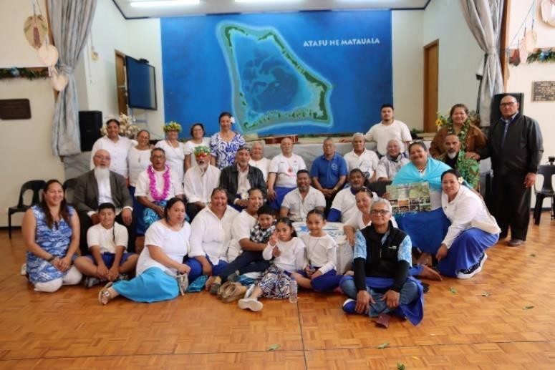

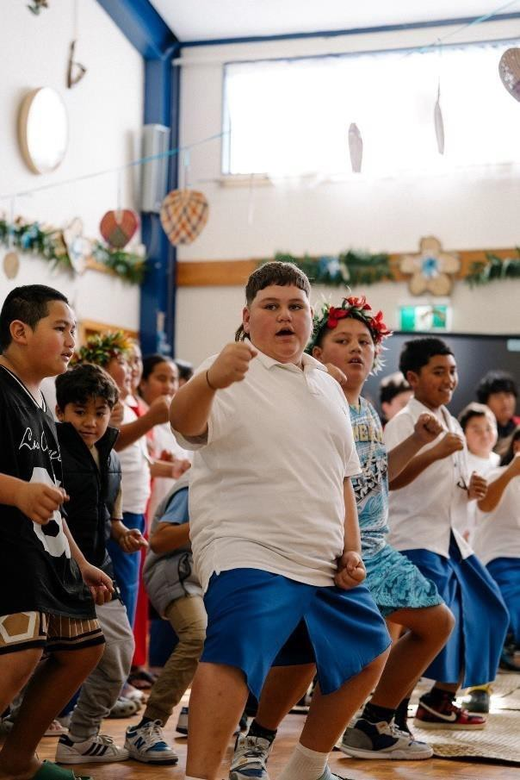

**Joanne Neilson** (Tairawhiti)

**Environmental scan**

In Tairāwhiti we are grateful the RMO doctors strike didn’t affect us too much. We remain very busy in the East coast providing the best care we can, but it is sad to see the emergency room full most days often for things that should be dealt with at the GP’s but the access to health care is still a luxury for some. This autumn seems colder, quicker than previous. And it is interesting to hear the apprehension in people as we had a very heavy rainfall the other day. The cyclone became the topic of the morning until the skies cleared.

**Activity (since last report)**

My costume exhibition closed and was a great success, the museum was delighted with the response from the community. I was thrilled to visit Nelson to participate in the Nelson Pride events. It was a great event on the Friday evening with speakers from around New Zealand. And to see the Nelson Costume exhibition was so well attended was wonderful to have been a part of. What a beautiful part of the country even if it rained the whole time. I also spent some time with the Transgender Heart Health team of course there is very little data available, and that is across the board for any trans data.

**Positive stories and exemplars**

I am over the moon to announce that I have been cast as Bernadette in the East Coast production of Priscilla, Queen of the Desert. This year makes the 30th anniversary of the film so it is great to be a part of the history and to be the first Transgender woman to play the role in New Zealand (and one of only 3 trans woman worldwide) is a great feeling and another chance to show the wider community so visibly in breaking down barriers.

**Edna Tu'itpou-Havea** (Porirua)

**Environmental scan**

**Activity (since last report)**

Health and Disability Commission engagement -In March I had a meeting with Jane Carpenter and Catherine to scope engagement with Pacific communities to review the Code of Health and Disability Services Consumer’s Rights.

Locality Porirua – still in limbo and waiting to hear from Te Whatu Ora on the future of localities.

**Services**

Public sector cuts affecting families financially, mentally, and emotionally. With a lot of uncertainties, families are feeling unsafe and undervalued as citizens of New Zealand.